Surgical Instrument for Robotic Open Microsurgery

Olivia Puleo, Radhika Rajaram

Mentors: Dr.R.H.Taylor, Yunus Sevimli, Dr.Christopher Razavi

February 20, 2017

Project Proposal for
EN.600.646, Advanced Computer Integrated Surgery
Johns Hopkins University, Baltimore, MD

Contents

- Summary
- Background, Specific Aims and Significance
- Technical approach
- Deliverables
- Key Dates and Timeline
- Dependencies
- Management plan
- Reading list
- References

Summary
The Galen robot is a cooperatively controlled robot which has been developed for the purpose of improving the speed and accuracy of microvascular anastomosis in otolaryngology. The usual microvascular instruments, when used with the Galen robot, can be difficult to maneuver and cannot optimally use the workspace afforded by the robot. The aim of our project is to develop alternative microvascular forceps and needle-holders that can be integrated with the Galen robot and enable the surgeons to perform the procedure with ease of manipulation, while respecting the workspace limits during normal operation.
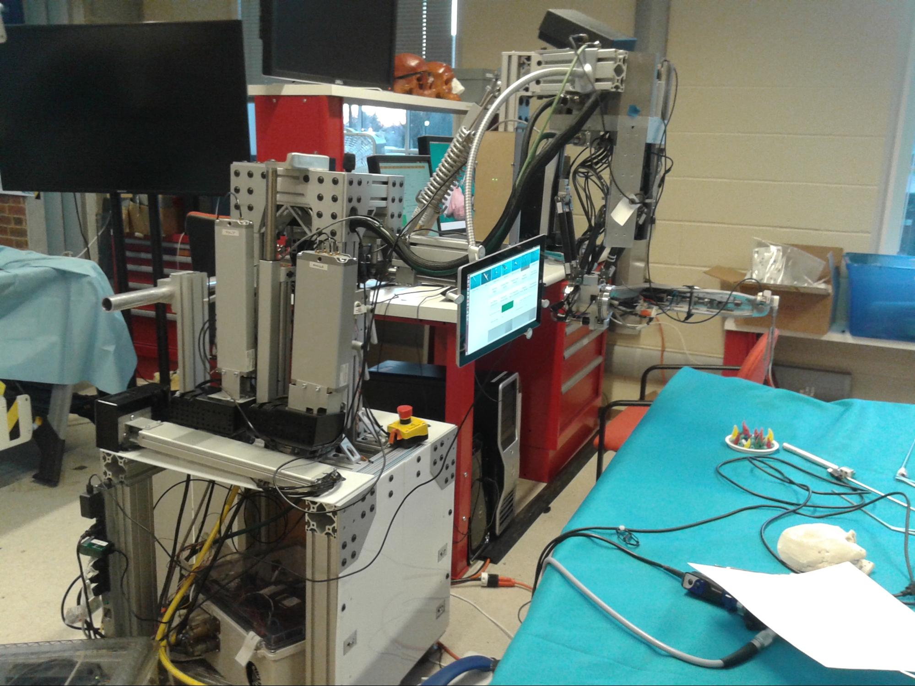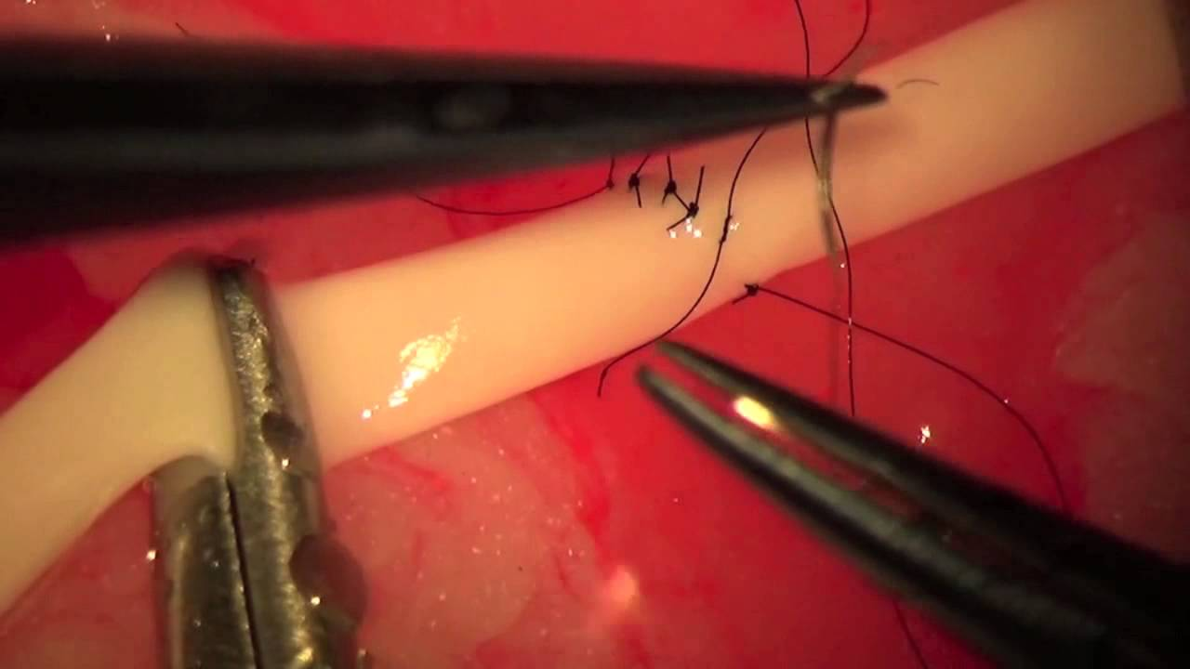
Figure 1. The Galen robot Figure 2. Microvascular anastomosis ^{[1]}

Background, Specific Aims, and Significance
Microvascular anastomosis is a surgical procedure which involves connecting small blood-vessels in order to restore circulation in transferred tissue/transplants or in reattached body parts that were severed^{[2]}. Because of the microscopic scale at which the surgery is performed, it becomes very critical to control hand tremor. It is also necessary to complete the surgery while the tissue is still alive. To assist the surgeons in performing the surgery faster and more precisely, the Galen robot (also known as the REMS robot or Steady-hand robot) was developed at Johns Hopkins University.
The Galen robot is a 5 DOF robot which holds the surgical tool. It has two additional passive stages to allow for easy positioning in the operating room. The surgeon guides the tool directly while the robot’s control algorithms cancel out the hand tremor. A foot-pedal is depressed to control the admittance of the robot. When more pressure is put on the pedal, the stiffness or resistance of the robot towards movement reduces. Virtual fixtures can also be added to prevent the surgeon from touching critical sites that he may wish to avoid.
The advantage of this cooperative control over master-slave setups (such as the Da Vinci robot from Intuitive Surgical Inc.) is that it requires less training to use as it does not interrupt the usual workflow of the surgeon. The bulk of the robot is away from the operating table and this allows for more robots to be introduced into the operation without occluding the view significantly ^{[3]}. Though the Da Vinci robot has multiple arms, the tool-shafts cannot be placed in parallel and in close proximity to each other as required by several otolaryngological procedures.
The main drawback of this robot (as with most other surgical robots) is the lack of haptic feedback from the tool. The robot takes away the weight and forces from the tool and so the surgeon might unknowingly apply too much force to the tissue and cause the rupturing of the delicate blood vessels. The eventual goal is to develop special surgical instruments that are ergonomic and provide dexterity and haptic feedback when integrated with the robot’s tool holder.
Currently, as shown in Figure 3, the forceps and needle-holder are held at the top by the robot’s end effector via a tool adapter. So the surgeon must control the tool below the end effector. There are two problems with the this configuration: 1) the surgeon may run quite often into workspace limits 2) orientation of the robot becomes harder due to the larger lever arm. The proposed solution is to make the instruments such that they can be operated by the surgeon from above the end-effector. Thus, the tool will be pivoted close to its centre instead of the top. This will approximately halve the lever arm and the effort to reorient the tool, while respecting workspace limits.
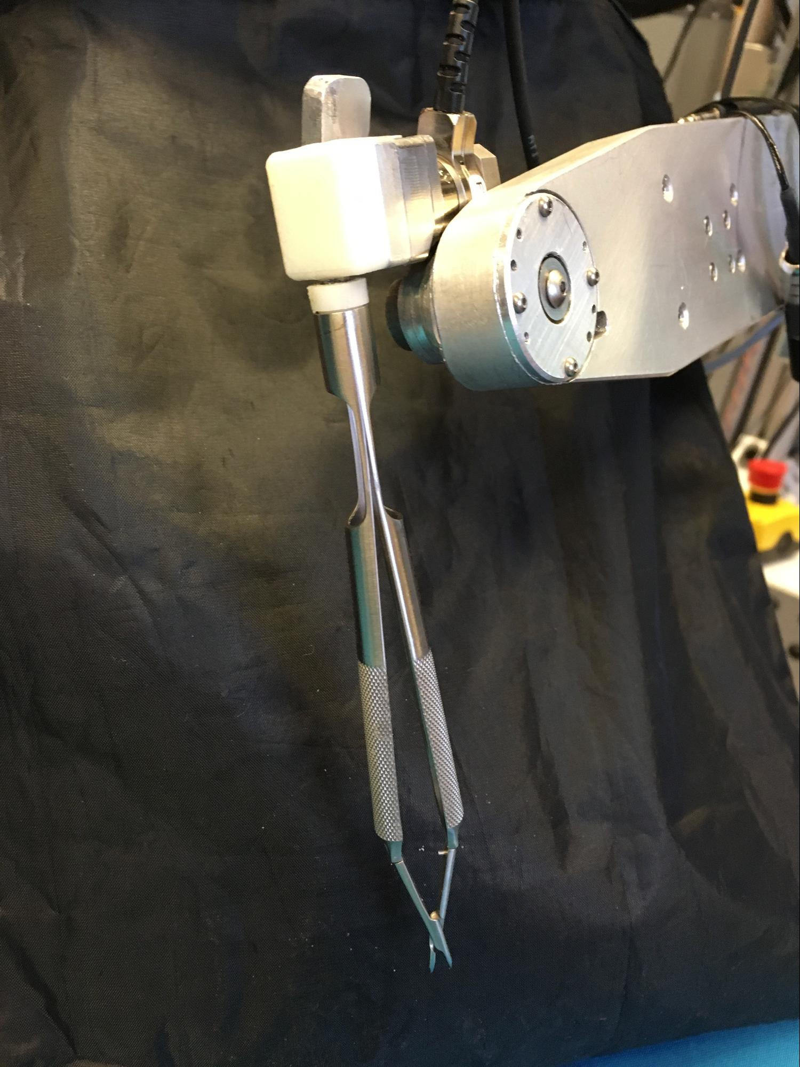
Figure 3. Tool attached to Galen end effector from the top

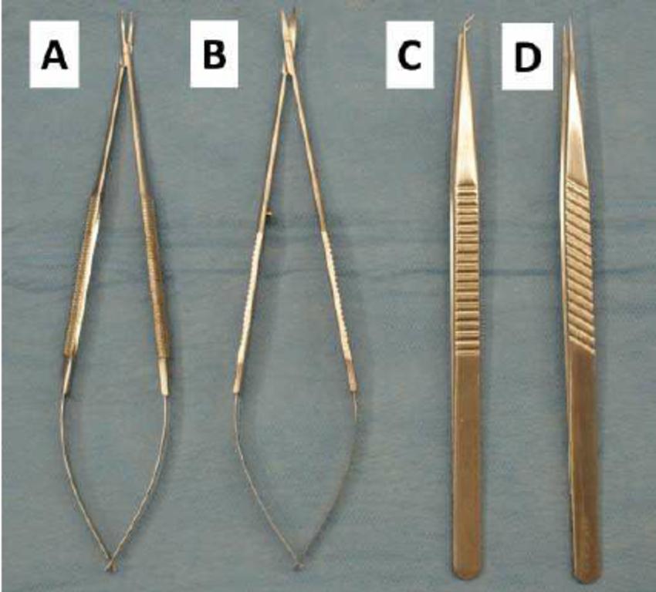
Figure 4. Instruments used in microvascular surgery: A) Needle holder B) Microscissors C) Angular micro-forceps D) Straight micro-forceps
(Image credit: Aesculap surgical instruments, USA)
It is also necessary that a rotational degree of freedom about the tool’s axis is provided to improve dexterity of the tool. This degree of freedom will not be controlled by the robot. Other design considerations include 1) easy manufacturability 2) slim profile and 3) good sterilizability. Both forceps and needle-holder must have a normally-open configuration. This achieved usually by using bendable surgical steel that has been heat treated to keep the jaws apart when there is no pressure on the tool.^{[4]}
Technical Approach
- Take apart existing forceps and tools to learn how they are designed and actuated
- Sketch multiple design ideas for the needle holder
- Pick two or three of the most viable and create detailed designs in CAD
- Sketch design ideas for the rotational accessory
- Create detailed rotational accessory design in CAD
- Rapid prototype the most feasible designs
- Test with the Galen, get user feedback, and evaluate
- Iterate over design and fabrication methods

Deliverables
Minimum: March 16th
- 3D printed needle holder prototype
- Galen tool attachment with rotational DOF
Expected: April 9th
- Stainless steel alpha version of needle holder
- Preliminary testing with surgeons
Maximum: May 4th
- Microvascular holder instrument
- Both instruments designed for manufacturing ability
- Sterilizable instruments

Key Dates

Preliminary sketches of tool and accessory | February 24
CAD model for tool and accessory | March 7
3D printed model | March 16
New design | March 28
Fabricated alpha version | April 9
Testing & Surgeon feedback | April 17
Modified design & evaluation | May 4
Final presentation | May 18

Timeline
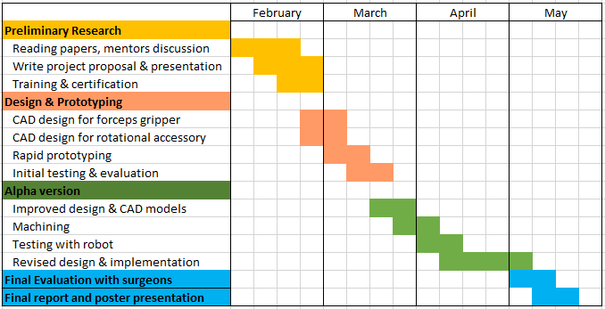

Dependencies
Our dependencies include:
- Access to the Galen
  - Status: Already resolved.
- Machine shop access
  - Status: We are in the process of signing up for the Wyman Park building self-service machine shop training.
- Funds for training and machining
  - Status: We are speaking to our project mentors about the project budget and fund access.
- Availability of residents and experienced surgeons for testing
  - Status: We will start coordinating with Galen Robotics’ medical collaborators as well as our project mentors in order to find willing testers.

Management Plan
Radhika will be in charge of the design of rotation accessory and machining.
Olivia will be in charge of the design of the needle-holder and 3D printing.

Reading List
Ashai, Z. and Lakshminarayanan, P. (2015, May 5). Surgical Instruments for Robotic Microsurgery. Retrieved from https://ciis.lcsr.jhu.edu/dokuwiki/doku.php?id=courses:446:2015:446-2015-03:project_3_main_page

Gudeloglu, A., Brahmbhatt, J. V., & Parekattil, S. J. (2014). Robotic-Assisted Microsurgery for an Elective Microsurgical Practice. Seminars in Plastic Surgery, 28(1), 11–19. Retrieved from http://doi.org/10.1055/s-0034-1368162

Katz, R. D., Rosson, G. D., Taylor, J. A., & Singh, N. K. (2005). Robotics in microsurgery: use of a surgical robot to perform a free flap in a pig. Microsurgery, 25(7), 566-569

Medline. (2016). Konig® Surgical Instruments. Retrieved from http://www.medline.com/media/catalog/Docs/MKT/KONIG%20SURGICAL%20INSTRUMENTS%20CATALOG.PDF

Olds, K.C. (2015). Robotic Assistant Systems for Otolaryngology-Head and Neck Surgery (Doctoral Dissertation). Retrieved from https://jscholarship.library.jhu.edu/handle/1774.2/37927

Taylor, R., Jensen, P., Whitcomb, L., Barnes, A., Kumar, R., Stoianovici, D., ... & Kavoussi, L. (1999). A steady-hand robotic system for microsurgical augmentation. The International Journal of Robotics Research, 18(12), 1201-1

References:

[1] MacDonald JD.(2005) Learning to perform microvascular anastomosis. Skull Base - an Interdisciplinary Approach. 2005;15:229.

[2] Daniel, R. K., & Williams, H. B. (1973). THE FREE TRANSFER OF SKIN FLAPS BY MICROVASCULAR ANASTOMOSES: An Experimental Study and a Reappraisal. Plastic and Reconstructive Surgery, 52(1), 16-31.

[3] Olds, K., Chalasani, P., Lopez P., Iordachita, I., Akst, L., Taylor, R.H. (2014) Preliminary Evaluation of a New Microsurgical Robotic System for Head and Neck Surgery. Retrieved from http://ieeexplore.ieee.org/stamp/stamp.jsp?arnumber=6942721

[4] Malis, L. I. (1985). Instrumentation for microvascular neurosurgery. In Cerebrovascular Surgery (pp. 245-260). Springer New York.

