Dante Navarro
03/09/2020
Critical Review

Introduction

The paper in review is titled: MEMS Based Broadband Piezoelectric Ultrasonic Energy Harvester (PUEH) for Enabling Self- Powered Implantable Biomedical Devices. The paper was authored by Qiongfeng Shi, Tao Wang and Chengkuo Lee. The topic to the aforementioned text revolves around wireless charging modalities that are being explored for implanted medical devices. These approaches are further split up into the various techniques that are used to harvest energy from an ultrasound source including internal sources using Lead Zirconate Titanate (PZT) devices and from external sources including PZT, Inductive Power Transfer (IPT) and Acoustic Energy Transfer (AET). The aim of this text is to compare these methods and their functionality in a practical setting, more specifically for Implanted Biomedical Devices. This text provides brief insight into the possible applications of the device and the feasibility of these assertions by comparing the common power consumption of said devices with preliminary results from the experimentation. The design and characterization of the fabrication are then outlined while the evaluation of the results is explored based on the variation of independent variables including distance and frequency.

Summary

The text specifically depicts the two previous approaches for harvesting energy:

The first method includes harvesting energy from an internal source with the heart or lung and converting its natural periodic vibrations to electronic energy that can be utilized by an implanted device. This is done by implantable triboelectric devices or piezoelectric devices which utilizes the phenomenon based on the contact of different materials. The triboelectric energy harvesters utilize this contact and separation to allows charges, and therefore current, to flow to the circuit connected to the implant. The piezoelectric effect in due to the electrical changes of the piezoelectric material once a force is applied to it. The second method includes harvesting energy from an external source that is outside the body often utilizing a propagating wave to conduct both inductive power transfer (IPT) and acoustic energy transfer (AET).

These methods are then compared to each other by which each establishing the drawbacks and advantages to each. IPT has been rigorously tested because of simple design and ultimately good performance but often these are offset in practical settings because of the negative effects on human tissue, interference with other electrical components, decreased performance with increased distance and inability to pass through certain conductive material. AET however, has greater range to transfer energy and there are no negative effects to the surrounding human tissue. Both of these methods suffer from destructive interference between the propagating and reflecting wave which can affect the efficiency of the system at various distances. Technology is being explored to adapt the frequency to certain situations to mitigate this issue.

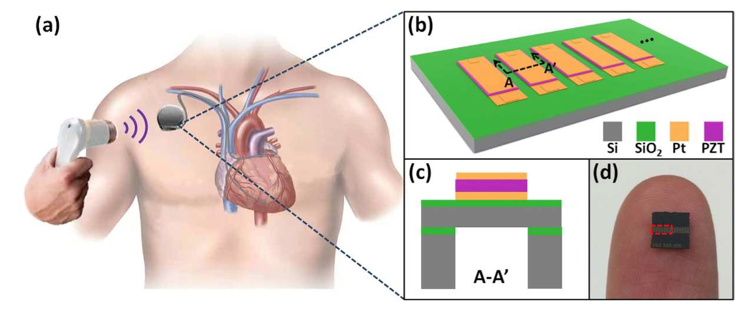
The technology that is explored further in experimentation is the MEMS Based Broadband Piezoelectric Ultrasonic Energy Harvester (PUEH).
(a) Schematic of the proposed PUEH system integrated with pacemaker, (b) rendered illustration, (c) cross section of the system and (d) sizing compared to a human finger.

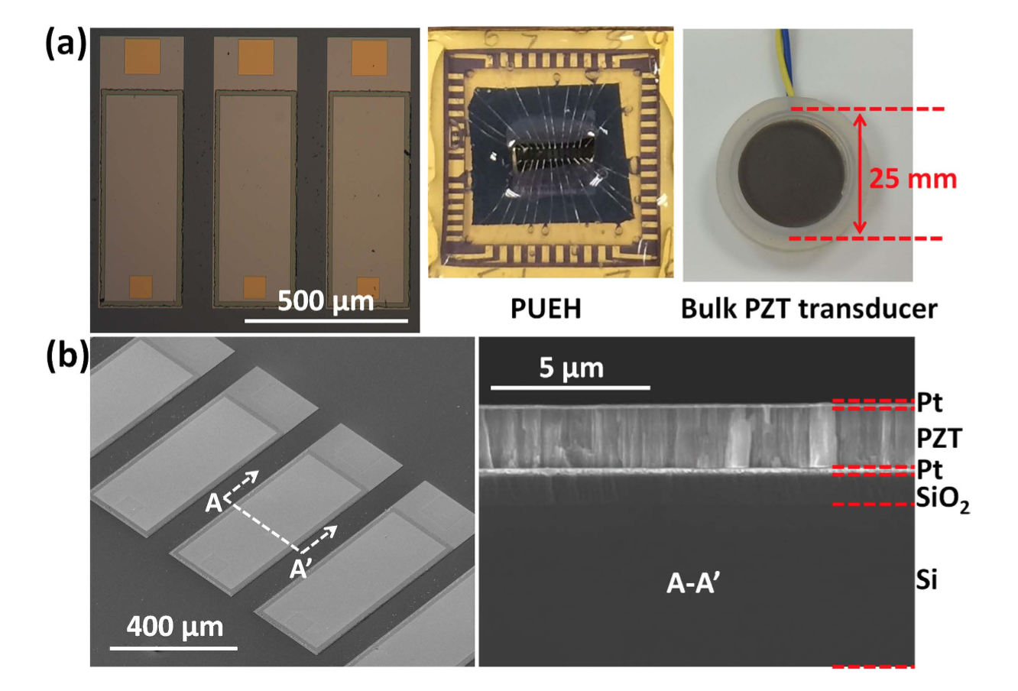
This specific method utilizes a miniaturized PZT diaphragm array that can harvest energy from a standard hospital external ultrasound head. Design, characterization and evaluation of this array outlined the methods of fabrication and validation of the setup used as well as the results of said setup.
(a) Microscope image of the PZT with packing in the middle and the transducer on the right, (b) images of the PUEH from above and as a cross section.

Critique

This paper provides an extensive background on the previous harvesting technologies such as IPT and AET. The diagrams could help extensively with continued fabrication process as well as developing more of an understanding between the experimentation and technology.

Though the entirety of the experimentation involves the PUEH system, there should be more of an emphasis of the underlying mechanics such as a more in-depth depiction of the MEMs system or even more background on the physical phenomena that occurs in PZT. To further expand on the experimentation and specifically fabrication, I think that the testing setup could have been expanded in the following ways:

Circuit Diagrams are necessary to understand what is being measured in the experimentation as well as a helpful tool to reproducibility.

The orientation of the Bulk PZT transmitter and its comparison to the PUEH receiver could have been clearly defined to understand if distance as well as orientation of the transmitter has an impact on the amount and efficiency of the harvested energy.

Conclusions

From reading the results from the experimentation, we have concluded that in further studies, we hope to utilize this PUEH method. The fabrication process with materials and methods are clearly outlined in the paper and we hope to collaborate with the other members of the larger lab group to explore the already in place fabrication. The conclusions from the PUEH depict that this system is robust in a setup that includes pork tissue, simulating human tissue. With the ease of fabrication, we expect that there can be benchtop testing for the group.

This provided, the extensive background on the other technology allows us to determine that we should proceed with the PUEH system rather than reverting to either the AET or IPT systems.

There is no documentation on the orientation of this wireless charging device with the respect to the harvesting system. Because our system includes variable orientations of the harvesting system, we must continue to explore the implications of a transducer head that is off-center from the harvesting system. Exploring this in supplement to other benchtop testing to ensure feasibility in the system is imperative but yet to be conducted.

