CIS II background reading
Guanyu Song, 04/05/2022

Paper:
Nguyen, T., Plishker, W., Matisoff, A. et al. HoloUS: Augmented reality visualization of live ultrasound images using HoloLens for ultrasound-guided procedures. Int J CARS 17, 385–391 (2022). https://doi.org/10.1007/s11548-021-02526-7

The reason of selection:
This is a recent article, so the devices and methods are new which means they may have more potential for references for my own project. Also, this article is detailed enough for a novice like me to learn the methods for conducting such a research. After reading, I think this is a very complete study including clear technology and evaluation process which is worth summarizing and analyzing.

The relevance to my project:
We both explore the use of HoloLens for ultrasound visualization. The technique it introduced uses ultrasound imaging combined with HoloLens visualization which is also the basic components of my research.

For technique realization, it has many similar procedures compared with my project such as ultrasound probe 3D pose estimation and AR ultrasound image rendering. From my point of view, this article is very helpful for me to understand the process of tracking and display with HoloLens.

What’s more, the user study is phantom-based which is also envisioned by my plan. So I can refer to the test plan.

Technical summary of the paper:
The main achievement of this article is to design a HoloLens application. The application of this system uses an App called HoloUS which can be found in the Microsoft App Store. Besides, the researchers add voice-control function to interact with the ultrasound machine instead of physical methods and this application operates on the first-generation HoloLens and interfaces with an ultrasound machine.
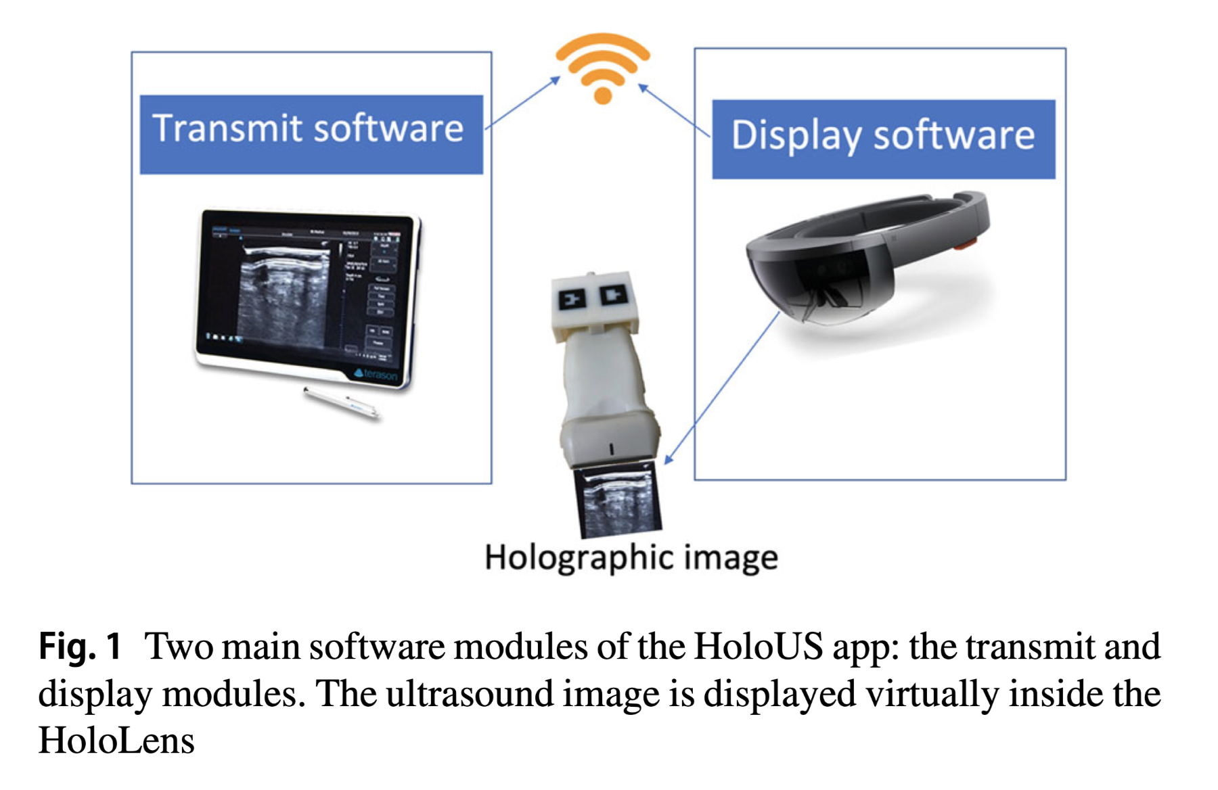
We can see from the Fig.1 that the HoloUS app can be divided into two modules. One is transmit module written in C++ on Terason system and the other is display module developed in C# using Unity 3D 2018. The transmit process will be finished with Terason system (a part of ultrasound tablet) through the IP address of the HoloLens using Wi-Fi.

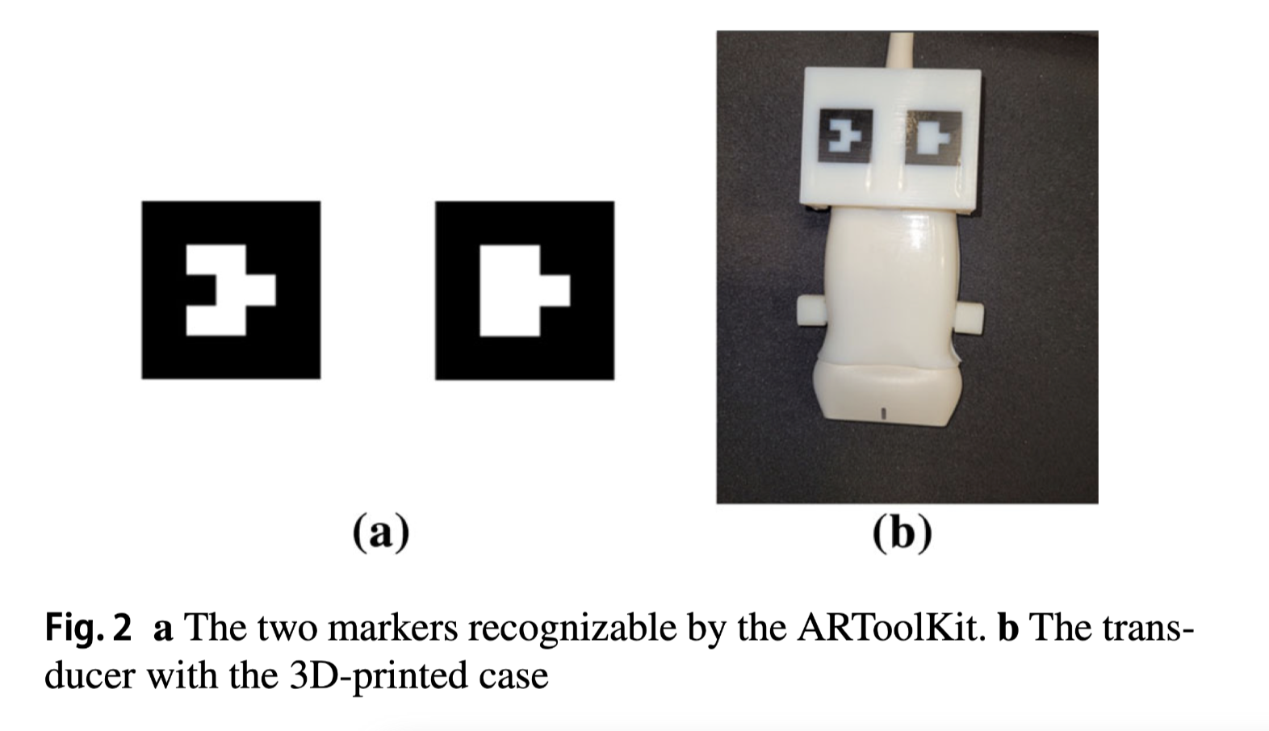
To track the ultrasound transducer’s 3D pose is necessary to correctly display the hologram in situ at the transducer. The researchers use the world-facing camera of the HoloLens to track the transducer using an AR-pattern printed on a custom transducer case. For the recognition of the ultrasound probe, they use two markers for tracking with robustness in case one got occluded. Then they adopt the ARToolKit library to estimate the real camera position and orientation relative to physical markers attached on the ultrasound probe model. Because the dimensions of the ultrasound transducer and AR markers are known, the holographic ultrasound image placement can be performed based on the fixed-offset distance between the face of the transducer and the location of the AR-pattern.

For better visualization effect, the team developed two visualization modes called tracking mode and floating mode. In tracking mode, the ultrasound image can be placed directly under the face of the transducer and closely tracked the movement of the transducer. This mode has better real-time property so it is better for diagnosis. In floating mode, the image doesn’t track small movements of the transducer so practitioners won’t be distracted when advancing a needle. So it’s better for treatment.

This system also supports speech recognition for voice commands with predefined keywords, which enables doctors to manipulate the virtual ultrasound image to move along six Cartesian directions as well as to scale up or down by 15%.

Finally, for the measurements of the technical performances, we can make a summary as follows:
Technical characterization:
- Frame rate: Employ the built-in visual profiler Unity component of the Microsoft Mixed-Reality Toolkit.
- Tracking accuracy： Calculate with the HoloLens’s camera matrix by measuring the reprojection error between the detected marker points and their corresponding reprojected points.
- Latency: Measure the latency between the needle tip appear on the ultrasound monitor and in the virtual image.
Evaluation:
- System’s user study: Compare the completion time of the novice and expert group when they carry out ultrasound-guided needle tasks using either the HoloLens or the conventional ultrasound display.
- Assess the usability of the HoloUS app: Design a questionnaire to gauge AR visualization quality, ease of use, user-friendliness, and other aspects.

Analysis of the paper:
Pros:
- 1. The description of the research technology is very detailed, from ultrasound machine information transmission to HoloLens image display, which is quite in order and easy for readers to understand and transfer to their own research work.
- 2. The research process it described is complete. From technical method to system evaluation, so it’s intuitive enough for readers who is a newbie to conduct his own research.
- 3. There is a certain degree of innovation. For example, the self-created App helps to complete the HoloLens ultrasound puncture added voice-control function to operate the displayed images. In my opinion, this function is pretty convenient.
- 4. The visualization part is equipped with two modes which are friendly for diagnosis and treatment independently so doctors can balance the two needs when utilizing the system.
- 5. The testing work was implemented on novices and experts separately and it showed different effect on them. This method allows for more precise measurements.

Cons:
- 1. Overall, the research is not deep enough. The main problem of this article is that its insight is kind of simple. So it’s easy to think of and there is not much inspiration for deeper exploration. For this reason, it can only be regarded as a preliminary scientific research exploration but far from medical application.
- 2. As already mentioned in the context, the image quality is poor, which causes inconvenience for observation . For such ultrasound-based systems, this is a big problem of all(so as to my own system).
- 3. The narrow field of view leads to multiple times of heads-adjusting for finding the right viewing angle. This problem is mainly caused by the outdated research equipment HoloLens 1. Therefore, it may be solved by utilizing HoloLens 2.
- 4. The frame rate was too slow to allow interactive image guidance. Better transmit schemes need to be adopted.
- 5. The precision for matching is not good enough for more complicate surgeries such as neurosurgery.
- 6. From my point of view, the user study contains relatively few test samples. It equips with only 8 novices and 8 experts, which makes the application results from this analysis kind of unreliable.

About my research:
This article really inspires me on some research ideas.

As for my research, the image quality can also be one of the most typical problems. I will conduct a in-depth search on display solutions in the future.

As it mentioned, HoloLens 2 can have better visualization effects than HoloLens 1, so my implementation will start from a HoloLens 2 device.

Further more, it is important to design awesome methods for HoloLens-ultrasound machine interaction function. In my previous plan, I employ a HoloLens clicker to complete this function. But, to take into further consideration, I have to admit it’s not the most convenient and efficient way. Hence for my future application, to come up with a better interaction method should also be included into my agenda.

Finally, it’s an genius idea to put forward two modes for visualization. In the process of research, I will try to think over the needs of doctors so that the research can be easier to implement in practical application scenarios.

