Closed Loop Transfer Functions and Control Systems:

From “Towards Collaborative Drilling with a Cobot Using Admittance Controller”
Aydin et al (2020)
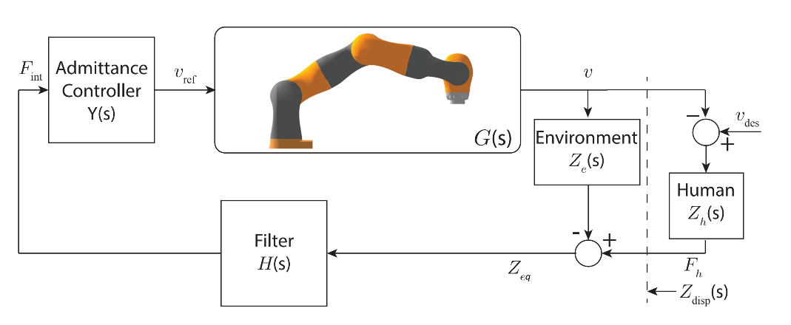
Figure 1 Basic Admittance Control System for Cobot [1]
Resultant Transfer Function:
$T1\left(s\right)=\frac{V\left(s\right)}{F_{ref}\left(s\right)}=\frac{G\left(s\right)Y(s)}{1+G\left(s\right)Y\left(s\right)H\left(s\right)Zeq(s)}$ Eq 1

From “Admittance control for physical human–robot interaction”
Stienen et al (2020)

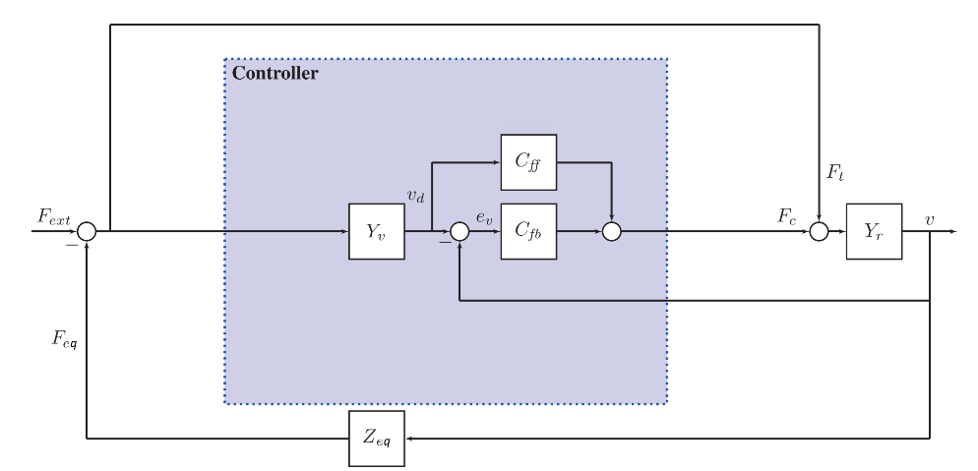
Figure 2 Basic Admittance Control System for Feedforward and Plant Linearization [2]
Resultant Transfer Function:

$T2\left(s\right)=\frac{V\left(s\right)}{F_{ext}\left(s\right)}= \frac{Yr\left(s\right)\left(C_{fb}\left(s\right)Yv\left(s\right)+C_{ff}\left(s\right)Yv\left(s\right)+1\right)}{Yr\left(s\right)\left(Zeq\left(s\right)+C_{fb}\left(s\right)\left(Yv\left(s\right)Zeq\left(s\right)+1\right)+C_{ff}\left(s\right)Yv\left(s\right)Zeq\left(s\right)\right)+1}$Eq 2

Feedback Control System for Velocity Control of Basic Mass Spring Damper:

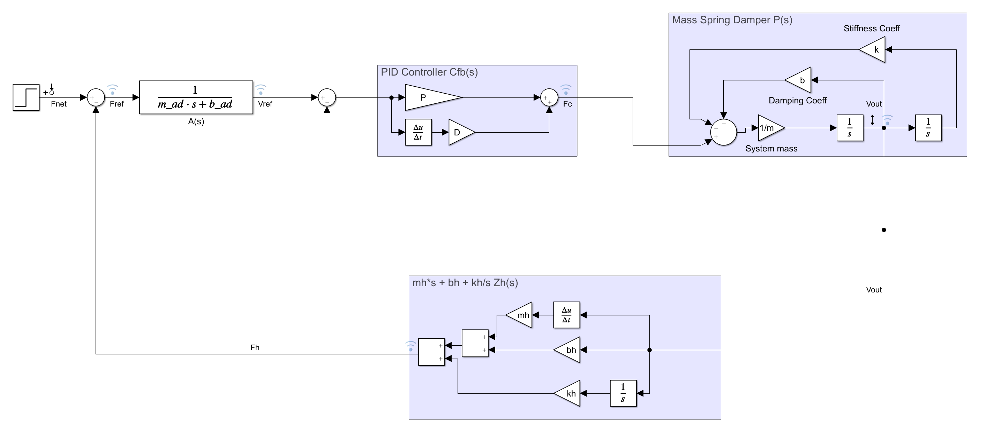
Figure 3 Admittance Control System for Feedback Controller
Resultant Transfer Function:

$T3\left(s\right)=\frac{V\left(s\right)}{F_{net}\left(s\right)}= \frac{A\left(s\right)C_{fb}\left(s\right)P\left(s\right)}{1+C_{fb}\left(s\right)P\left(s\right)\left(A\left(s\right)Zeq\left(s\right)+1\right)}$Eq 3

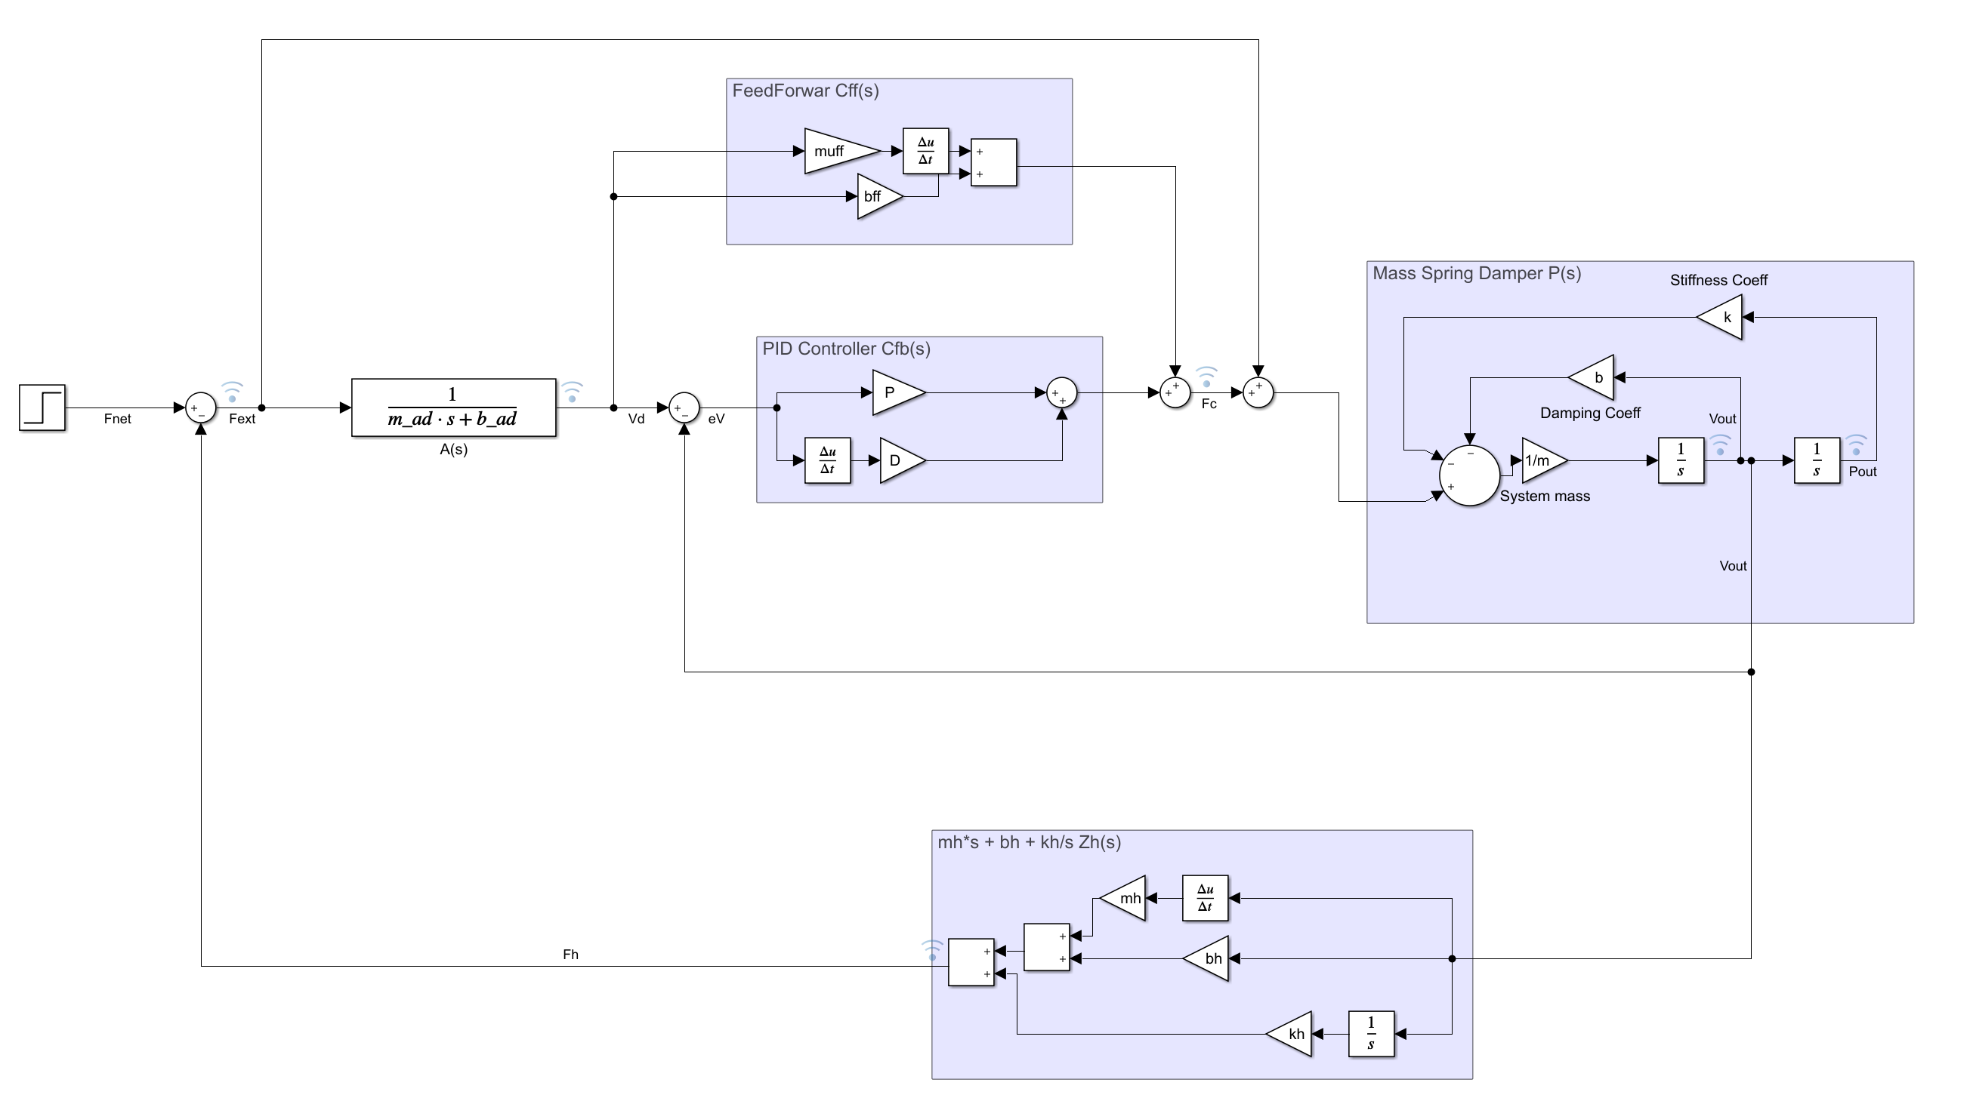
Figure 4 Admittance Control System for a Feedback Controller with Feedforward and Plant Linearization
Resultant Transfer Function:

$T4\left(s\right)=\frac{V\left(s\right)}{F_{net}\left(s\right)}= \frac{P\left(s\right)\left(A\left(s\right)C_{fb}\left(s\right)+A\left(s\right)C_{ff}\left(s\right)+1\right)}{P\left(s\right)\left(Zeq\left(s\right)+C_{fb}\left(s\right)\left(A\left(s\right)Zeq\left(s\right)+1\right)+A\left(s\right)C_{ff}\left(s\right)Zeq\left(s\right)\right)+1}$Eq 4

Notation Unified For Transfer Functions:
$$T1\left(s\right)=\frac{V\left(s\right)}{F_{net}\left(s\right)}=\frac{GA}{1+GAHZeq}$$

$$T2\left(s\right)=\frac{V\left(s\right)}{F_{net}\left(s\right)}= \frac{P\left(AC_{fb}+{AC}_{ff}+1\right)}{P\left(Zeq+C_{fb}\left(AZeq+1\right)+C_{ff}AZeq\right)+1}$$

$$T3\left(s\right)=\frac{V\left(s\right)}{F_{net}\left(s\right)}= \frac{AC_{fb}P}{1+C_{fb}P\left(AZeq+1\right)}$$

$$T4\left(s\right)=\frac{V\left(s\right)}{F_{net}\left(s\right)}= \frac{P\left(AC_{fb}+AC_{ff}+1\right)}{P\left(Zeq+C_{fb}\left(AZeq+1\right)+AC_{ff}Zeq\right)+1}$$

Open Loop Transfer functions for the Controller in figure 3 (fb) and the controller in figure 4 (ff) for mass spring damper systems.

$T5\left(s\right)=\frac{F_{eq}\left(s\right)}{F_{net}\left(s\right)}= \frac{AC_{fb}PZeq}{PC_{fb}+1}$ Eq 5

$T6\left(s\right)=\frac{F_{eq}\left(s\right)}{F_{net}\left(s\right)}= \frac{(A\left(C_{fb}+C_{ff}\right)+1)PZeq}{PC_{fb}+1}$ Eq 6

Stability identification Methods:

Aydin et al. : Closed Loop Poles of T(s) with root locus

Stienen et al. : Open Loop Phase of $\frac{F_{eq}}{F_{net}}=Y_{a}Zeq$

Stienen et al. form applied to the Controller in figure 3 (fb) and the controller in figure 4 (ff) for mass spring damper systems.

Mass Spring Damper Systems:

Values for m, b, and k used here: M = 10; b = 5; k = 1;
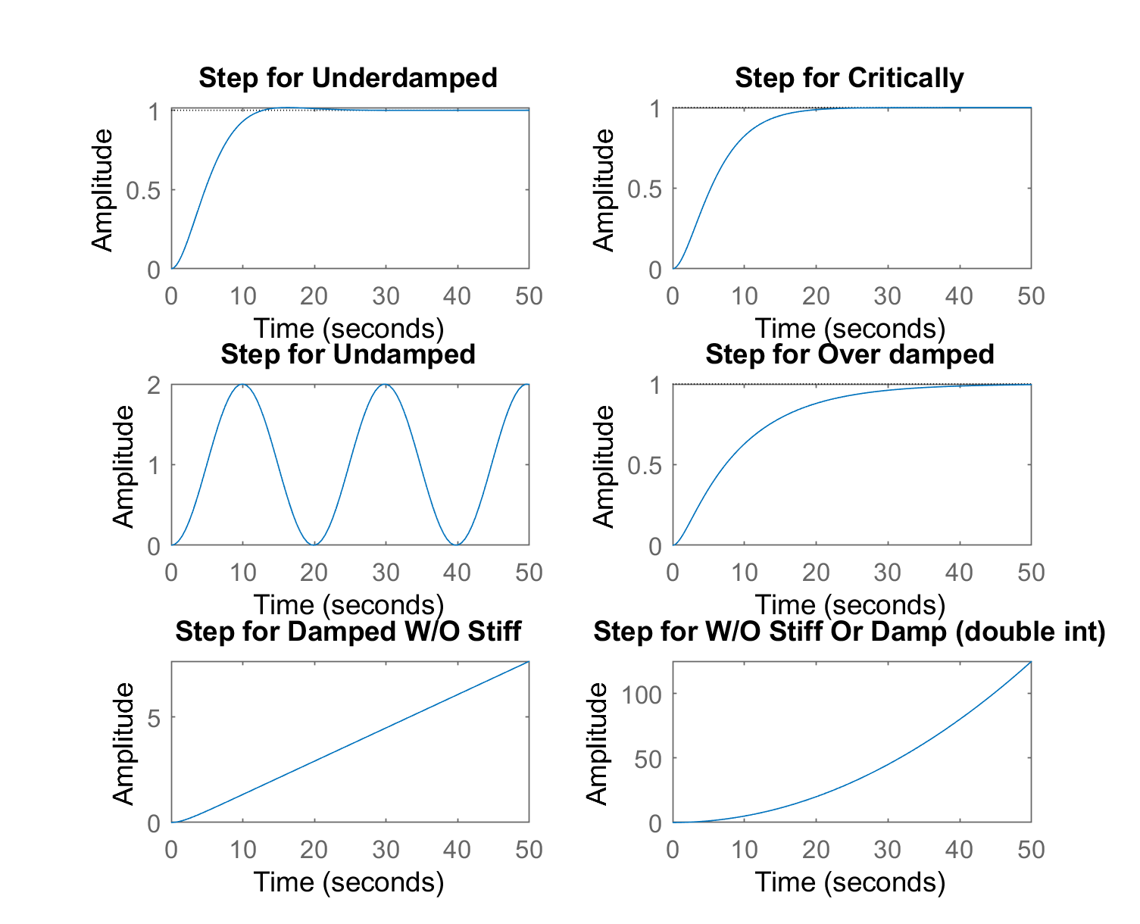
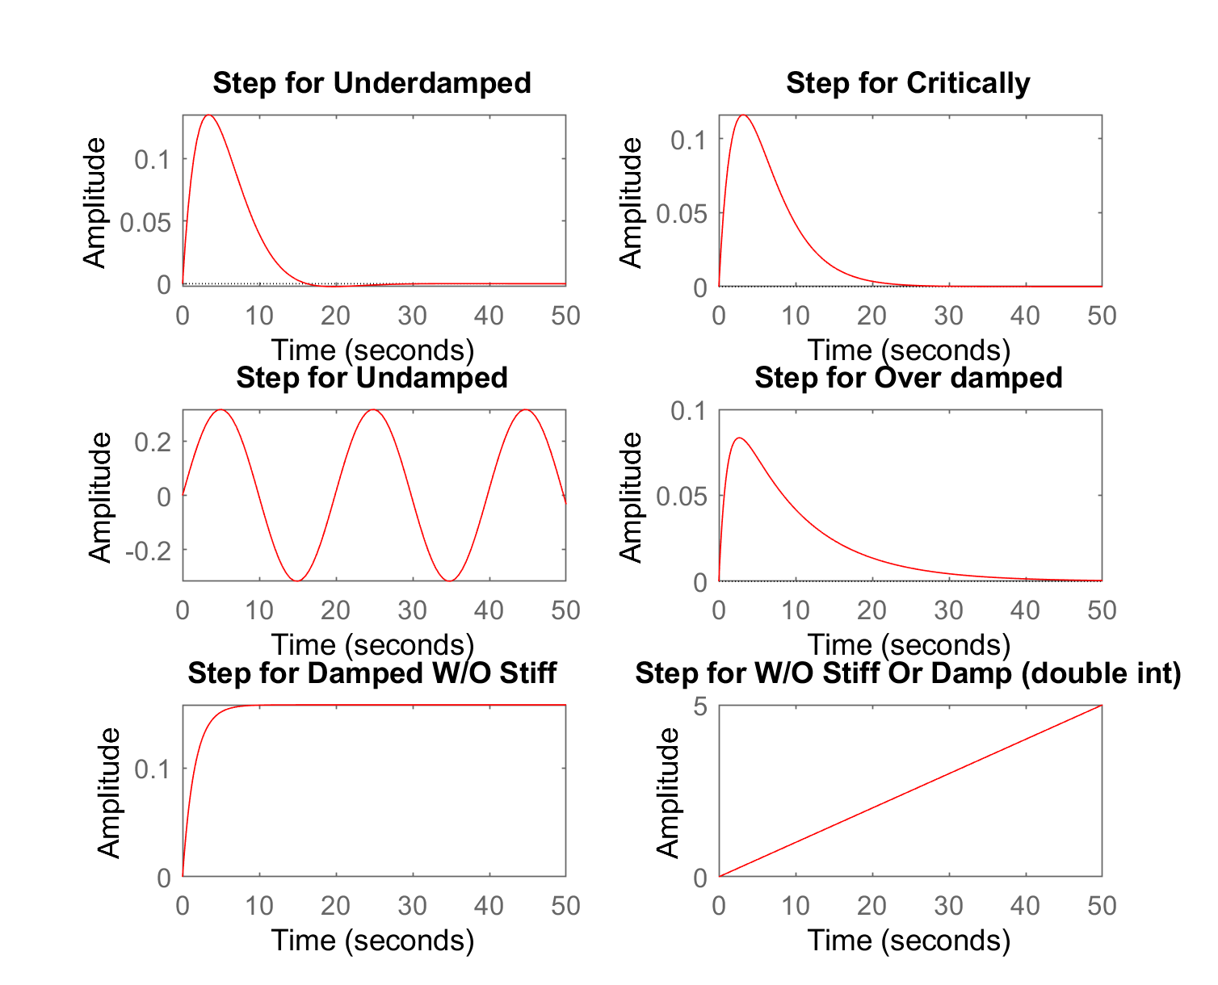

Key Terms/Abbreviations:

ff – feedforward with feedback and linearization
fb – feedback alone
MSD – Mass spring underdamped system
MSCD – Mass spring critically damped system
MSUD – Mass spring undamped system
MSOD – Mass spring overdamped system
MD – Mass damper only system
M – Mass only system

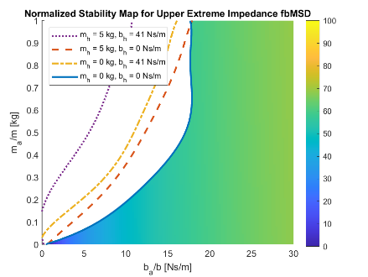
Normalized Stability Results: Feedback

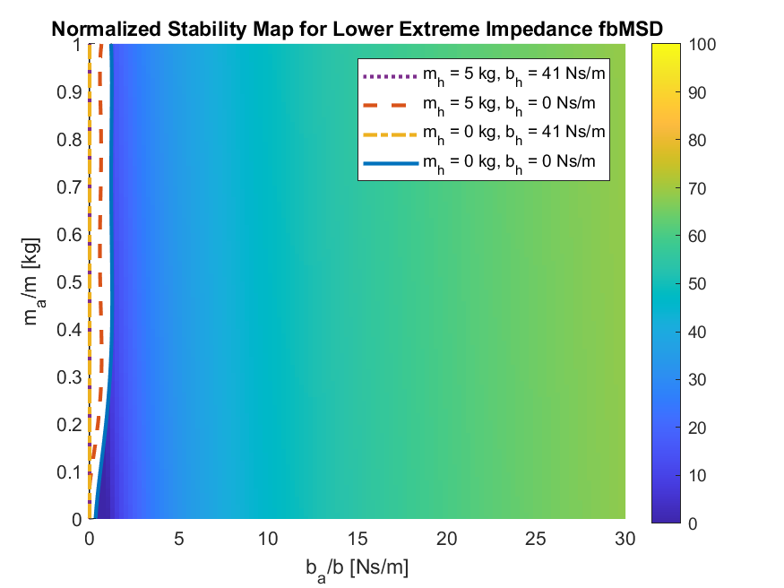

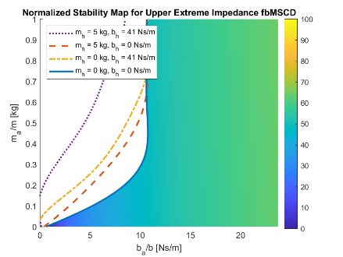
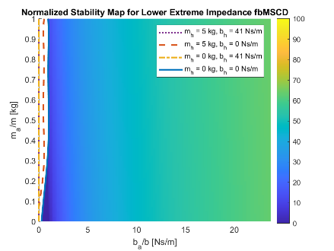

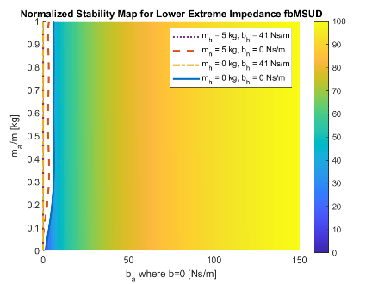
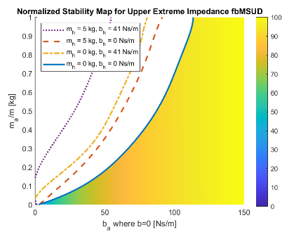
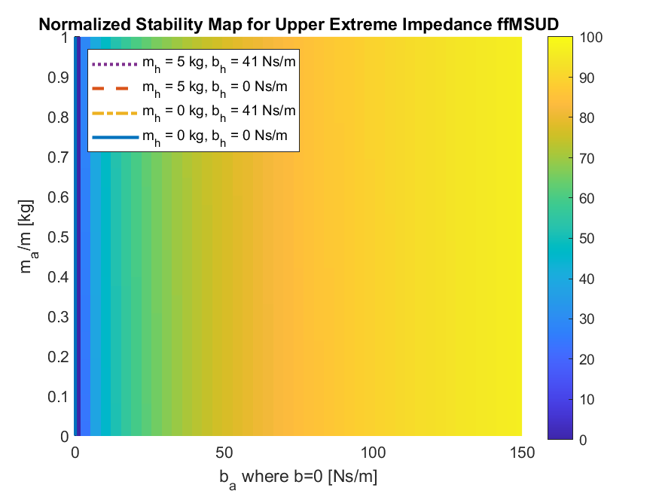

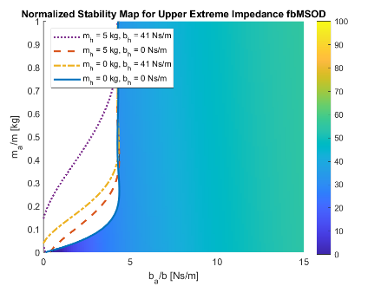
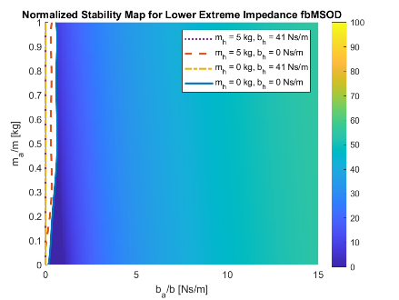

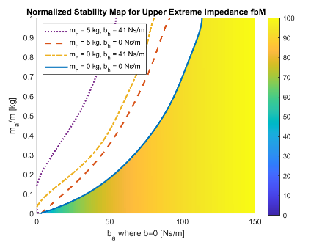
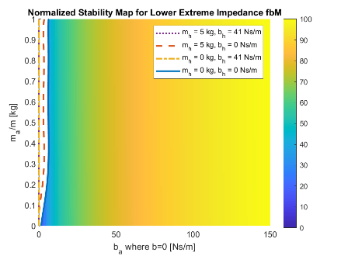
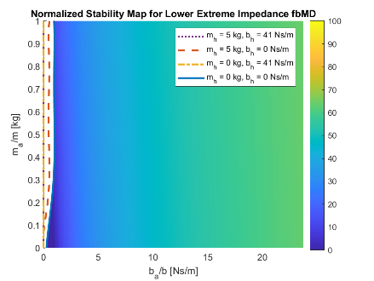
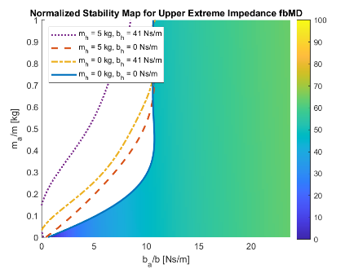
Normalized Stability Results: Feedback with Feedforward and Linearization
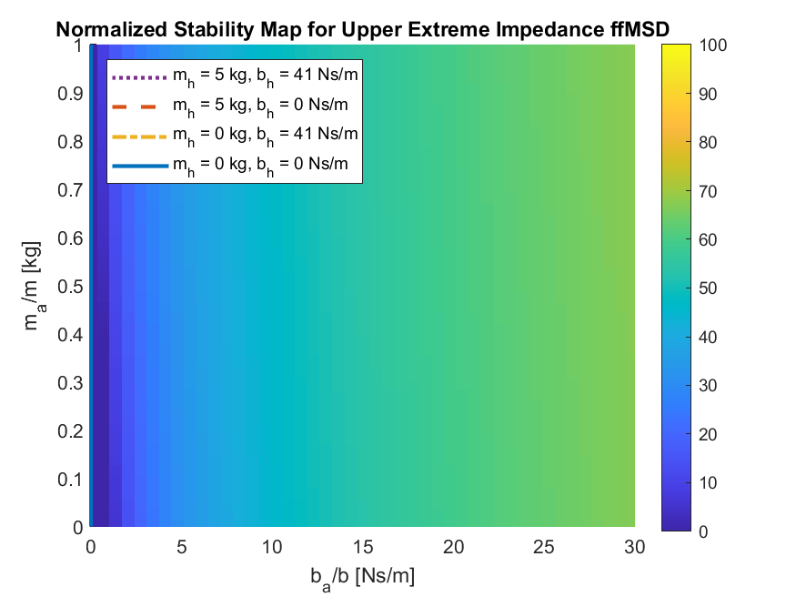
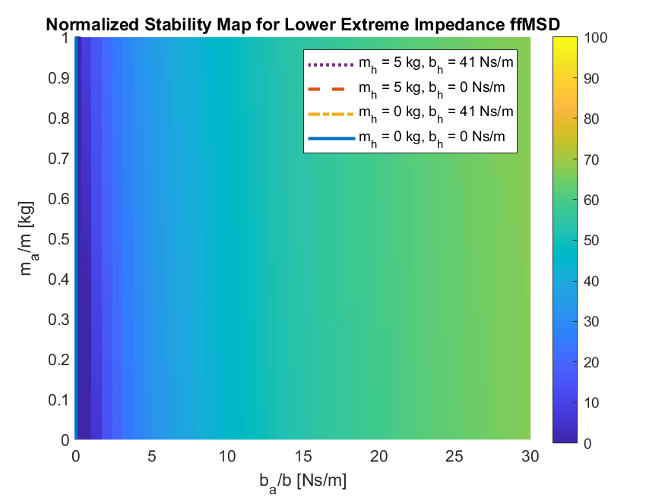
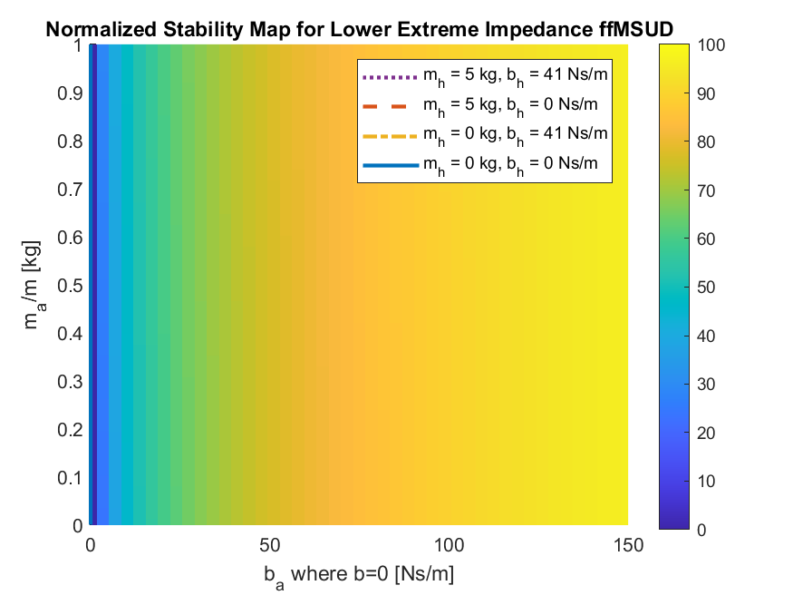
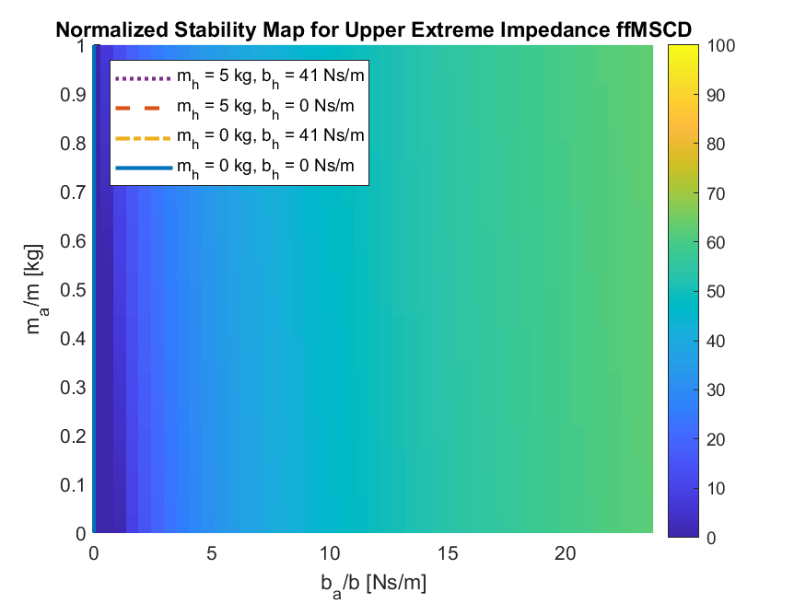
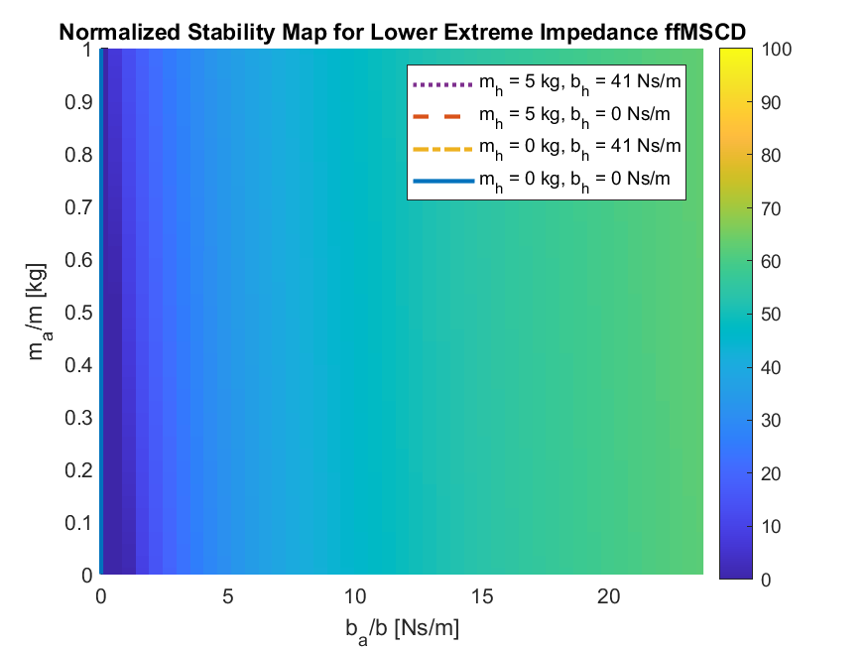
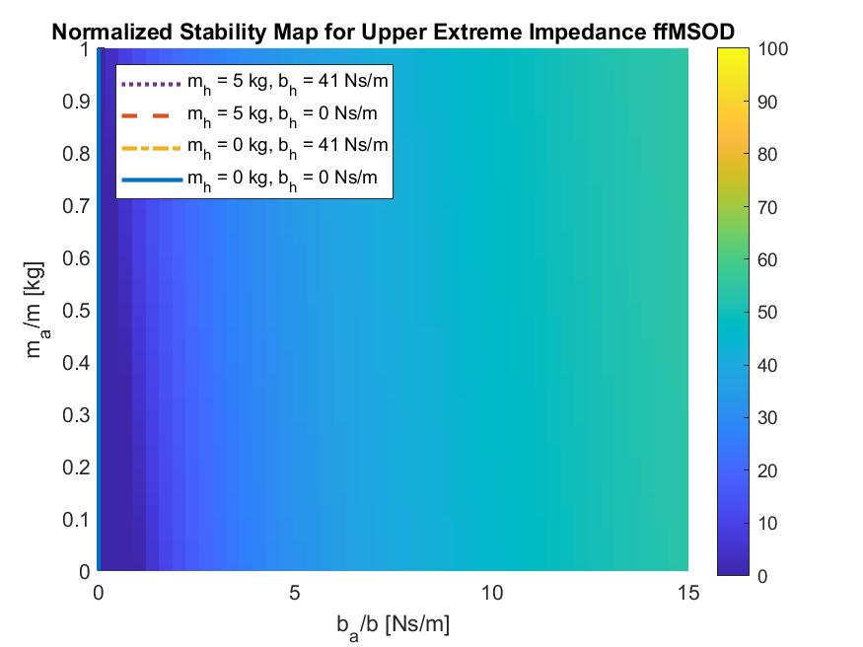
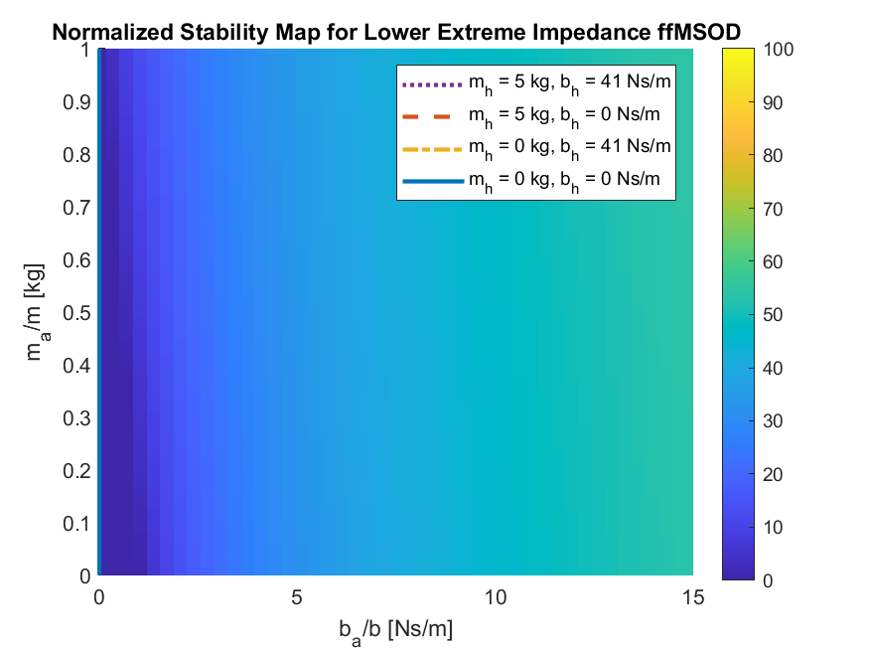
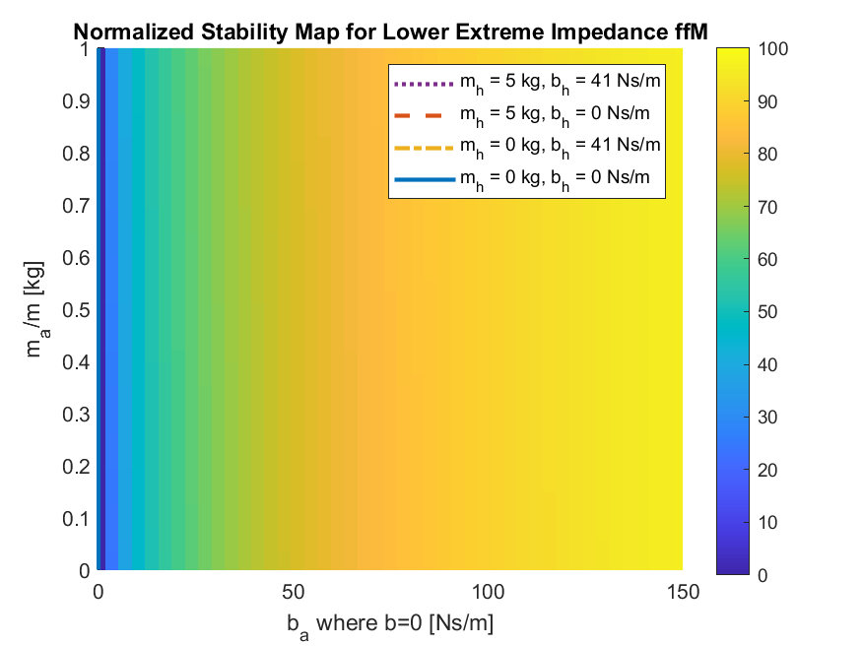
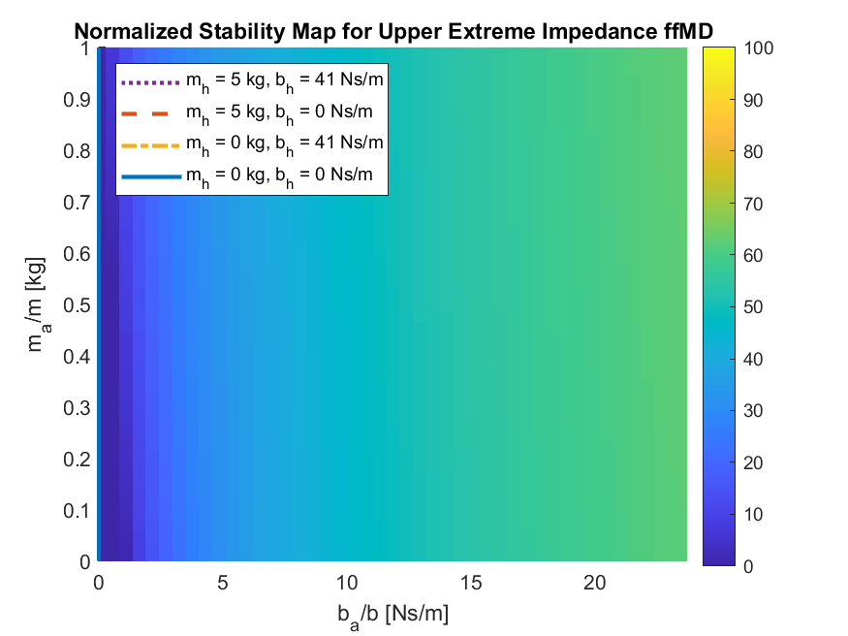
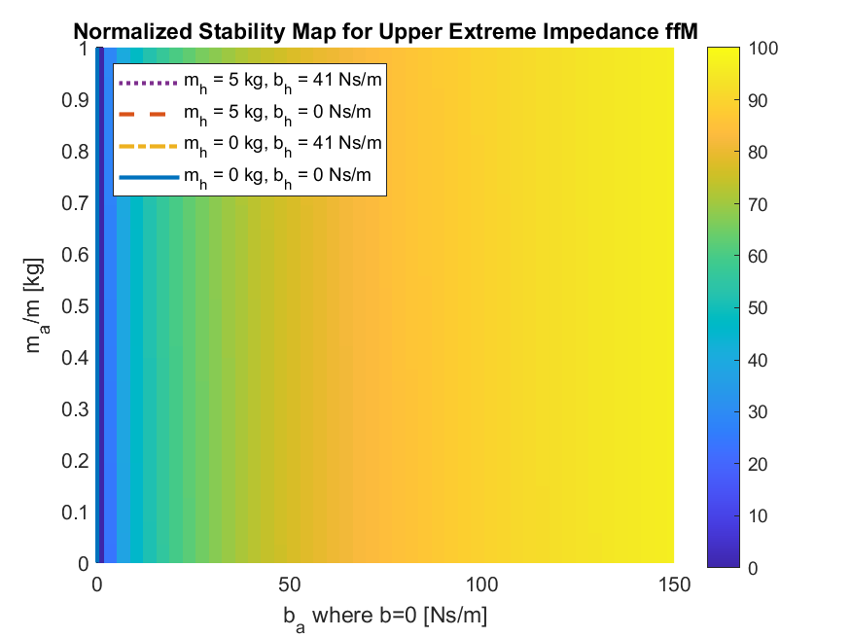
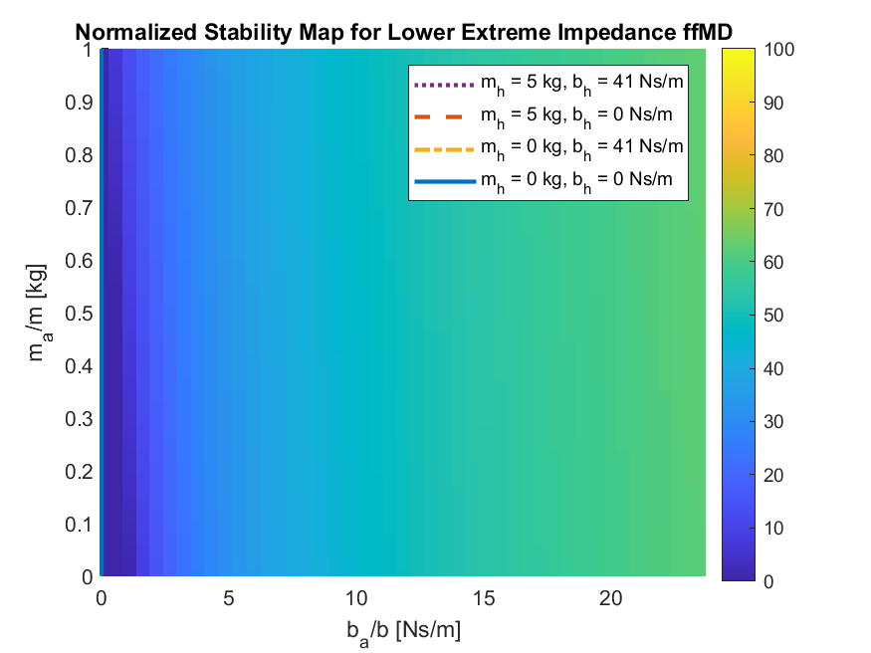

References

- Aydin, Y., Sirintuna, D., & Basdogan, C. (2020). Towards collaborative drilling with a Cobot using admittance controller. Transactions of the Institute of Measurement and Control, 43(8), 1760–1773. https://doi.org/10.1177/0142331220934643

- Keemink AQ, van der Kooij H, Stienen AH. Admittance control for physical human–robot interaction. The International Journal of Robotics Research. 2018;37(11):1421-1444. doi:10.1177/0278364918768950

Appendix A

$$Admittance \\ A\left(s\right)= \frac{1}{m_{ad}s+b_{ad}}$$

$$Plant variations$$
$$P_{1}\left(s\right)= \frac{1}{ms^{2}+bs+k}$$ Position

$P_{2}\left(s\right)= \frac{s}{ms^{2}+bs+k}$ Position derivative -> Velocity

$P_{3}\left(s\right)= \frac{1}{ms+b}$ Velocity no stiffness

$$Impedance \\ Zeq\left(s\right)= mhs^{2}+bhs+\frac{kh}{s}+\frac{ke}{s}$$

