  - TOGAC50_AMBF_IN_AdmittanceControlTeleop.docx

These instructions are for the use of the admittance control schemes and velocity controller in the files TOGAC43_AMBF_VelocityController.m
TOGAC44_AMBF_CartesianAdmittanceTest.m
TOGAC45_AMBF_CartesianAdmittanceTestWController.m

Contents
1. Basic Velocity Controller 1
2. Running the Galen Robot in AMBF: 2
3. AMBF RigidBodyCmd 5
4. Python Controller 6
5. AMBF and Blender for Editing ADF Files 12

Basic Velocity Controller

With AMBF open and running with ROS and MATLAB according to the instructions in TOGAC25_AMBF_IN_AMBFforGalen.pdf and TOGAC29_AMBF_IN_ConnectMatlab2AMBF.pdf we can now use the code in the MATLAB file called TOGAC43_AMBF_VelocityController.m which will launch the galen interface for basic robot control in AMBF and utilize velocity control.

The file is best run by using the MATLAB editor and running the separate sections of the file as scripts themselves. This is done by simply placing and clicking your cursor into the separate sections of the file and running them as sections instead of running the entire file. A quick way to do this is with the cursor in the section you want to run pressing cntrl+enter.
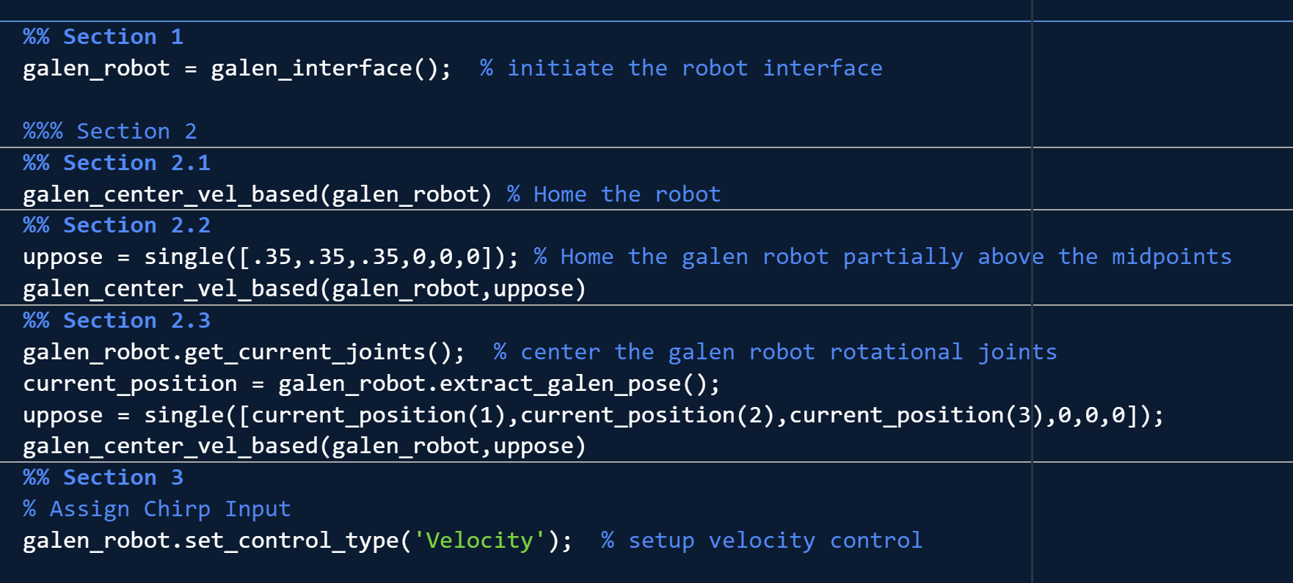
Figure 1 Velocity controller sections 1, 2, and 3
Run section 1 to establish a connection with the Galen robot. You may need to rerun section 1 until you have successfully read the joint states and the force sensor data at the E35 joint. This should be clearly indicated in the MATLAB output terminal if successful. If it fails to run or if you're waiting for the loop to continue because it's hung and subscribing or receiving, then cancel the loop and try again. If this does not eventually work, then update your ROS_MASTER_URI or your ROS_IP in either the galen_interface file or on your linux machine until you can get a good connection. You may need to do a restart of your device. If you cannot establish any connection, you may also benefit from looking into online ROS documentation on interfacing with ROS and MATLAB and changing a few variables in the environment or workspace.

You can run any section in section 2 to home, home offset, or center the robot. If you would like to use the AMBF simulated robot without gravity, select the running AMBF window and push 2. If you want the gravity turned back on press 1 in the AMBF window.

Chirp Trajectory

With the robot in the position, you can run any script in section 3 to move the robot with cartesian commands. Of the different sections are a Chirp type trajectory input, Step, and Sine.
These will take whatever desired trajectory you have of these types with you desired amplitude and/or frequency and execute them on the robot for your desired simulation time.

For example, to command a chirp trajectory for 60 seconds between 0.001Hz and 5Hz we can define the following variables before the control loop begins.
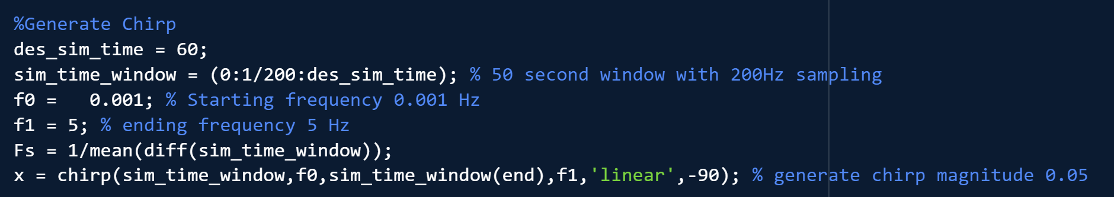
Figure 2 Chirp generation variables for velocity trajectory
The chirp command in MATLAB creates a discretized chirp signal to use as a reference.
To grab the correct value for any given time t within this commanded trajectory during the control loop, the code uses an interpolation function as follows.
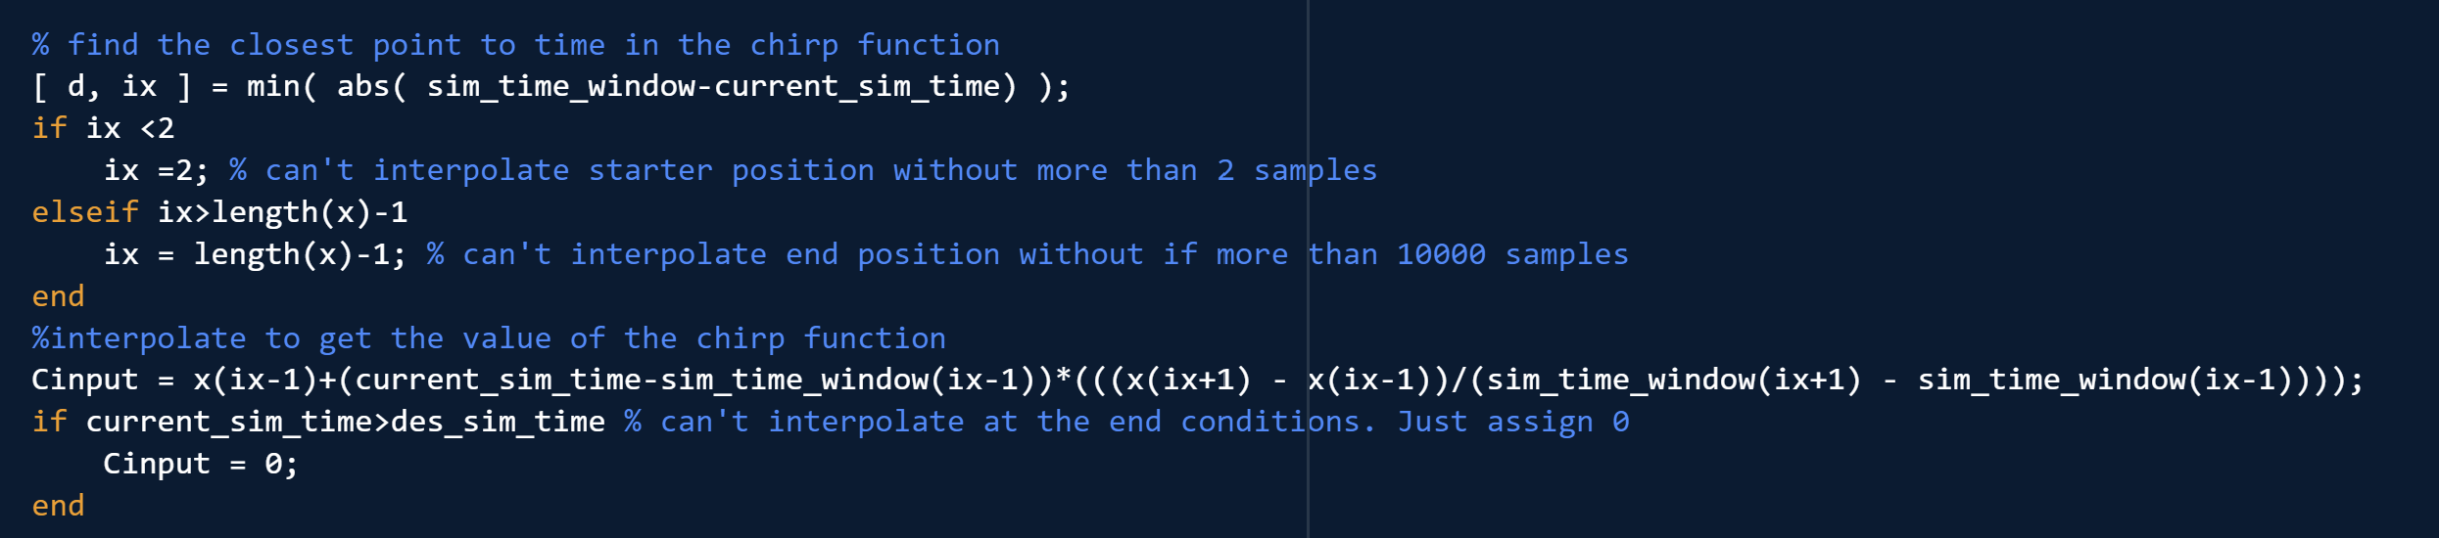
Figure 3 Trajectory interpolation for a given discretized trajectory.

If you would like a direct function based on current time you may look into generating a custom chirp function with the tools found here at the linear chirp signal https://en.wikipedia.org/wiki/Chirp

The function would take the following form for the example in figure 2 for any time t:
$$chirp(t)=sin⁡(rad2\deg\left(-90\right)+2π\left(\frac{{\left(f_{1}-f_{0}\right)}/{des sim time}}{2}t^{2}+f_{0}t\right))$$

Step trajectory

The step input trajectory section simply takes in a reference velocity from cartesian space. This should be assigned before the control loop begins. Note that direct reference commands must all be single in type otherwise ROS will not register the commands correctly or the Jacobian may become singular later on.
Figure 4 Step input example

Sin trajectory
The sine trajectory is rather similar to the step and chirp inputs and uses just the sign input itself.
Here is an example where a sign input with an amplitude of 0.01 is applied to all 3 Galen carriage joints.
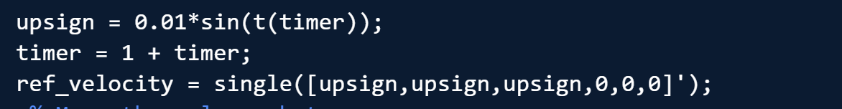
Figure 5 Sine input on all 3 carriage joints

This input needs to be called during each iteration of the control loop.

Running the Galen Robot in AMBF:

Ensure ROS is running in the background in a separate terminal. Run:
Roscore
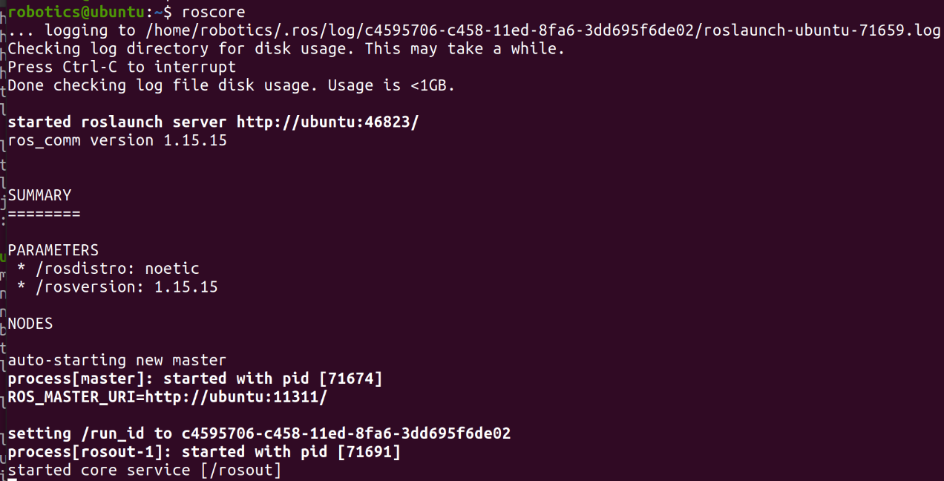

Open another terminal for running AMBF. If needed Run:
source ambf/build/devel/setup.bash

To run the Galen robot, ensure you are in the folder (corresponding to your OS):
cd ambf/bin/lin-x86_64
To run the Galen robot with the skull and sensors, assuming your file path has Galen_AMBF_Simulation at the home directory, run:
./ambf_simulator --launch_file ~/Galen_AMBF_Simulation/ADF/launch.yaml -l 0,1,2
To run the Galen robot with just the robot run:
./ambf_simulator --launch_file ~/Galen_AMBF_Simulation/ADF/launch.yaml -l 0
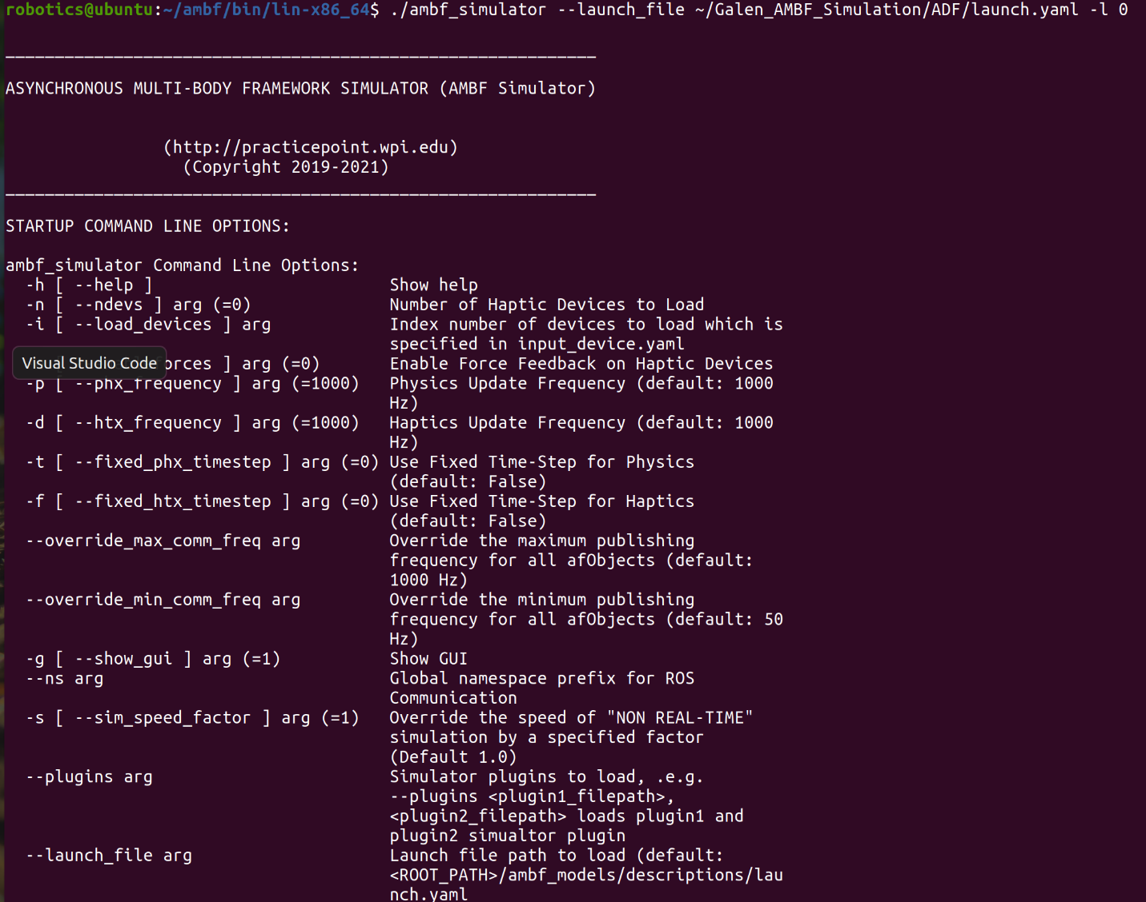
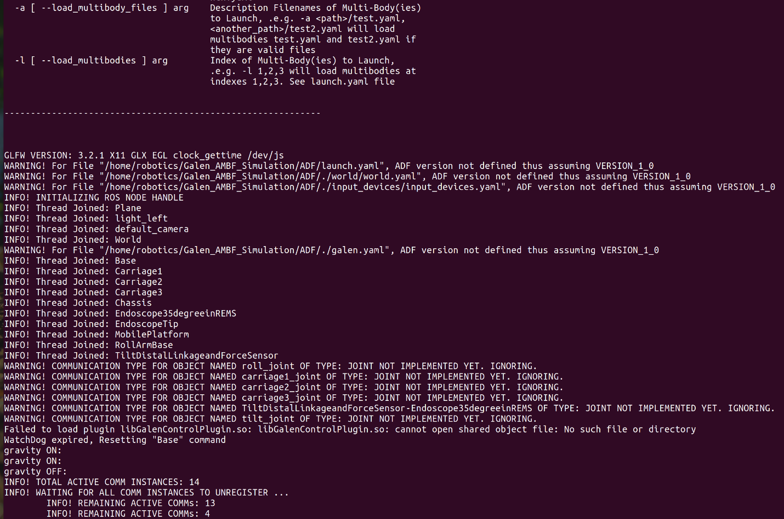

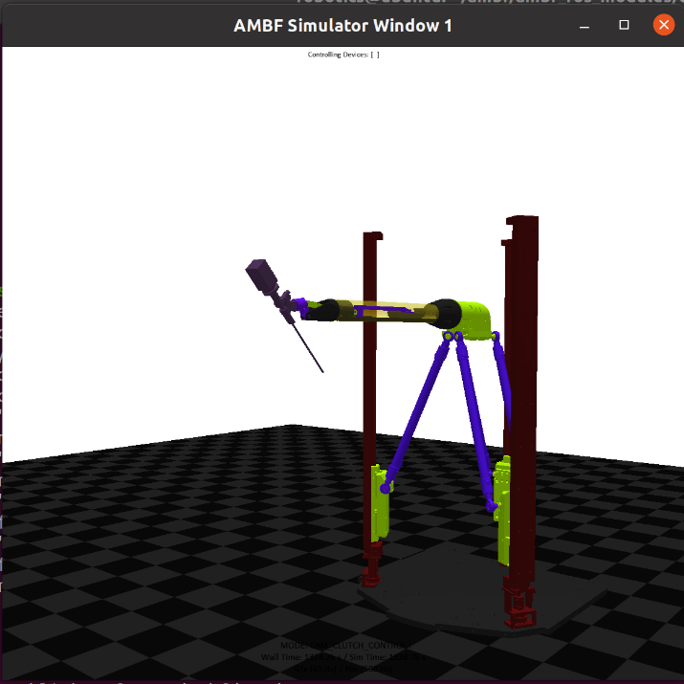

The robot will appear in a window similar to this where visualization of control responses will be available.

AMBF RigidBodyCmd

Observe how AMBF publishes ROS messages for a robot with RigidBodyCmd.
In a separate terminal (with the AMBF simulation closed) run:
rosmsg show ambf_msgs/RigidBodyCmd
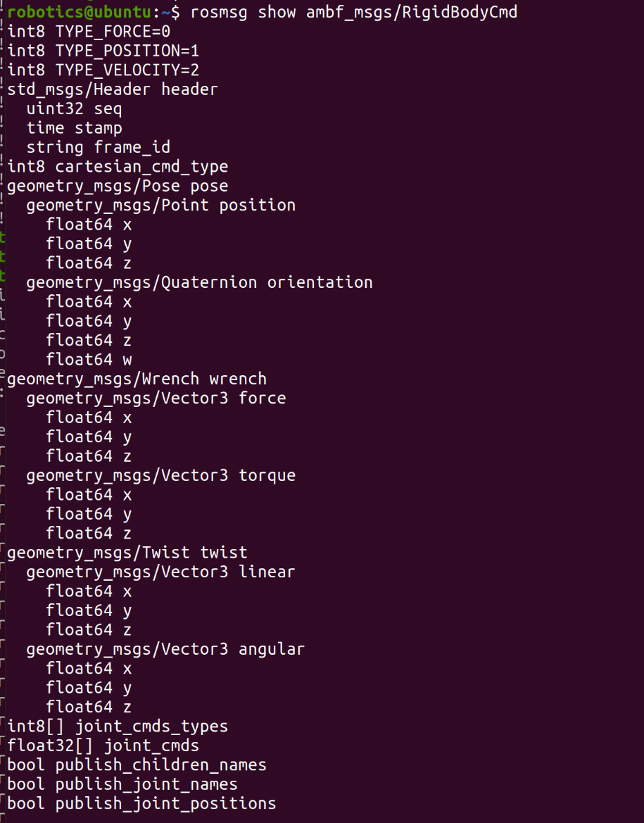

This will display the different types of messages publishable to ROS from AMBF. These can be used to program in python, MATLAB, etc. messages that control the robot in AMBF. Notice that there are 3 types at the top. TYPE_FORCE, TYPE_POSITION, AND TYPE_VELOCITY. These indicate what type of control is being applied to a specific joint of the robot when commands are applied to the cartesian_cmd_type. (0 for force control, 1 for position control, and 2 for velocity control).

This is a test example for using the RigidBodyCmd message publisher. This will display the different controllable perspectives of the robot. It should show the cartesian_cmd_type which represents the type of control being applied to the robot. run:
rostopic pub /test ambf_msgs/RigidBodyCmd "header:
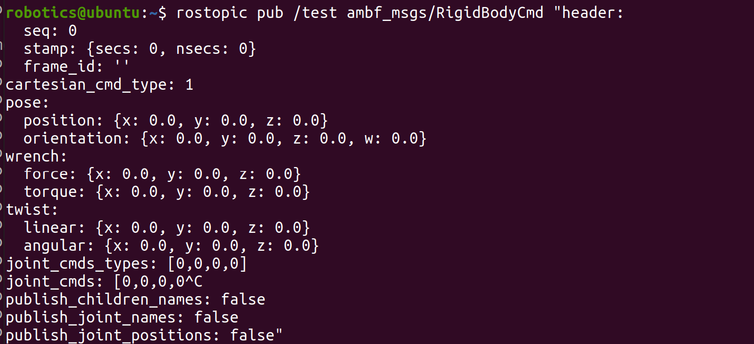

Python Controller

There is a convenient python client for controlling the robot joints that publishes using the messages from RigidBodyCmd. You can use this controller and echo the published messages to observe how the controller implemented the command. These messages can be used in the ROS toolbox in MATLAB to publish to the robot.

Start by navigating to the python controller path:
cd ambf/ambf_ros_modules/examples/object_control_example/
We will run the python controller in this location. Using -h you can see the relevant and possible commands:
python3 -h
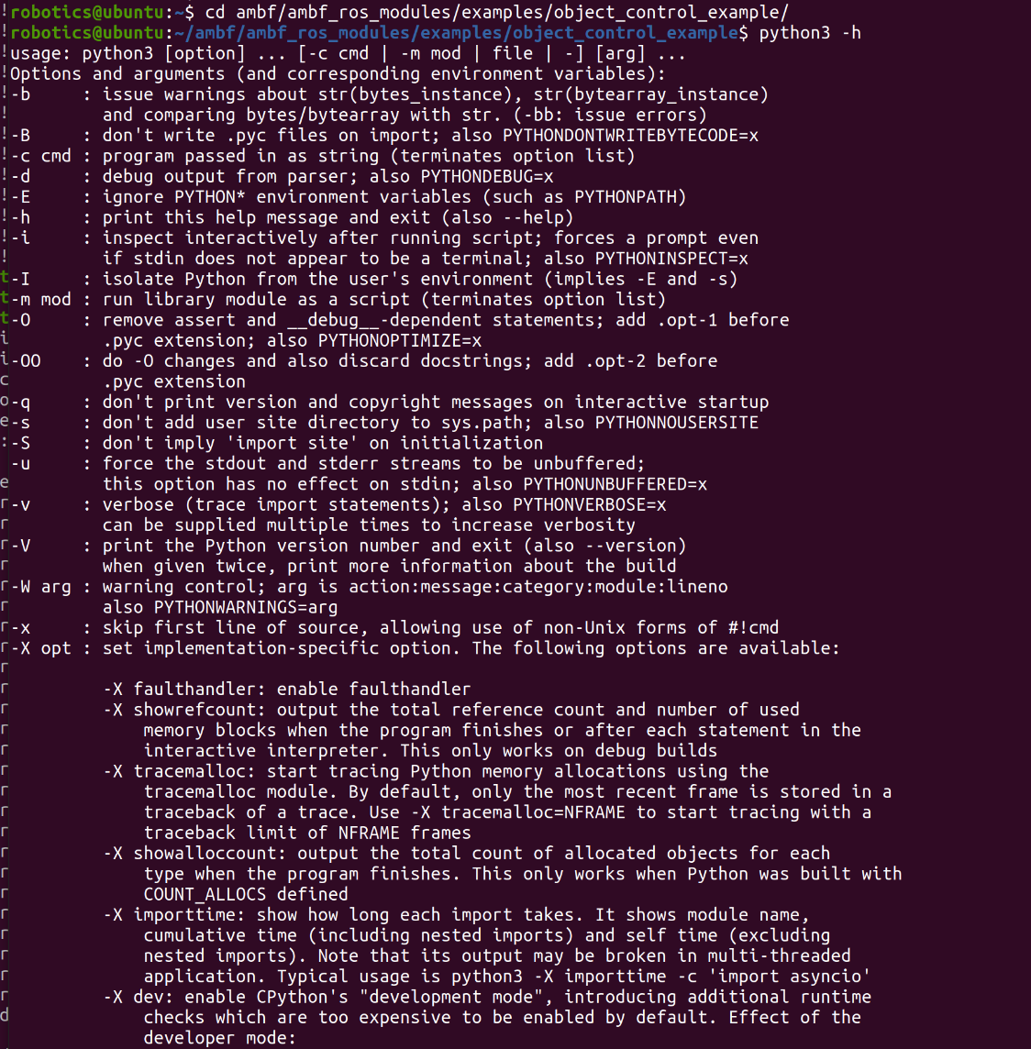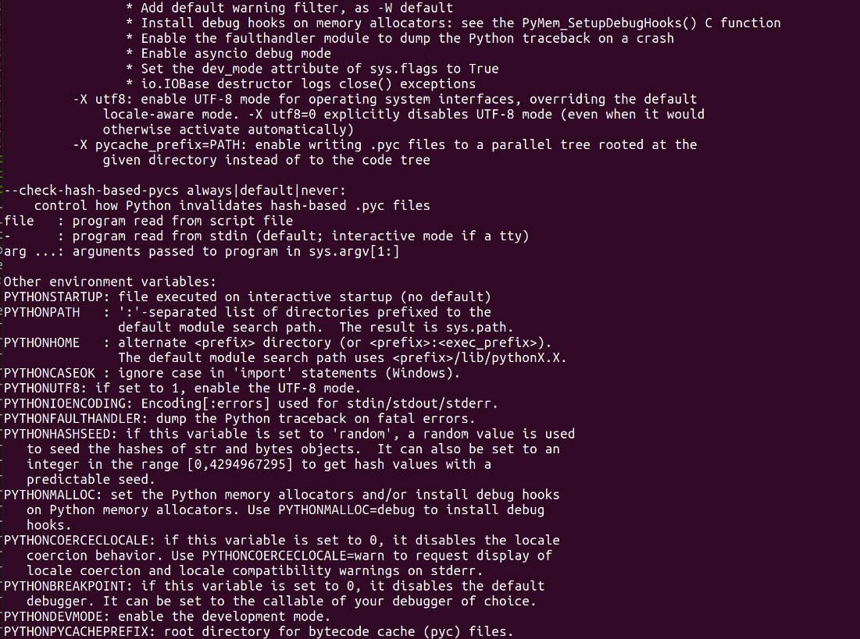

We will create an instance of the python script control_object.py in a second. Using -h you can see the relevant and possible commands associated with this controller script:
python3 control_object.py -h
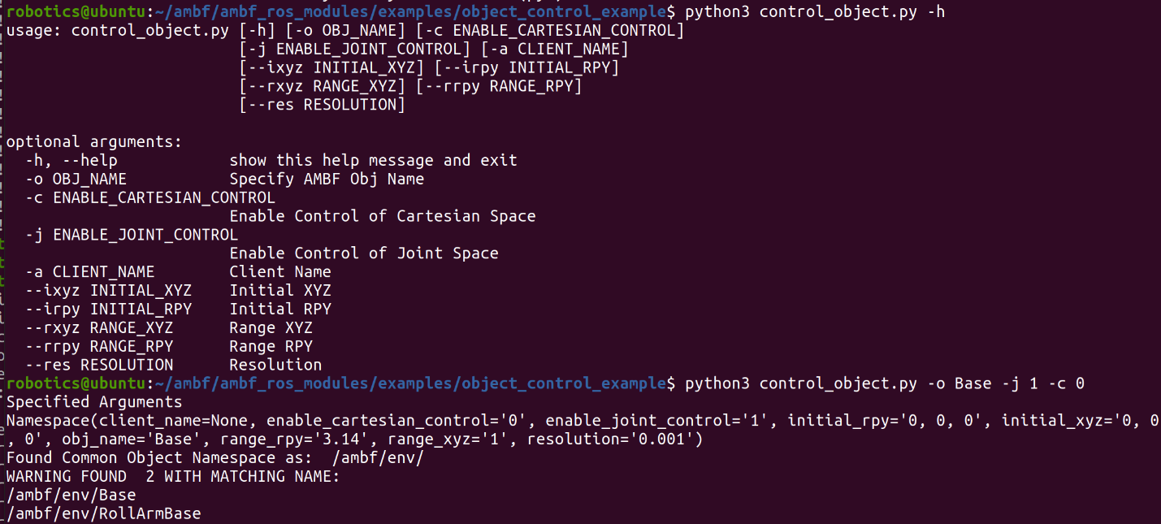

You can see -o will specify the object (the most parent robot link you'd wish to control and following children. Most likely the base of the robot). You can choose which link to use. The Base of the Galen robot is chosen in this case. 'Base'. -j will enable joint space control with 1 setting the node to true. -c will enable cartesian space control with 0 setting the node to false. In our controller design we are intending to implement a joint space controller with velocity control. To initiate the python controller instance run:
python3 control_object.py -o Base -j 1 -c 0
The output may be confused by the term 'Base' as many robots often have a link of this name in the ambf/env/ directory. To be more explicit you can use /ambf/env/Base to specify the desired body. Run:
python3 control_object.py -o /ambf/env/Base -j 1 -c 0

A tk window will open up with buttons that can change the type of control as well as the angle and scale of command. By default, effort is selected as the control scheme.
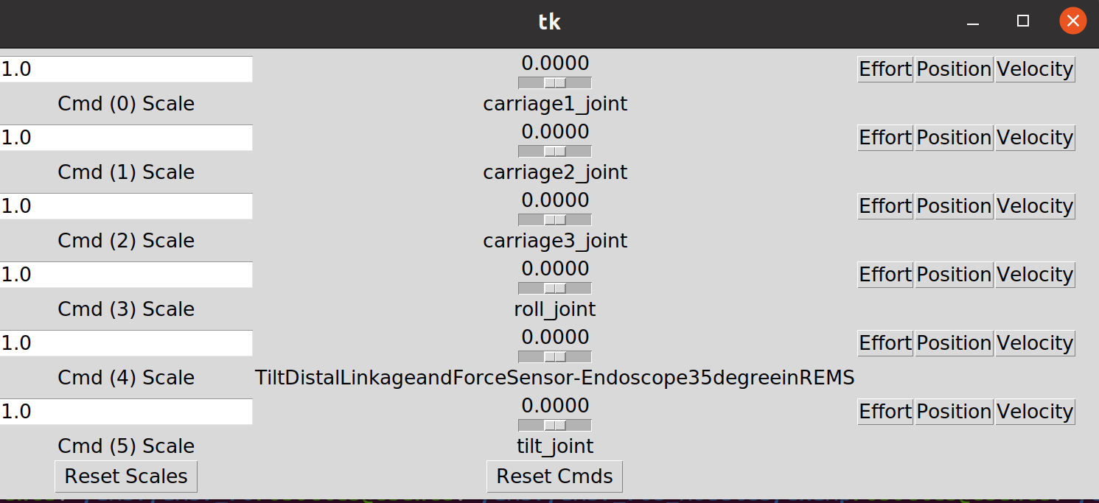

To see the different topics that are affected by these controls you can look at the rostopic lists. Run:
rostopic list
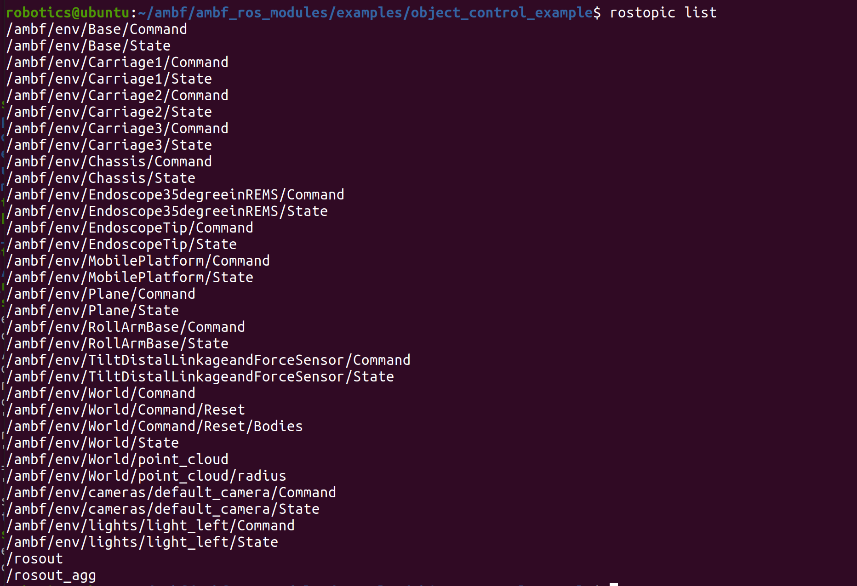

The topic /ambf/env/Base/Command in this example is the parent topic that sends subroutines to the Carriages and other joints. If you try to observe the Commands for children you may not be able to see anything, but observing the Command for the base will show the control type for each child joint and the current input. It should be noted that in order to have the desired inputs actually move the joint children inside the parent 'Base' it is required that you publish to /ambf/env/Base/Command. Observe the Command of the Base. Run:
rostopic echo /ambf/env/Base/Command
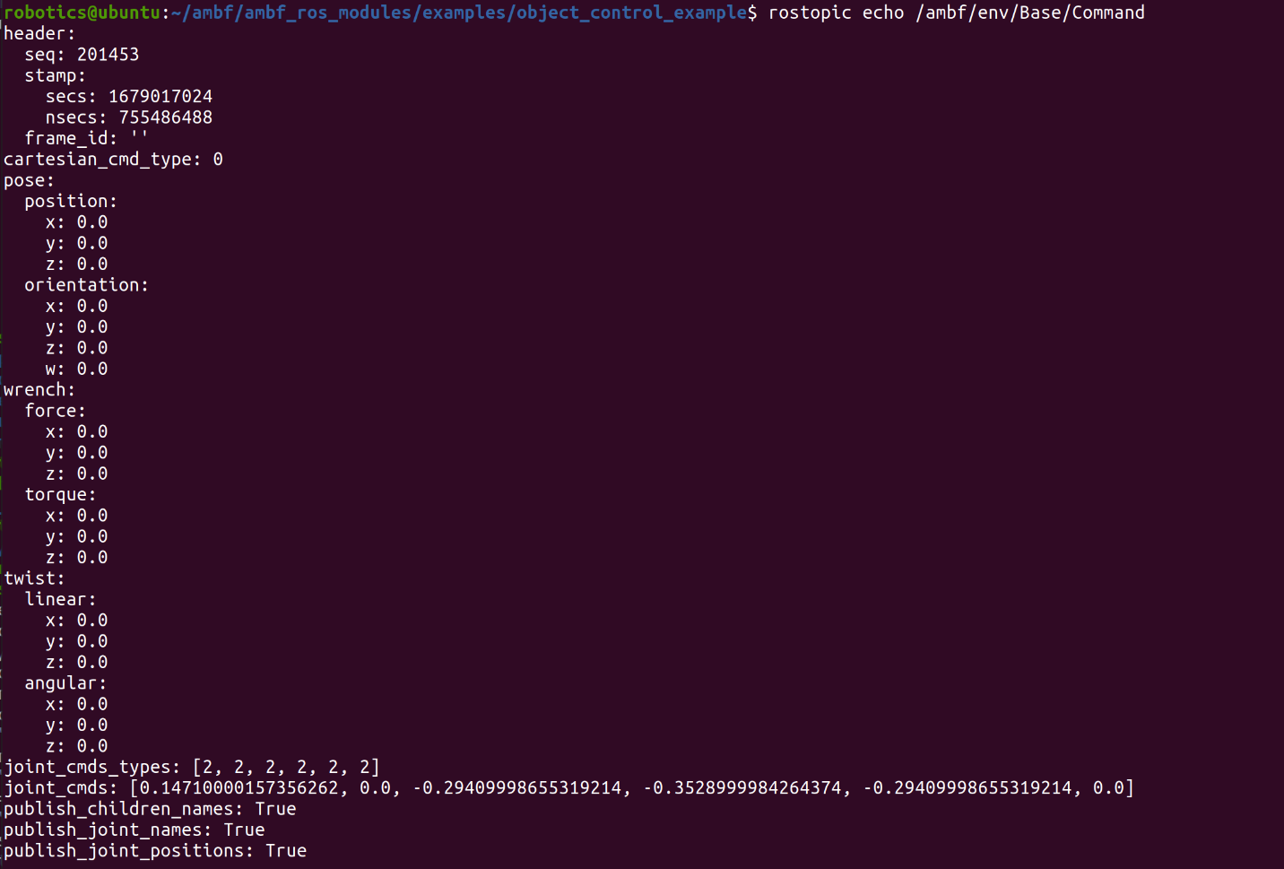

You can observe the state of the Base and other joints by looking at their State topics.

For the Base run:
rostopic echo /ambf/env/Base/State
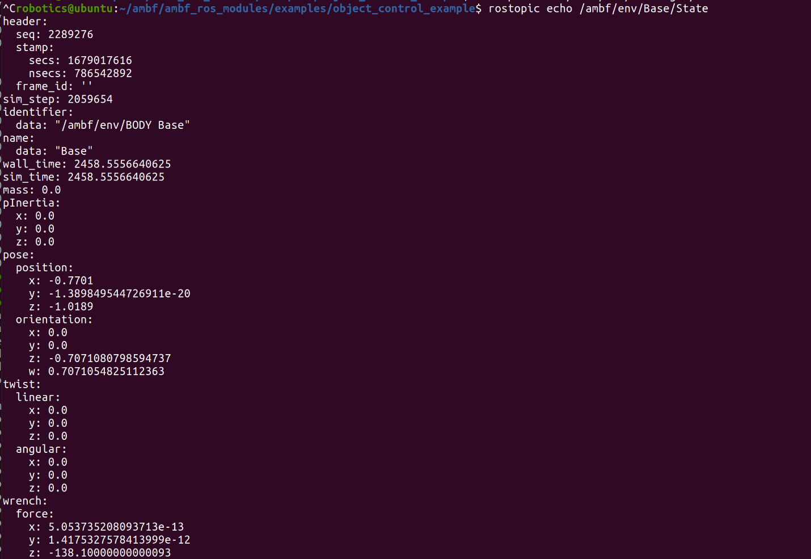
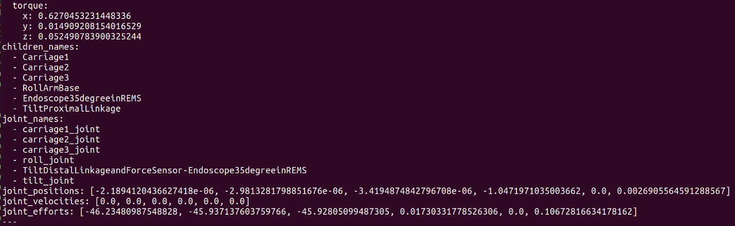
  - Note the input between running State and Command changed because the inputs of the controller were played with. It is okay that the output from State and Command don't agree here in the images.
An example of the joint could be Carriage1. run
rostopic echo /ambf/env/Carriage1/State
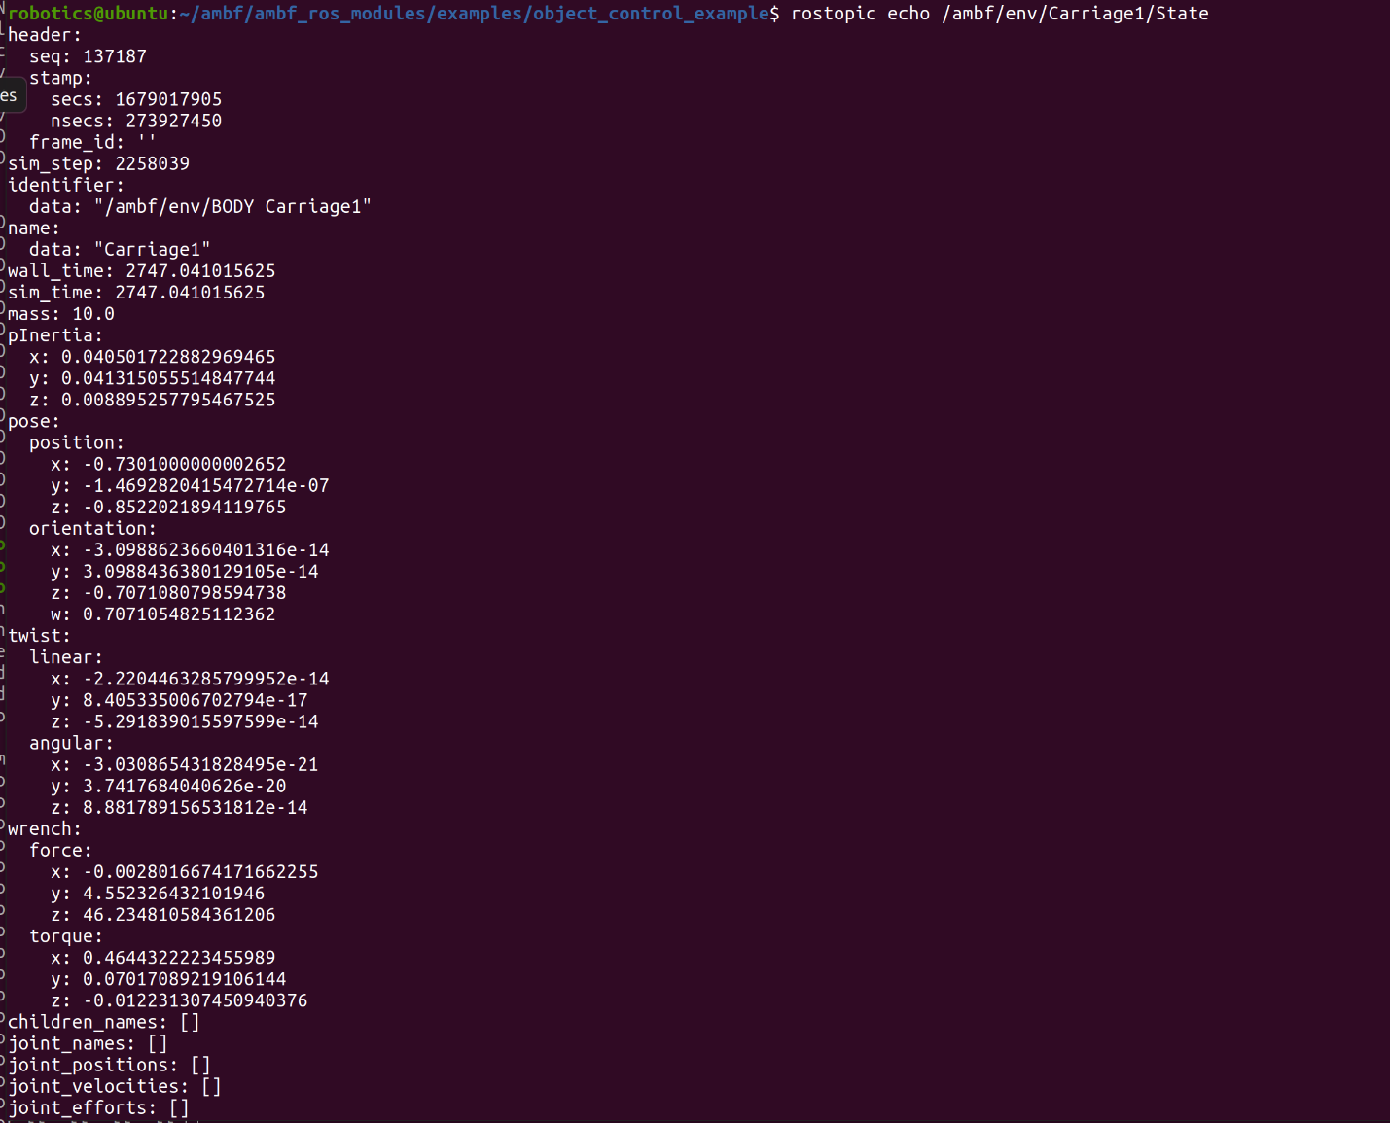

Publishing the state topics will give you specific information about the state of the robot and its joints.

AMBF and Blender for Editing ADF Files
If you want to change the robot ADF file, you can use the blender addon for AMBF.
Follow the instructions here to install blender and the addon if needed.
https://github.com/WPI-AIM/ambf_addon

We can use Blender to update/change the robot dynamics, joint limits, saturation limits, etc.
Navigate to the blender executable and run it by running (depending on your OS):
cd Downloads/blender-2.92.0-linux64/
and then run:
./blender
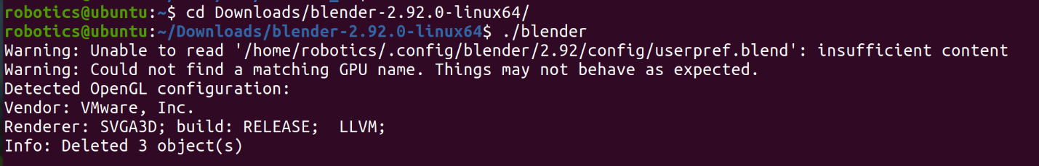

In blender you can press N or pull the side tab to open the AMBF addon window
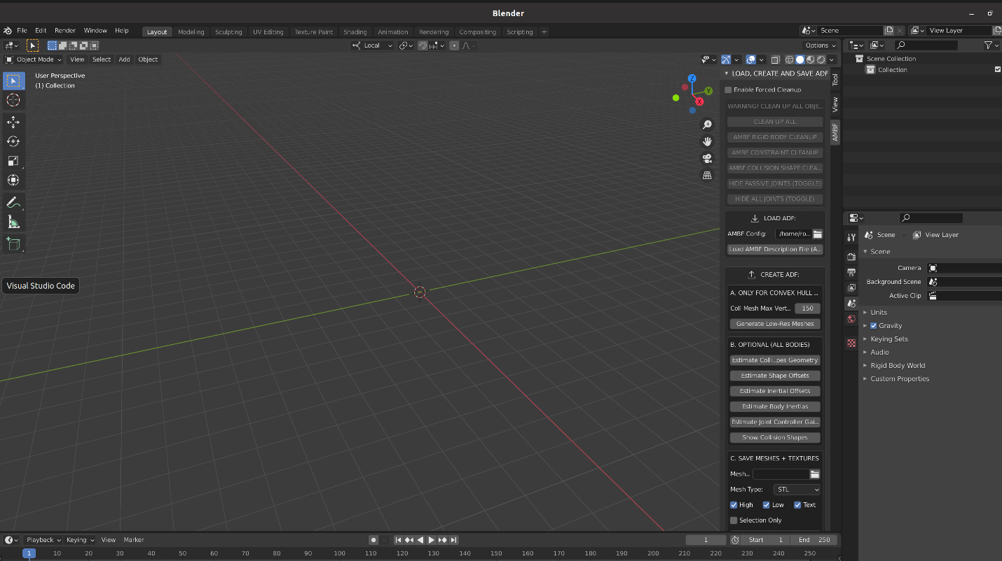

We can then load in the robot ADF by navigating to in our file explorer and then selecting the load AMBF Description file button. The Galen Robot should be located at

/home/robotics/Galen_AMBF_Simulation/ADF/galen.yaml

With the model loaded the joints and STL’s can be observed. If you want to make changes to collision groups, damping, mass, system parameters you can play with the settings throughout the tabs. In general, most of the basic updatable parameters are found in the physics properties tab.

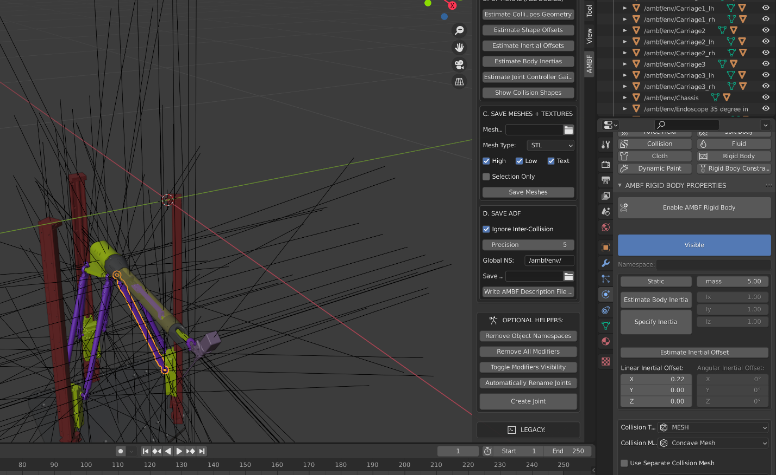
It is highly recommended to review the YouTube tutorials on the AMBF blender addon for updating ADF files. Here you can find the first of 4 short videos that explain the process to update and customize ADF files.

https://www.youtube.com/watch?v=iezOjg8qjZA&list=PLKH7Q-IzaPumDw77qQzF8deR1l4LgbWeP&index=3&ab_channel=AdnanMunawar

