Johns Hopkins Medicine - eForm A

- Use the section headings to write the eForm A, inserting the appropriate material in each. If a section is not applicable, leave heading in and insert N/A.
- When submitting eForm A (new or revised), enter the date submitted to the field at the top of eForm A.

***************************************************************************************************

- Abstract

Transcervical surgical approaches to the upper aerodigestive track result in disruption of the laryngotracheal framework with resultant sensory and motor deficits. Efforts to reduce the morbidity of external approaches have led to advances in endoscopic surgery that access the airway through the mouth. Technologic advances in binocular microscopy, rigid telescopes, microlaryngeal instrumentation, and lasers have led to dramatic improvements in the management of benign and malignant conditions of the airway. Nonetheless, this surgery continues to have disadvantages; namely, reduced depth perception, relatively small exposure, and the operator’s distance from the surgical field. These limitations restrict the surgeon’s ability to manipulate instruments from outside the oral cavity resulting in poor sensory feedback and magnification of the operator’s tremor. In addition, the lack of distal dexterity risks injury to surrounding healthy tissue. Line of site limitations inherent in microscopic or telescopic visualization limit the ability to view around corners rendering certain areas challenging to visualize fully.
Robotic surgery offers potential advantages with steerable modular instrumentation and three-dimensional viewing that are lacking in traditional airway surgery. A collaborate effort between the Otolaryngology and Engineering Departments of Johns Hopkins University led to the development of a simple robotically controlled endoscope system (Robo-ELF) to drive commercially available endoscopes that may overcome some of the challenges faced today with transoral endoscopic surgery. This has been tested on cadavers and we seek to evaluate this technology in a live human population.
- Objectives

Primary:
1) To demonstrate comparable if not superior field of vision with the Robo-ELF scope over standard rigid telescopes.

Secondary:
- To achieve full visualization of normally challenging anatomical areas to allow precise biopsy sampling.
- To drive the Robo-ELF to a desired position and leave it in a fixed position in order to demonstrate the ability to perform two-handed endoscopic procedures.

- Background (briefly describe pre-clinical and clinical data, current experience with procedures, drug or device, and any other relevant information to justify the research)

Current means of evaluating the upper aerodigestive tract depend on both open and endoscopic techniques. Open transcervical approaches to the upper aerodigestive tract result in disruption of the laryngotracheal framework with resultant sensory and motor deficits. Efforts to reduce the morbidity of external approaches have led to advances in endoscopic surgery that access the airway through the mouth. Technologic advances in binocular microscopy, rigid telescopes, microlaryngeal instrumentation, and lasers have led to dramatic improvements in the management of benign and malignant conditions of the airway. Nonetheless, each of these techniques has inherent limitations. Binocular microscopy allows for bimanual manipulation but is restricted in that the optics are outside the patient and only structures along the line of site can be visualized. The more distal the structure, the poorer the visualization. Rigid telescopes allow for endoluminal optics with superb magnification but are limited in the need for one hand to drive the scope (precluding bimanual surgery) and further line of site limitations with zero, 30, and 70 degree scopes making frequent scope changes necessary and cumbersome. Flexible scopes require two hands to manipulate but are ideal at providing a high-definition, magnified image with a flexible tip with multiple degrees of freedom providing a wide and guidable field of vision. Their use however has been limited in the operating room since two handed control is the rule making a secondary assist necessary to perform diagnostic and therapeutic procedures.
A collaborate effort between the Otolaryngology and Engineering Departments of Johns Hopkins University led to the development of a simple robotically controlled endoscope system (Robo-ELF) that may overcome some of the limitations mentioned above. The robot attaches to commercially available FDA approved endoscopes that are already frequently used in clinical practice. The robot allows for joystick manipulation of the flexible endoscope in the upper aerodigestive tract permitting a wider field of vision than that afforded by standard microscopy and telescopic endoscopes. There are no line-of-sight limitations and both single and bimanual endoluminal instrument manipulation is possible using the Robo-ELF. The robot was built to satisfy all clinical engineering requirements of Johns Hopkins Hospital. The Robo-ELF has been successfully tested on cadavers (manuscript in submission) and we seek to evaluate this technology in a live human population.

- Study Procedures

Patients undergoing routine evaluation under anesthesia for lesions of the upper aerodigestive tract are eligible to participate in this study. This would include patients scheduled for diagnostic pharyngoscopies, laryngoscopies, esophagoscopies, and bronchoscopies. Participants in this study would undergo their routine procedure with the additional evaluation by the Robo-ELF. Consistent with standard of care and as dictated by their condition, patients will have a rigid laryngoscope (e.g. Dido, Lindholm) inserted into the mouth and suspended from a Mustarde stand and they would undergo laryngoscopy with rigid endoscopes, Still images of any areas of interest, as well as the larynx with standard 0, 30, and 70 degree telescopes will be obtained. One copy will be de-identified and kept in a research file.
Task 1: With the patient still suspended with the laryngoscope, the Robo-ELF flexible scope will be passed through the central shaft into the upper airway. It will be manipulated by 3-D joystick control to fully evaluate the entire field of vision. Photos and video will be taken of areas of interest as well as the limits of the visual field with scope tip manipulation. These photos and videos will be de-identified and kept in a research file. . Task 2: To achieve full visualization of normally challenging anatomical areas. With one hand controlling the joystick and the other manipulating a laryngoscopic suction, the subglottis, anterior commissure and ventricle (areas challenging to visualize with traditional scopes) will be visualized and palpated. Views will be graded according to a Likert scale assessing the extent of the view obtained (i.e. Full view of entire anatomic area, partially obstructed view (<25 obstructed), moderately obstructed view (25-50% obstruction), significantly obstructed view (>50% obstruction), view not obtained of anatomic area.) No biopsies will be performed through the working port of the robo-ELF or with the robot itself.
Task 3: To demonstrate the ability to perform two-handed endolaryngeal procedures with the Robo-ELF in a fixed position. The Robo-ELF will be driven to an optimal position above the vocal cords and left in position such that two-handed microlaryngeal surgery could be performed. No actual tissue manipulation will be performed. Photo and video documentation will be recorded.
Assessment: Photo and video documentation of the above tasks will be de-identified and reviewed by two blinded laryngologists to compare the effectiveness of the Robo-ELF to the traditional rigid scopes. The laryngologists will be presented with all photos obtained from each patient and asked to rate the quality of each endoscopic image and the completeness of the overall endoscopic exam. Data will be recorded on Likert scales.
As this is a feasibility study of a novel robotic scope driver using commercially available endoscopes, we believe a convenience sample of 20 subjects would be sufficient to evaluate this technology.

- Inclusion/Exclusion Criteria

Study group: 30 patients undergoing diagnostic evaluation under anesthesia (EUA) of the upper aerodigestive tract will be consented to meet the accrual goal of 20 patients. Each patient will serve as his/her own control as they will undergo both traditional and robo-ELF endoscopic evaluation.

Inclusion Criteria:
Patients undergoing a diagnostic evaluation under anesthesia of the upper aerodigestive tract
Age >= 18
Exclusion Criteria:
Inability to read or write English
Any patient on contact restrictions (i.e. MRSA, VRE, TB).
Active infection

- Drugs/ Substances/ Devices

The Robotic Endo-Laryngeal Flexible Scope (Robo-ELF Scope) is a small, inexpensive robot that takes full advantage of existing clinical equipment with the goal of using this technology in the operating room on anesthetized patients. It was designed to hold and actuate a clinical endoscope, allowing the surgeon to control the scope with one hand using a custom joystick console thereby freeing the other hand to operate, or to position the scope using the robot and operate bimanually. The Pentax VNL-1570STK (Pentax Corporation, Golden, CO) flexible laryngoscope has been used with the system.
Surgeons typically use three degrees of freedom when manipulating flexible endoscopes: bending of the scope’s tip using the scope handle, rotation of the scope about its axis, and translation of the scope along the axis of the airway (Fig 1). These are the degrees of freedom that the Robo-ELF Scope was designed to actively control. To aid in positioning and removal of the scope, two passive lockable degrees of freedom were added to the robot, as well as a five-degree-of-freedom passive positioning arm (Fig 2). The power system and motor controllers are housed in an electronics enclosure separate from the robot itself, connected by a watertight cable and connectors with no voltages in the robot exceeding 12V. The system is controlled using a custom joystick interface which mounts to the rail of the operating table. A PC is used to interface to the motor controller through Ethernet. Numerous redundant hardware and software safety features have been incorporated to ensure that no single fault in the system can result in patient injury (see Safety Systems and Procedures section of Technical Description). The scope is held by an adjustable plastic scope holder which, along with the rest of the robot, is completely covered by a sterile drape. The scope is attached by taping it onto the scope holder outside the drape with surgical cloth tape. All procedures for setup, takedown, operation, and cleaning are outlined in the User Manual. Regular maintenance operations are covered in the Maintenance Manual and Maintenance Checklist. Software specifications and documentation are covered in the Software Documentation.
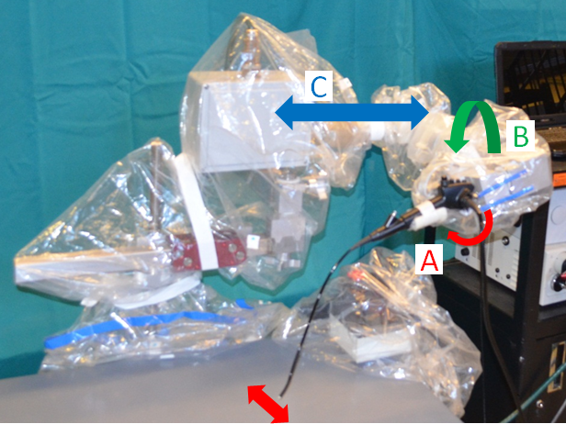
Figure 1: Robotic Scope Manipulator Degrees of Freedom. A) Scope tip manipulation joint. B) Scope rotation joint. C) Insertion/extraction joint.
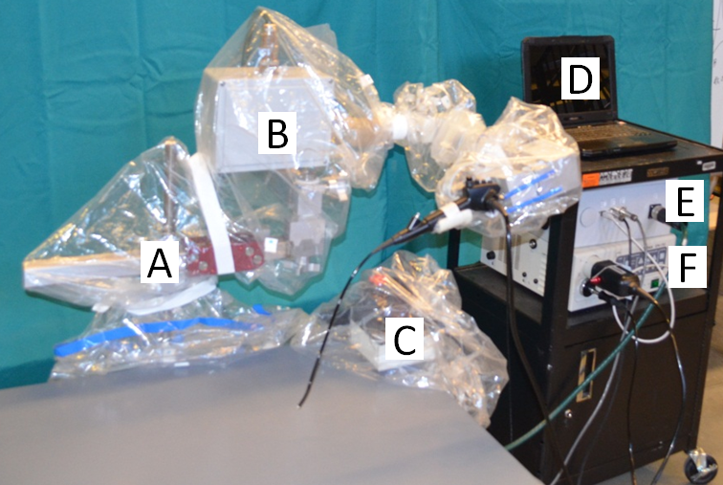
Figure 2: A) Passive positioning arm. B) Robotic scope manipulator with three active degrees of freedom. C) Joystick controller. D) Control PC. E) Electronics enclosure. F) Endoscope Video Processor.

- Risks

Use of the Robo-ELF introduces no more risk than that of traditional upper aerodigestive tract endoscopy. The flexible scopes that can be used with the Robo-ELF are FDA approved for endoscopy and are frequently approved for this application at JHH. Only the scope itself enters the patient’s airway. The Robo-ELF does not contact or enter the patient. The Robo-ELF was built to satisfy Johns Hopkins Hospital clinical engineering guidelines and meets all the necessary safety requirements.
The main risk of this study is the additional time under general anesthesia. Based on our cadaver study it is estimated that evaluation of the Robo-ELF will require 15 additional minutes of anesthesia time. This is estimated to increase the entire length of the procedure by approximately 25%.

- Benefits

Participants most likely will not directly benefit from this study. It is possible that a few participants may have lesions that are unable to be visualized and biopsied with traditional endoscopic techniques and therefore derive benefit from being evaluated with the Robo-ELF. Patients will benefit from knowing that their participation in this study will allow other patients to benefit from this new technology in the future.

- Payment and Remuneration
- none

- Costs
- There are no costs associated with this study.

