Novel User Interface
for
Data Integration during Robotic Ultrasound guided Surgery

Members
Vineeta Khatuja, Andrew Wang, Tifany Yung

Mentors:
Surgery: Michael Choti MD MBA, Theodore Katsichtis
Engineering: Russell Taylor PhD, Colin Lea

Table of Contents

Background and Significance 3
Goal 4
Current System 5
Major components 5
Tile Pro 6
Deliverables 8
Minimum: 8
Expected: 8
Maximum: 8
Possible follow-ups: 8
Technical Approach 8
Software 8
Non-clinical testing 9
Dependencies 9
Project Management 10
Project Bibliography 11

Background and Significance
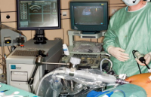
Robotic assisted surgery is increasingly implemented to a variety of surgical procedures. A robotic platform offers the surgeon an array of advantages compared to conventional open and laparoscopic techniques. Stereoscopic 3D vision, 7 degrees of motion and physiologic tremor attenuation allow the surgeon to be more precise and competent.
Real time ultrasonography is commonly used in modern open, laparoscopic and robotic surgery. Ultrasound data helps in surgical decision making, intraoperatively in terms of lesion localization and its relative position to other structures.
Currently,the Ultrasound images are displayed on the da Vinci console but the processing of the imaging data like the measurements of the lesions are done in a different monitor. This obliges the surgeon to look to different monitors and ask Ultrasound technicians to process the US data, in cost of efficiency, ergonomy and operative time.
We propose the development and utilization of a novel da Vinci interface, integrating and displaying live intraoperative US as well as additional preoperative data (CT, MRI, X-ray and DICOM) to the surgeon. Displaying all the necessary data to the surgeon through the Da Vinci master console, can potentially increase the ergonomy and efficacy of robotic procedures improving patient outcome.

Goal
Our project aims at improving the existing interface for the da Vinci robot console and make it ready to be used clinically for Ultrasound guided surgery. We would recruit the Surgical collaborators for clinical testing to determine the effectiveness of the interface in minimizing the difference in success of liver surgeries between novice and expert surgeons. Further improvements will be incorporated into the interface to allow the user to manipulate 3D lesions and fiducials within the da Vinci console itself.

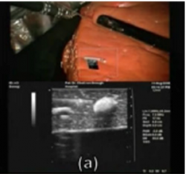

Current System

Major components

A. Inputs
There are three inputs to the surgical workstation.
- Camera 1
- Camera 2
- Live Ultrasound

B. Surgical WorkStation
It is responsible for processing the input data and perform necessary calculations.

C. Surgical Console
This is the console seen by the surgeon while performing the surgical procedure.

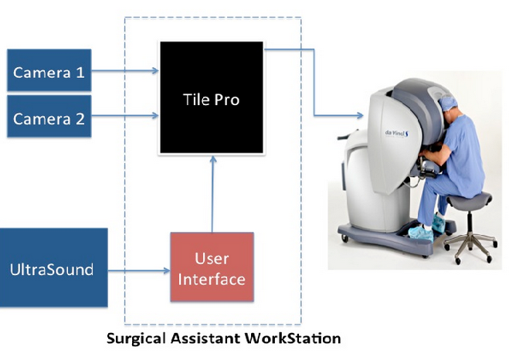

Tile Pro

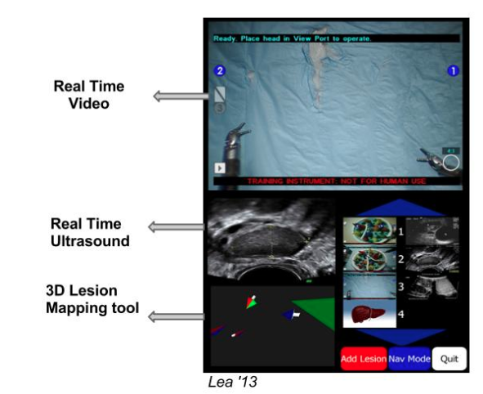

TilePro is the interface that the surgeon sees on his console. It has two slots
a) Upper slot : Displays the the 3D live video of the operative field using the Camera 1 and Camera 2 inputs.

b) Lower Slot : Displays the live ultrasound video, image browser and other related items which is called the LapUs interface.

Problems with the current LapUs interface
- 3D lesion mapping tool is not ready for clinical use.It obstructs the surgeons view.
- It is difficult to see the information like the saved Ultrasound images.
- Surgeon cannot see measurements intraoperatively.
- Operative tool measurements.
It is important for the surgeon to measure the movement of the operative tool.
- Lesion size in the ultrasound.
This information is currently provided by the Ultrasound technicians.
- Surgeons must switch between screens for preoperative images.

Deliverables

Minimum:
  - Acquire software dependencies, Mock OR access.
  - Propose budget and acquire funding for da Vinci usage ($50/hr) from Dr. Taylor.
  - Remove 3D lesion mapping tool.
  - Implement real time operative field measurement tool.
  - Implement saving and browsing of US images on the console.
  - Phase 1 (baseline interface) clinical study design (patient + surgeon IRB, tasks).

Expected:
a. Contact surgical collaborators for clinical study.
- Schedule and confirm participating surgeons for study.
- Complete Phase 1 clinical testing of the software in the Mock OR.
- Incorporate features and changes requested in feedback from the clinical trials.
- Implement lesion measurement tool on the US.

Maximum:
  - Incorporate DICOM reader with Masters as Mice into the interface.
  - Build a 3D model of organs from CT scans.
  - Ability to manipulate a 3D model of a lesion or organ.
  - Use 3D fiducials to show previously viewed areas.

Possible follow-ups:
- Speech-to-text intrap notes.
- 3D representation of the US probe in the UI.
- Enable 3D fiducial placement on the 3D models, not just the US images.

Technical Approach

Software
- Remove the 3D lesion mapping tool.
  - Understand the LapUs code and identify the code to be removed.
- Real time operative tool measurement.
  - Use the daVinci API to get the operative field measurement tool.
- Lesion measurement tool.
  - Perform calibration between the US images and user interface.
- User-friendly interface.
  - Less disruptive color scheme.
  - Save and browse capabilities with the US images, with lesion descriptions.

Non-clinical testing
Once the baseline interface is complete (3D lesion mapping is removed, color scheme and interface component arrangement improved), our team members Andrew and Tifany will perform non-clinical tests on the interface. These tests aim to assess the stability and compatibility of the baseline interface on the Hopkins da Vinci system. The tests will be performed using the da Vinci robot in the Hackerman mock OR on a gelatin phantom liver with pseudo-lesions. We will perform the tasks of identifying and locating lesions using the LapUS interface. Since the interface has not been tested for more than a period of 10 minutes, our goal is to use the interface for a more extensive period of time to check for any possibility of the UI crashing during use and to discover any possible glitches or bugs.

Once the enhanced interface is complete (3D organ model manipulation, 3D lesion mapping properly implemented, etc.), another stability and functionality test will be performed to discover potentials for crashes or glitches. A clinical study will then be performed to test the utility and functionality of these added features. Since we plan to have surgeons test the interface during procedures on actual patients, we will require an IRB approval. A questionnaire will be issued to the surgeons participating in the study that will determine their satisfaction and comfort with interface. A supplementary questionnaire will also be issued to determine the surgeons’ opinions of the LapUS interface with respect to having just the da Vinci live camera feed.

Budget Proposal
Funding for use of the Hackerman mock OR for debugging and testing of the interface will be required. A budget must be proposed to receive project funds.

Dependencies
Dependency | Purpose | Status | Planned Source / Issue | Planned Resolution Date
QT Creator | For interface development. | Resolved | Internet | February 22, 2013
CISST library | For computer-assisted workstations. | Resolved | Internet | February 22, 2013
Intuitive API | Operative Field Measurement tool | In progress | Colin | February 22, 2013
LapUS Code | Current interface code to be improved. | In progress | Colin.  (Video input not working and images directories incomplete in the original source code) | February 22, 2013
Video Grabber driver | Required to run LapUS Code, | Resolved | Internet | February 28, 2013
Possible IRB | For clinical study on patients. | Incomplete | Theodre | March 1, 2013
Liver phantom | For non-clinical stability test. | Incomplete |  | March 1, 2013
Surgical collaborators | For clinical study on patients. | In progress |  | March 8, 2013
Mock OR  And da Vinci Access | For interface debugging/testing. | Complete |  | February 28, 2013
Budget proposal for project funds to use Mock OR | For interface debugging/testing. | In progress | Pending budget finalization | March 1, 2013.

Project Management

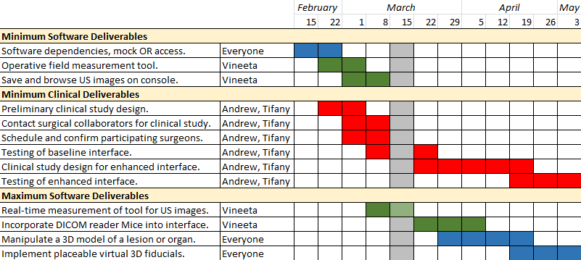

Project Bibliography
- Bartosz F. Kaczmarek, S. S., Firas Petros, Quoc-Dien Trinh, Navneet Mander, Roger Chen, Mani Menon, Craig G. Rogers (2012). “Robotic ultrasound probe for tumor identification in robotic partial nephrectomy: Initial series and outcomes.” International Journal of Urology.
- Caitlin M. Schneider, B. P. D. P., MD; Russell H. Taylor, PhD; Gregory W. Dachs II, MS; Christopher J. Hasser, PhD; Simon P. DiMaio, PhD; Michael A. Choti, MD, MBA, FACS Surgical Technique: Robot-assisted laparoscopic ultrasonography for hepatic surgery.
- Caitlin M. Schneider, G. W. D. I., Christopher J. Hasser, Michael A. Choti, Simon P. DiMaio, Russell H. Taylor Robot-Assisted Laparoscopic Ultrasound, Johns Hopkins University; Johns Hopkins Medicine; Intuitive Surgical, Inc.
- Craig G. Rogers, M. R. L., MD; Akshay Bhandari, MD; Louis Spencer Krane, MD; Daniel Eun, MD; Manish N. Patel, MD; Ronald Boris, MD; Alok Shrivastava, MD; Mani Menon, MD (2009). “Maximizing Console Surgeon Independence during Robot-Assisted Renal Surgery by Using the Fourth Arm and TilePro.” Journal of Endourolgy 23(1): 115-121.
- Francesco Volonté, N. C. B., François Pugin, Joël Spaltenstein, Boris Schiltz, Minoa Jung, Monika Hagen, Osman Ratib, Philippe Morel (2012). “Augmented reality to the rescue of the minimally invasive surgeon. The usefulness of the interposition of stereoscopic images in the Da Vinci robotic console.” The Internation Journal of Medical Robotics and Computer Assisted Surgery.
- Joshua Leven, D. B., Rajesh Kumar, Gary Zhang, Steve Blumenkranz, Xiangtian (Donald) Dai, Mike Awad, Gregory D. Hager, Mike Marohn, Mike Choti, Chris Hasser, Russell H. Taylor DaVinci Canvas: A Telerobotic Surgical System with Integrated, Robot-Assisted, Laparoscopic Ultrasound Capability, The Johns Hopkins University; Intuitive Surgical, Inc.

