Willis Wang
4/11/2016
CIS II: Seminar Paper Critical Review
Group 12

Project Overview
During some cranial surgeries, pieces of the skull must be removed in order to gain access to the brain. These pieces are generally destroyed during the surgery process and a new implant must be constructed to replace the missing bone flap. These implants can take a significant amount of time to produce, compromising patient safety and leaving the patient vulnerable to infection. The purpose of our project is to build on a previous project whose goal was to significantly reduce the time of creation of this implant through the use of modern 3D scanning cameras and creating a segmentation algorithm to identify the defect site. The aim of our project is to use patient-specific ground truth models of the defects to determine accuracy and robustness of not only the segmentation algorithm, but also registration of the defect to the patient. If successfully done, surgical time and exposure time to infections will be reduced considerably to cranioplasty patients.

Paper Selection and Why
The paper that I selected is:
Yang, Jialong, Hongdon Li, and Yunde Jia. “Go-ICP: Solving 3D Registration Efficiently and Globally Optimally.” 2013 IEEE International Conference on Computer Vision (2013): n. Pag. Web.
I chose this paper because it claims to solve a significant issue with our current work pipeline. Specifically, it claims to have a robust and efficient algorithm that achieves a global minimum in the ICP algorithm – a very well-known issue that the algorithm suffers from. Currently, a large issue with the project is the resulting local minima that our algorithm falls into, preventing us from achieving a good result in our defect to patient registration. Specifically, the robustness and automation are desired for streamlined operation during surgery. The local minima problem is especially an issue with our project due to the relatively featureless surface of the skull. This means that despite our best guesses for good initial seeds, ideal results are very rarely, if ever, achieved.

Summary of Problem and Basic approach
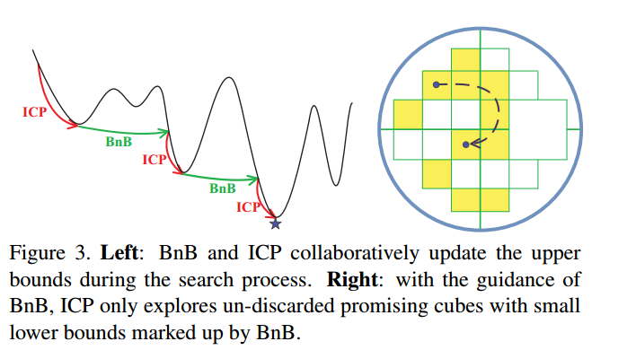
The problem that the paper addresses the local minima pitfall that ICP, a very commonly used point cloud algorithm, suffers from. As mentioned above, this is a major problem that we are currently facing in our defect-to-patient registration. Currently, many alternative algorithms have been proposed to solve this problem including simulated annealing and use of extra features. However, these can all still result in a local minima trap, especially in the case of bad seeds. The paper attempts to tackle this local minima trap problem by using the Branch and Bound design pattern in tandem with classical Iterative Closest Point. The sample space of possible rotations and translations is broken down using an Octree. Each subspace is then assigned an upper bound and lower bound through a combination of Euclidian geometry and ICP executions using the center of a subspace as a seed. This new algorithm is named the “Go-ICP” for Global-ICP.
Background
Iterative Closest Point (ICP)
Iterative closest point is an algorithm for registering two point clouds under Euclidean transformations. It is very popular and well known for its many real-world applications. It is commonly used in computer vision and medical applications. The algorithm’s aim is to estimate a rigid body transformation between two point clouds. This is done by iteratively generating a transformation involving a rotation and a translation and then estimating a L₂ –error/point correspondence. In this particular paper, this is error E between two point clouds X and Y of size M and N, respectively is defined as:
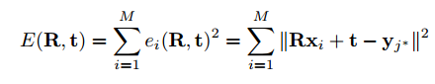
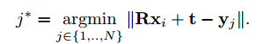
Here R and t are the rotations and translations, respectively. Additionally, y_{j*} is defined as the best correspondence point to the x_{i}.

Branch and Bound (BnB)
Branch and Bound is an algorithm used for optimizing combinatorial problems. The goal of the algorithm is to essentially to find a global maxima or minima of a function f(x), called the objective function. It works by creating possible decision branches and eliminates potential paths through bounding. Specifically, it recursively splits the search space into smaller spaces and finds the local minima, assuming minimization of the objective function is desired. This splitting is known as branching.
To prevent unnecessary checks in spaces, an upper and lower bound is assigned for each subspace. Before enumerating the candidates under each branch, the branch is checked against upper and lower bounds of current optimal solution. This essentially prunes the search space to eliminate candidates that are not necessary to be checked. A priority queue is used to rank each of the possible branches at a particular node with the lowest lower bound prioritized.

Method
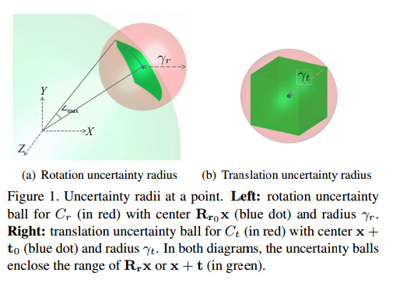
Defining 3D Bounds
The first issue that was tackled by the paper was the bounding of the each subspace. This was done by first defining an area of uncertainty. This area of uncertainty is a rotation and a translation cube defined to enclose the domain of all feasible 3D motions. This area is partitioned from an Octotree into C_{r} and C_{t} for rotation and translation domains. Regarding the translational cube, there is assumed to be an optimal translation within a bounded cube [-ζ, ζ]³.
We can define the uncertainty radius, or a radius of possible rotations, as a sphere with radius γ_{r} centered around some transformation R_{r0}. This radius can be defined as:
$\left|\left|R_{r}x- R_{r0}x\right|\right|≤γ_{r}=2\sin\left(\min\left(\sqrt{3}\frac{σ_{r}}{2},\frac{π}{2}\right)\right)\left|\left|x\right|\right|$,
where 𝜎_{r} is half of the side-length of the rotation cube given from the octree partitioning and R_{r} is any rotation within the sphere. The uncertainty cube’s sides can similarly be easily defined as: $||tr - t0|| ≤ γ_{t} = sqrt(3)σ_{t}$
Once these are defined, a proper definition of an upper and lower bound can be determined. The upper bound for the per-pixel residual error, ${\overline{e}}_{i}$, of a subspace can be easily defined as the error of the initial rotation and translation guess – defined as the center of each subspace. As a result, the final upper bound is defined as:
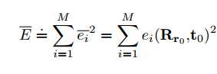

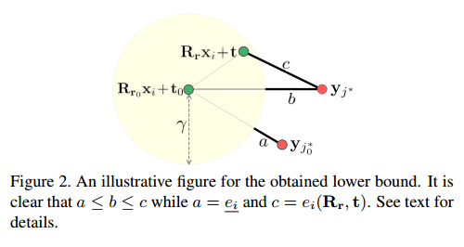
The lower bound’s derivation is slightly more complex and can be explained intuitively through the figure to the right taken directly from the paper.
Given a point $y_{j_{0}^{*}}$ defined as the closest point to the center R_{r0}x_{i} + t₀ of the uncertainty ball with radius $γ$, then it is also the closest point to the surface of the uncertainty ball. It can be said, then, there exists no transformed data point within the ball that is closer than this distance from $y_{j_{0}^{*}}$ to the surface. Therefore, the lower bound is defined as:
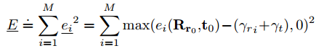
Nested BnB
The paper tackles the separate rotation and translation aspects of the transformation by segmenting the Branch-and-Bound algorithm into two parts: a rotation and translation aspect. The translation calculations are done nested within an outter, rotational BnB search. This outer rotational BnB solves for its bounds and optimal translations by calling on the inner rotational BnB. More specifically, an outer BnB pulls the next lowest bounded cube from the priority queue and calls on an inner BnB to calculate its corresponding bounds and translation. For a given C_{r}, the outer BnB uses the bounds listed above but with a lower bound of:
The inner BnB uses the original equations but with the uncertainty of rotation, 𝛾_{r}, set as 0. The returned upper bound is then checked, and if it is lower than the current optimal solution, then ICP is re-run to retrieve the new best point. This process is continued until a minimum error threshold is reached. A more detailed pseudocode from the original paper is outlined below:
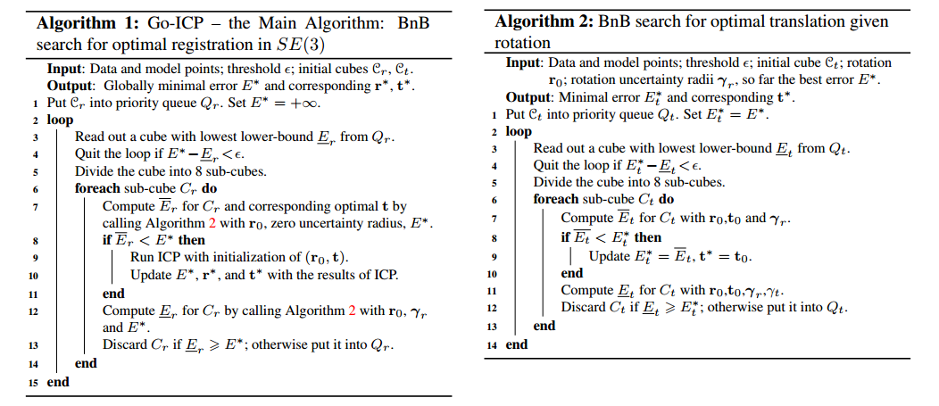
Results and Assessment
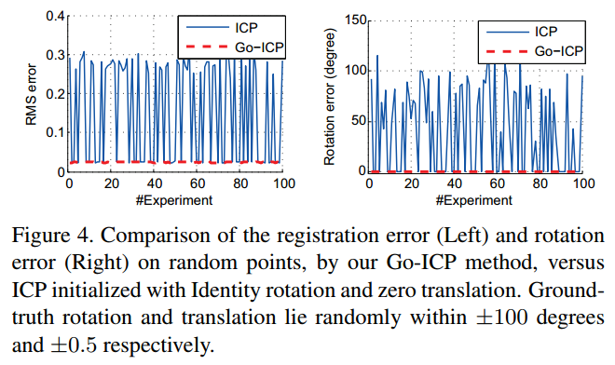
Included are graphs and images directly from the paper to aid in the discussion of the results and overall assessment. Directly to the right shows the RMS error comparison of traditional ICP and the newly named “Go-ICP”. As can clearly be seen, the RMS error of Go-ICP performs incredibly consistently with no movement in final RMS error. Compared to the erratic and non-consistent behavior of traditional ICP, this is a marked improvement.
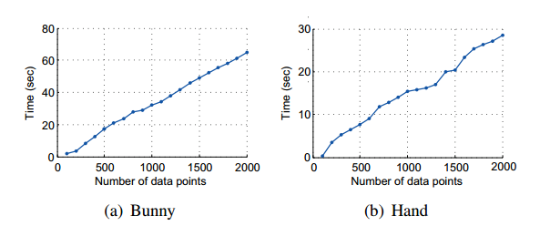
Additionally, the overall runtime seems to be relatively efficient. However, it should be noted that the authors of the paper scaled the convergence threshold with the number of data points, compromising accuracy for run time. This in particular is a bit of a red flag for me as the manual tweaking of both the convergence threshold and translation range in the translation uncertainty cube sacrifices autonomy and masks the real runtime complexity.
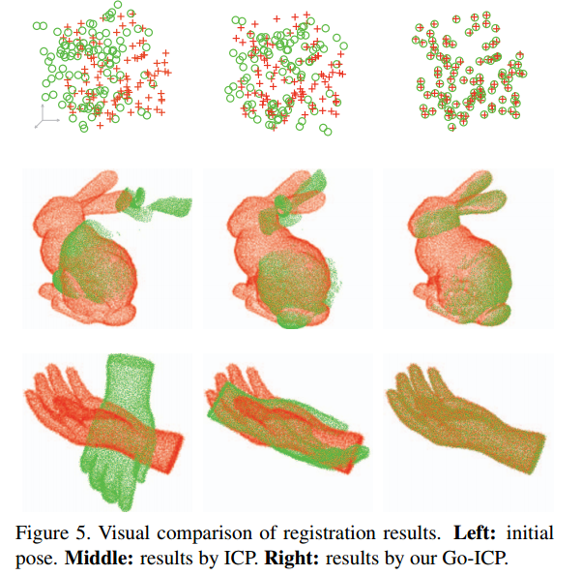
Finally, the paper tackled noisy data to determine robustness of the algorithm. To deal with outlier handling, an ICP with trimming algorithm was used. Noise in data is a very real problem that we have to tackle in our project as the 3D scanning hardware we use is very prone to noisy data which can easily throw off our registration. This is also very promising for our own uses. The trimmed ICP works by only taking a subset of the data points with the smallest closest-point distances. The bounding equations are adjusted and further reading can be found in section ‘8. Extensions’ of the paper.
Overall, I found this paper relatively difficult to comprehend initially due to the difficulty of concepts, but well written. The paper outlined an approach that will mesh very well with our current plan of attack and may prove very promising in practice. The only issue I have with it is that it seemed to have massaged a few of its run-time data, giving rise to some suspicions to its true autonomy and use in real-world applications.

Conclusion
The paper outlines a promising approach to achieve a global minimum for ICP and may prove incredibly useful for our own registration. However, it is unknown whether the run time will be a significant factor. Currently, the size of our sample points is much more significant than those used in the papers. Additionally, the paper reduced their run time by scaling their error threshold with the number of samples. It may be possible for us to downsample our current sample data such that the run time is reduced significantly, but this needs to be tested before and strong conclusions can be made.

