Olivia Puleo
Seminar Report

Paper 1: Patkin, M. "Ergonomics in Microsurgery." The Australian & New Zealand Journal of Obstetrics & Gynaecology 21.3 (1981): 134. Print.

Introduction
The paper starts out by stating that there are two special problems created by working under high magnification: seeing fine detail and controlling fine movement. Both of these contribute to the relationship between the instruments used and the operator, generally known as the ergonomics of the situation.
Patkin continues by describing the “external precision grip” which is most often used in microsurgery. It consists of three components: the touching tips of the thumb, index, and middle fingers, the patch of skin at the apex of the thumb cleft, and anti-tremor support from the pinky finger, palm, wrist, and forearm. The components then come together to create a grip that has a large amount of dexterity while also working to minimize natural hand tremor.

Hand tremor
Factors that contribute to hand tremor can be divided into long-term, intermediate, and short-term factors. Long-term factors include things like age and general constitution of the person – things that are there forever. Intermediate factors include experience level, amount of training, and the bodily state of the person like their level of anxiety or how much caffeine they have had that day. These things are able to be changed, but not on short notice. The most relevant factors are short term ones, which include how well the arm, hand, and fingers are supported, along with the types of movements being made. Within the short-term factors, Patkin comments that pressing much harder than 50g with the index finger exaggerates hand tremor, which is relevant to the design of our instrument as it gives us a maximum force to operate.

Visual Factors
Essentially, because there is very little haptic feedback when working on such a small scale, visual cues play a major role in how the surgeon perceives the environment. As such, the microscope lens needs to be clean and of high quality, and the lighting intensity and glare of the environment need to be controlled.

Implications for Instrument Design
After starting off with a disclaimer that everyone will have their individual preferences, Patkin argues that the anatomy of the external precision grip, along with factors that influence hand tremor, determine minimum logical criteria for instrument design. In order for an instrument to be able to reach from the fingertips to the thumb cleft, the handle must be at least 12cm long. This limits mobility, but greatly steadies the instrument. Handle thickness should be about 1cm in diameter in order to barely separate the surgeon’s fingertips, which indent about 5mm while holding an instrument. While flat cross-sections are simpler and less expensive, semi-cylindrical handles are far preferable if twirling motions are needed (such as during needle rotation for suturing). As mentioned above, the closing stiffness should be such that no more than 50g of force is needed to work the instrument in order to minimize tremor. He briefly mentions that shaft length and the working end are also factors in design, but that they are highly dependent on the instrument in question, and that the working end is not in his domain.
This section was the most useful to us, as it validated some of our design choices as well as provided us with measurements to use as a baseline. However, he doesn’t have any real data backing up his suggestions other than “I say this is right and therefore it is.”

Seating
In order to be most comfortable, the thighs and forearms of the surgeon should be as close to horizontal as possible. The chair along doesn’t account for all of the seating comfort, as the operator needs to be able to use the foot controls of the microscope and reach all of the necessary equipment.

Skilled Performance
Patkin uses this section to mention how the old method of learning surgery by apprenticeship doesn’t work in this day and age, and that a new method of learning microsurgery needs to be developed. He suggests that skills need to be broken up into elements at the start, and then recombined later to focus on the goal of the activity. Thus, he thinks that initially learning in a microsurgery lab by demonstrations, tutorials, and practice is a good start, but that the skills need to be continually reinforced through microsurgical exercises in order to retain an acceptable standard of treatment.

Overall Assessment
This paper provides us with general guidelines on what needs to be considered when designing a microsurgical instrument, along with some numbers to base our design off of. On the other hand, it’s from 1981 and so is outdated, and it’s just the author’s thoughts as opposed to a study. Still, my partner and I have decided to use the 12cm handle length and 1cm handle length suggestions for our instrument design.

Paper 2: van Veelen, M.A., et al. "New Ergonomic Guidelines for Laparoscopic Instruments." Minimally Invasive Therapy & Allied Technologies 10.3 (2001): 163. Print.

Introduction
M.A. van Veelen et al. start out by stating that most laparoscopic instruments are designed and developed by a technology-driven approach rather than taking into consideration the physical and emotional comfort of the users. Because of this, instruments may be designed in ways that cause discomfort to the user’s hands, arm, and/or back after prolonged use. In order to prevent this, they suggest that “instruments and equipment in the minimally invasive operating room (OR) should be optimized in terms of technical, ergonomic (user friendliness) and emotional (aesthetic) aspects.” They then created a study to present a new set of guidelines for the design of ‘instruments for intensely manipulating tissue’ such as needle holders and grasping forceps that they hoped would be used to set up European standards for instrument design.

Materials and methods
Surgeons representative of the user group performed tests either in situ or in a pelvi-trainer in order to assess the technical, user friendly, and emotional performance of the instruments and equipment. All three areas were assessed both objectively via various methods and subjectively by having the surgeons fill out a questionnaire at the end of the tests. Technical comfort was assessed in straightforward ways, and essentially boiled down to “did the product work?” and “how good are the specs?” User friendliness was assessed by analyzing video to see the posture and body movements of the surgeon, as well as analyzing time-tasks assigned to the surgeons. The time-task method especially (having the surgeon perform a task within a time limit and then assessing its quality or the number of mistakes made) is something that we could borrow in order to assess the design of our instrument. Finally, the emotional comfort was assessed by observing the surgeon’s behavior in video. This doesn’t seem like that objective or quantifiable of an assessment, but it’s what the group did.

Results
The group created a rather odd-looking 3D model of the guidelines for the instrument group, with guidelines pertaining to all four instrument types falling into the middle cylinder and guidelines for specific instruments falling into the outer wedges.
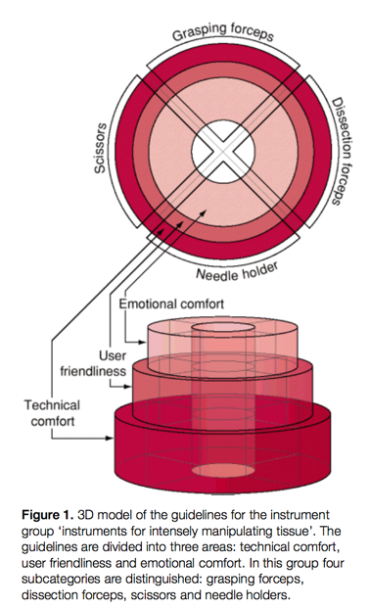
Overall Assessment
So far, only the middle cylinder and dissection forceps wedges have been filled in, and it doesn’t seem as though the group will fill in guidelines for the other tool types. This was published in 2001, and I have not been able to find any more recent papers from the group that continue this model of comfort assessment, so it would seem that they abandoned this idea. This is rather unfortunate, as having specific guidelines for needle holders and/or grasping forceps would be extremely relevant to our work. Also, they state near the end that the guidelines for emotional comfort that they suggested had not yet been validated at time of publishing. Still, the division of comfort into the three categories and the general guidelines for how to assess instruments according to these categories is useful for us to consider during our design iterations. The model also takes into account how sometimes, even if the instrument or equipment is not the best in a technical sense, it still may be preferable to the technically superior option if it is more user-friendly or, in essence, is better liked by the surgeons.

