ReHAP
Rehabilitation Healthcare Analytics Platform
A Johns Hopkins Technology Innovation Center Project

David West
Mentors: Gorkem Sevinc, Michael Cohen, Dr. Krishnaj Gourab, John Adamovich

Computer Integrated Surgery II
Dr. Russ Taylor
Spring 2016
Johns Hopkins University
I. Introduction

Summary
ReHAP is a decision support system for patient rehabilitation teams. The software employs algorithms that help physical and occupational therapists use patient prioritization factors to optimize care. The software is intended to be used by therapy teams at Johns Hopkins Bayview, NYU, and other beta testing institutions in the summer of 2016.
Background and Significance
Owing to an aging American population, the demand for rehabilitation therapy services (RTS) is projected to grow by 26 to 30% over the next decade. While access to appropriate RTS is critical for optimum clinical and operational outcomes, the cost of providing RTS will increase by $7.5 billion (for patients in the hospital) and $32.3 billion (for patients outside the hospital) over the next decade. I am developing a software tool, ReHAP, with a team at the Johns Hopkins Technology Innovation Center and Johns Hopkins Dr. Krishnaj Gourab that will allow hospitals and healthcare systems to successfully manage the costs associated with this projected increase in demand while still delivering appropriate RTS to patients truly in need of such services.
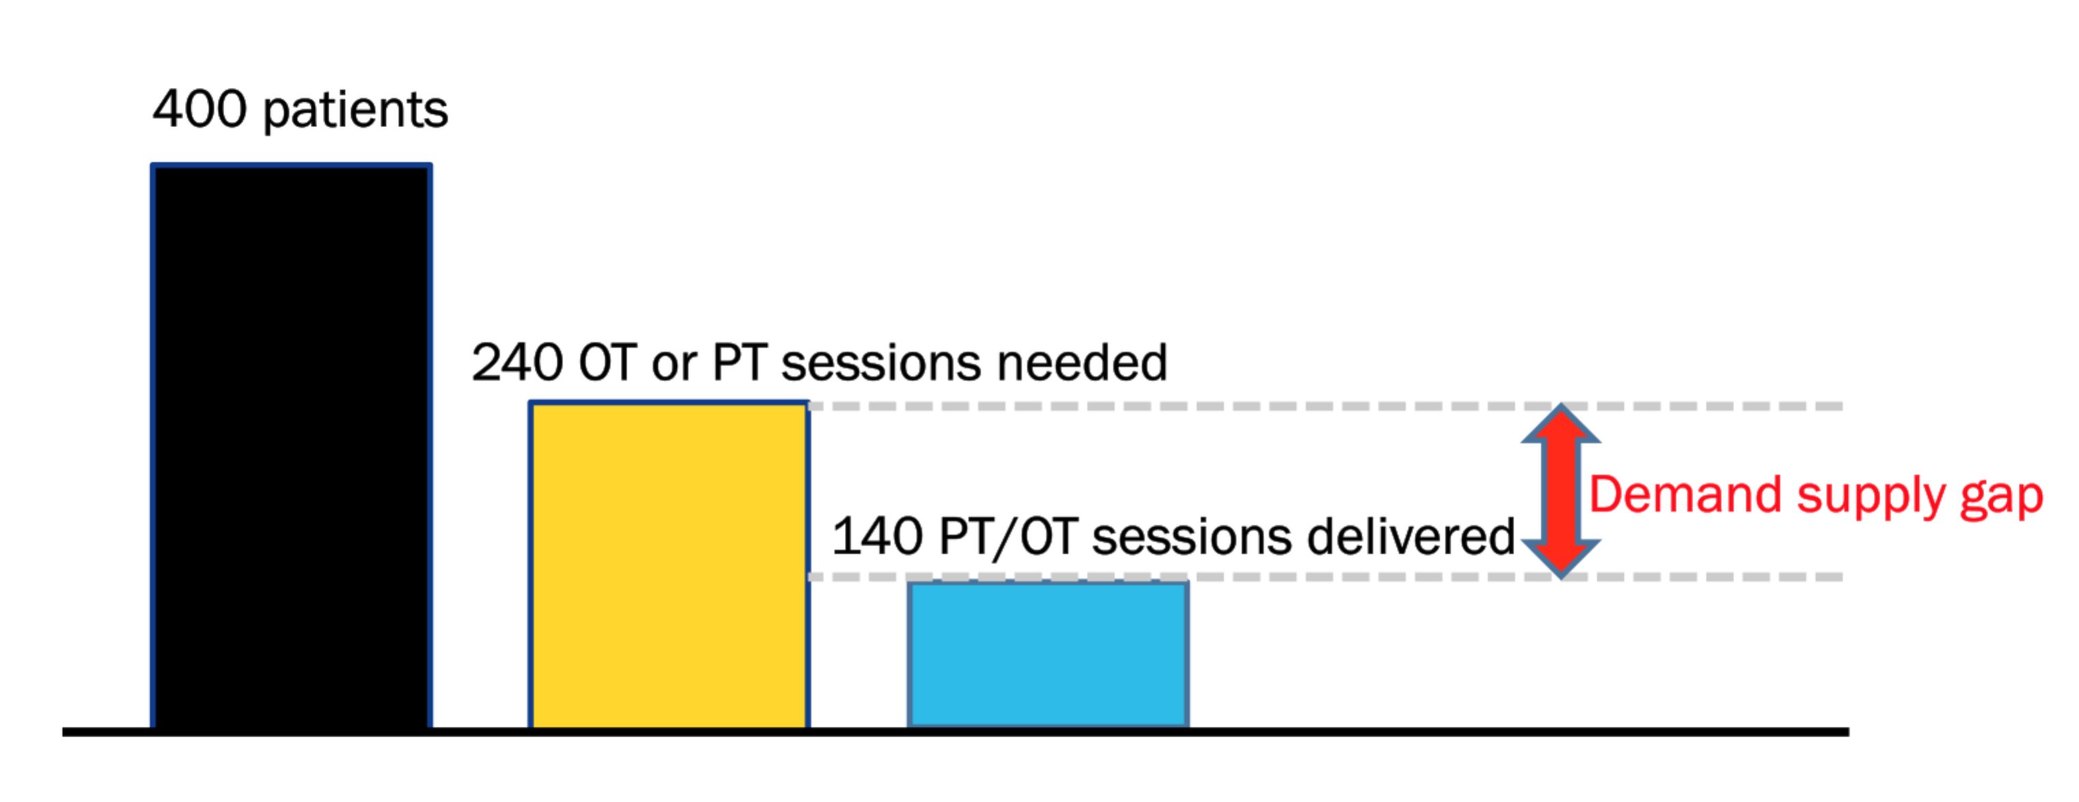

Specific Aims
- Web-based tool
- ReHAP “Priority List” on every therapists’ laptop
- Connect to live EMR (EPIC) data
- Auto refresh every 5 min
- Modes for PT, OT, Manager, Physician
- Instance of application to be deployable on-site
- Simple and seamless to use
II. Technical Approach

Design
Dr. Krishnaj Gourab has design algorithms that can be tailored by therapy managers to make decision support recommendations for patient prioritization, therapist scheduling, and discharge management. Physical or Occupational therapy includes the cooperation of multiple parties, each playing an important role in the patient’s rehabilitation. The nature of the workflow will require that there be critical information available and manageable in the web app by therapists (PT and OT), therapy team managers, and physicians. Thus, a critical component of the design of the system is to have access points and permissions for all of these profiles.
The application will be built using the Ruby on Rails framework. Therapists, therapy managers, and physicians will access private deployments of the system via the browser via a secure connection.

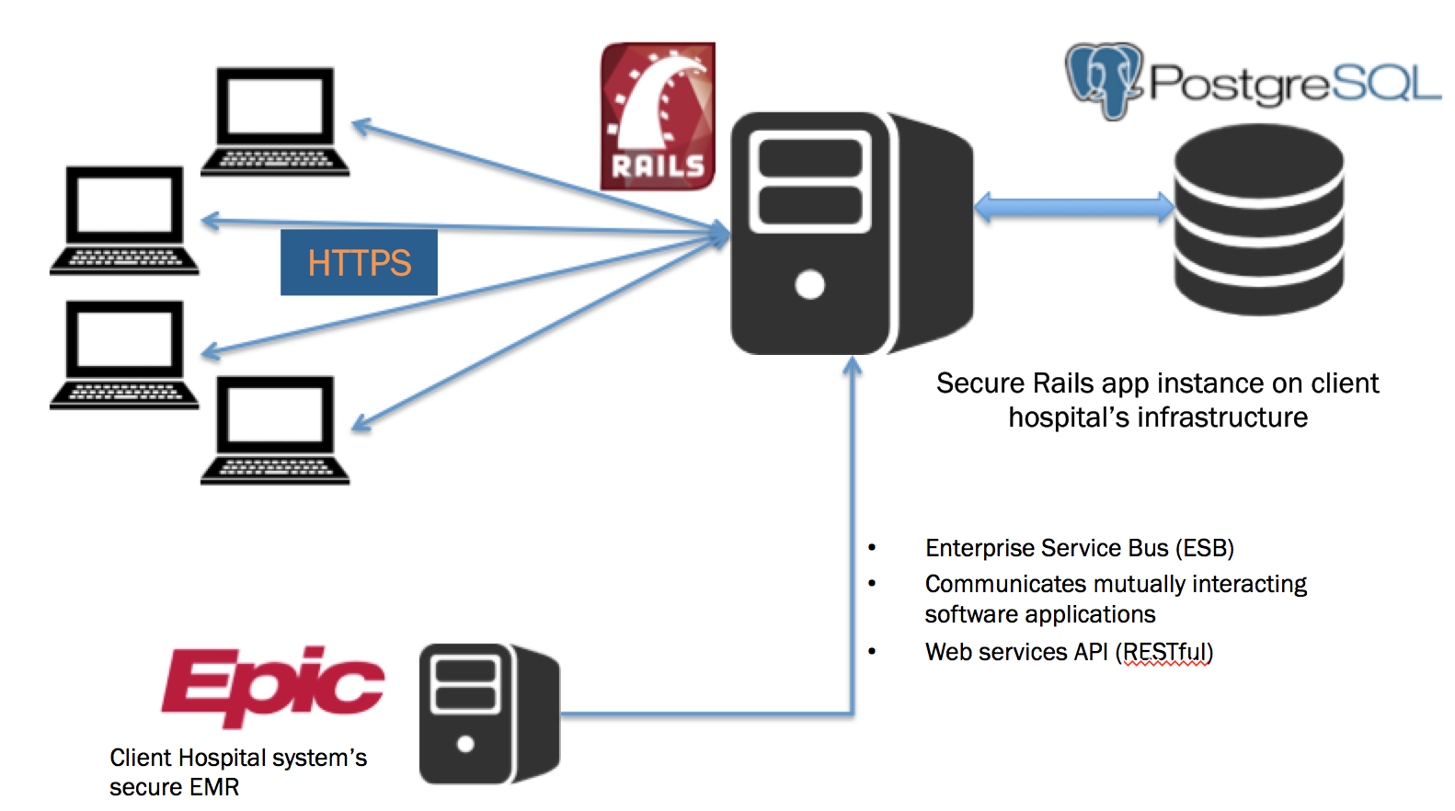
While an initial prototype will be developed by seeding the system with data pulled from EPIC as snapshots, a sustainable system requires a dynamic updating of the database from the EMR system utilized by the institution. EMR systems use a common framework for deploying web applications that utilize the EMR technology stack – namely, the Enterprise Service Bus (ESB). ReHAP will utilize a custom API that will be developed by the Johns Hopkins EPIC Web Services team that will allow <15 minute refresh of data in parallel with the development of the rails app.
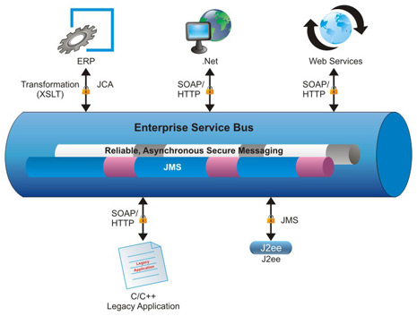
The ReHAP Rails application will be built with consideration for a utilization of the Web Services API.
Resources and Dependencies
- Enterprise Service Bus (ESB) integration
- Cooperation between Web Services
- Secure development environment
- SSL into Hopkins server
- Knowledge of Rails
- PostgreSQL
- JIRA + Bitbucket (SCRUM)
- Cooperation with JHBMC PT/OT team for shadowing
- HIPAA compliance (intermediate certification)
- D3.js for visualization
- Possibly DataTables.js + DTEditor.js
- Weekly team meetings Tuesdays on Hangout and at FF East
- Cooperation with Tony Pan (dev partner)

The development is done on a HARB server (TIC development resource) accessed via ssh on the Hopkins network (VPN if off network). All development must be in compliance with HIPAA standards.
III. Deliverables and Timeline
Minimum
- Rails database populated with seed data from EPIC
- Implemented Rails app framework
- PT/OT view and permissions
- Shadow-informed front-end mockups for all users
- Prioritization algorithm implemented in Rails app
Expected
- Manager view + permissions
- ESB set up and integrated with Rails app
  - Refreshing every 5 mins
- Single-sign-on server configuration
Maximum
- Physician view + premissions
- Deployed app at JHBMC
- Testing by PT/OT teams at JHBMC
- Deployed or configured to be deployed instances at non-JH facilities
Milestones and Gantt Chart
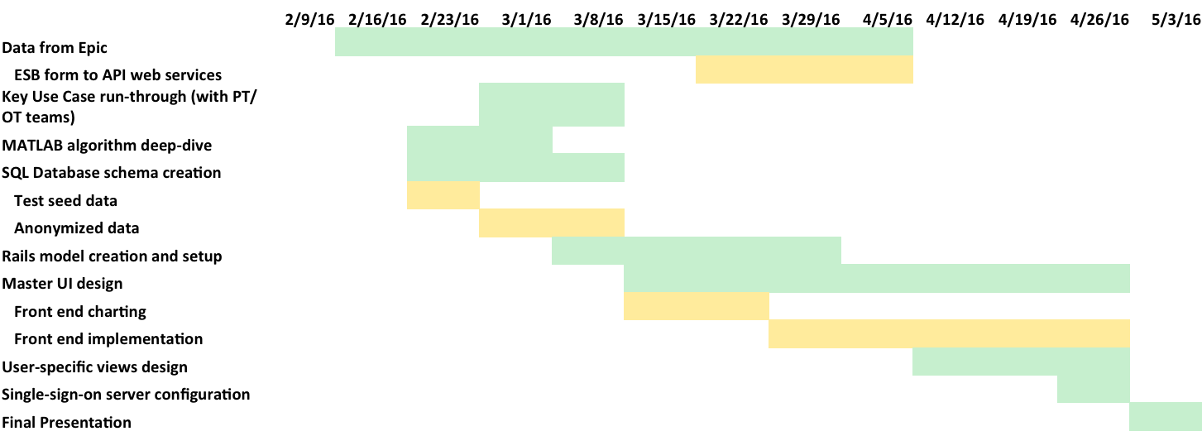
IV. Reading List
Relevant literature is broken into three categories demonstrating:

- Patients deteriorate functionally in hospital, specially elderly patients

- Appropriate rehab therapy can improve mobility, facilitate early discharge from hospital, with improved clinical and financial outcomes
- However, you cannot give therapy to every patient in the hospital – who have been referred for therapy because of current demand for therapists , which is going to further increase due to the aging American population.

4. So we are building a decision support tool for therapist which tells them which patients should be seen as a high priority. Decision support is well entrenched for physicians- we are the first ones to build this for rehab therapy services for in –hospital patients.

See color coded references for the above arguments (from ReHAP MII grant)
1. Physical Therapists : Occupational Outlook Handbook: : U.S. Bureau of Labor Statistics. http://www.bls.gov/ooh/healthcare/physical-therapists.htm. Accessed October 25, 2015.
2. Occupational Therapists : Occupational Outlook Handbook: : U.S. Bureau of Labor Statistics. http://www.bls.gov/ooh/healthcare/occupational-therapists.htm. Accessed October 25, 2015.
3. Sleiman I, Rozzini R, Barbisoni P, et al. Functional trajectories during hospitalization: a prognostic sign for elderly patients. J Gerontol A Biol Sci Med Sci. 2009;64(6):659-663. doi:10.1093/gerona/glp015.
4. Peiris CL, Taylor NF, Shields N. Extra physical therapy reduces patient length of stay and improves functional outcomes and quality of life in people with acute or subacute conditions: a systematic review. Arch Phys Med Rehabil. 2011;92(9):1490-1500. doi:10.1016/j.apmr.2011.04.005.
5. Calthorpe S, Barber E a, Holland AE, et al. An intensive physiotherapy program improves mobility for trauma patients. J Trauma Acute Care Surg. 2014;76(1):101-106. doi:10.1097/TA.0b013e3182ab07c5.
6. Lord RK, Mayhew CR, Korupolu R, et al. ICU early physical rehabilitation programs: financial modeling of cost savings. Crit Care Med. 2013;41(3):717-724. doi:10.1097/CCM.0b013e3182711de2.
7. Shepperd S, Na L, Lm C, Mccluskey A, Id C, Sl B. Discharge planning from hospital to home ( Review ). 2013;(1).
8. Chang F-H, Ni P, Jette AM. Does activity limitation predict discharge destination for postacute care patients? Am J Phys Med Rehabil. 2014;93(9):782-790. doi:10.1097/PHM.0000000000000097.
9. Hoyer EH, Needham DM, Atanelov L, Knox B, Friedman M, Brotman DJ. Association of impaired functional status at hospital discharge and subsequent rehospitalization. J Hosp Med. 2014;9(5):277-282. doi:10.1002/jhm.2152.
10. Fisher SR, Kuo Y-F, Sharma G, et al. Mobility after hospital discharge as a marker for 30-day readmission. J Gerontol A Biol Sci Med Sci. 2013;68(7):805-810. doi:10.1093/gerona/gls252.
11. Chawla H, Bulathsinghala C, Tejada JP, Wakefield D, ZuWallack R. Physical activity as a predictor of thirty-day hospital readmission after a discharge for a clinical exacerbation of chronic obstructive pulmonary disease. Ann Am Thorac Soc. 2014;11(8):1203-1209. doi:10.1513/AnnalsATS.201405-198OC.
12. Real-time Health Monitoring Will Revolutionize Patient Home Care in 2015. http://hitconsultant.net/2015/01/05/real-time-health-monitoring-revolutionize-patient-home-care/. Accessed December 22, 2015.
13. Report: 19 million will use remote patient monitoring by 2018 - MedCity NewsMedCity News. http://medcitynews.com/2014/06/biggest-market-remote-patient-monitoring/. Clinical Decision Support System Market worth $558 Million by 2018Accessed October 26, 2015.
http://www.marketsandmarkets.com/PressReleases/clinical-decision-support-systems.asp

