Material Decomposition using Dual-Energy X-ray of the nView System

Member: Cong Gao

Mentor: Mathias Unberath, Mehran Armand, Russell Taylor

Objectives: Build a learning-based end-to-end multiple material decomposition system using dual-energy X-ray acquisitions by explicitly including the physical constraint in the estimation part.
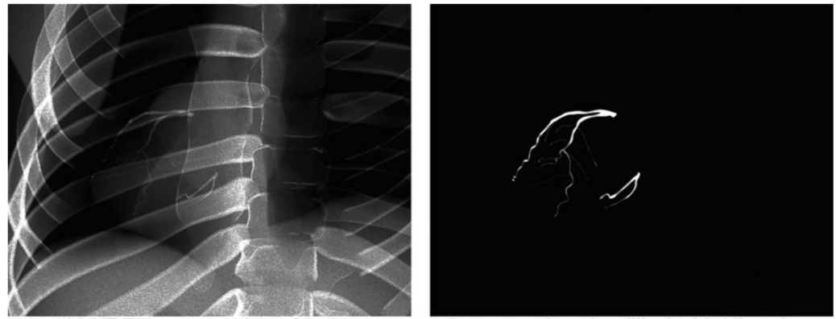
Figure 1 Illustration of material decomposition. Left: Simulated X-ray projection. Right: Decomposed material of interest
Background and Motivation:

Conventional X-ray imaging is not sufficient to characterize object precisely, especially in the aspect of density, material identity, volume thickness, 3D depth of the object, etc. It is then hard for the surgeons to identify Region Of Interest (ROI) using X-rays with multiple material stacked intensities. Thus, there is a need to develop an efficient decomposition system that can separate multiple materials in projection domain.

Taking dual-energy X-ray, which means acquiring two radiographs the same position at two distinct energies, will enable the recover of material density and thickness due to the physics of the X-ray formulation. According to the Beer-Lambert law, $N=N_{0}⋅exp(-μ⋅T)$ , where $N_{0}$ is the number of photons emitting from the source, $N_{0}$ is the number of photons received from the detector. $T$ is the thickness of the material, and $μ$ is the attenuation parameter. After log measurement, $m_{E}=-Log(N/N_{0})=T⋅μ$, $T$ and $μ$ have formulated a linear combination.
Then, in the case of two materials, we can formulate the following linear system with two energy projections, note as $LE$ and $HE$,
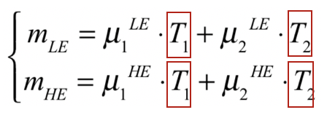
In this scenario, the analytical solution exists, because there are two unknowns for two equations. While in a more realistic situation with multiple materials, and considering energy-dependent attenuation, the measurement will look like
$$m_{\left[E_{1}, E_{2}\right]}\left(r\right)= -Log(\int_{E_{1}}^{E_{2}}{N_{0}\left(E\right)}⋅e^{-\sum_{i}{T_{i}\left(r\right)⋅μ_{i}\left(E\right)}}dE)$$
Then, we have more unknown $T_{i}(r)$ than our measurements. The problem will become mathematically ill-posed. Even in the two-material situation, we are not including noise, disturbances, uncertainties and scatter inside the detector. Taking into account of these factors, the problem is very hard to model and resolve using traditional methods.

Technical Approach:

Thus, we propose to introduce deep learning to build end-to-end prediction framework, by explicitly including the physical constraint in the estimation part.

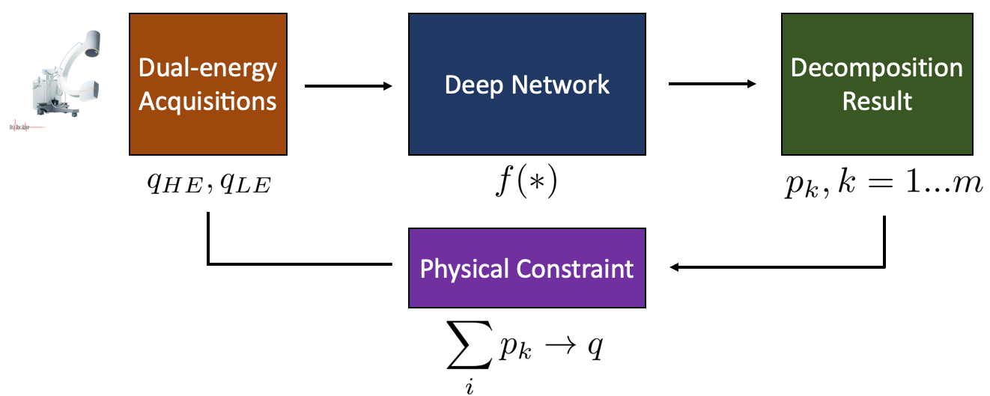
Figure 2. workflow
Figure.1 presents the overall workflow of the proposed pipeline. The input is the dual-energy acquisitions ($q_{HE}$ for high energy and $q_{LE}$ for low energy X-rays). The output is the decomposed projection result $p_{k}, k=1…m$, for $m$ materials. One of physical constraints we want to introduce is that the reconstruction from the decomposition result should be close to the original input, which means $\sum_{k}{p_{k}}→q$. We expect that the network can model the complex mapping function by training on large data samples.

Simulation Study
In order to conduct simulation study, we want to use the recently proposed X-ray simulation framework – DeepDRR, which can perform fast and realistic simulation of fluoroscopy and digital radiography from CT scans by using deep learning. We can also simulate X-ray projections with different energy levels. Another benefit by introducing DeepDRR is that it enables segmentation in 3D domain, including bone, soft tissue and air, which can be used to generate target decomposition projections as groundtruth images for training.

Figure 3 DeepDRR Framework
Simulation study will start from testing on two materials. Iodine is our first target, because it has an obvious K-edge jump in its photon attenuation at around 70keV (shown in Figure. 3), which is a very good feature to do dual-energy decomposition. We plan to first simulate bone injection cement inside the femur, which mainly composes of iodine, and try to decompose it from the other background materials. If it works well, we then plan to test on more complicated situations.
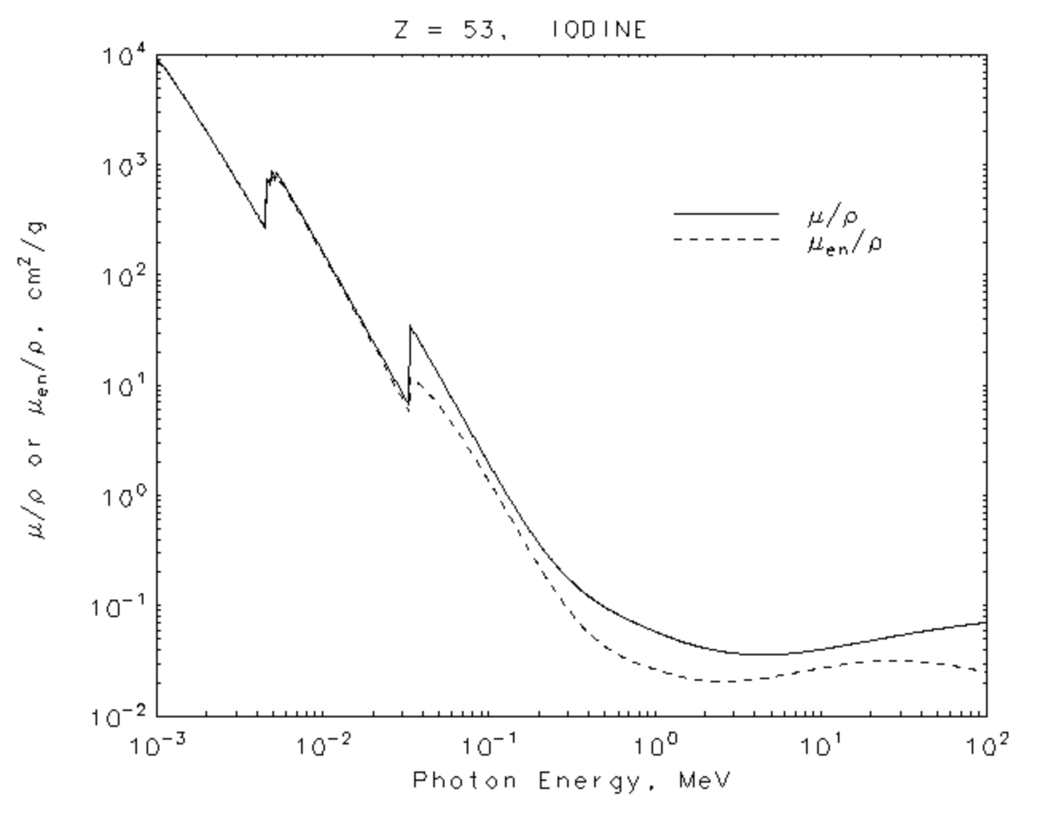
Figure 4 Iodine Attenuation Coefficient

Real X-ray Validation
For Real X-ray validation, we plan to use the nView system, which is a fast 3D reconstruction system using low dose X-ray projections. Because the X-ray projections and reconstruction have correspondence with this system, its 3D reconstruction data can be used to label material groundtruth for validation.
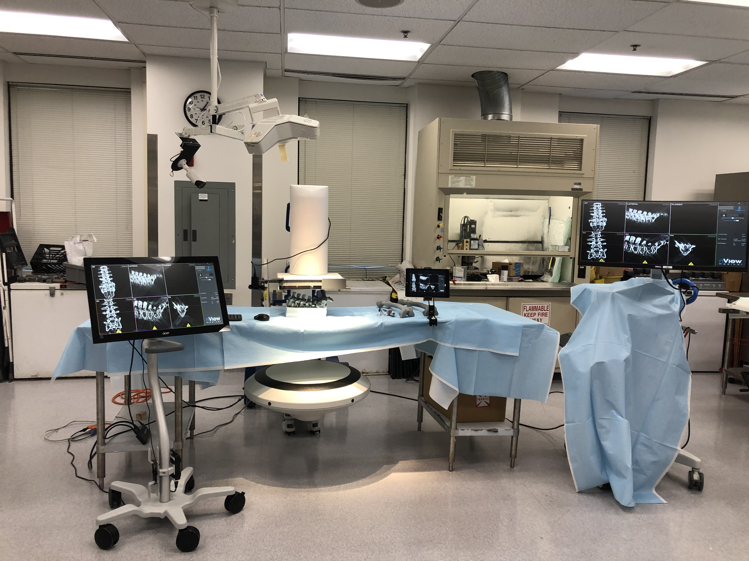
Figure 5 Image captured from the nView system
We plan to use this nView system to conduct femoroplasty injection experiment and collect dual-energy dataset during cement injection process for validation of the proposed algorithm.

Deliverables:
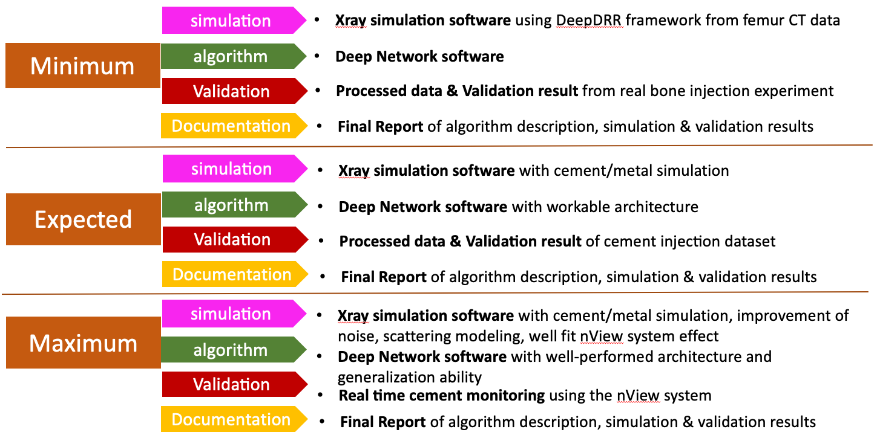
Dependencies:
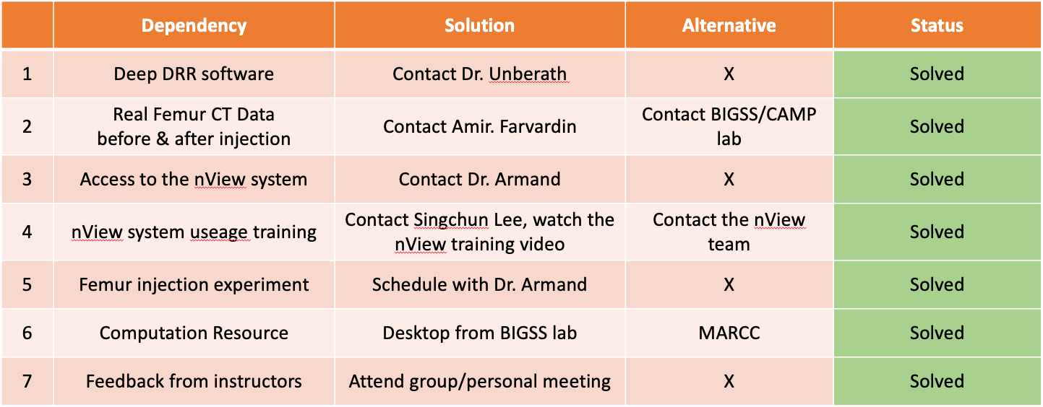

Schedule:
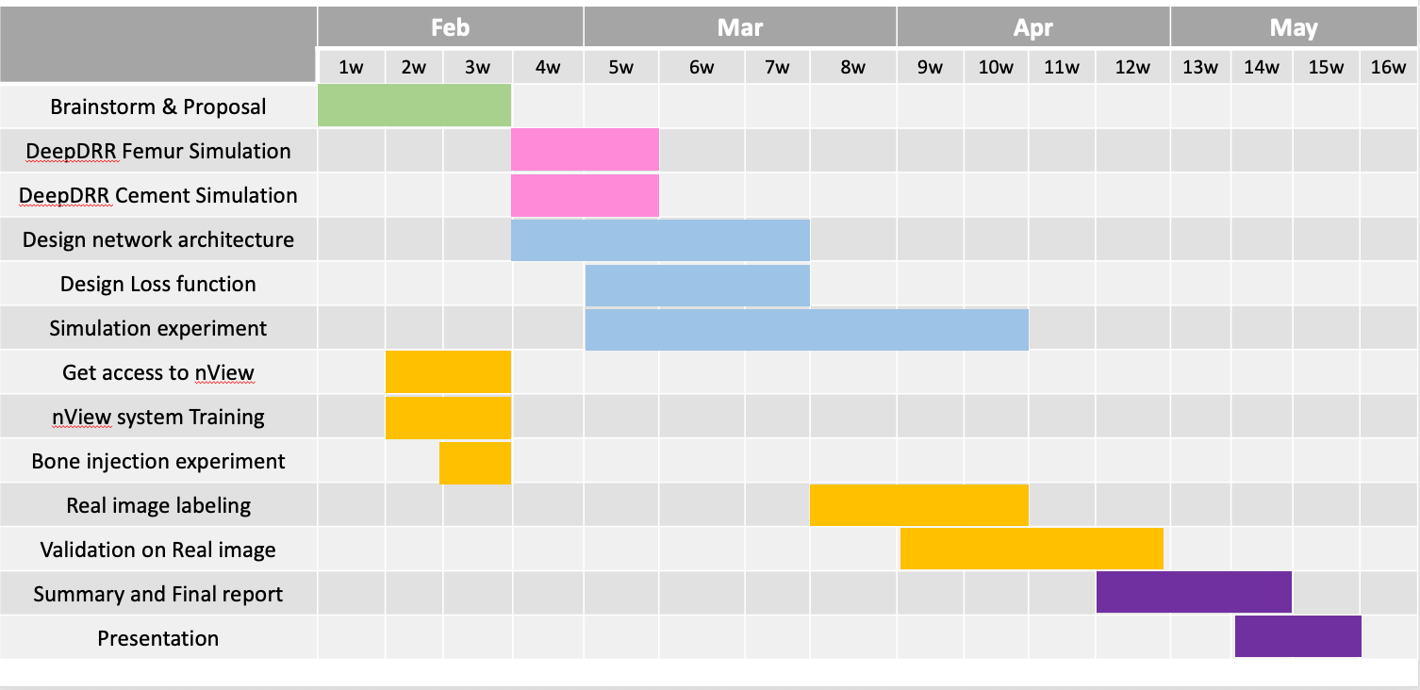

Milestones:
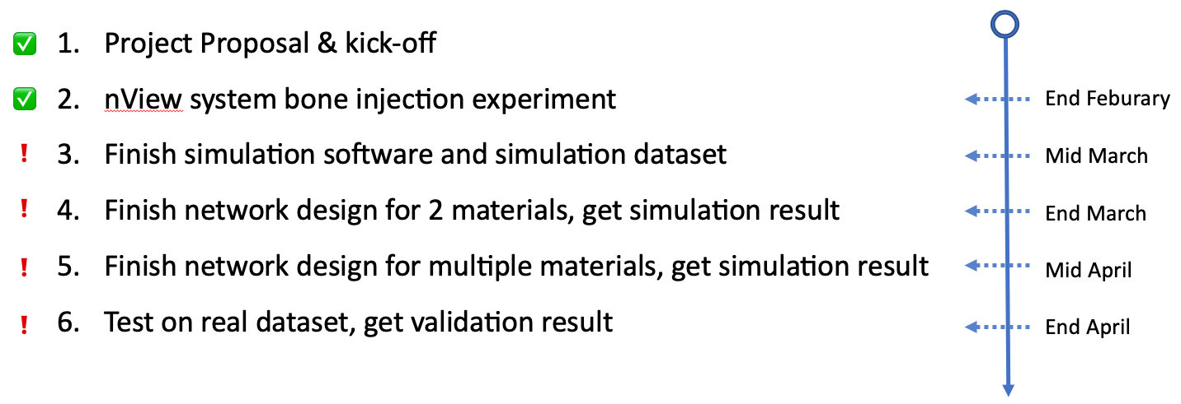

Management Plan:
- Meeting with mentors:
  - Weekly meet with Dr. Armand and Dr. Unberath, Tuesday morning
  - Attend weekly meeting with Dr. Taylor, Friday afternoon
- Data management:
  - Simulation data: save locally on BIGSS desktop
  - Real Xray data: share across BIGSS shared drive
- Software:
  - Save locally under development
  - Publish on github after work is published

Reading List:
- Mazess, R. B., Barden, H. S., Bisek, J. P., & Hanson, J. (1990). Dual-energy x-ray absorptiometry for total-body and regional bone-mineral and soft-tissue composition. The American journal of clinical nutrition, 51(6), 1106-1112.
- Rebuffel, V., & Dinten, J. M. (2007). Dual-energy X-ray imaging: benefits and limits. Insight-non-destructive testing and condition monitoring, 49(10), 589-594.
- Albarqouni, S., Fotouhi, J., & Navab, N. (2017, September). X-ray in-depth decomposition: Revealing the latent structures. In International Conference on Medical Image Computing and Computer-Assisted Intervention (pp. 444-452). Springer, Cham.
- Lu, Y., Kowarschik, M., Huang, X., Xia, Y., Choi, J. H., Chen, S., ... & Maier, A. (2018). A learning‐based material decomposition pipeline for multi‐energy x‐ray imaging. Medical physics.
- Ding, Q., Niu, T., Zhang, X., & Long, Y. (2017). Image-domain multi-material decomposition for dual-energy CT based on correlation and sparsity of material images. arXiv preprint arXiv:1710.07028.
- Atria, C., Last, L., Packard, N., & Noo, F. (2018, March). Cone beam tomosynthesis fluoroscopy: a new approach to 3D image guidance. In Medical Imaging 2018: Image-Guided Procedures, Robotic Interventions, and Modeling (Vol. 10576, p. 105762V). International Society for Optics and Photonics.
- Unberath, M., Zaech, J. N., Lee, S. C., Bier, B., Fotouhi, J., Armand, M., & Navab, N. (2018, September). Deepdrr–a catalyst for machine learning in fluoroscopy-guided procedures. In International Conference on Medical Image Computing and Computer-Assisted Intervention (pp. 98-106). Springer, Cham.

