Development of comprehensive blunt/sharp dissection and energy-cutting models for robotic surgery training

Project Information:
Spring 2014
Computer Integrated Surgery II
Student: Shayer Chowdhury (schowdh8@jhu.edu)
Mentors: Dr. Gyusung Lee (glee59@jhmi.edu)
Final Report
Project #3

Background, Relevance, and Importance:

Robotic surgery is becoming a quickly advancing field and as a result, many learning and practicing surgeons are focusing their training on using robot-assisted surgical devices for an increasingly large amount of procedures. One area that robotic surgeons have expressed a need and desire for is more proficiency in basic blood vessel dissection. Typically, robotic surgeons are well versed in the technique of suture tying and basic general surgery procedures. However, when simulating actual blood vessel dissection, there is much that is left unaddressed. Primarily, the main problem is that current blood vessel dissection phantoms are extremely expensive, costing up to $80 per unit. Additionally, these models can at most be used once or twice at most before the tissue and vessel material are irreversibly damaged. The purpose of this project is then to develop a blood vessel dissection phantom that is cheap, reusable, long-lasting, and easy to make compared to commercial phantoms, but at the same time replicates and exercises the same techniques used in blood vessel dissection as these commercial models do.
The project was broken down into two focus areas. One component surrounded implementing a blunt/sharp blood vessel and tissue dissection simulation and the other centered on a model for electrosurgery training. Further sub-topics included the study of blood vessel histology as well as exploring and experimenting with synthetic biomaterial replication of human tissue and vasculature. Additionally, this project incorporated and required a development of a basic understanding of energy-cutting electrosurgery and electrocoagulation. Upon study of the literature, extensive evaluation and feedback with robotic surgeons was utilized to make changes to the models.

Technical Summary of Approach and Methods:

The goal of this project was to create an inanimate surgical training model for both sharp and blunt tissue dissection as well as blood vessel energy-cutting that is ultimately cheap, effective, potentially reusable, and long-lasting. After gathering the materials used for experimenting with various model prototypes, user feedback from currently practicing surgeons through the Minimally Invasive Surgical Training and Innovation Center (MISTIC) was incorporated to further develop a comprehensive dissection and energy-cutting model for future robotic surgery training.
Our workflow was implemented as below:

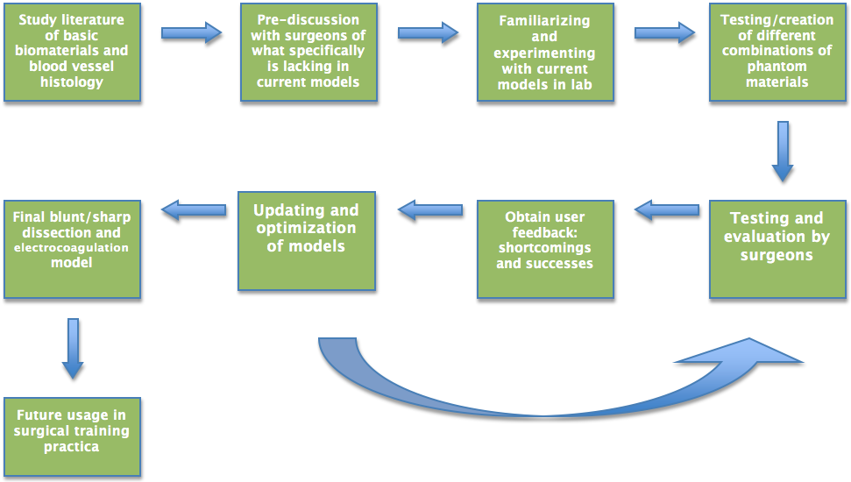

Figure 1: Workflow diagram detailing and outlining series of steps taken during project

For the blunt/sharp dissection model, our technical approach centered on ensuring that the focus of the phantom remained on the realistic simulation of the human tissue and its ability to expose the blood vessels. Before physically experimenting with materials, we discussed possible gels and instruments that would adequately simulate human tissue. We discovered several options based off of literature on ultrasound phantoms. The three types of material we focused on initially were a cotton and rubber band model, a silicone gel model, and a chicken breast model encased in plastisol. The cotton and rubber band model utilized rubber bands to simulate blood vessels, cotton placed around the rubber bands to simulate elastic tissue, and strings threaded through the side of the dish for added required maneuverability. This model seemed to be the most feasible right away. The silicone gel model was a dielectric gel that initially seemed to be a good choice. However, upon constructing it, it was obvious that the gel tore too easily, even just by pressing down on it slightly, so it was not representative of human tissue. The final chicken breast model was a regular, boneless chicken breast encased in plastisol. This model was the least effective because the chicken breast and plastisol would have gone bad and moldy very quickly, which was counterintuitive to our goal of making the phantom reusable and long lasting. As a result, we decided to proceed with the simple cotton and rubber band model. We then proceeded to present this model up for evaluation and testing to different surgeons. Based upon their comments and suggestions, we would then update and make changes to the model.
For the electrosurgery model, the technical approach focused on the ability to ensure the conductivity of the gel and the blood vessel phantoms. After understanding the literature regarding electrosurgery, we spent time finding conductive materials that could still be reused after several tries and extensive damage to the tissue phantom. For this model, we had two major options. One was a porcine gelatin gel model and the other was a similar silicone gel model from the blunt/sharp dissection portion. Both of these models would have silicone tubing embedded into the gels to simulate the blood vessels. Ultimately we proceeded with the gelatin gel model for the same reasons that the fragility of the silicone gel made it a poor choice. The porcine gelatin gel simply proved to be much more durable and representative of human tissue. At the same time, it was cheap and easy to make. We then proceeded to undergo testing and evaluation to understand its reusability. The recipe we used for the initial gelatin gel model followed instructions that were used to create an ultrasound phantom from the same material and is as follows:

- Measure out cold water and pour it into a pot. Every cup of water used will yield 14.44 cubic inches of porcine gelatin.
- Gelatin powder should then be measured out into an empty, dry container at 5 tablespoons of powder per cup of water used.
- Slowly pour the container of powder into the pot of water while stirring the mixture with a spoon. It is very important to avoid combining the water and powder too quickly without mixing, as lumps will form. This will result in an incorrect, immeasurable concentration of the gelatin mixture, as well as an inhomogeneous sample of gelatin.
- After the pot of water and powder are thoroughly mixed, the resulting substance may have the thickness and appearance of grits or mashed potatoes. Regardless of its appearance, one should cover it and heat it to boiling (about 4 or 5 on the lab’s hot plate), stirring the mixture constantly. If it was originally as solid as mashed potatoes, it should form a cloudy, yellowish liquid after being heated to boiling. As soon as it boils, reduce the mixture to a low heat (just below a setting of “1” on the lab’s hot plate), stirring the mixture the whole time to prevent it from being burned.
- With the mixture at a low heat, it should gradually change from a cloudy liquid to a clear one. If any foam is present, skim it from the top with a spoon.
- Pour the mixture from the pot into a curing container. If any bubbles have formed on the surface of the gelatin, use a spoon to move them away from areas where you would want to see the needle.
- With the gelatin mixture contained inside, the curing container should be cooled to about 45°F for about 5 minutes per cup of water used or until the gelatin is very firm.
- If it is removed from the curing container, the gelatin should be covered and stored in a similar environment.
- NOTE: The covered gelatin will “weep” water, or secrete it from exposed surfaces, after it has hardened as much as it can. This will cause its material properties to change within hours if small samples are used or within days if the samples are larger. In addition, because this is a damp, organic product that must be stored in a dark place, it will become moldy if not used soon enough.

In step #3, we would add salt to the water and gelatin powder mixture for additional conductivity when we updated our model. We also embedded the 3mm silicone tubing to act as blood vessels at various depths and layers during step #6. Ultimately, this produced our electrosurgery prototype, which we then proceeded to undergo testing with different surgeons and took their feedback into consideration when making changes.

Results and Significance:

For the blunt/sharp model, after extensive feedback and multiple trials with several different surgeons, we finalized a cotton/Vaseline and rubber band model. The initial comments made regarding our first prototype included:
- For basic and elementary training on how to navigate using the tools, this model seemed sufficient
- However, the cotton “tissue” was still not realistic enough to simulate human tissue; needs to be a bit thicker and resistive
- Still did a good job in training dexterity and maneuvering in a similar fashion to a realistic blood vessel dissection
Upon receiving this feedback, we had the idea of adding Vaseline to increase the thickness and elasticity of the human tissue phantom. We tried this in two different ways: one as a homogenous mixture of cotton and Vaseline with the rubbed bands and string embedded in the mixture and another as a layer of pure Vaseline where the rubber bands would be embedded and a layer of plain cotton on top to represent varying thickness of skin as you dissect deeper. This model simulated the elasticity and thickness of human tissue well, as said by surgeons. The materials used for this model were fairly cheap as well. Vaseline, cotton, string, and rubber bands are all things that can be bought in bulk and stored for extensive amounts of time without “expiring.” When undergoing blunt and sharp dissection, even if the material is damaged, it is easily replaceable and available for multiple usages. The approximate cost for one unit was calculated to be less than $10, which is much cheaper than the $80 commercial phantoms.

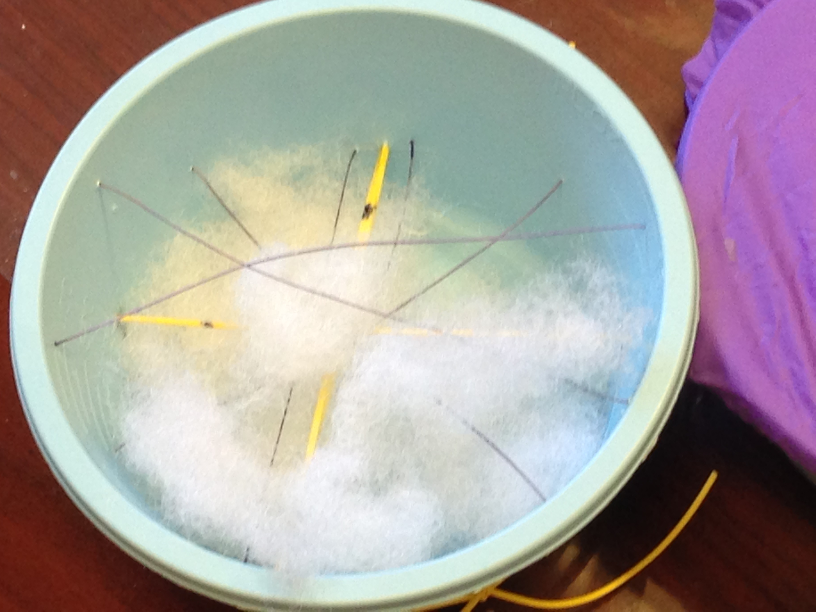

Figure 2: The cotton, rubber band, and string model for blunt/sharp dissection

For the electosurgery model, we used 3mm silicone tubing encased in a conductive gelatin gel/Jell-O substitute mixture. The gelatin gel recipe followed a basic porcine gelatin preparation with added salt for conductivity. The initial porcine gelatin gel tissue phantom did not work primarily due to the fact that it was simply not conductive enough for the current to pass through when electric surgical tools were applied to it. The silicone tubing made sense and was conductive enough, but the focus of this model for the majority of the time was to create a conductive tissue gel phantom. After extensive research, we experimented with a porcine gelatin gel model (recipe above) with added salt to increase conductivity. The current status of this model is that it is much better than our prototype, which was almost entirely non-conductive, but still leaves room for improvement. Nonetheless, the electrosurgical tools were able to be applied and simulated for blood vessel dissection. The burning and damage of the “tissue” seemed to be minimal. The property of the porcine gelatin gel allows it to be re-melted which could potentially allow for repeated use by removing the damaged tissue. However, this may take more trials and more feedback from surgeons. Overall, the materials were also relatively cheap to purchase and construct, although a little bit more expensive than the blunt/sharp dissection model.

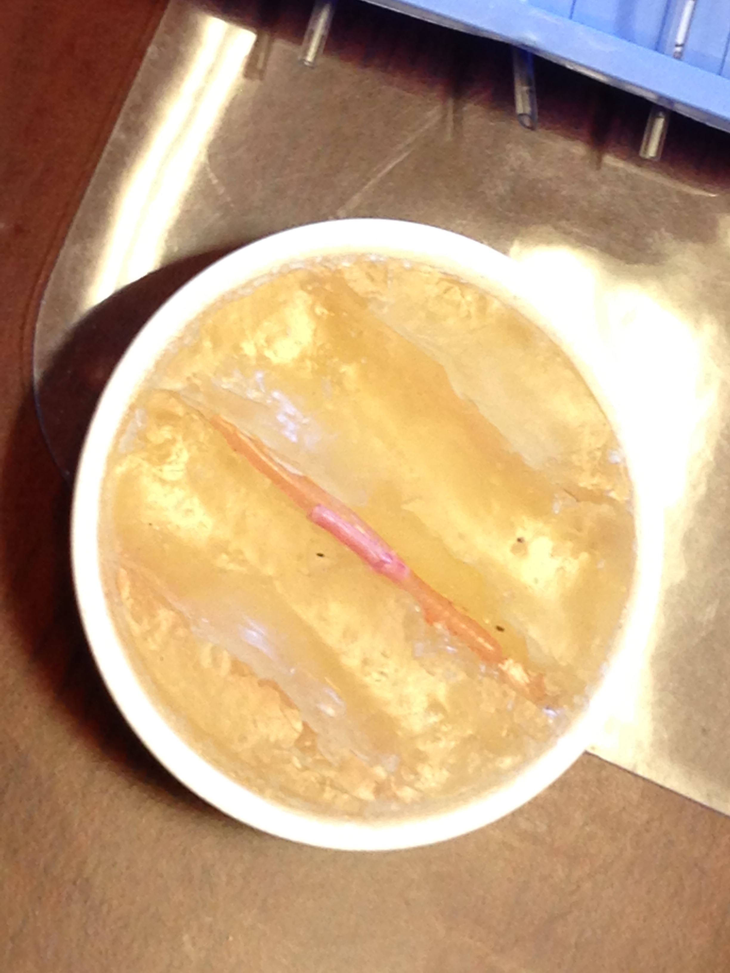

Figure 3: The porcine gelatin gel model for electrosurgery with embedded 3mm silicone tubing

Ultimately, we were able to produce an effective blunt/sharp dissection model that is competitive to commercial models. It uses cheaper materials, is more reusable, and longer lasting than commercial phantoms while still able to exercise the same techniques involved in robotic blood vessel dissection. The electrosurgery model is still a work in progress. We were close to finding an effective human tissue phantom, one that was conductive enough for electrosurgery to take place. However, there is still a lot of room for improvement. Regardless, the materials used were also relatively cheap and the potential for reusability is prevalent as well.

Management Summary:

Accomplished Vs. Planned:

The blunt/sharp model underwent more trials and therefore received more feedback and evaluation than the electrosurgery model. Surgeons commented that the blunt/sharp model did a good job in training dexterity and maneuvering in a similar fashion to a realistic blood vessel dissection. The electrosurgery model was also successful in that the gelatin gel phantom modeled human tissue fairly well and the conductivity of the phantom allowed for the electric current to pass. The materials used were fairly cheap and easy to put together, as we had desired. The approximate price of both models was less than $10 per unit, which is many times more economical than commercially sold models. Surgeons evaluated the models based on their ability to realistically simulate human blood vessel dissection and in comparison to commercially sold products. Given more time, I would have liked to undergo more trials and evaluation for the electrosurgery model, due to the fact that it was delayed since I needed to find an adequately conductive gel material. We met our expected deliverable and were in the process of achieving our maximum deliverable. After finalizing the blunt/sharp dissection model and undergoing more feedback and updating the electrosurgery model, we can perhaps integrate them into surgical curricula for training robotic surgeons, as part of our maximum deliverable.
Future Work:

Had there been more time, one aspect that was left neglected was the electrocoagulation simulation. Blood has coagulative properties when subjected to heat, so it would have been possible to insert some fluid into the vessels that had these properties. However, it was difficult to exactly mimic the viscosity and exact properties of blood, so that would be a route to pursue in the future. Additionally, more testing and evaluation for both models from different surgeons would be excellent, perhaps followed by integration into basic robotic surgery training curriculum. Also, it would be beneficial it find a more quantitative way of comparing these models to commercial versions and showing that these are up to standard. Furthermore, there may even be a potential to mass-produce these models once the exact manufacturing protocol is set and better understood.
What We Learned:

Had I been given the opportunity to redo this project, I would allow for a much larger buffer region time-wise. I realized during the middle of my project that surgeons are busy people and as a result, evaluation took much longer than expected. Additionally, I would have enjoyed working with a partner or collaborating with others to examine more creative ideas and pursuits. Finally, we understood that the field of robotic surgery is extensive and especially with so many surgeons deciding to pursue this area as a focus of specialty, it is important that teaching practica are comprehensive and reflective of realistic and legitimate operating room situations.

Deliverables:

Minimum: Expected date: March 20th
- Blunt/sharp dissection model prototype
- Involves cotton stuffing to simulate the elasticity of tissue and rubber bands to simulate blood vessels
- Cheap and reusable; currently receiving feedback from surgeons and further evaluation and searching for more effective materials
- Status: Achieved

Expected: Expected date: April 1st April 21st
- Modified and improved blunt/sharp dissection model with user feedback and experimentation with other materials
- Electrocoagulation model prototype
- Modified expected date
- Involves silicone rubber tubing embedded in gelatine from porcine skin ordered from Sigma-Aldrich
- Finished extensive evaluation and feedback and searching for more effective additions for electrosurgery model
- Status: Achieved

Maximum: Expected date: May 7th TBD
- Completed blunt/sharp dissection and electrocoagulation models
- Integration into future standard robotic surgery training practicums
- Production and storage of models for future planned usage
- Status: TBD

Dependencies:

Access to mentors
- Weekly meetings with Dr. Gyusung Lee
- Status: Achieved - Weekly meetings on Friday

Access to lab space to create phantom media
- Available lab space at MISTIC at the JHMI (12th floor of Blalock)
- MISTIC will also be used as headquarters and main address for delivery of materials
- Status: Achieved

Cost to afford material
- Material will be fairly inexpensive, since cheap and efficient is our goal anyways
- Dr. Lee is in the process of obtaining a small grant to fund the project
- Attempt to use recyclable lab material
- Status: Achieved - I will buy materials and Dr. Lee will reimburse me

Access to relevant literature
- Articles available online and at the MSE Library
- Status: Achieved

Access to surgeons who are willing to practice on and evaluate the effectiveness of the model prototypes
- Dr. Lee will arrange and work with surgeons at MISTIC who will participate in testing out prototypes and commenting on shortcomings and successes
- Status: Achieved - Still have limited access depending on surgeons' schedules, so modifying expected dates accordingly.

Timeline:

Milestone date: March 7th
- Finish discussion with surgeons regarding current models
- Familiarization with current models and production of phantom materials
- Status: Achieved

Milestone date: March 20th
- Creation of first blunt/sharp dissection model prototype
- Status: Achieved

Milestone date: April 1st April 21st
- Obtain user feedback from surgeons on blunt/sharp model
- Creation of first electrocoagulation dissection model prototype
- Status: Achieved

Milestone date: April 15th May 1st
- Continue modifying blunt/sharp dissection model
- Obtain user feedback from surgeons on electrocoagulation model
- Status: Achieved
Milestone date: May 4th
- Continued modification and optimization of models
- Status: Achieved

Milestone date: May 9th
- Poster presentation and final report
- Status: Achieved

Milestone date: TBD
- Possible paper
- Integration into surgery curriculum
- Completed models
- Status: TBD

References:

- C Schneider, C Kut, N Carter-Monroe, Creation of Ultrasound Elastography Phantoms

- GI Lee, MR Lee, T Clanton, E Sutton, AE Park, MR Marohn, Comparative assessment of physical and cognitive ergonomics associated with robotic and traditional laparoscopic surgeries

- DS Kopac, J Chen, R Tang, A Sawka, H Vaghadia, Comparison of a novel real-time SonixGPS needle-tracking ultrasound technique with traditional ultrasound for vascular access in a phantom gel model

- KB Lawrenson, FO Stephens, The Use of Electrocutting and Electrocoagulation in Surgery

- T Diamantis, M Kontos, A Arvelakis, S Syroukis, D Koronarchis, A Papalois, E Agapitos, E Bastounis, AC Lazaris, Comparison of monopolar electrocoagulation, bipolar electrocoagulation, Ultracision, and Ligasure.

- K Charoenkwan, N Chotirosniramit, K Rerkasem, Scalpel versus electrosurgery for abdominal incisions

- IA Hein, WD O'Brien, A flexible blood flow phantom capable of independently producing constant and pulsatile flow with a predictable spatial flow profile for ultrasoundflow measuremeant validations

- BL Hainer, Fundamentals of Electrosurgery

