Maintenance Manual for the Robotic EndoLaryngeal Flexible (Robo-ELF) Scope

- Review log of last operation and check for problems
- Boot up robot according to user manual but without drape or scope and recalibrate
- Check joystick by testing each of the joystick axes and check that the system moves appropriately.
- Check e-stop by pushing the e-stop button while holding one of the joystick axes and check that the system stops moving.
- Check relay by unpluging the USB cord, which will cause the relay to open, while holding one of the joystick axes and check that the system stops moving.
- Use a multimeter to check that robot case is grounded to earth ground by checking the connectivity between the ground plate in the electronics enclosure and the scope holder enclosure.
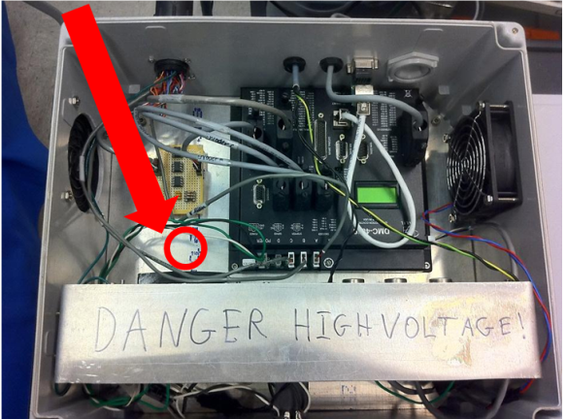
- Remove scope holder enclosure cover and check cover and bearing seals for degradation or any sign of penetration.
    - Scope manipulator bearing seal
    - Cover seal
    - Roll bearing seal
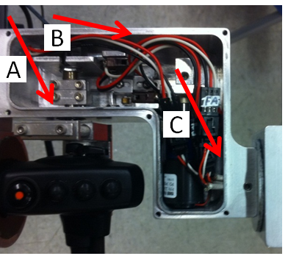

- Remove roll stage enclosure cover and check cover and bearing seals for degradation or any sign of penetration.
- Roll bearing seal
- Arm joint seal
- Cover seal
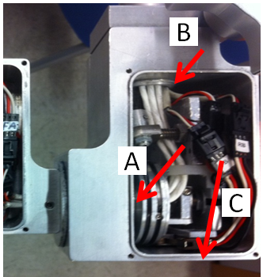
- Remove main enclosure cover and check cover and bearing seals for degradation or any sign of penetration.
    - Arm flange seal
    - Connector seal
    - Cover seal
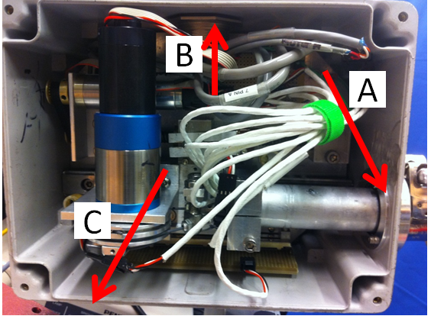
- Loosen elbow locking collar and check friction collar will not move from the influence of gravity with a 10 pound load applied to the rotation stage enclosure. If the joint does move, tighten the friction collar screws until it does not.
- Loosen tilt locking collar and check friction collar will not move from the influence of gravity with a 10 pound load applied to the rotation stage enclosure. If the joint does move, tighten the friction collar screws until it does not.
- Tighten all locking collars and try to move robot with reasonable operating force, and verify that the robot does not move.

