Robotic EndoLaryngeal Flexible (Robo-ELF) Scope User Manual

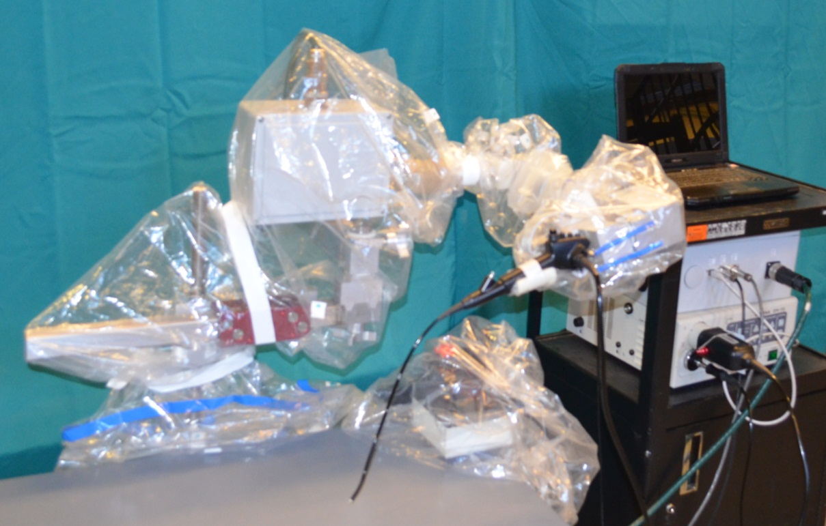
Table of Contents
I. System Overview 3
II. Usage Instructions 4
A. Compatible Scopes 4
B. Set Up Instructions 4
C. Proper Use 20
1. Positioning the Robo-ELF in the OR 20
2. Adjustment of the Robo-ELF Passive Arm 20
3. Controlling the Scope 20
D. Take Down Instructions 23
III. Safety/Emergency Protocol 31
A. Emergency Shutoff Methods 31
IV. Appendix 32
A. Software Messages 32
B. Terminology 35
1. Components 35
2. Grippers 37
3. Drapes 38
4. Cords 38
C. Passive Joints and Adjustment 40
1. Knobs/joints 41
2. Robot Positions and Configurations 42

System Overview
The Robotic Endo-Laryngeal Scope (Robo-ELF Scope) is a robotic system for the manipulation of unmodified clinical flexible endoscopes (Fig 1). It is designed to improve precision, coordination, ergonomics, and surgical capabilities when using flexible endoscopes in the operating room for visualization of the upper airway. The system includes a robot which is mounted to the rail of the operating table with a passive positioning arm, a joystick controller, a standard clinical flexible endoscope, an electronics enclosure, and a control PC. The robot and joystick are designed to be draped for easy cleanup. The robot is slow moving with limited range of motion, and incorporates several redundant layers of hardware, electronic, and software safety features. The tip and shaft of the endoscope, which is already approved for clinical use, are the only parts of the system that contact the patient. The Robo-ELF can be operated with one hand using its joystick, enabling steady, precise positioning of the scope tip with no fatigue or hand tremor. The Robo-ELF Scope enables manipulation of a standard flexible endoscope in three degrees of freedom: tip flexion, scope rotation, and insertion/extraction. Each degree of freedom is controlled by an independent joystick axis, providing simple, direct control of the scope. In the event of an emergency, the scope can be quickly removed and the robot arm swung out of the way, providing direct access to the patient in seconds.

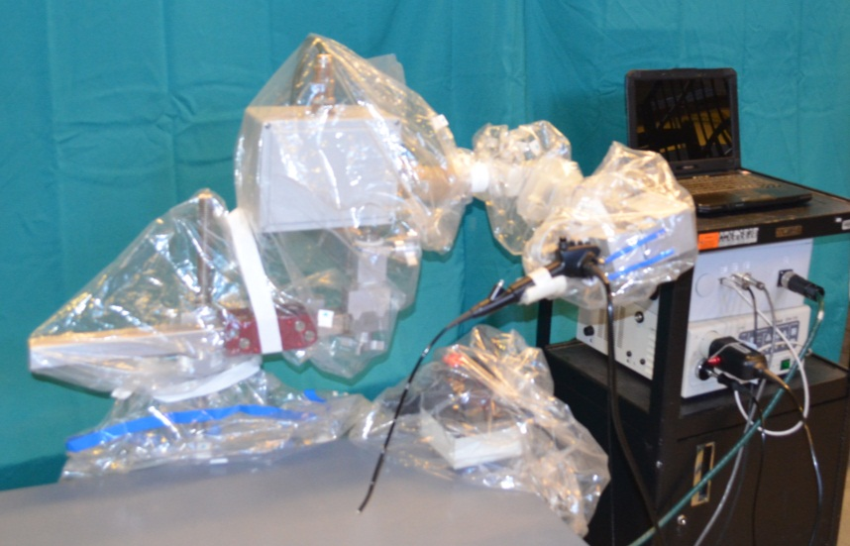
Figure 1: The Robo-ELF Scope

Usage Instructions

Compatible Scopes

The following list of scope(s) has been approved for use with the Robo-ELF Scope system. Use of unlisted scopes is prohibited.
- PENTAX VNL-1570STK naso-pharyngo-laryngoscope

Set Up Instructions

- Remove cover from cart

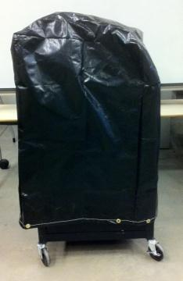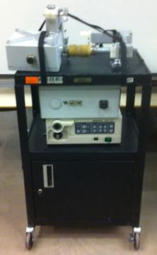

- Remove the three straps (A, B, C) securing robot
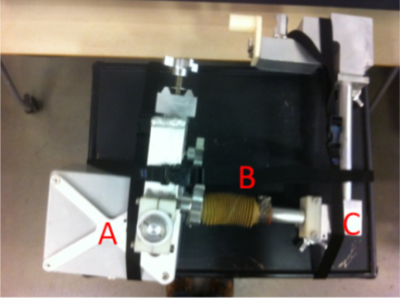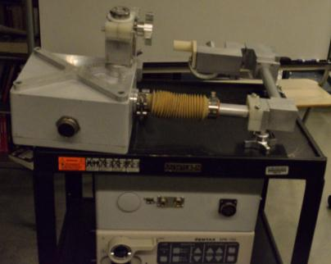

- Remove the support arm shaft from the cart
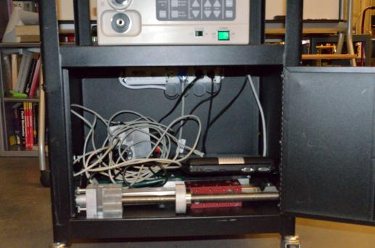
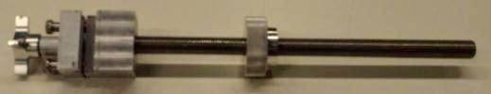

- Align support arm shaft gripper with bed rail and slide it along the bed rail until the desired position is reached. Tighten the knob to secure the gripper in the desired position.
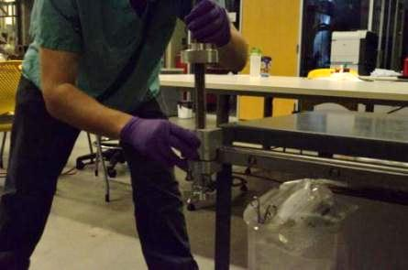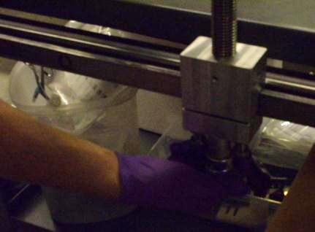

- Grab the support arm shaft at the top of the threaded rod and try to move it back and forth to test the strength of the connection. If the tip of the rod moves more than 1cm, tighten the handle further.
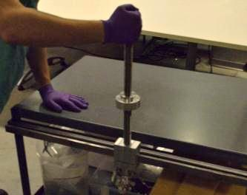

- Remove the support arm from the cart
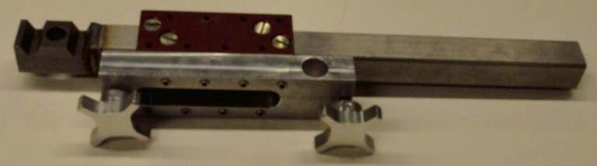

- Adjust the height adjustment knob until the desired height is reached
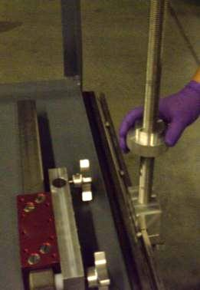

- Place the support arm onto the support arm shaft
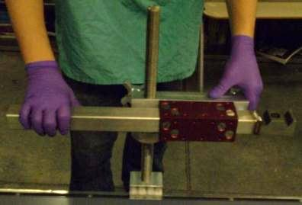

- Tighten the support arm knob to secure the support arm onto the support arm shaft
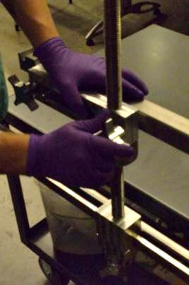

- Remove the robot attachment knob and washer from the robot on the cart
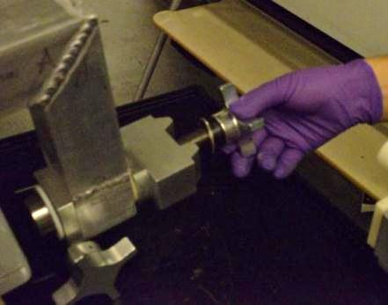

- Pick up the robot from the cart as shown and place it in adjustment position on the support arm so that the attachment shaft on the robot passes through the hole in the support arm.
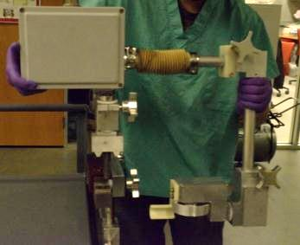

- Loosen the elbow knob of the robot and rotate the robot arm 180 degrees away from the support arm so that it is in the upright position, then retighten the knob.
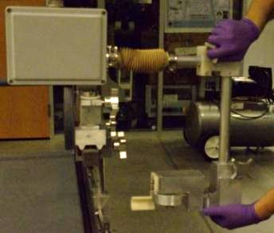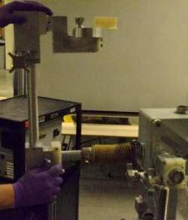

- Lift the robot off of the support arm and place it back on the support arm in operating position (rotated 90 degrees from adjustment position)
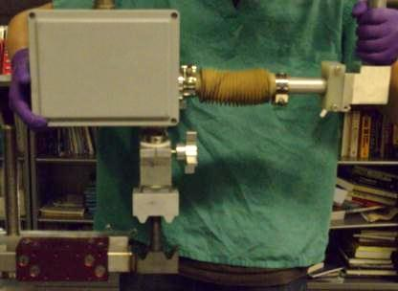

- Screw the robot attachment knob and washer back onto the robot and tighten fully
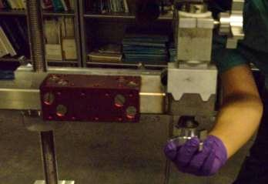

- Loosen the elbow knob and rotate the robot arm into ready position. Press down on the arm to make sure the friction collar will not allow the arm to fall.
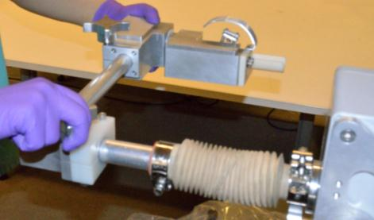

- The robot should appear as pictured.
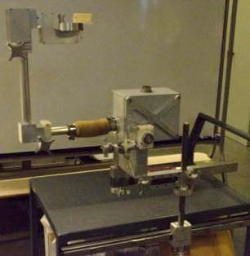

- Tighten all of the knobs to ensure that the robot is secure
- Remove the joystick from the cart and unfold the joystick arm by loosening the joystick adjustment knob, positioning the joystick arm, and retightening the knob.
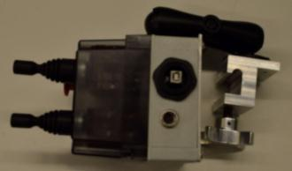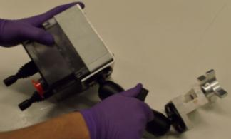

- Align the joystick gripper with the end of the bed rail and slide the joystick along the bed rail to the desired position (loosen the joystick gripper knob if needed to slide it onto the rail). Tighten the joystick gripper knob to secure it in place.
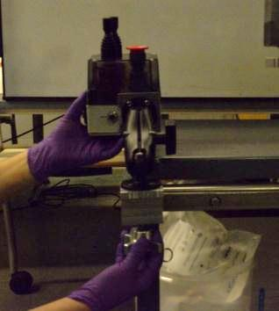

- The system should look as pictured
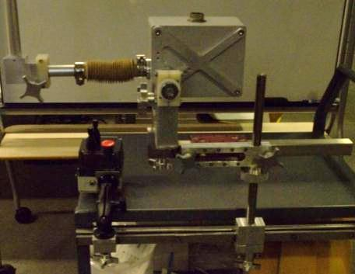

- Take the robot cord out of the cart and plug the metallic end into the robot, twisting the end of the connector to lock it in place.
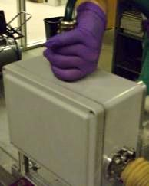
- Plug the plastic end into the robot box. Twist the end of the connector to lock it in place.
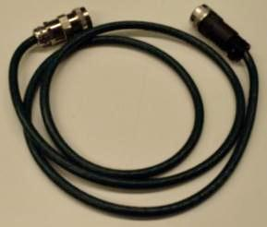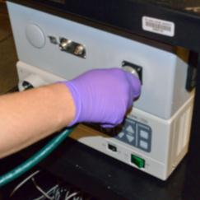

- Take the joystick power cord out of the cart and plug it into the joystick and robot box, turning the end of the connector to lock it in place.
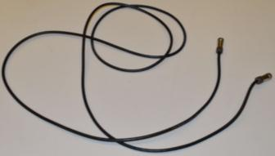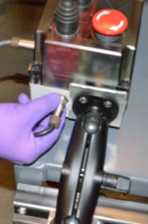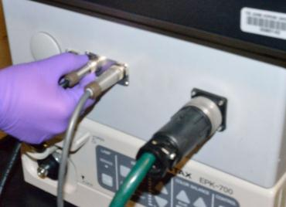

- Take the joystick signal cord out of the cart and plug it into the joystick and robot box, turning the end of the connector to lock it inplace.
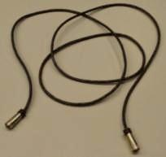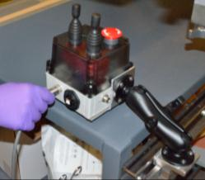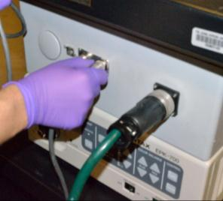

- Take the laptop out of the cart and place it on top
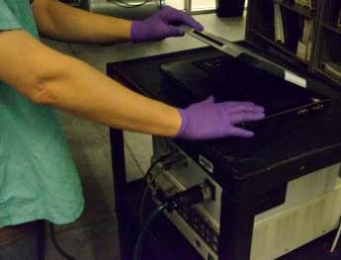

- Feed the laptop power cord through the cable feed-through holes in the cart and plug it into the laptop
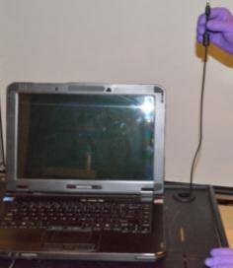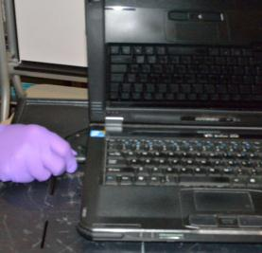
- Take the USB cord out of the cart and plug it into the laptop and joystick, screwing in the joystick end to secure it.
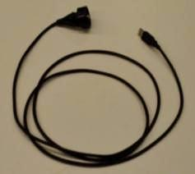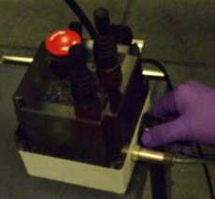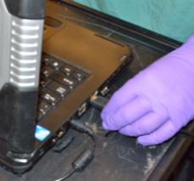

- Take the Ethernet cord out of the cart and plug it into the robot box and the laptop, making sure to feed it though the cable feed-through hole on the cart’s upper level
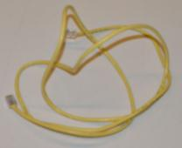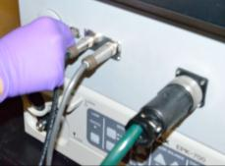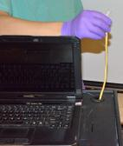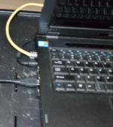

- Check that the robot box, scope box, and laptop are all plugged into the internal power strip inside the cart
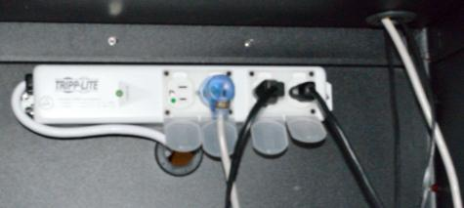

- Close the door on the cart
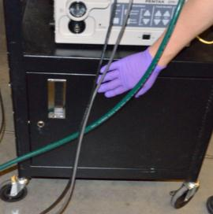

- Place the joystick cords behind the joystick adjustment handle
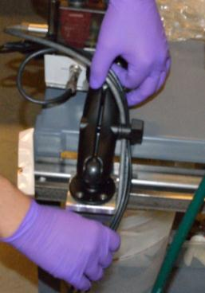

- Remove one joystick drape from its package and place it over the joystick until the elastic band in the drape is around the joystick cords below the joystick gripper
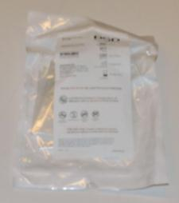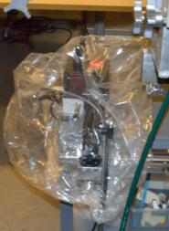

- Put the robot arm into ready position
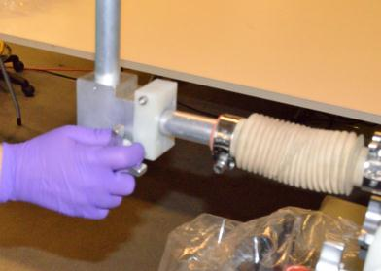

- Open and unfold the robot drape
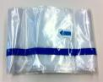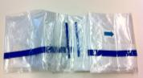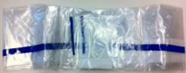

- Slide the drape over the robot beginning at the scope holder
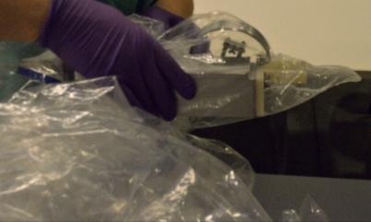

- Fold the drape tip into the scope holder
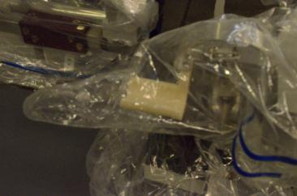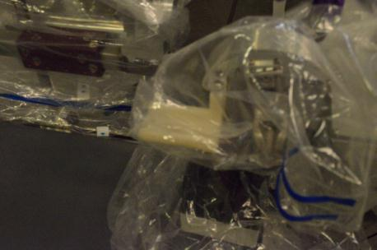

- Adjust the drape over the scope holder so that it appears as shown
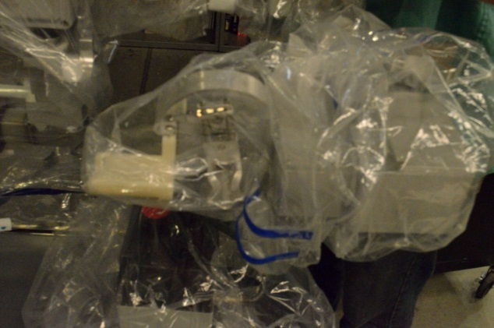

- Tighten the four white tape strips around the drape as shown, making sure to leave enough room for each knob to turn
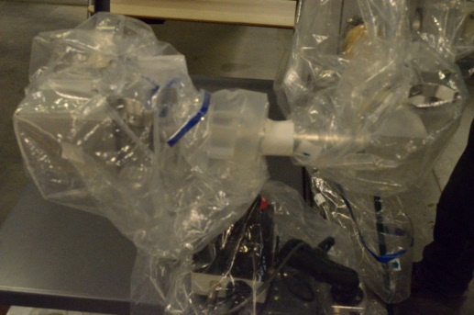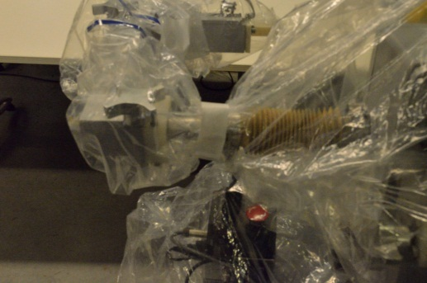
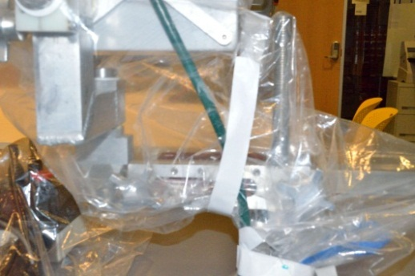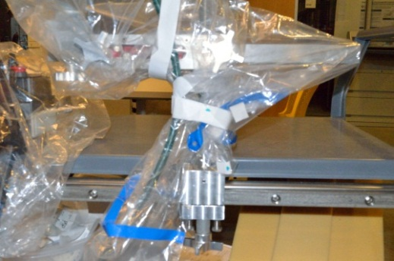

- Connect the scope control box to the video display according to the instructions for the scope and display.
- Inspect the scope for any surface marring that could compromise sterility. Only un-marred scopes should be used.
- Plug in the scope’s video feed and light source cables to the scope control box
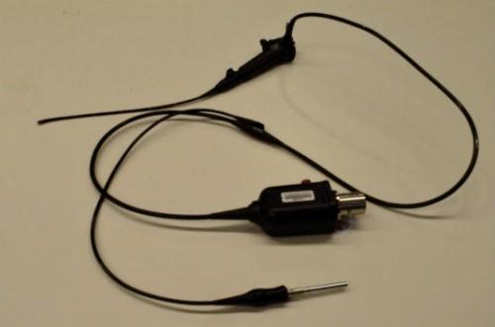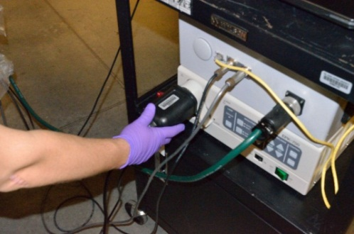

- Use silk tape to attach the scope onto the scope holder so that the scope’s handle axis is aligned with the scope handle manipulator’s axis on the robot. Make sure that the scope handle is well seated inside the scope holder. Run the scope cables in front of the joystick box on the operating table and underneath the robot’s arm, place the scope within the clasp, being sure that the axis of rotation of the scope lines up with the groove of the rotation of axis of the robot’s arm. See figure.
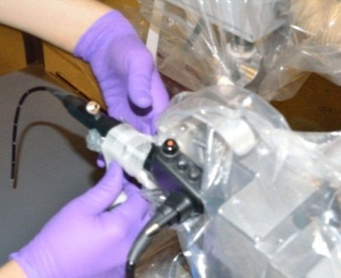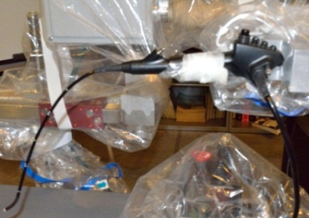

- Plug the main power cord on the cart into the wall socket

- Turn on the robot box and scope box
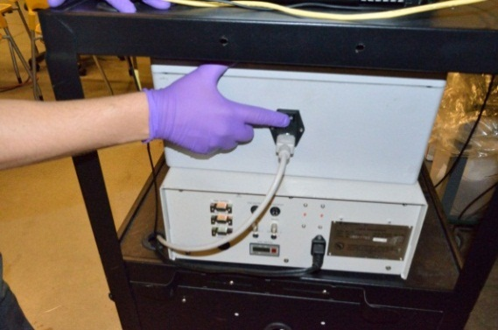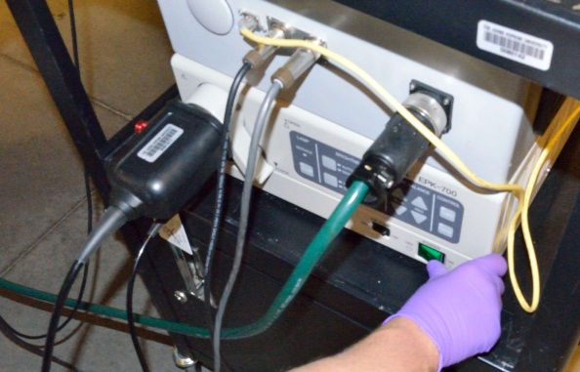

- Turn on the computer
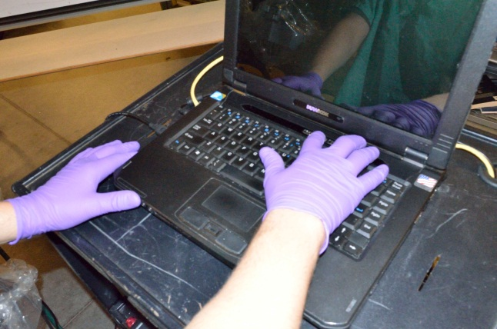

- Boot the computer into Ubuntu(First option on boot list)
- Run the program by double clicking the Run RoboELF icon on the Desktop
  - Select the “Run in Terminal” option on the popup menu
  - You may be prompted to enter the admin password(Robot)
- Enter ‘y’ and press <Enter> to continue when prompted.
- The following menu will be presented to select the desired calibration option:
“Do you want to:
[1] Normal Recalibration
[2] Load Previous Calibration From File”

Enter the number in brackets([ ]) and press the <Enter> key to make a selection.

Option [1], “Normal Recalibration”, should be used in most situations. This will run the robot through its full range of motion to build calibration tables for each axis. The new values are checked to make sure they are close to expected values.

Option [2], “Load Previous Calibration From File”, will reload the most recent calibration table that is stored on file. This option should only be used in the event of a quick restart during an ongoing procedure. It should only be used if the system has not encountered encoder errors prior to shut down, and then only if it was already calibrated successfully at the start of this procedure.
- Stay clear of the robot while it performs automatic calibration routines. It will move through its full range of motion. DO NOT touch the robot or impede its motion during this time. When automatic calibration is complete, the system will display the message “Calibration Successful”. If the calibration failed for any reason, it will display an error message. See Appendix for an explanation of error codes.
- When calibration has successfully completed, the system will display the message “RoboELF Ready for Use”.

- Put the robot into upright position in preparation for bringing in the patient
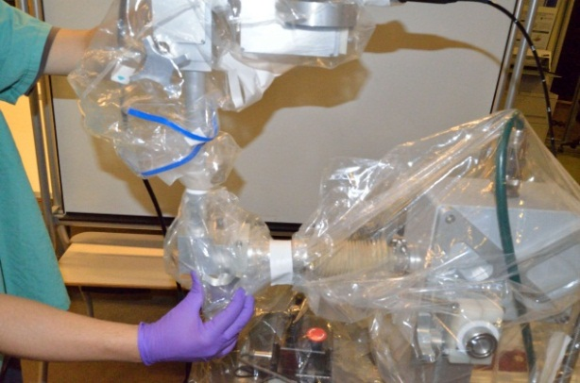

- Let the OR staff transport the patient to the OR, administer anesthesia, and suspend the patient with the laryngoscope

- Once the patient is ready, the system should look as pictured
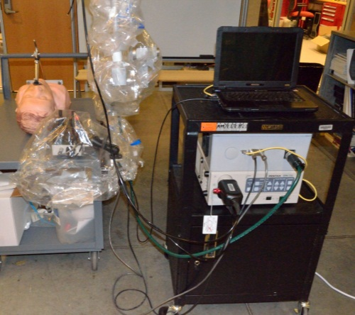

- Put the robot into ready position
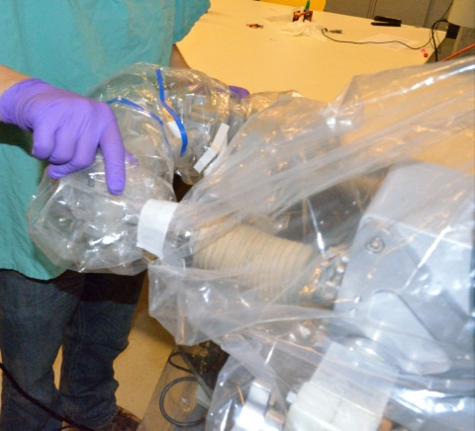

- Adjust passive degrees of freedom so that scope shaft points down laryngoscope

- Put scope into laryngoscope
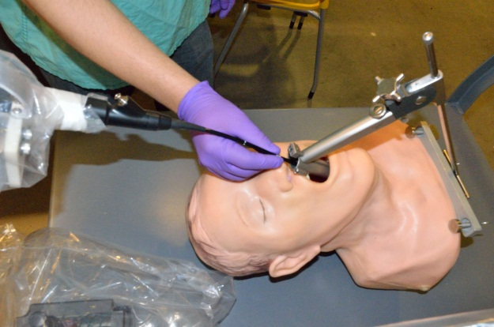

- Adjust passive degrees of freedom so that view is optimized. See Appendix Section IV.C for details on adjusting passive degrees of freedom.

Proper Use

Positioning the Robo-ELF in the OR

The figure below shows the recommended positioning of the Robo-ELF Scope relative to the other equipment in the OR.

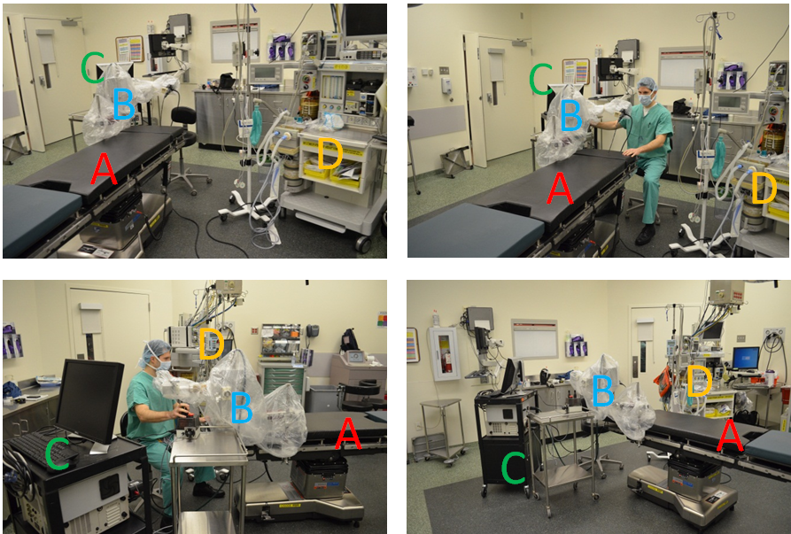
- Surgical Bed B) Robo-ELF robot C) Robo-ELF cart D) Anesthesia cart E) (not shown near the foot of the bed) AV cart with scope screen display

Adjustment of the Robo-ELF Passive Arm

The Robo-ELF passive arm may be adjusted during the procedure if necessary. See Appendix Section IV.C for details on adjusting passive degrees of freedom.

Controlling the Scope

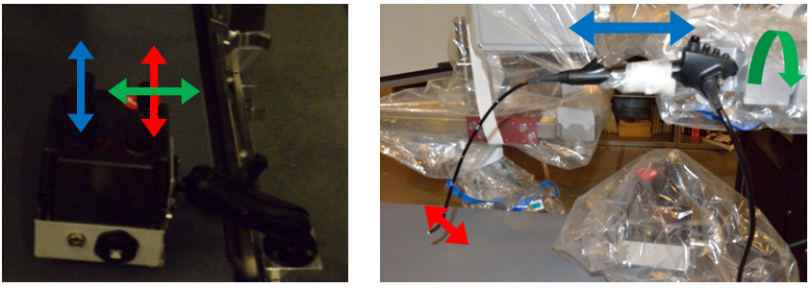
The Robo-ELF Scope system controls the endoscope with three degrees of freedom: bending of the scopes tip using the scope handle (RED), rotation of the scope about its axis (GREEN), and scope insertion/extraction (BLUE). These degrees of freedom are actively controlled by the joysticks. The joysticks should be operated as on-off switches in that once they move far enough passed a threshold position, the robot will begin to move. Once the joystick is passed the threshold where the robot starts moving, moving them further will have no additional effect. Because of the on-off nature of the joysticks, the best way to move the robot a small distance is to tap the joystick quickly. Also, once the joystick passes the threshold, the speed of the robot ramps up over the course of one second, so initially the robot will move slowly. Since the joysticks act as on-off switches, they should never be operated by moving them very slowly over the threshold position. It is also important not to use more than one joystick at once since this makes control more difficult.

Safety Tips
- Be careful to lock knobs and adjust passive joints carefully to avoid unwanted movement.
- Be careful of the position of cords to avoid cord tangles. This particularly important for the scope cord, especially when putting the robot into upright position.
The RoboELF GUI window displays the current status of the robot. The current position of the axes are shown in three formats, a graphical representation as a dial or slider, the current encoder count of the axis motor, the current analog output value of the axis potentiometer. The graphical display will be most useful during procedures. The others are more useful for maintenance of the system. The scope tip and rotation axes are represented by circular dials with tip motion on the far left and rotation in the center. Insertion/extraction is represented by a vertical slider on the right of the window. The dials and slider will move along with the robot, illustrating where in its range of motion the robot currently is.

Motor limit indicators are also shown on the GUI. The limit indicators display one of three symbols. When an axis has reached a software or hard limit, it will not move any farther in that direction.
- “-“ indicates free to move.
- “S” indicates software limit reached.
- “H” indicates hard limit reached.
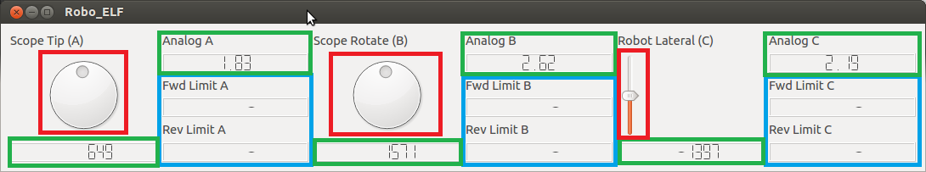

The areas highlighted in RED are the graphical current position indicators. The areas highlighted in GREEN are the text value position displays. The areas highlighted in BLUE are the forward and reverse motion limit indicators.

Take Down Instructions

- Remove scope shaft from laryngoscope
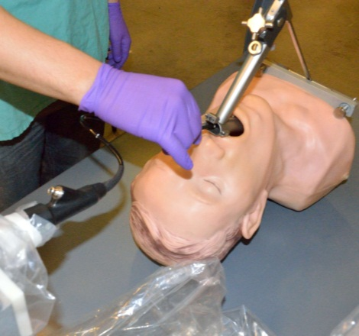

- Put the robot into upright position
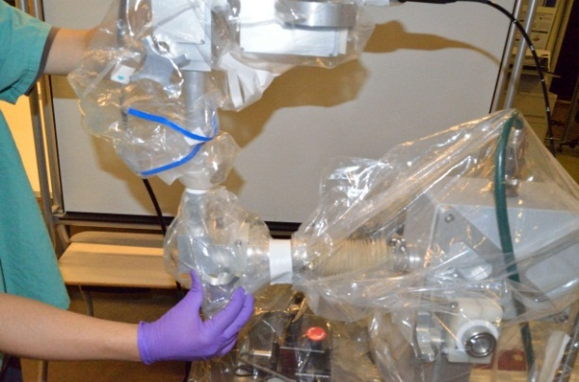

- Let OR staff attend to the patient to remove the laryngoscope and transport the patient out of the OR

- Put the robot into ready position
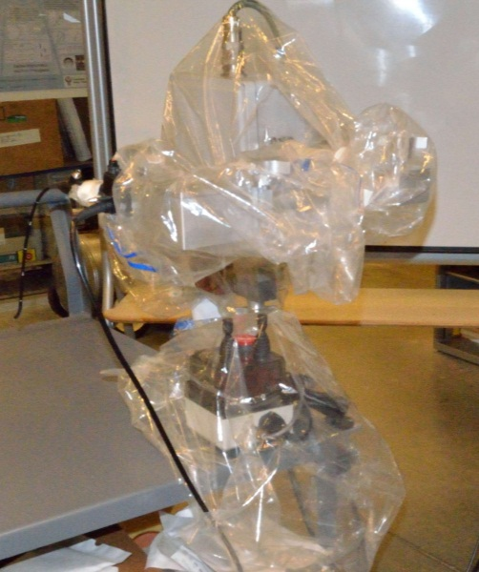

- Turn off the scope box, unplug the scope from the scope box, and un-tape the scope from the robot
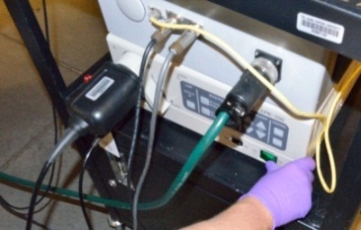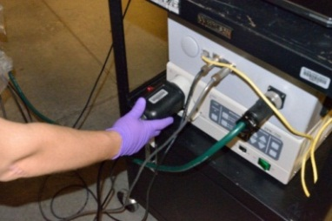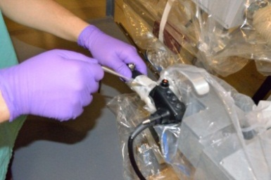

- Check the scope for any surface marring and send the scope for reprocessing according to its instructions.

- Click the close “x” on the GUI window. The message “Shutting Down” should be displayed on the terminal prompt. Before shutting the system down, ensure that none of the axes are in contact with a hard limit as this may cause improper calibration on restart.
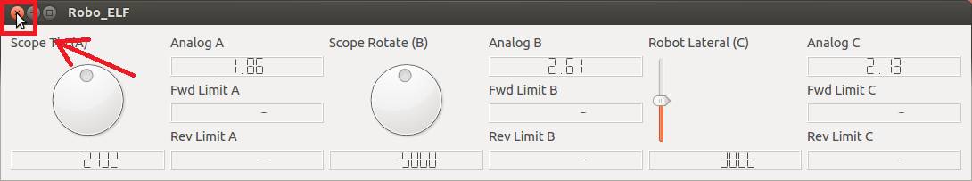

- Turn off laptop and robot box
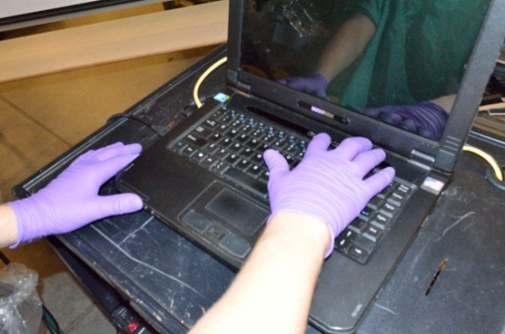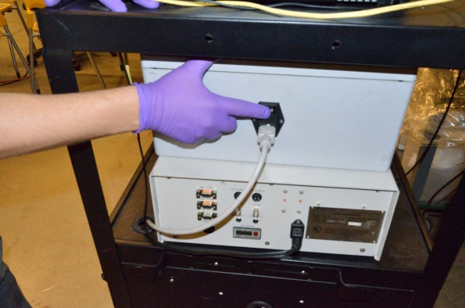

- Unplug and roll up cart main power cord

- Unstick all four white adhesive strips on robot drape
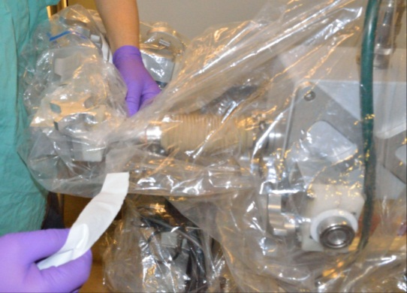

- Unroll the drape from the robot so that it turns inside out, taking care that the outside of the drape does not contact the robot. Dispose of the used drape.
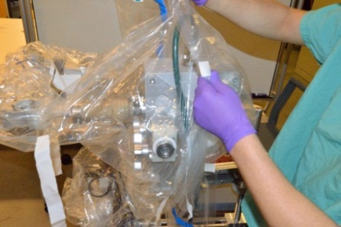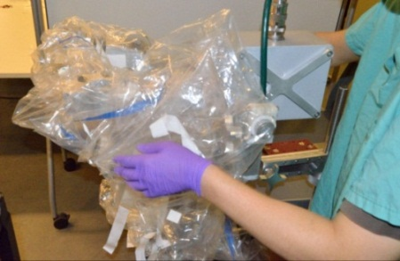
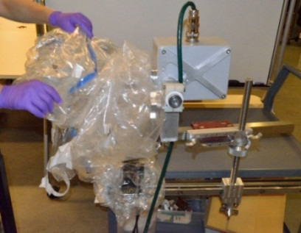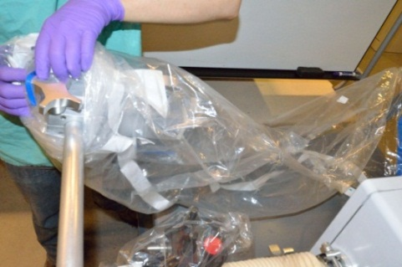
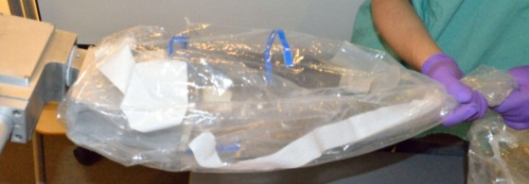

- Put the arm upright
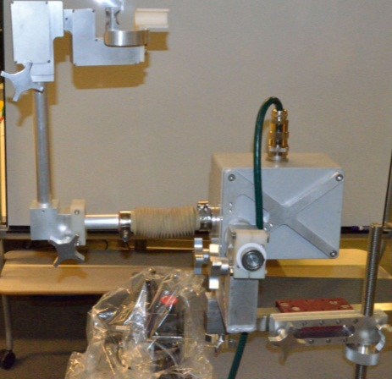

- Unroll the drape from the joystick and dispose, again making sure the outside of the drape does not contact the joystick
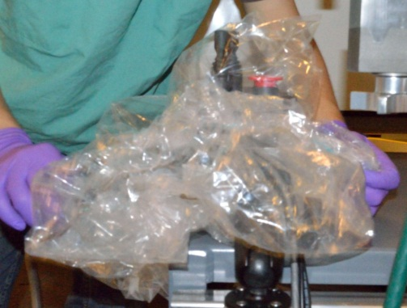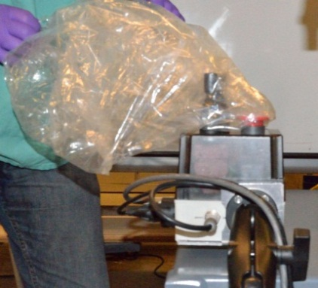

- Spray the robot, passive arm, and joystick with Metrex Cavicide until all surfaces are wetted, and wait for the required contact time according to the Metrex Cavicide instructions. Wipe down cords with Metrex CaviWipes, making sure to wet every surface with disinfectant.

- Unplug Ethernet cord and store in cart

- Unplug USB cord and store in cart

- Unplug Joystick power cord and store in cart

- Unplug Joystick signal cord and store in cart

- Unplug Robot cord and store in cart
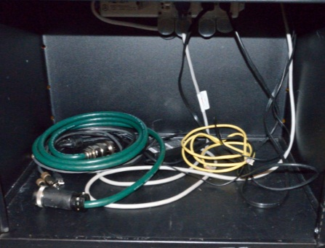

- Detach joystick from bed
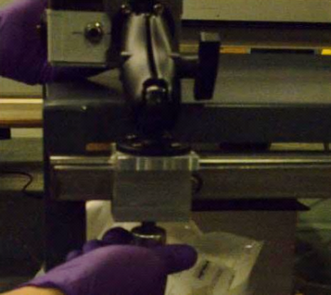

- Fold into storage configuration and store in cart

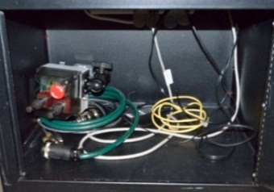

- Close laptop and store in cart
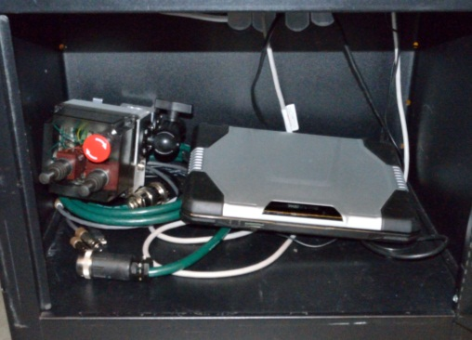

- Remove robot attachment knob and washer

- Lift robot from support arm and rotate robot 90 degrees into adjustment position

- Rotate robot arm 180 degrees into storage position

- Place robot on cart, screw on attachment knob and washer for storage, and secure with straps A, B, and C

- Detach support arm from support arm shaft and place in cart
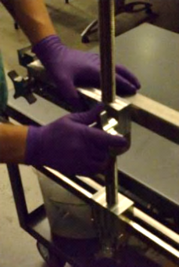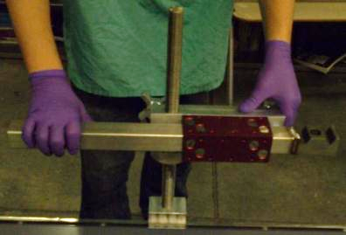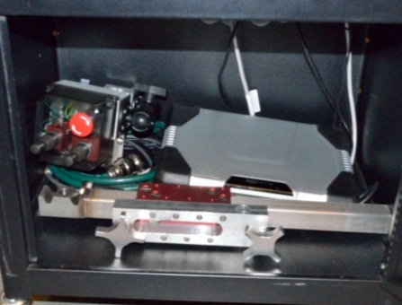

- Detach support arm shaft from bed and place in cart
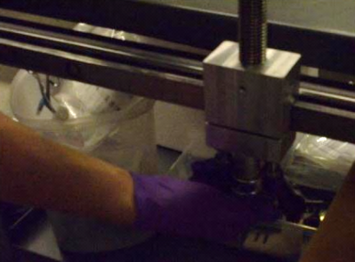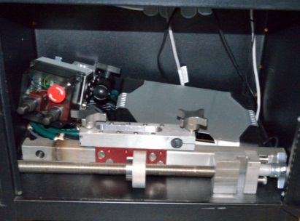

- Close cart, cover, and store system
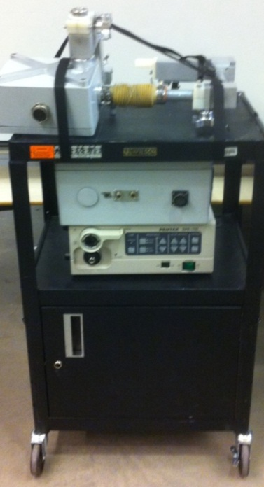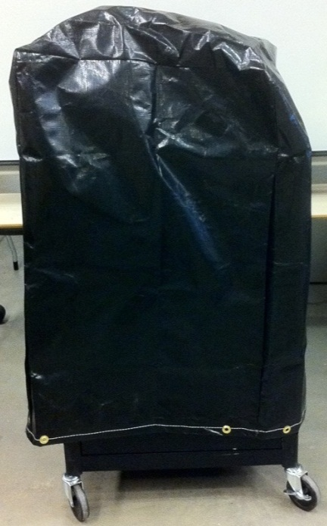

Safety/Emergency Protocol

Emergency Shutoff Methods

- Robot issue automatically detected
  - Robot will stop when internal safety relay shuts off
  - Check command prompt for information
  - If not recoverable:
    - Turn off robot
    - Remove scope from robot
    - Put robot in upright position
    - Continue operation manually
- Robot issue undetected by software or other emergency involving robot
  - Press e-stop button on joystick enclosure
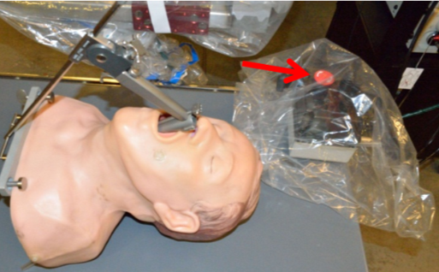
  - Remove scope from robot
  - Put robot arm upright position
  - Continue operation manually
- Patient issue unrelated to robot
  - Pull scope shaft out of laryngoscope
  - Put robot arm in upright position
  - Attend to patient

Appendix

Software Messages

Below is a brief explanation of error messages generated by the Robo-ELF system and the proper response for dealing with each one, as well as other system failures. Where it is indicated to “Shutdown the software”, the user should close the program window for the software(Step 7 in shutdown instructions) but not turn off the laptop or Robot Box unless otherwise indicated. This makes a safe, quick restart possible. If the Robot Box is turned off or loses power at any point during the procedure, a full recalibration must be performed.

Computer/Program crash

In the case that the program or computer crashes without reporting an error message, a full system restart may be attempted, but if multiple crashes continue to occur, the system should be shut down and sent for maintenance.

Calibration Error!

- Indicates that there was an error in the calibration of the system. The system cannot be guaranteed safe to use if calibration is not successful.
- Can occur during calibration(Full recalibration or from file)
- If error occurs during calibration from file, a full recalibration may fix the issue.
  - Shutdown and restart the software, selecting Option [1] for recalibration.
- If error occurs during full recalibration, it cannot be guaranteed that the system is safe to use until a maintenance check has been performed.
  - Shutdown the system and do not attempt to use it until maintenance is complete.
System Error! EStop Connection Failed

- Indicates that the PC cannot communicate with the Emergency Stop switch. Without proper connection to the Emergency Stop, the robot cannot stop itself in the event of a safety failure.
- Can occur at any point after completed calibration due to system failure or if the USB cable becomes disconnected or broken.
- Shutdown the software.
- Check the USB connection between the PC and the Joystick Box. Verify that the cable is properly plugged in.
- Restart the system(step 44 in startup instructions)
  - The script “Estop.sh” must be run prior to running the RoboELF program to ensure proper connection with the Emergency Stop switch.
- If a successful calibration was completed prior to the error, the system may be restarted using the previous calibration data instead of re-running the calibration routine(Option [2] on the calibration selection). If this error continues to occur, send the system for maintenance.
- If this error continues to occur, send the system for maintenance.
Connection Error! Check Connections and Restart System

- Indicates that the PC cannot properly communicate with the Robot Box. If the PC cannot communicate with the Robot Box, it cannot issue commands to move or stop the robot.
- Can occur at any time after completed calibration due to a system failure or if the Ethernet cable becomes disconnected or broken.
- Shutdown the software.
- Check the Ethernet connection between the PC and the Robot Box. Verify that the cable is connected properly at both ends.
- Restart the system(step 44 in startup instructions)
- If a successful calibration was completed prior to the error, the system may be restarted using the previous calibration data instead of re-running the calibration routine(Option [2] on the calibration selection). If this error continues to occur, send the system for maintenance.
- If this error continues to occur, send the system for maintenance.
System Error! Encoder Failure

- This message indicates a problem with the motors and/or internal sensors in the system. If the motors or sensors(potentiometers and encoders) are not functioning properly, the robot cannot be properly controlled.
- Can occur at any time after completed calibration due to malfunctioning motors or sensors. The system may give false positives if it is too close to an error condition.
- Shutdown the software.
- A system restart may be attempted in case the error was a false positive.
  - Restart the system(step 44 in startup instructions)
  - Full recalibration (Option [1] on the selection menu) should be used in this case.
- If this error continues to occur, send the system for maintenance.
Error! Motor Error Detected!

- This message usually indicates that something is blocking the motion of the robot or that there is a mechanical problem with the robot.
- Shutdown the software.
- A system restart may be attempted in the case that the error was a false positive.
  - Restart the system(step 44 in startup instructions)
  - If a successful calibration was completed prior to the error, the system may be restarted using the previous calibration data instead of re-running the calibration routine(Option [2] on the calibration selection).
- If the error persists after restart, the Robo-ELF should be shut down, and the procedure finished by hand.
Joystick Error Detected

- Indicates an error in the joysticks. If the joysticks are not functioning properly, the robot cannot be properly controlled.
- Can occur due to joystick failure or improper use of the joysticks(multiple joysticks depressed at the same time, joystick not fully depressed during use)
- Shutdown the software.
- A system restart may be attempted in the case that the error was a false positive.
  - Restart the system(step 44 in startup instructions)
  - If a successful calibration was completed prior to the error, the system may be restarted using the previous calibration data instead of re-running the calibration routine(Option [2] on the calibration selection).
- If the error persists after restart, the Robo-ELF should be shut down, and the procedure finished by hand.
  - Send the system for maintenance.
System Error!

- This message indicates a serious failure of the software or hardware system.
- Shutdown the RoboELF system. The procedure should be finished by hand.
- A system restart is not advised in this case.

Terminology

Components

  - Support arm shaft
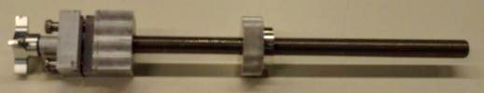

  - Support arm

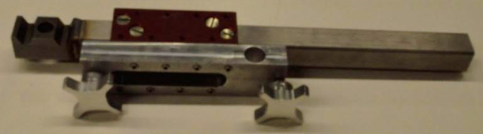

  - Attachment shaft
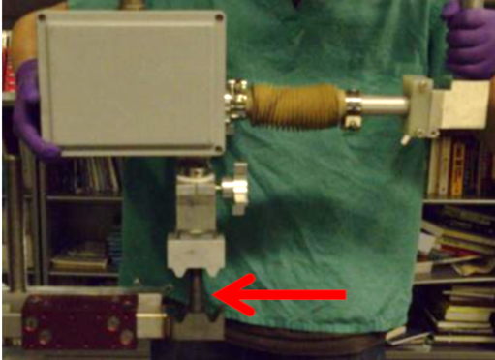

  - Robot
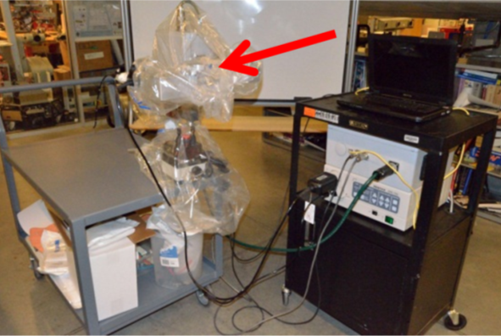

  - Joystick
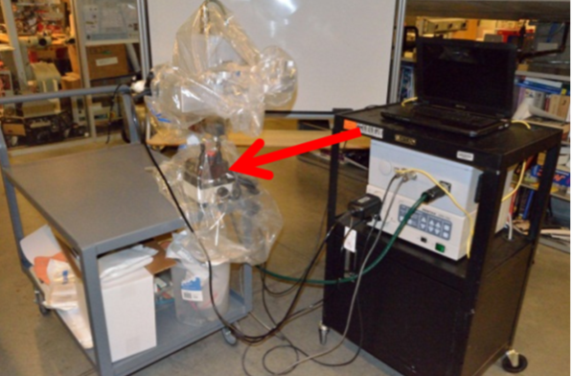

  - Cart
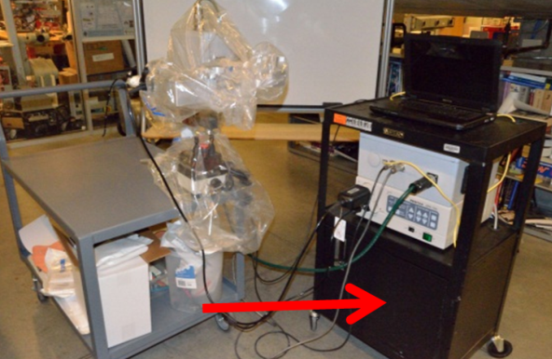

  - Laptop
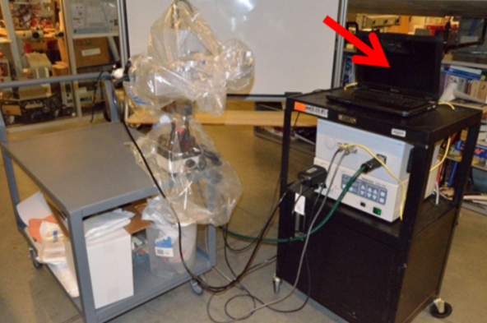

  - Scope
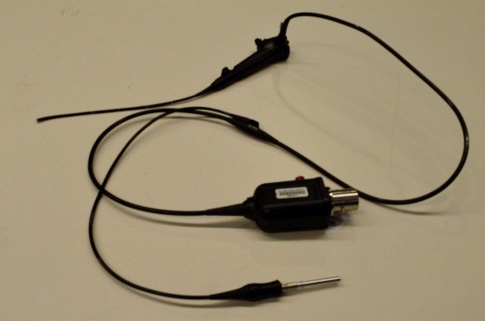

  - Scope box
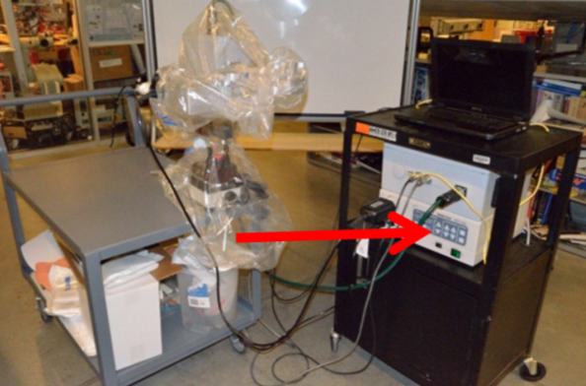

  - Robot box
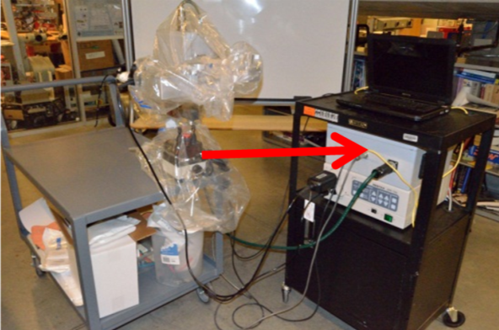

Grippers
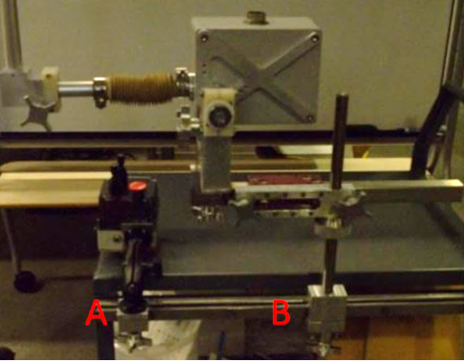

  - Joystick gripper
    - Attaches Joystick to bed rail.
  - Support arm gripper
    - Attaches support arm to bed rail.

Drapes

  - Robot drape
Intuitive Surgical Camera Arm Drape Ref: 420022 Ver: -02
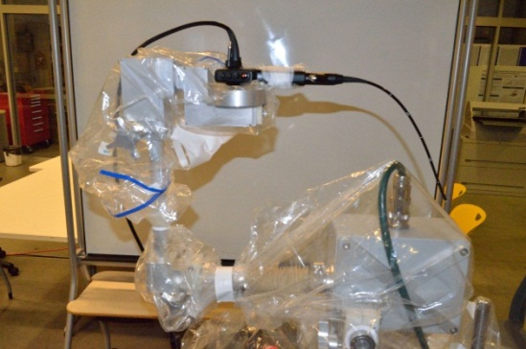

  - Joystick drape
Preferred Surgical Produces Band Bag with Tape 30”x30” Ref: BB-05

Cords

  - AC power cord

  - Scope cord
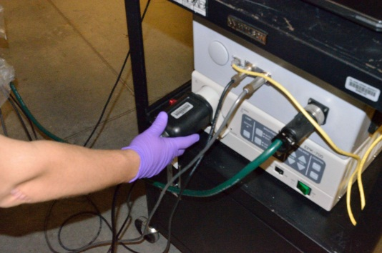

  - Robot cord
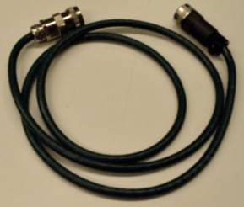

  - USB cord
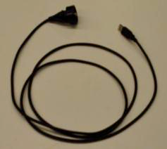

  - Ethernet cord

  - Joystick power cord

  - Joystick signal cord
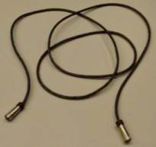

Passive Joints and Adjustment

Passive joints that can be moved by gravity alone if loosened have friction collars to prevent accidental motion; however it is still necessary to adjust the joints correctly to minimize the possibility of unintended motion.

- Firmly hold the robot distal along the robot to the joint being adjusted
- Loosen the adjustment knob of the desired joint to unlock it
- Use the hand holding the robot to adjust the joint position.
- When in the desired position, re-tighten the knob to lock the joint
- Test that the joint is properly locked by lightly attempting to further adjust it
Note: never release the robot when one of the joints has been unlocked, always have one hand holding the robot until the joint is confirmed to be locked. Whenever adjusting a joint, the scope cords should be checked to ensure that they do not catch on anything, damaging the scope.

Knobs/joints

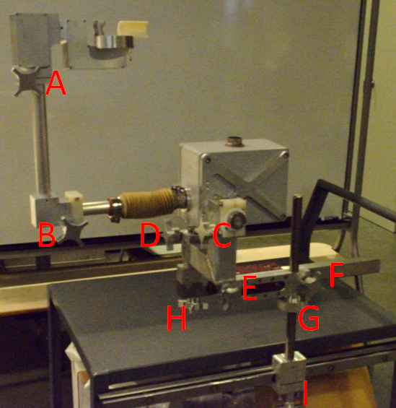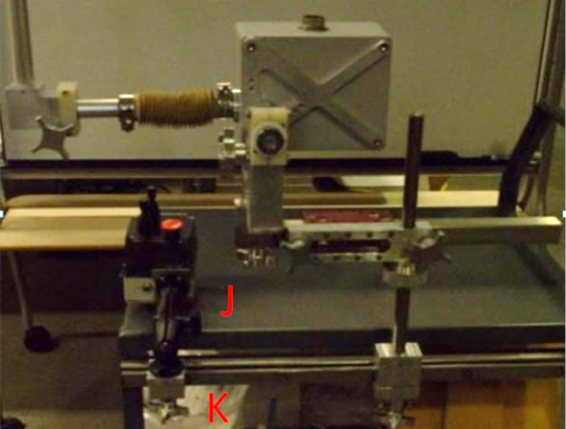
  - Wrist joint, wrist knob
    - Adjusts the scope angle. Use the wrist knob to align the scope shaft so that it points directly down the laryngoscope.
  - Elbow joint, elbow knob
    - Rotates the robot arm and scope away from the patient. Use the elbow knob to switch the robot between the “Ready”, “Upright”, and “Storage” positions.
    - When adjusting the elbow joint, check that the scope cords don’t catch on anything.
    - Never bend the elbow joint so that the scope holder is beyond the back half plane of the robot
  - Tilt joint, tilt knob
    - Adjust the insertion angle of the scope.
  - Yaw joint/ knob
    - Adjusts the angle of the robot in the plane of the surgical bed.
  - Slider joint/knob
    - Adjusts the length of the support arm.
  - Support arm joint/knob
    - Adjusts the angle of the support arm in the plane of the surgical bed.
    - Use the planar positioning knobs together to adjust the robots position and orientation in the plane of the surgical bed.
  - Height adjustment joint/knob
    - Adjusts the height at which the support arm holds the robot. Use the height adjustment knob to set the height of the support arm before the robot has been attached.
  - Robot attachment knob
    - Attaches the robot to the positioning arm.
  - Robot gripper knob
    - Tightens the support arm gripper onto the bed rail
  - Joystick adjustment knob
  - Joystick gripper knob

Robot Positions and Configurations

- Elbow Joint Positions
  - Ready Position
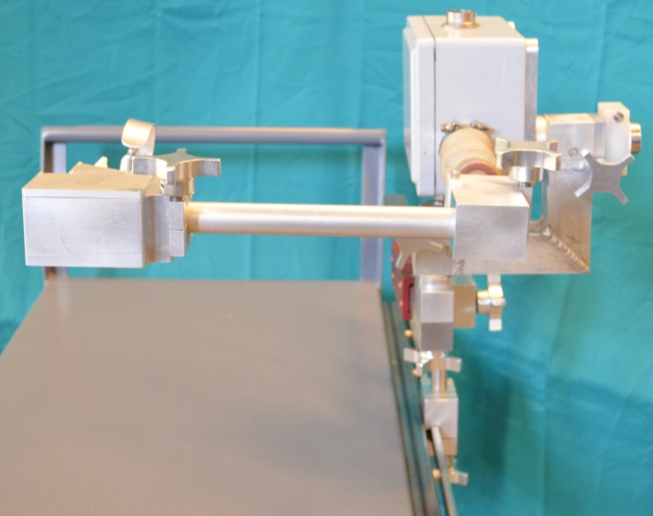
Elbow joint is parallel to the bed top. Ready position is used for draping/undraping, and operating the system.

  - Upright Position
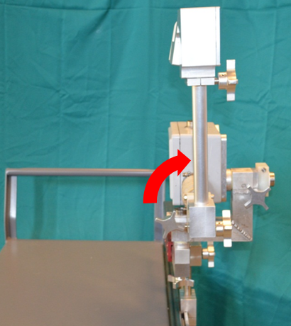
Elbow joint is at a 90 degree angle up with respect to the bed. Upright position is used when the arm cannot impede access to the bed.

  - Storage Position
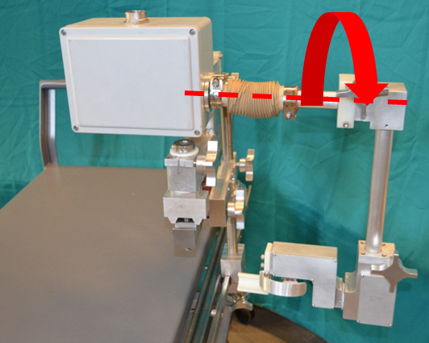
Elbow joint is at a 90 degree angle down with respect to the bed. Storage position is used when the robot is going into storage on its cart. Note, storage position should only be used in Adjustment configuration (see below).

- Robot Attachment Configurations
  - Operating Configuration
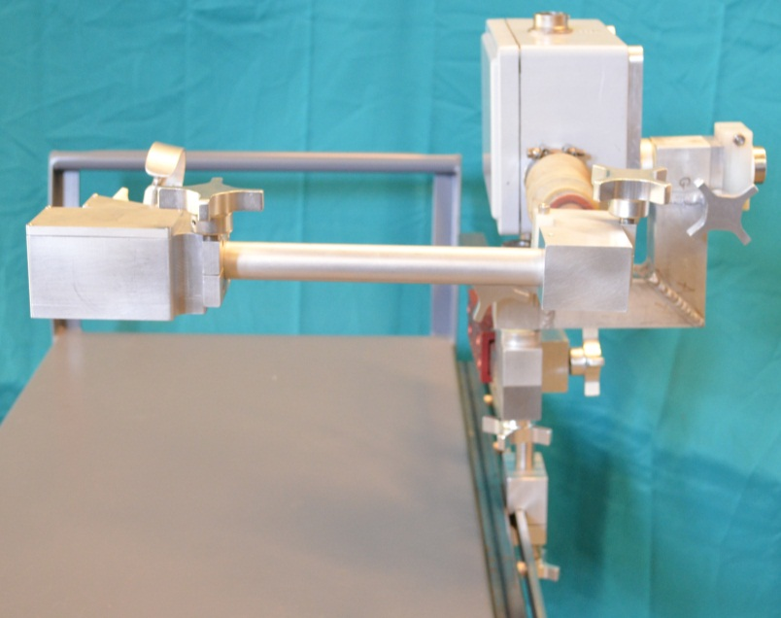
In Operating Configuration, the robot is mounted such that the axis of the elbow joint is parallel to the bed rail. Operating Configuration should always be used except when the robot is going into/coming out of storage.

  - Adjustment Configuration
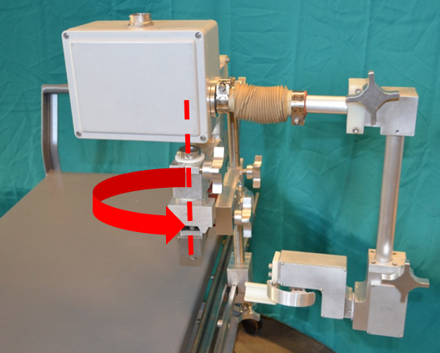
In Adjustment Configuration, the robot is rotated 90 degrees about the axis of the attachment joint from Operating Configuration. Adjustment Configuration is used when the robot is being put into storage configuration, in order to avoid collision between the scope holder and the bed.

