Force Feedback of Dual Force-Sensing Instrument for Retinal Microsurgery

Seo-Im Hong, Can Wang, Woo Yang
Mentors: Dr. Iulian Iordachita, Xingchi He, Dr. Russell Taylor

Abstract
Overview: Retinal microsurgery is a very delicate procedure requiring small and accurate movements. The forces the surgeons deal with throughout the surgery are well below the perceptible human threshold. The surgery can benefit largely from the use of a robot, which can reduce error and invasiveness as well as speed up the operation and recovery time.
Objective: To develop and access different force feedback methods for a dual force sensing instrument for retinal microsurgery; to assist the surgeon by providing maximal operational safety for the safety
Methods: Design and build phantoms to simulate forces on the sclera and retina for eye experiments. Carry out assessment experiments to test the combinations of force feedback methods and evaluate experiment results.
Results: It was determined that 50 OO was the closest in the hardness of rubber to model the sclera. Other methods of feedback lowered the amount of force used in experiments; the usage will be up to user preference.

Keywords
Retinal Surgery, Force-Feedback, Vibrotactile Motor, Dual-Tip Sensing, Eye-Robot

1. Background
A. Retinal Surgery

The main challenge of microsurgical procedures is to be able to perform surgical motions on structures that require accuracy within millimeters—even microns. Currently, with respect to retinal surgery, it is performed under a surgical microscope. The main technical limitations in vitreoretinal retinal surgery are:
- inadequate spatial resolution and depth perception of microstructures to identify tissue planes
- imprecise movements during micromanipulation of tissue due to physiological tremor which contributes to increased operative time and fatigue –a significant limiting factor in microsurgery [1]
- lack of force sensing due to the movements required for surgery are well below the surgeon’s sensory threshold [2]

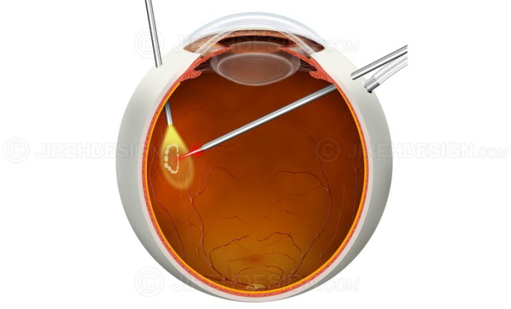
(Retina Surgery; Jireh Design)

Such factors make retinal microsurgery one of the most technically demanding surgeries. Much advancement [3, 4] has been made in the robotic systems for surgery to improve a surgeon’s ability to manipulate retinal tissue on a fine scale—including the Steady-Hand Eye Robot at the Johns Hopkins University.

B. Steady-Hand Robot (SHR)

The JHU Steady-Hand Robot is a cooperatively controlled robot assistant designed for retinal microsurgery [5]. Cooperative control allows the surgeon to have full control of the robot; the surgeon’s hand movements dictate the movements of the robot. It is a valuable assistant during high-risk procedures by eliminating the physiological tremor in the surgeon’s hand.

(Diagram of ER2; JHU CIIS)

In this experiment, the second generation, Eye Robot 2 (ER2) was used. ER2 consists of four components

- XYZ linear stages for translation
- rotary stage for rolling
- tilting mechanism with a mechanical RCM, and
- a tool adaptor with a handle force sensor.

Since the first generation, a foot pedal has been incorporated for intuitive gain control.

(Photo of ER2; JHU CIIS)

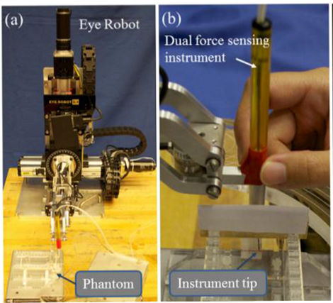
(a. Eye Robot; b. Dual force-sensing instrument)

C. Fiber Bragg Grating (FBG Force Sensor)

A fiber Bragg grating sensor consists of a short segment of optical fiber that reflects particular wavelengths of light and transmits all others. The refractive index varies periodically along the length of the fiber.
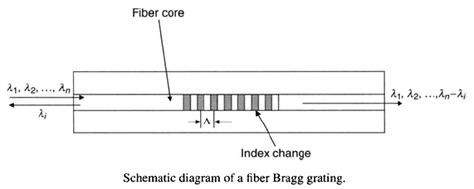
Bragg gratings are made by illuminating the core of the optical fiber with a spatially-varying pattern of intense UV light. The short wavelength (<300 nm) UV photons have sufficient energy to break the highly stable silicon-oxygen bonds, resulting in the damage of the fiber’s structure and increasing its refractive index slightly. A periodic spatial variation in the UV light intensity gives rise to a corresponding periodic variation in the refractive index of the fiber. [6]

This modified fiber serves as a wavelength selective mirror. The light traveling down the fiber is partially reflected at each tiny index variations. However, these reflections interfere destructively at most wavelengths and the light continues to propagate down the fiber uninterrupted. Nevertheless, at one particular narrow range of wavelengths, constructive interference occurs and the light is returned down the fiber.

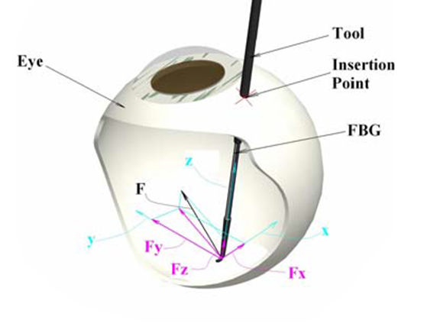
(Retinal Surgery Tool [8])

Maximum reflectivity occurs at the Bragg wavelength (λ_{B}) which is defined as:

λ_{B} = 2n_{eff}Λ

where n_{eff} is the effective refractive index of the mode propagating in the fiber and Λ is the FBG period.

Different physical or mechanical properties, such as strain or temperature, affect the reflected wavelength.

The FBG has several useful characteristics:

- FBG sensors are immune to drifts and have no down-lead sensitivity. Its responses to strain and temperature are linear; the FBG itself requires no on-site calibration.
- Multiple gratings can be combined in a single fiber (multiplexing). This gives the FBG sensor an advantage to read large numbers of sensors with a fewer number of fibers.
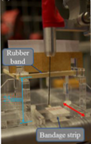
- Both temperature and strain can be measured with the same sensor.

In our report, multiplexing is an important characteristic in our FBG sensor because we are measuring both the tip force and the sclera force.

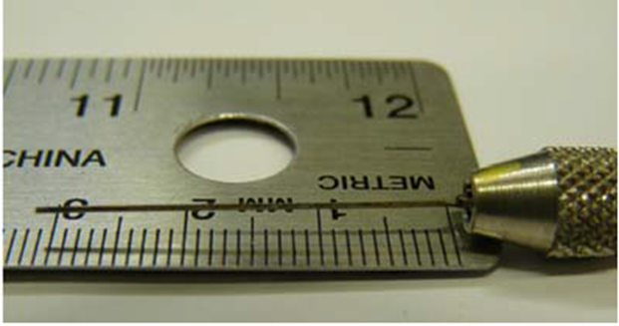
(Photo of FBG Sensor [8])

In general, FBG is an attractive candidate in robotic systems as it can be used as a sensitive, stable, strain and temperature sensors or be able to be built into transducers for other measurements such as pressure and acceleration. Key advantages of FBG include minimal size, high strength, linearity, and ease of multiplexing.

2. Method
Phantom

Previous membrane peeling experiments has been done in testing the eye robot by using a very simple eye phantom. It consisted of an open top rectangular box with tape on the bottom surface to represent the membrane. Rubber band was wrapped around the top perimeter of the box to model the sclera. While this model makes it relatively easy to perform the linear peeling procedure, it does not accurately represent the eye which is spherical. In addition, it is hard to test out the scleral constraint since the rubber band is not in contact with the tool most of the time.
(Photo of first original eye phantom)

To perform a more realistic eye membrane peeling experiments, we developed a new eye phantom. The first generation eye phantom consisted of a half pipe “inner eye” and rubber of unknown elasticity and hardness was attached to the insertion point to represent the sclera. At the bottom of the half pipe, we attached the tape in similar manner as the old phantom. Small loop made out of smooth silky string was glued at the end of the tape to help the tool grab onto it easier. The half has radius of curvature of 24 mm, the average curvature of a human eye. The choice of geometry was a half cylinder rather than a sphere since an enclosed sphere would make it harder to make membrane peeling a fast and repeatable procedure. If peeling is done only in one direction, the same movement used on the spherical eye can be replicated with a half pipe. In addition we initially intended to have large number of trials with many volunteers performing this task so this attribute of the phantom was a necessity. After the peeling was done, the half pipe would be removed and the tape would be reapplied and be ready for the next experiment.

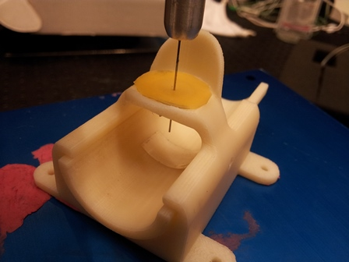
(Photo of second eye phantom)

The second generation eye phantom incorporates a few improvements over the first. First, better quality 3D printer was used to generate the model, giving it slicker and smoother surface. Second, we produced two replaceable half cylinders with different radius of curvature. The first one maintains the average value 24mm radius. The second one is 50mm, which has its foci at the actual insertion point of the tool on the phantom, which able it to maintain RCM when performing the peeling. This provides an advantage over the 24mm curvature which require the tooltip to move in and out of the opening to perform a full peel. Third, the insertion point was also made replaceable and we produced two alternatives. While one is vertical as in the previous phantom, the second is tilted 15 degrees to represent the angled insertion made to the eye as in a real surgery. For collection of the data, we found it most fit to use 50mm radius of curvature half pipe in conjunction with the tilted insertion piece. Finally, to better represent the sclera, we purchased various sheets of sorbothane and rubber of hardness ranging from 30 OO to 30 A. We asked two experienced surgeons to insert a handheld surgical instrument into each sheet and select which material feels nearly like the sclera. While one surgeon preferred the 30 OO sorbothane, the other chose the 50 OO sorbothane. We decided to average the two inputs and use the 40 OO sorbothane for sclera on our phantom.

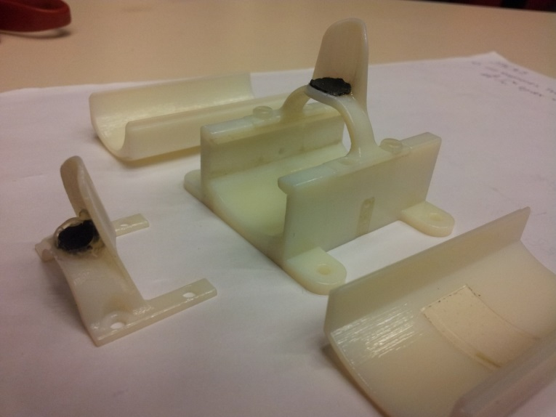
(With installed rubber)

Motor

Previous experiments with this technology involved visual and auditory feedback. However, visual feedback usually requires very high level of experience and expertise, and the operation room is routinely very noisy, therefore people tend to not pay as much attention to the audio beeps as they should. It seemed to us that a less ignorable method should be developed. For this reason, we developed a vibrotactile feedback method, as a comparison to the original auditory feedback method.

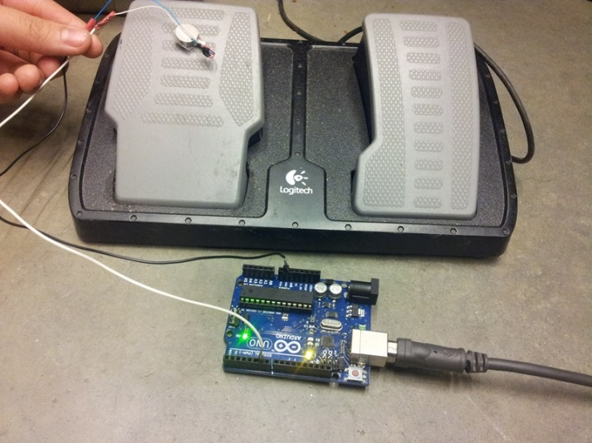
(Vibrotactile Motor)

A vibration motor is attached to an Arduino, which is then connected to the computer. The motor that we used (model number) is a relatively cheap motor that only vibrates if the potential across the motor is above 3V; the amplitude of the vibration cannot be altered by voltage potential or PWM control. In vibration feedback mode, the FBG force is read and categorized into 3 different zones: safe, cautious, and dangerous. 3.5mN marks the threshold between safe and cautious, and 7.5 marks the threshold between cautious and dangerous. A signal (character ‘z’, ‘x’, ‘c’) is then sent to the Arduino, and the motor will vibrate accordingly. After some testing, we developed the following method:

In the safe zone (0-3.5mN), the motor will not vibrate
In the cautious zone (3.5-7.5mN), the motor will vibrate for 250ms and turn off for 750ms indefinitely
In the dangerous zone (7.5mN+), the motor will vibrate for 750ms and turn off for 250ms indefinitely

The above method is adopted after some testing with ourselves. The position of the vibrator was also altered and tested. We do recognize that at some positions, vibration may have negative effects on the surgeon’s control of the surgery – we want to find an optimal position that is hard to ignore but will not affect the surgeon in a way that makes them lose control. After several testing with hand palm, elbow, ear lobe, ankle, etc., we concluded that the best position was at the toe tip on the pedal with the surgeon’s shoes on. It is far away from the upper limb, which ensures that the hand will not be affected much, but also ensures constant feedback to the surgeon.

3. Results & Analysis
While we submitted application for human subject research to IRB on 3/15/2013, we were not able to get the approval before the termination of the project to recruit volunteers to perform membrane peeling with the eye robot and collect large pool of data.

As an alternative, we performed the trials amongst ourselves to analyze the data. However, while we were performing one of the trials involving robot haptic feedback on the sclera, glitch in the system made the robot arm go into a wild feedback loop and it rammed the tool into the phantom causing the tool to disfigure and effectively ruined it. We were unable to do much about our unfortunate situation since one of our mentors with the knowledge to calibrate the tool was traveling in Germany for the rest of the duration of the project.

The only complete set of data we were able to work with was for the no force feedback peeling as negative feedback and the auditory feedback method. Each person completed three membrane peelings for each trial. The raw data was collected by the computer which we later used to calculate maximum and average forces at the tool tip and the sclera as well as their standard deviations. As the results show, the auditory feedback shows notable improvements in reducing not only the maximum force, but also on the average and variance of the force at both sites.

One remarkable result is the total average maximum force dropped from 20mN in no force control mode to a near half, ~10mN when using auditory feedback. While data collection on the vibrotactile method is yet to be done, we anticipate it will yield similar improvements as in the auditory feedback method. We hypothesize this since strictly speaking, one can hear the vibration pattern as well as feel it on the pedal so it can be considered as auditory plus vibrotactile feedback.

Tip Sclera
avg ∆Max -10.503 4.021
avg ∆Avg -2.109 -9.347
avg ∆Std -2.257 4.681

Significance/Future Research
The glitches from the robotic haptic feedback should be further improved to prevent future mishaps. There are many more variables to be considered regarding the force-feedback loop direction and magnitude.

A more fine-tuned vibrotactile motor could be incorporated to experiment with different amplitudes and faster refresh rate.

Human subject testing for larger data collection will also more strongly validate our findings.

There is much room to venture beyond the stereotypical auditory feedback. We envision that it will be up to the individual surgeon’s preference to select which mode of feedback will assist them the best during their performance of a surgical operation.

We hope that in the future more investigation regarding the vibrotactile feedback will be done and perhaps a new mode of feedback will be incorporated as well.

4. Management Summary
Tasks

Throughout our project it was highly essential to coordinate the tasks because the components were dependent on each other.

Can developed our vibrotactile motor—gluing and soldering the parts. Woo worked on our secondary eye phantom. Seo-Im assisted the experimental design and protocol.

During the process, we got a lot of support from our mentor, Xingchi He who was always readily available.

Accomplished Vs. Planned

Originally, we sought to have a larger pool of data. However, these initial plans were obstructed due to the lack of approval of our IRB. Instead we had to make do of our current resources at hand and the trials were limited to the three participants.

Furthermore, we had an unfortunate incident with our FBG sensor breaking during the project. With our mentors in Germany, it was impossible to recreate the FBG sensor with proper calibration. However, because our project also evaluated qualitative assessments, we decided to continue on the project and measure what we could.

Our original objectives to introduce a new feedback method and redesign the eye phantom were met.

Lessons Learned

Many lessons were learned and will be applicable for future experiments. This was the first time for our group members to work with the IRB. We first-handedly learned this was a meticulous process that requires much attention to details and flexibility in time frame.

Other lessons include acquirement of general knowledge of retinal microsurgery and FBG sensors.

We learned to accommodate many errors, mistrials, mistakes, etc. Throughout the process of our project this common notion was reinforced multiple times.

Appendix
Materials

FBG Force Sensing Instrument
Arduino + Cable
Vibration Motor
Sorbathane
(thickness: 1cm, hardness: 50 OO A)

Code

char state = 'c';

void setup() {
pinMode(A0, OUTPUT); // pin will be used to for output
Serial.begin(9600); // same as in your c++ script
}

void loop() {
if (Serial.available() > 0)
{
state = Serial.read(); // used to read incoming data
}
switch(state)// see what was sent to the board
{
case 'z': {
analogWrite(A0,200);
delay(750);
analogWrite(A0,0);
delay(250);
Serial.println('danger');
}
break;
case 'x': {// if 0 was sent
analogWrite(A0,200);
delay(250);
analogWrite(A0,0);
delay(750);
Serial.println('cautious');
}
break;
case 'c':
analogWrite(A0, 0);
delay(1000);
Serial.println('safe');
break;

}
}

#print "Running ForceMode2Serial.py"
#print "Initializing"

# Python standard library
import ctypes
import platform
import sys
import time
import os
import math
import numpy as np
from Frame import *
#automatically connects to
import EyeRobot2 as robot;

print "Robot Ready!"
time.sleep(1.0)

import serial
s = serial.Serial('/dev/ttyACM1', baudrate=9600)
print "Arduino Ready!"

threshold = np.array([0.1, 0.5, 1])

while 1:
#force from FBG is a 4x1 vector
#FBGForce = robot.GetFBGForce()
FBGForce = robot.GetHandleForce()

# sclera force is the third and fourth element
Fs = FBGForce[2:4]

#norm
FsNorm = np.linalg.norm(Fs)

print FsNorm

if (FsNorm < threshold[0]): # mode 0
print('mode 0')
s.write('c') # send 'c'
elif (FsNorm < threshold[1]):
print('mode 1')
s.write('x')
else:
print('mode 2')
s.write('z')
# last mode
time.sleep(0.01)

References
- Patkin M (1977) Ergonomics applied to the practice of microsurgery. Aust NZ J Surg 47:320–329. doi:10.1111/j.1445-2197.1977.tb04297.x
- Gupta PK, Jensen PS, de Juan E Jr (1999) Surgical forces and tactile perception during retinal microsurgery, MICCAI’99. LNCS 1679:1218–1225
- Chui, C.K., Hguyen, H.T., Wang, Y., Mullick, R., Raghavan, R., Anderson, J.: Potential field and anatomy vasculature for real time computation in daVinci. In: First Visible Human Conference, Bethesda, USA (1996)
- Ikuta, K., Yamamoto, K., Sasaki, K.: Development of remote microsurgery robot and new surgical procedure for deep and narrow space. In: IEEE ICRA, pp. 1103–1108 (2003)
- B. Mitchell, J. Koo, M. Iordachita, P. Kazanzides, A. Kapoor, J. Handa, G. Hager, and R. Taylor, “Development and application of a new steady-hand manipulator for retinal surgery,” in IEEE ICRA, Apr 2007
- pp. 623–629.E. Udd, "An overview of fiber optic sensors", Rev. Sci. Instrum., vol. 66, no. 8, pp.4015 -4030 1995
- J. Canning, Fiber Gratings and Devices for Sensors and Lasers, Lasers and Photonics Reviews, 2 (4), 275-289, Wiley, USA (2008)
- I. Iordachita et al. A sub-millimetric, 0.25 mN resolution fully integrated fiber-optic force-sensing tool for retinal microsurgery. Int J CARS (2009) 4:383–390

