Surgical Instruments for Robotics Open Microsurgery

Group 1: Radhika Rajaram and Olivia Puleo
Mentored by Yunus Sevimli, Dr. Russell Taylor and Dr. Christopher Razavi

Advanced Computer Integrated Surgery, Spring 2017

Abstract

Different microsurgical forceps designs were fabricated and evaluated for use with a cooperatively controlled surgical robot. Based on clinical requirements and available manufacturing means, one of the designs was chosen to be manufactured in metal. This paper details the design selection and iteration process and explains the rationale behind the choices made.

Keywords:

Microsurgery, forceps, surgical robot, ergonomics, instrument design, design for manufacturability

I. Introduction:

The Robotic ENT Microsurgery System (REMS) shown in Figure 1, also known as the Steady hand robot and the Galen robot, was developed at the CIIS laboratory at Johns Hopkins University with an aim to reduce hand tremor of surgeons in head and neck operations via a cooperative control schema¹. One such procedure, called endolaryngeal phonosurgery, involves the use of microlaryngeal instruments that amplify hand tremor by virtue of their long length and can result in sub-optimal outcomes when used conventionally. These instruments can be attached to the REMS robot through a tool adapter. The surgeon can then manipulate the tool, while the robot cancels unintended tremor. Virtual fixtures and preset tool paths can also be enabled. The robot has five active degrees of freedom, three of which are provided by a linear delta stage and the other remaining two are provided by an arm with two rotary joints. There are two passive degrees of freedom from a support stand. The admittance of the robot is controlled by a foot pedal, as the foot pedal is depressed more, it becomes easier for the surgeon to move the tool. From studies using phantoms, it was demonstrated that significant improvement in surgical precision could be achieved by using the robot.

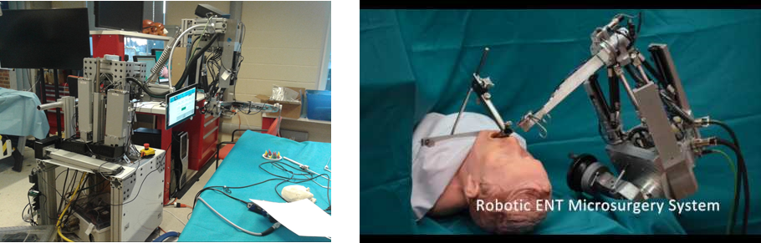
Figure 1. A Latest iteration of the REMS B Close up of the REMS

The studies also identified some areas of improvement. As shown in Figure 2., the microsurgical forceps were held at the top by the robot and at the middle by the surgeon. This contributed to a large lever arm that made it harder to reorient the tool. Also the user ran into workspace limits (current workspace volume is 125 mm x 125 mm x 125 mm) with the tool held this way. Therefore, it was concluded that a new microsurgical forceps was required to be made such that the surgeon could hold the tool above the robot attachment point. The other characteristics of the original tool namely the ability to rotate the tool easily about its own axis, the symmetric and cylindrical profile, the non-handedness and the normally-open configuration of the jaws were required to be preserved.

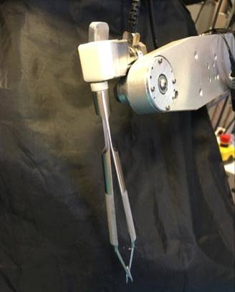
S.No | Minimum tool Requirements
1. | Held by surgeon above the robot attachment point
2. | Rotation about own axis
3. | Symmetric / cylindrical profile
4. | Held with either dominant non-dominant hand
5. | Normally-open configuration
S.No | Additional requirements
1. | Sterilizable (stainless steel)
2. | Design for Manufacture and Assembly

Figure 2. Forceps used in original REMS study Table 2. Requirements from new forceps tool

II. Methodology:

As the microsurgical forceps jaws are challenging to prototype, it was decided that the jaws as well as other parts would be cannibalized from existing forceps. There is a huge variety of microsurgical forceps, each adapted to different areas of the body and the preferences of the surgeon. By analyzing and evaluating the existing forceps designs we aimed to identify the design features that would be applicable to our situation and create with initial prototypes that can be iterated on until a satisfactory design which optimized usability, manufacturability, sterilizability and price could be achieved.

III. Overview of Forceps Varieties:

In order to simplify the selection process from the myriad shapes that forceps come in, a classification system was created based on method of actuation and handle type. The method of actuation was broken into three categories: scissoring type, tweezer type, and sliding rod type. Based on our search of medical catalogs, every combination of the actuation and handle type were found. Scissoring type forceps, as shown in Figure 3A, 3B and 3E are generally made of two pieces that overlap in an X shaped joint. By pushing the parts above the joint together, the jaws are closed. Tweezer type forceps, shown in Figure 3C and 3E consist of two deformable arms hinged together (similar to several non-medical tweezers) The single body allows for easy sterilizability. The third type of actuation is the sliding rod type, is often seen in laparoscopic instruments. As seen in Figure 3D, they consist of a long hollow cylinder with a sleeve and sliding rod, with the jaws fixed to one end and a handle at the other. By actuating the handle, the sliding rod could be moved up and down thereby opening and closing the jaws.
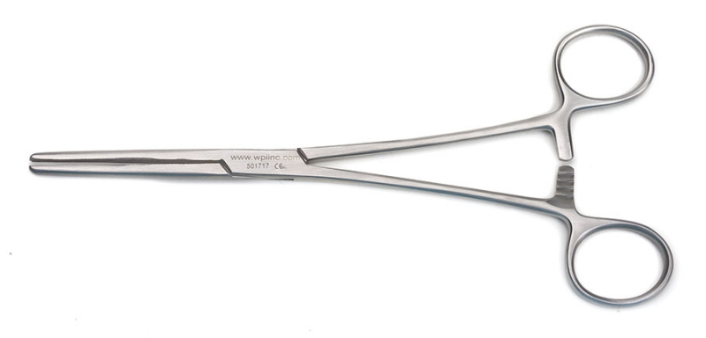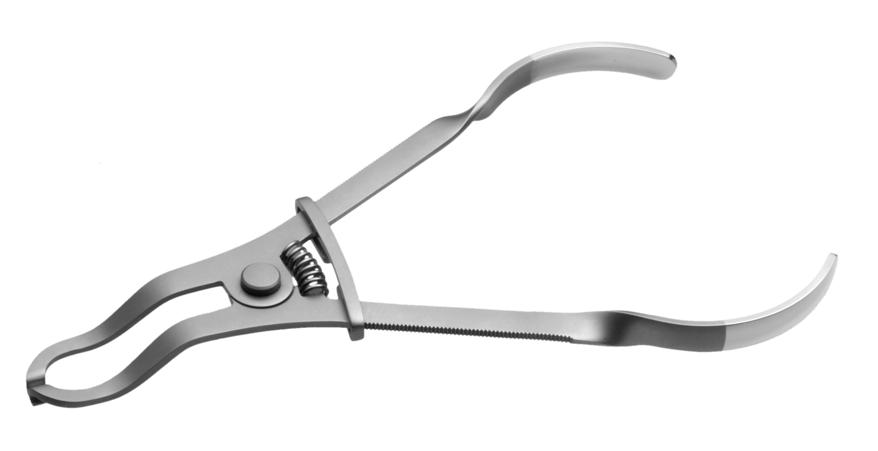
A B

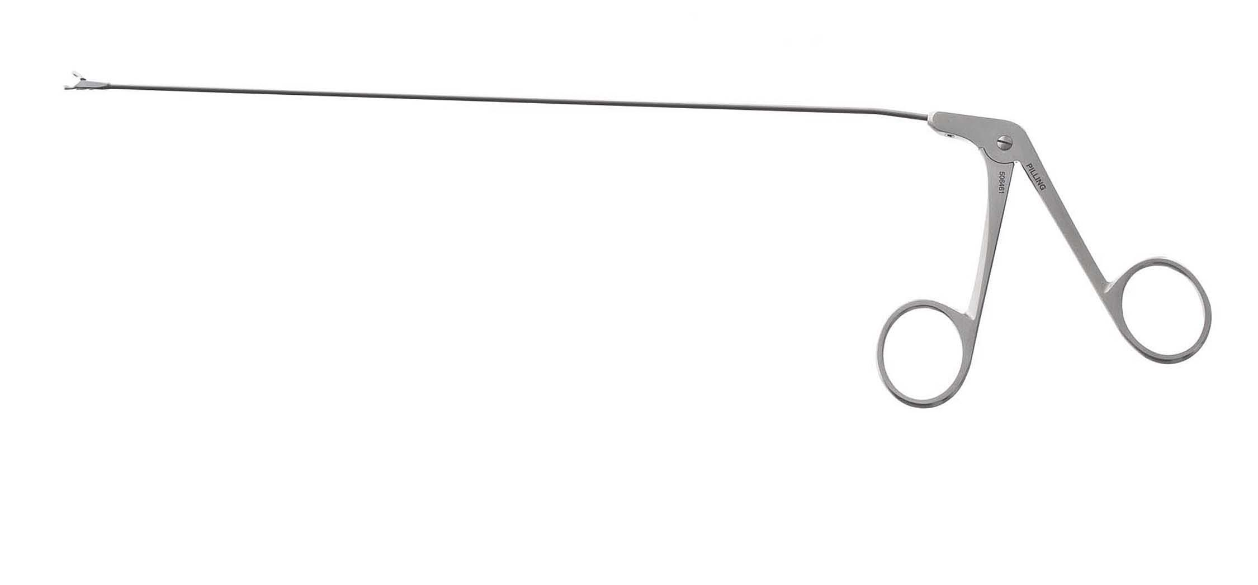
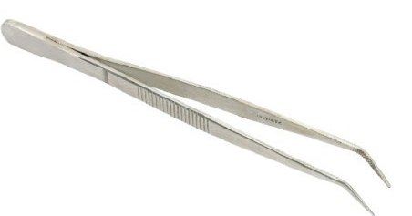

C D

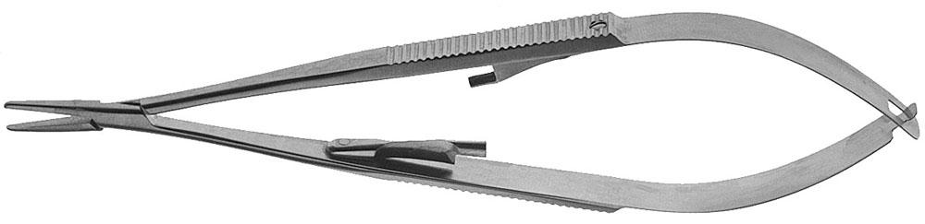

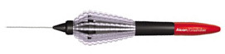

E F

Figure 3. A Scissoring actuation with loop handle, B Scissoring actuation with pliers handle, C Tweezer actuation with tweezer handle, D Sliding-rod actuation with loop handle, E Scissoring actuation with tweezer handle, F The Alcon Grieshaber forceps- sliding rod actuation with bending strip handle

The handle type was broken into four categories: loop handle, tweezer handle, pliers handle, and miscellaneous. Loop handles, seen in Figure 3A and 3D, are similar to what is seen in conventional scissors and are easy to hold on to for that reason, but are difficult to rotate. In medical terminology, it leads to surgeon using a “hook grip” (Figure 4A) which does not allows for average force and precision. A tweezer handle is identified by the inverted “U-shape” design (Figure 3C and 3E) . A tweezer handle is usually made of a deformable material or two arms connected by a deformable or spring-loaded hinge. The advantage of this is that it creates an instrument that is normally open and does not require any actions on the surgeon’s part to open it. Tweezer handles are used for work which require a “precision grip” (Figure 4B). Pliers handles, shown in Figure 3B are found in forceps that need a “power grip” (Figure 4C). The entire palm can close around the pliers handles and as a result they often end up being rather large and clunky. Pliers handles do not allow for precision work. Any handle type that did not fit these categories was relegated to miscellaneous. Most notably is the handel developed for the Alcon Grieshaber Revolution DSP line (Figure 3F), which is made of a ring of twelve deformable plastic strips that are equally spaced concentrically to the main cylindrical shaft.

IV. Selection Criteria:

After considering these different handle and actuation categories, a tool with a sliding rod actuation and tweezer grip was selected. The sliding rod actuation gives the tool a slim profile, which is critical for use in microsurgery as it does not obstruct the view of the microscope. The instrument’s cylindrical nature means that it has an inherent rotatability and can be used with the existing tool adapters for the Galen. Also, it would be easier to salvage parts from existing laparoscopic forceps and repurpose them with new handles.

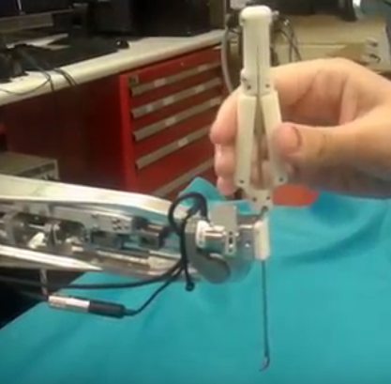
A tweezer grip with semi-circular grips was selected in order to capitalize on ease of rotation inherent in the cylindrical sliding rod actuator. This way, a surgeon could easily roll the tool both in their hand and in the robot’s grip ‒ a necessary and repeated motion in suturing. The tweezer grip allows for high precision and lesser force which is ideal for suturing tiny blood vessels.

Patkin (1977) identified some desirable characteristics for microsurgical tools which are listed in Table 2 from numbers 1 -6 ². Additionally, the National Institute of Occupational Health put recommendations 6-9 for hand-held tools ³.

piece shaft collar. However, it was found that the ABS plastic did not have enough friction, hardness and rigidity to reliably hold on to the shaft. So, instead of splitting the cap and ring, a single threaded hole was introduced in the components such that a screw could be used to bite the shaft and hold the handle in place.

VI. Manufacturability:

Although a single body tweezer grip made from die-cut and die-pressed sheet metal would be ideal for easy assembly and sterilizability, it is cost-effective to manufacture only in high quantities due to the need for precise and custom made dies, inserts and other tooling. A multi-part design with a separate spring allows us to use the same design with multiple materials with little or no change. In addition, since the spring is axially loaded, it can be easily switched with another spring or even stacks of springs to achieve the right stiffness depending on the task (suturing, cutting, clamping, grasping etc.). This would have been harder to achieve with torsional or non-axially loaded springs.

VII. Final Design Statistics:

S.No | Dimension | Value
1. | Total length | 19.5 mm
2. | Handle length | 85 mm
3. | Minimum Actuation force | 150 gm
4. | Travel length of rod | 2.3 mm
5. | Diameter of shaft | 1.8 mm
6. | Diameter of Handle | 14 mm
7. | Grip span | 25 mm
8. | Mechanical advantage | 3.5:1

Figure 10. Final Design attached to the robot Table 4. Important dimensions of the new tool

The diameter of the handle had to be increased to 14mm from the recommended upper limit of 10 mm, in order to accommodate the holes and the shaft body. The actuation force of 150 gm seemed to be more appropriate in our case than the recommended upper limit of 100 gm-force.

VIII. Evaluation:

When the new tool was used with the robot, our mentors reported better ergonomics due to better management of workspace. They also reported that the tool was easy to rotate and actuate. One of our mentors preferred a stiffer spring to the current spring being used. One drawback of the tool was that there was noticeable flexing when the tool was reoriented through large angles. This problem can be eliminated using a stiffer cylindrical shaft.

IX. Conclusion:

The creation and fabrication of these new forceps was done with specific use with the Galen in mind. Because of this, it integrates more naturally than the more standard forceps that had been adapted for use with the platform in the past. The design takes advantage of the ability of the robot to steady the user’s hand by having the actuation point farther away from the tool tip, and because of this makes a better use of the robot’s workspace.

X. Future Work:

Unfortunately, the company that we have outsourced the making of the metal prototype to did not process our order properly and so the metal version of the final prototype will not be delivered in time for the end of the semester. As such, the first item of future work is to assemble and test the metal tool as soon as it is available. There is also a user study being planned to quantify the benefit that the Galen surgical robot gives surgeons during microvascular suturing and anastomosis that may include this instrument.

Works Cited

- Olds, K.C. (2015); Robotic Assistant Systems for Otolaryngology-Head and Neck Surgery (Doctoral Dissertation). Retrieved from https://jscholarship.library.jhu.edu/handle/1774.2/37927

- Patkin, M. (1977). Ergonomics Applied to the Practice of Microsurgery. ANZ Journal of Surgery,47(3), 320-329. doi:10.1111/j.1445-2197.1977.tb04297.x

- Cal/OSHA, NIOSH, & CDC. (2004). Easy Ergonomics: A Guide to Selecting Non-Powered Hand Tools. Retrieved May 18, 2017, from https://www.cdc.gov/niosh/docs/2004-164/pdfs/2004-164.pdf

S.No | Feature | Reason
1. | Cylindrical/Semi-cylindrical shape | To allow for rotation in a precision type grip
2. | Milled for friction | To allow for better grip
3. | The length of the handle from where it is gripped  to the top end must be around 10 cm | To allow for proper balance in a precision grip. This may not  exactly apply to the situation where the tool is balanced by the robot
4. | 5-10 mm diameter of handle | Small enough to rest in the cleft between the forefinger and large enough to avoid excessive rotation
5. | 40-100 gm opening/closing force | Above this limit, the surgeon may experience fatigue and below this limit the surgeon will not be able to hold the instrument without actuating it
6. | 3:1 - 6:1 mechanical advantage | This will ensure less fatigue to the surgeon
7. | Grip span no more than 3 inch when fully open | To allow for precision hold
8. | Grip span no less than 1 inch when fully closed | To allow for precision hold
9. | Handle does not rest inside of palm | To avoid injury of palm from the tip of the handle

Table 3. Desirable characteristics of microsurgical tools

V. Design Iteration and Discussion:
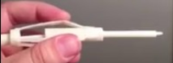
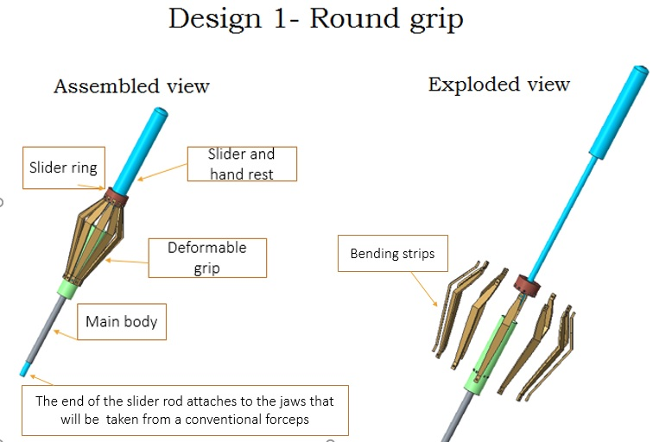

Figure 5. CAD model and assembled prototype of design 1

The first design (Figure 5) was modelled after the Alcon tool mentioned previously. It would be actuated by pushing on the deformable grip, which would move the slider ring and the tool shaft within. A plastic prototype was printed, and though the prototype worked as expected, it was determined that this design had too many pieces to be easily assembled.
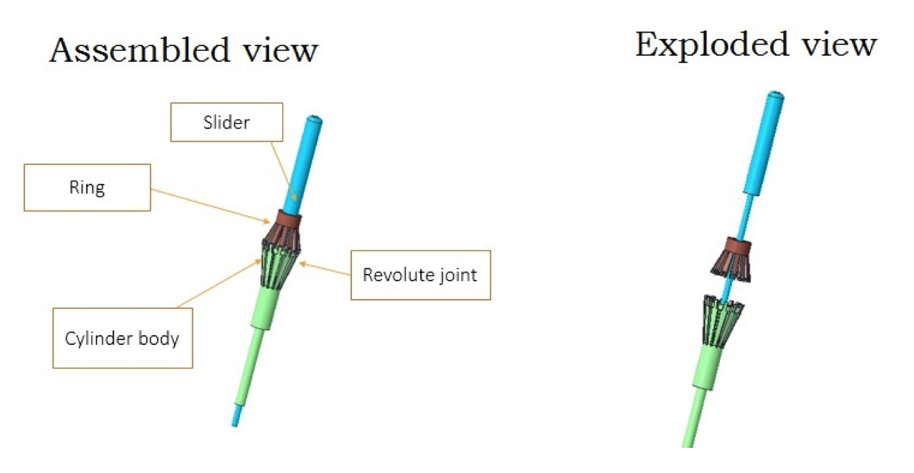
Figure 6. CAD model of design 2

A second Alcon-like design (Figure 6) was created where the deformable strips were combined into two solid parts that would be assembled with pins. The 3D printed prototype of this design did not have the required deformability even though the bending strips were made very thin. Also, this design would be very hard to make with surgical steel which is the material that would be required in future clinical trials.
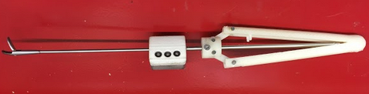
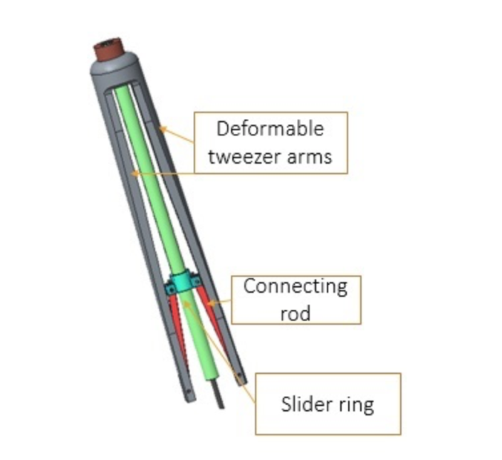
Figure 7. CAD model and prototype of design 3

Because of the reasons listed above, we decided to switch to a tweezer grip design seen in Figure 7, where the tweezer arms would serve as a crank, and two links would serve as a connecting rod . This design would rely on the inherent properties of its manufacturing material for its elastic return and the inner moving parts would be actuated in the same manner as in the round grip design. After creating a plastic prototype of this design, we realized that it would be ideal to have a design that is more material agnostic.
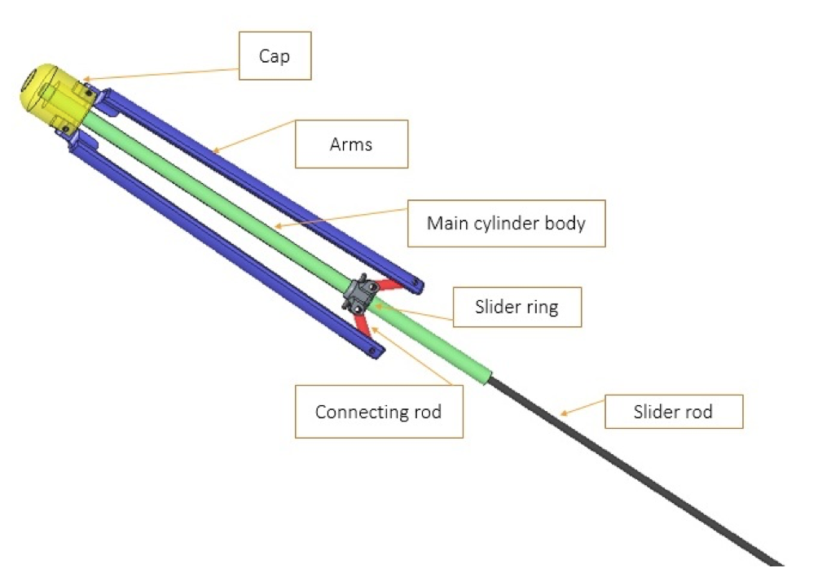
Figure 8. CAD model and prototype of design 4

The second tweezer grip design, seen in Figure 8, addressed the issues that the previous one had with the single bodies tweezer arms. The single piece was separated into two arms and a cap, and the connecting pins were shortened to accommodate this new shape. The cap contained a spring that pushed the sliding rod down and allowed for a normally open configuration of the jaws.
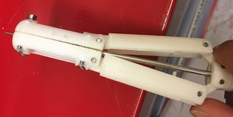
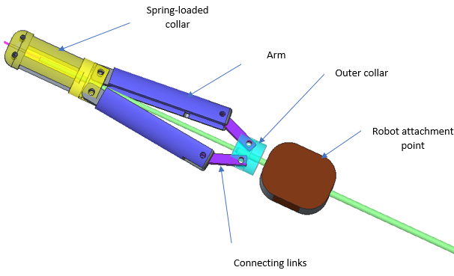
Figure 9. CAD model and prototype of design 5

Our final design, shown in Figure 9, addressed a critical actuation difficulty that had been noticed with the previous designs. In all of the designs before this, the ring below the either the round grip or the tweezer arms was the moving part, and would slide up and down in order to open and close the jaws. With the way that the sliding rod instruments are designed, this would mean cutting a slot through the outer cylinder in order to affix the sliding ring to the inner rod. Because the instruments in question are only 2mm in diameter, this would prove to be a rather difficult task. In order to address this, the moving part of the grip was moved from the ring to the end cap. Now, pushing the tweezer arms together would push the end cap upwards, which would pull the inner sliding rod and close the instrument’s jaws. Also, the previous iteration had the arms and connecting link at an acute angle which limited the size of the ring component. The latest iteration features the arms and connecting link at an obtuse angle that allows for a larger and thus stronger ring component. The ease of manufacturing and assembly of this instrument made this a strong choice for a final design.

In order to test the handle prototypes with the cannibalized forceps shaft, the handle would need to fix firmly on to the shaft without a permanent attachment method. So the cap and the ring were split into two pieces with threaded holes running perpendicular to the axes, similar to a two

