Shayer Chowdhury
5/9/14
CIS II
Final Report
Project #3
schowdh8@jhu.edu

Development of a comprehensive dissection and energy-cutting model for robotic surgery training

Stated Topic and Goal

This project surrounded the topic of implementing a blunt/sharp blood vessel and tissue dissection simulation as well as a model for electrosurgery training. Further sub-topics included the study of blood vessel histology as well as exploring and experimenting with synthetic biomaterial replication of human tissue and vasculature. Additionally, this project incorporated and required a development of a basic understanding of energy-cutting electrosurgery and electrocoagulation. The goal of this project was to create an inanimate surgical training model for both sharp and blunt tissue dissection as well as blood vessel energy-cutting that is ultimately cheap, effective, potentially reusable, and long-lasting. User feedback from currently practicing surgeons through the Minimally Invasive Surgical Training and Innovation Center (MISTIC) was incorporated to further develop a comprehensive dissection and energy-cutting model for future robotic surgery training.

Team Members, Mentor
Student: Shayer Chowdhury
Mentors: Dr .Gyusung Lee and Dr. Mija Lee (glee49@jhmi.edu, mlee204@jhmi.edu)

Technical Summary
Practicing and training robotic surgeons have expressed a desire to spend more time on blood vessel dissection preparation. I developed comprehensive inanimate surgical training models for blunt/sharp dissection and electrosurgery of blood vessels. The main goal of the project was to develop models that would be cheap, reusable, and easy to make from common products and/or recyclable lab material. In essence, I created simple, cheap, and reusable training models for surgeons to practice blood vessel dissection on that exercised a variety of techniques.
The current state is that there is a lack of a cheap, effective, and reusable blood vessel dissection phantom for robotic surgery training. Training is key for practicing surgeons so that mistakes are minimized on human patients. The issue is that current models are very expensive, reaching up to $80 and higher per unit and can usually only be used once or twice at most. Creating a cheap and reusable training model will allow for a more effective and economic method for robotic surgeons to gain proficiency.

The approach we took was as follows:
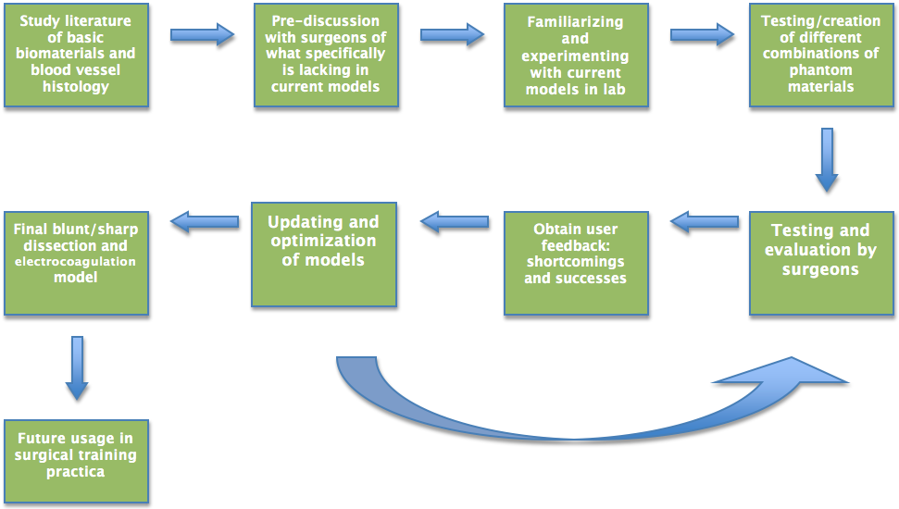
I proceeded to break the problem down into two focus areas: one part centered on building a blunt/sharp dissection model that focuses on the simulation of human tissue and the other part was building an electrosurgery model that focuses on the conductivity of the tissue and vessel phantoms. I worked with surgeons at JHMI MISTIC (Minimally Invasive Surgical Training Innovation Center) regarding what aspects are lacking in current models through repeated feedback and evaluation of models. For the blunt/sharp model, we finalized a cotton/Vaseline and rubber band model. This model simulated the elasticity and thickness of human tissue well, while rubber bands acted as blood vessels. For the electosurgery model, we used 3mm silicone tubing encased in a conductive gelatin gel/Jell-O substitute mixture. The gelatin gel recipe followed a basic porcine gelatin preparation with added salt for conductivity.

Management Summary
The blunt/sharp model underwent more trials and therefore received more feedback and evaluation than the electrosurgery model. Surgeons commented that the blunt/sharp model did a good job in training dexterity and maneuvering in a similar fashion to a realistic blood vessel dissection. The electrosurgery model was also successful in that the gelatin gel phantom modeled human tissue fairly well and the conductivity of the phantom allowed for the electric current to pass. The materials used were fairly cheap and easy to put together, as we had desired. The approximate price of both models was less than $10 per unit, which is many times more economical than commercially sold models. Surgeons evaluated the models based on their ability to realistically simulate human blood vessel dissection and in comparison to commercially sold products. Given more time, I would have liked to undergo more trials and evaluation for the electrosurgery model, due to the fact that it was delayed since I needed to find an adequately conductive gel material.

Had there been more time, one aspect that was left neglected was the electrocoagulation simulation. Blood has coagulative properties when subjected to heat, so it would have been possible to insert some fluid into the vessels that had these properties. However, it was difficult to exactly mimic the viscosity and exact properties of blood, so that would be a route to pursue. Additionally, more testing and evaluation for both models from different surgeons would be excellent, perhaps followed by integration into basic robotic surgery training curriculum. Also, it would be beneficial it find a more quantitative way of comparing these models to commercial versions and showing that these are up to standard. Furthermore, there may even be a potential to mass-produce these models once the exact manufacturing protocol is set and better understood.

Had I been given the opportunity to redo this project, I would allow for a much larger buffer region time-wise. I realized during the middle of my project that surgeons are busy people and as a result, evaluation took much longer than expected. Additionally, I would have enjoyed working with a partner or collaborating with others to examine more creative ideas and pursuits.

