|  |
| --- |
|  |
| X-Ray Image-Based Navigation for  Hip Osteotomy |
| Project Report |
|  |

##### Jesse Hamilton, Michael Van Maele

##### Mentors: Dr. Mehran Armand, Dr. Yoshito Otake, Ryan Murphy

###### May 10, 2012

###### (EN.600.446) Computer-Integrated Surgery II

###### Dr. Russell Taylor

## Introduction

### Summary

The periacetabular osteotomy (PAO) is a joint reconstruction surgery intended to increase femoral head coverage and thereby to improve stability in patients diagnosed with developmental dysplasia of the hip (DDH). The project mentors have previously developed a software suite for geometrical and biomechanical planning of PAO, dubbed the Biomechanical Guidance System (BGS). One of the most appealing features of BGS is intra-operative fragment tracking via a Polaris optical tracker system. However, because optical trackers are expensive, obtrusive, and not widely available in hospitals, alternative methods for fragment tracking and procedure navigation are desirable.

The first aim of this project was to develop a workflow and software pipeline for a novel, X-ray image-guided navigation system for performing PAO. The second aim was to compare the proposed pipeline to the current optical tracker-based procedure. The proposed procedure involves placing several metallic radiopaque BBs on (1) the uncut pelvis ilium to provide a virtual reference frame, and (2) the bone fragment undergoing realignment to allowing fragment tracking.

Once BBs are placed (but prior to realignment), multiple pre-operative C-arm images in different poses are acquired and subsequently registered to a pre-operative CT model. A small (3x3x5 cm) fluoroscopic tracker (named FTRAC) is non-rigidly placed in the field-of-view near the pelvis to facilitate the computation of image poses. After the surgeon realigns the fragment, several intra-operative C-arm images are acquired and registered to the CT model.

Using the pose information of the pre- and intra-operative X-ray images provided by the FTRAC, the rigid transformation mapping the unmoved fragment to the realigned fragment is computed. This transformation is then used to update the fragment location in the CT model. BGS then computes the radiographic angles and biomechanical measures, whose ideal values will be attained by proper fragment realignment.

In this study, the fragment transformation as computed by the optical tracker-based navigation system was used as the ground truth against which the accuracy of the X-ray method-derived fragment transformation was benchmarked. Two experimental trials (one phantom, one cadaver) were completed in this project, and the fragment transformation error and its interpretation form the core of the results of the study.

### Background

#### DDH

Development dysplasia of the hip (DDH) is a congenital defect characterized by an abnormally aligned acetabulum, or hip socket. Reduced coverage of the femoral head and high joint contact pressure are common consequences of this misalignment. Numerous complications are possible if these symptoms are left untreated, degenerative osteoarthritis being a particularly painful example.

As with other disorders of the hip, options for surgical treatment exist. However, hip arthroplasty is not a recommended recourse for patients who are young, active, or have unilateral DDH. Given that most DDH sufferers are women below the age of 30, these patients are likely to outlive mechanical joint replacements and require revision surgery. Concerns regarding prosthetic surface durability and preservation of bone stock also exist. Thus, a reformative surgery is the best option for long-term relief.

#### PAO

One common surgical intervention is the periacetabular osteotomy (PAO), which reorients the acetabulum to increase femoral head coverage and lower joint contact pressure. In particular, the Ganz osteotomy utilizes a single incision and four osteotomies. The Ganz osteotomy is not only an effective treatment for DDH, but it is also more comfortable than alternative procedures as it preserves the posterior column and vascular supply of the patient.

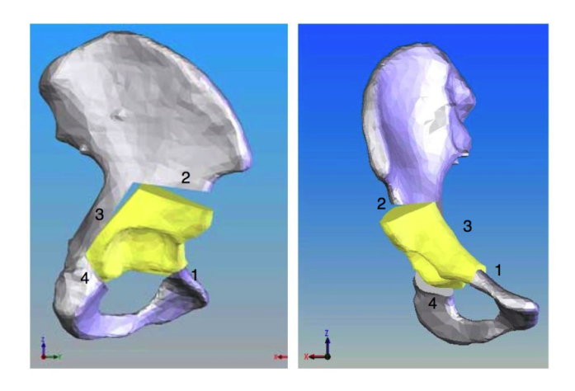

Figure 1 – 3D model of the hip (gray) and the fragment (yellow) created by PAO cuts (numbered).   
*Image courtesy of Ryan Murphy.*

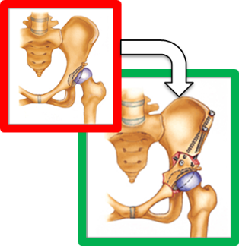

Figure 2 – Illustration of the PAO procedure to correct DDH.  
*http://www.hipandpelvis.com/patient_education/periace/page2.html*

#### BGS

Our research mentors have developed a software suite for the performance of computer-assisted PAO procedures, named the Biomechanical Guidance System (BGS). BGS allows both pre-operative procedure planning and intra-operative fragment tracking. A typical procedure using BGS begins with the acquisition of a full pelvic CT scan and then manual segmentation of the femur and pelvis. The Lunate-Trace algorithm segments the acetabulum and creates a surface mesh, and radiographic angles are computed from the CT image. During the planning stage, the software estimates contact pressures via Discrete Element Analysis (DEA)[1], and it suggests a reorientation of the acetabular fragment that minimizes simultaneous peak contact pressure in sitting, standing, and walking states.

### Current Tracking System (Optical)

BGS is also capable of intraoperative fragment tracking using a Polaris 3D position sensor. After performing a pivot calibration, a dynamic rigid body (DRB) is attached to the pelvis to serve as a fixed reference frame. A gross model-to-patient registration is performed by touching an optical pointer tip to four locations on the pelvis, and an iterative closest point algorithm performs fine surface registration. The surgeon chooses four confidence points on the ilium to serve as a fixed reference frame. After the osteotomy, the surgeon updates the model-to-patient registration by touching the four confidence points on the ilium and the four landmark points on the realigned fragment. BGS displays radiographic angles and biomechanical data indicating how the movement of the fragment might affect the joints of the patient. If necessary, the surgeon can adjust the realign the fragment additional times and update the registration until the desired outcome is achieved.

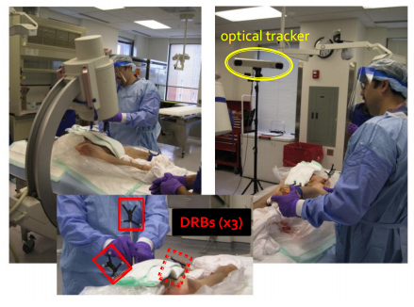

Figure 3 – Typical OR setup for the optical tracker-based navigation method during a PAO procedure.  
*Image courtesy of Ryan Murphy.*

### Project Motivation

Certain aspects of the optical tracker-based navigation system currently in use make an alternative navigation system desirable. Firstly, tracking may be interrupted by occlusion of the Polaris camera, which must have a clear line-of-sight to the DRBs.

Secondly, the registration process used by the optical tracker-based system requires the surgeon to drill a DRB into the ilium of the patient on the operative side. Avoiding such an invasive maneuver would be preferable.

Thirdly, optical trackers tend to be rarer in hospitals than other equipment which could serve as the basis of a navigation system. Moreover, when a camera is owned, it may not be available for PAO procedures if it has been designated a permanent component of a surgical system intended for another purpose.

Finally, most PAO surgeons are accustomed to working with X-ray images when performing orthopedic surgical procedures, and they are both more comfortable and more trusting of a navigation system native to X-ray images. These factors motivate the porting of the optical tracker-based navigation system to the proposed X-ray image-based navigation system described in this study.

## Solution Methodology

The proposed solution takes the form of a surgical data pipeline which implements the X-ray-based navigation method.

### Overview of Proposed Pipeline

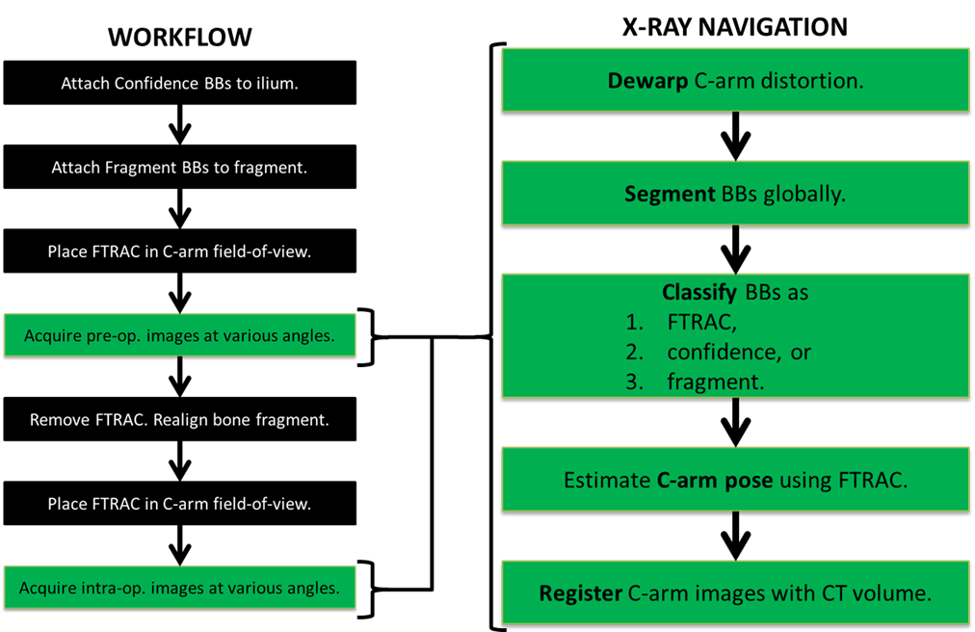

Figure 4 – High-level pipeline diagram

The surgeon begins by acquiring a pre-operative CT scan of the patient’s hip region. Next BGS constructs a 3D biomechanical model of the hip and femur and assists in planning the osteotomy. Intraoperative fragment tracking will be achieved using metallic, radiopaque BBs. It should be noted that this is similar to an FDA approved practice for radiostereometry analysis, in which tantalum beads are injected onto bone for tracking in certain orthopedic applications [RSA Biomedical 2009]. In our procedure, four confidence BBs are placed on the operative side of the ilium to provide a fixed reference frame,  and four BBs are attached to the acetabular fragment.

Before the fragment is realigned, the surgeon non-rigidly places a fluoroscopic tracker (FTRAC) [Jain 2005] within the field of view of the C-arm. The FTRAC is a fiducial containing points, lines, and ellipses in a configuration that allows the 6DOF C-arm pose to be uniquely calculated from any view. Two or more C-arm images are acquired at different orientations. Next BBs are segmented in the x-ray images and classified as confidence points, fragment points, or FTRAC points (Figure 5). The C-arm pose in each image is estimated using the FTRAC BBs. Confidence and fragment points are backprojected into a 3-dimensional patient coordinate frame and registered with the preoperative CT volume. This updates both the CT visualization and biomechanical data.

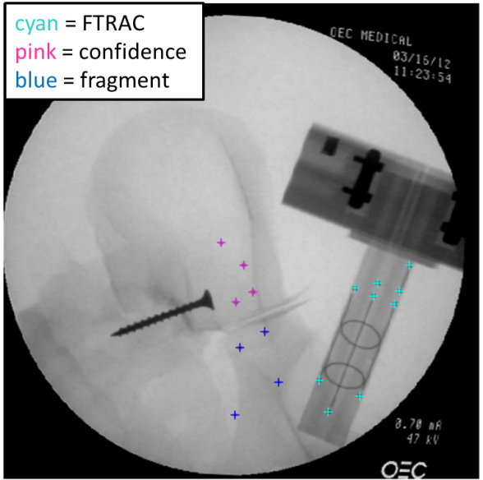

Figure 5 – Results of BB segmentation and classification on an image of a pelvic phantom and FTRAC.

After this imaging subroutine, the surgeon removes the FTRAC from the field of view and realigns the acetabular fragment. The surgeon repeats the imaging subroutine to confirm that the new configuration matches the biomechanical plan. The FTRAC is placed back within the field of view of the C-arm, and two post-realignment images are acquired at roughly 30° separation. The imaging subroutine is run to determine the transformation mapping post-realignment fragment BBs to pre-realignment fragment BBs. This information may be used to revise the osteotomy plan. The steps of realignment, imaging, and fragment transformation update can be repeated until the desired osteotomy result is achieved.

### Proposed Validation of Pipeline

The validation of the pipeline consisted of (1) frequent visualization of the progress of the pipeline at intermediate stages and (2) comparison of the fragment transformation output by the proposed pipeline to the transformation determined by the optical tracker-based navigation method.

The visualizations of the first validation process will be covered later. In the second validation process, the proposed pipeline was followed until the fragment transformation was obtained via the X-ray image-based navigation method. At that point, its accuracy was compared to the fragment transformation computed by the optical tracker-based navigation method. Note that the latter is considered to be the ground truth in the comparative error analysis contained in this report. The accuracy of the proposed method is covered in the experimental section.

### Technical Details of Pipeline Steps

The technical approach used in the proposed pipeline workflow will now be discussed in detail.

#### Distortion Correction

If a conventional C-arm with an x-ray image intensifier is used, then the raw images may be warped due to gravity-induced mechanical flex and interactions with the Earth’s magnetic field. Distortion correction was needed when using C-arm in the Johns Hopkins Swirnow mock operating room (Figure 6). A regular grid phantom was placed on the C-arm detector and an image was acquired. A distortion map was created by fitting Bernstein polynomials to the image of the grid. Although C-arm distortion is pose dependent, the distortion map was only created once pre-operatively. This introduced a potential source of error.

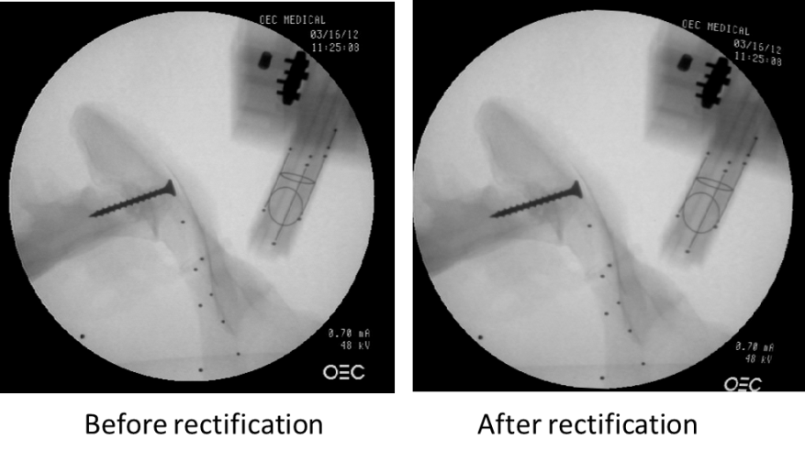

Figure 6 – Raw C-arm image (left) and image after dewarping correction.

#### Placement of BBs

In the current implementation, four confidence BBs were affixed to the ilium and four fragment BBs were attached on the acetabular fragment (Figure 7). To accurately compute the pre-to-post-realignment transformation of the fragment, it was necessary to use at least three non-coplanar confidence and fragment BBs each. In order to aid the automatic segmentation and classification algorithm, large diameter BBs were used for the confidence points and small diameter BBs for the fragment points.

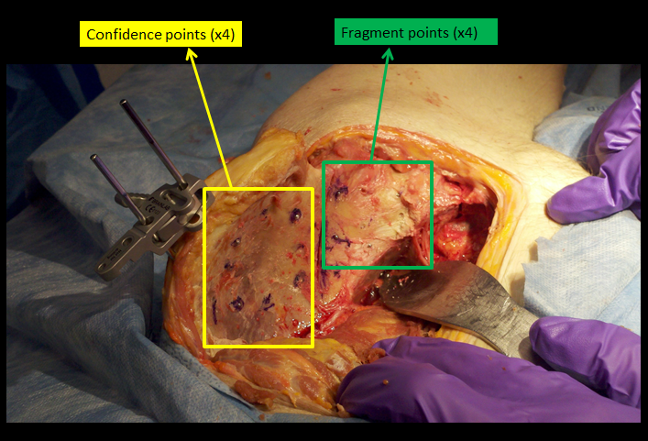

Figure 7 – Positions of confidence and fragment BBs on a cadaveric pelvis.

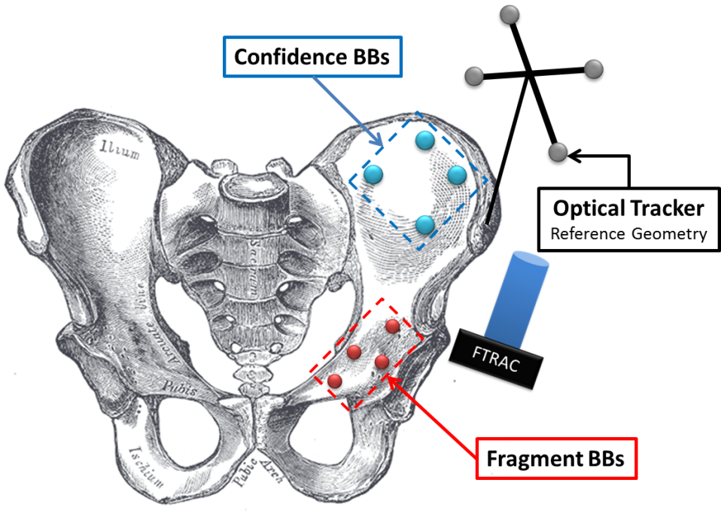

Figure 8 – Placement of confidence BBs (blue) and fragment BBs (red).

#### Method to Affix BBs

For the phantom experiments, BBs were purchased already containing adhesive, so it is straightforward to attach them to the pelvic model. During the cadaver surgeries, shallow burrs were drilled into the pelvis and BBs were fixated using Loctite superglue

#### Placement of FTRAC

The FTRAC was placed in the C-arm field of view in a non-rigid manner. As long as the FTRAC remained stationary while acquiring a set of images (pre-alignment or post-alignment), the C-arm pose could be estimated. It was permissible for the FTRAC to be placed in different locations for pre-realignment compared to post-realignment image set.

#### Acquisition of X-Ray Images

After placing the FTRAC within the field of view, at least two pre-operative C-arm images were acquired at roughly 30° separation. Next the FTRAC was removed and the fragment was realigned. The FTRAC was placed back in the field of view, and at least two intra-operative images were acquired.

#### Backprojection

The goal of this imaging procedure was to obtain a transformation which mapped pre-operative fragment points onto the intra-operative fragment points. In order to do this, BB locations had to be backprojected from the x-ray images into a 3-dimensional patient space (discussed below).

#### Segmentation of BBs

BB segmentation was performed using a radial symmetry algorithm provided by our mentors. To classify the BBs, the initial implementation of the pipeline prompted the user to manually draw loops around confidence, fragment, and FTRAC BBs with MATLAB’s roipoly() function (Figure 9). A later version attempted to automatically discriminate between confidence and fragments points based on size.

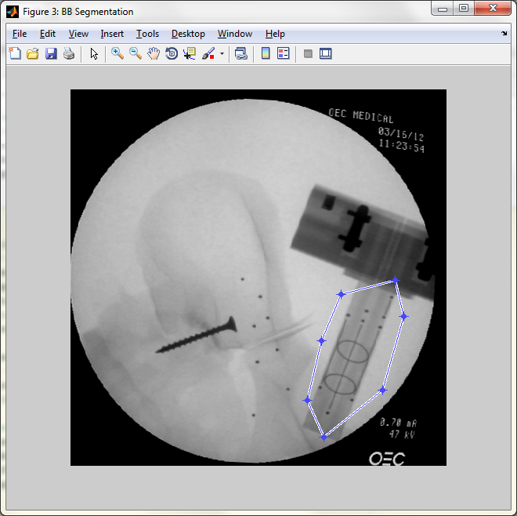

Figure 9 – Manual delineation of the FTRAC ROI.

#### Correspondences of BBs

In order to backproject the BB positions into a patient coordinate frame, it was necessary to know which BBs corresponded to one another across the multiple pre-operative (or post-operative) x-ray image sets.

One method we investigated for determining BB correspondences involved epipolar geometry. Epipolar geometry for a two-camera setup () is similar in principle to the acquisition of two C-arm images at different angles. In a setup with two cameras looking at a point , the image of one camera in the projection center of the other camera is called the epipole. An epipolar plane is defined by the two camera centers and , along with . The intersection of the epipolar plane with the left (right) image plane is called the left (right) epipolar line. According to the epipolar constraint, a point on the epipolar line in the left image must lie on the corresponding epipolar line in the right image.

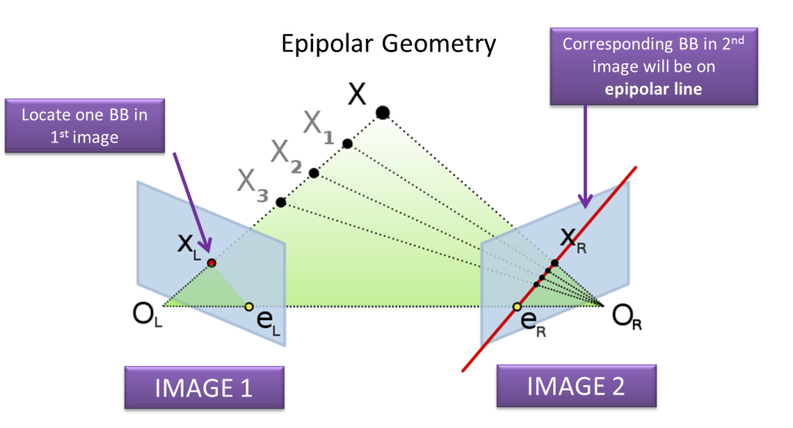

Figure 10 Epipolar geometry for a two-camera setup.

*http://en.wikipedia.org/wiki/Epipolar_geometry*

In this project, given a BB located in one x-ray image, the same BB in a second x-ray image should be found along its epipolar line. One problem is that several BBs may be located on the epipolar line. To alleviate this, more than two x-ray images could be used, and the BB would be located at the intersection of their epipolar lines.

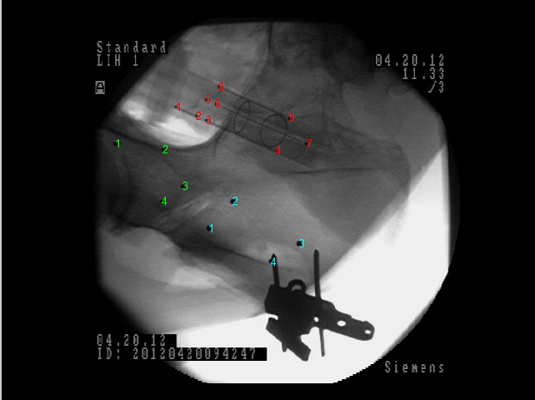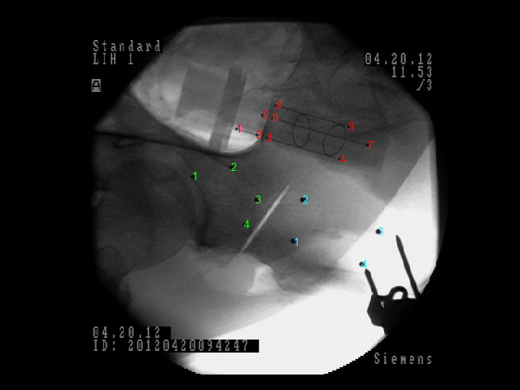

FTRAC

confidence

fragment

Figure 11 – BB correspondences were manually entered and verified by numbering the BBs in each image.

Because of difficulties with the epipolar implementation, BB correspondences were hard-coded manually. Figure 11 shows numbered FTRAC, confidence, and fragment points in two pre-operative images.

#### Pose Estimation

Two algorithms for estimating C-arm pose were investigated: Pose from Orthograph and Scaling (POSIT) and Expectation Conditional Maximization (ECM).

POSIT is an iterative algorithm for estimating object pose from a single image. In the pipeline, it uses at least four non-coplanar FTRAC BBs as feature points. One advantage of the algorithm is that it does not require an initial guess. However, feature point correspondences between the images must be known.

In contrast to POSIT, ECM does require prior knowledge of matching feature points. The algorithm iteratively updates a correspondence probability between each pixel in the first image with each pixel in the second image. However, convergence to the correct solution is sensitive to the estimated pose used for initialization. In this implementation of the pipeline, results from POSIT were used to initialize ECM.

Both of these pose estimation algorithms output an extrinsic parameter matrix, which maps points from the C-arm reference frame to the known world reference frame (the FTRAC-centered patientframe). The intrinsic parameters of the C-arm are known from pre-operative calibration and stored in a matrix .The projection matrix that transforms points from 3-dimensional patient space to x-ray image space is given by . If we assume there are pre-operative (or intra-operative) x-ray images, then there are projection matrices, .

#### Backprojection

In order to begin to compute the desired fragment transformation, the 3-D coordinates of the BBs in the FTRAC reference frame must be recovered. These may be computed from the 2-D coordinates of the BBs in the X-ray images via *backprojection*.

This mathematical transform utilizes the previously obtained projection matrices to backproject the 2-D coordinates into the 3-D FTRAC reference frame. In this investigation, original code was combined with pre-existing code (provided by the project mentors) to achieve backprojection.

Recall that the projection matrices for image views (obtained via the pose estimation functions) are given by

Equation 1 – Projection matrices obtained via pose estimation functions.

Consider the 2-D locations of a particular BB in each of the X-ray images, given by

Equation 2 – 2-D coordinates of a particular BB in each of the X-ray images.

Define the ray pointing from the *detector source* (of the C-arm) to the 2-D coordinate of the BB in the th X-ray image as

Equation 3 – Direction of ray pointing from the C-arm source to the 2-D coordinate of the BB in the th X-ray image.

Consider the position of the X-ray source in the FTRAC reference frame for the th X-ray image to be defined as

Equation 4 – Position of the X-ray source in the FTRAC reference frame for the th X-ray image.

Determining the 3-D coordinates of the backprojected point can be cast into a least squares minimization problem.

Equation 5 – Minimization which will give the 3-D coordinates of the backprojected point, .

The reason that the above minimization expression holds is that the 3-D coordinates of the backprojected point can be defined as the intersection of the lines which join the source of each X-ray image to 2-D coordinate of the BB point in that X-ray image. To see this more clearly, please refer to the figure below.

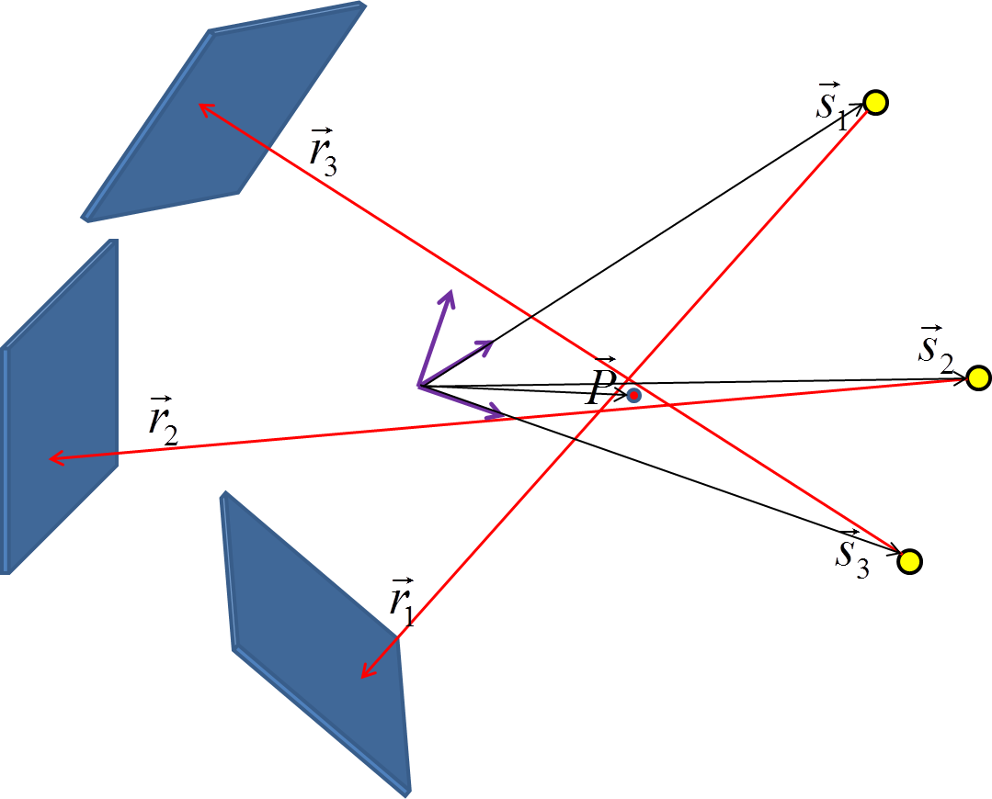

Figure 12 – The variables which appear in the backprojection transform and their corresponding relationships in the FTRAC reference frame.

Formally rewriting Equation 5 as a least squares minimization problem gives rise to the following:

Equation 6 – Least squares minimization problem leading to the 3-D coordinates of the backprojected point . It is solved by .

Note that the variables named in Equation 6 are computed along with in the solution to the least squares minimization but are only of interest when the *residual* is computed (that is, the distance between each backprojection line and the computed point ).

Solving the least square equation (as defined in Equation 6) allows to be recovered from . This procedure amounts to minimizing the red leg of the right triangle depicted below:

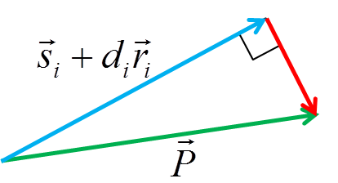

Figure 13 – The values of and which minimize the red leg of this right triangle are sought in Equation 6.

After the 3-D coordinates of each BB point with respect to the FTRAC reference frame have been recovered by this treatment, the fragment transformation may be computed. To do this, standard reference frames must be defined with respect to the confidence and fragment BBs.

#### Standard Reference Frames

One of the main goals of the pipeline was to determine transformation mapping pre-realignment fragment points to post-realignment fragment points. In order to compare the value of this transformation given by the optical method and x-ray navigated procedure, it was necessary to compute a standard confidence reference frame (CRF) and a standard fragment reference frame (FRF). For illustration purposes, the discussion describes how the CRF was created.

The four confidence points given in FTRAC-centered patient space are called and . The axes of the standard frame are defined as such:

**x-axis:**

**z-axis:**

**y-axis:**

If we denote the three components of as , and (and similarly for and ), the rotational part of the transformation from FTRAC-centered patient space to the CRF is

The origin of the CRF is chosen as the center of mass of the confidence points: . This is also the translational component .

#### Obtaining the Fragment Transformation

Table 1 shows the notation used in this section. In addition denotes the transformation that takes coordinate frame to frame .

|  |  |
| --- | --- |
| Notation | Description |
| FRF | **F**ragment point standard **r**eference **f**rame |
| CRF | **C**onfidence point standard **r**eference **f**rame |
| FTRAC_pre | FTRAC world frame, pre-realignment |
| FTRAC_post | FTRAC world frame, post-realignment |
| Opt_pre | Optical tracker frame, pre-realignment |
| Opt_post | Optical tracker frame, post-realignment |

Table 1 – Notation used when obtaining the pre-to-post fragment transformation.

For the X-ray-navigated system (Figure 14), the pre-realignment to post-realignment fragment transformation was computed as

An analogous procedure was used to obtain the fragment transformation using the optical data (Figure 15):

The accuracy of the transformation was quantified by computing

and extracting the translational error and Euler angles .

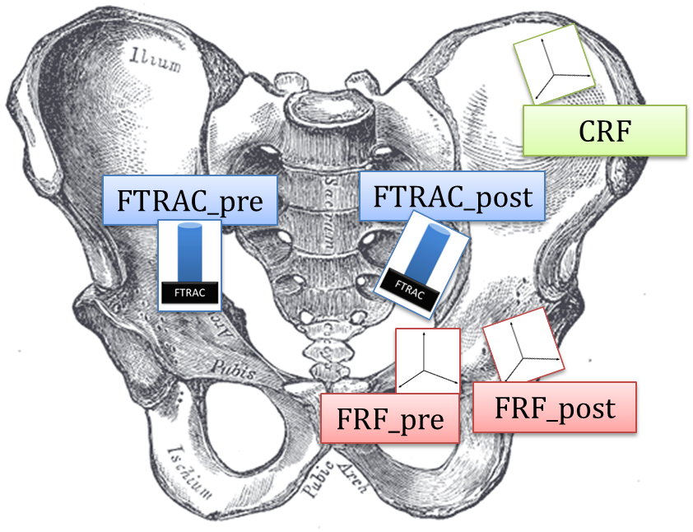

Figure 14 – Coordinate frames for determining pre-to-post fragment transformation from x-ray navigation.

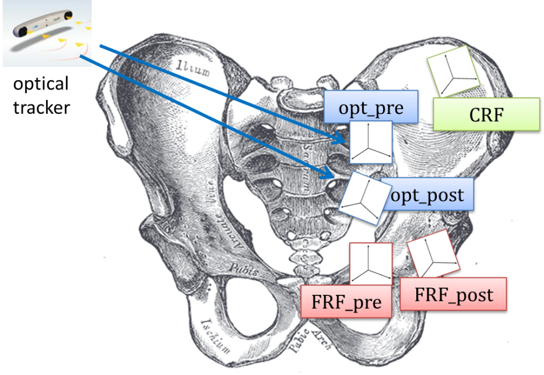

Figure 15 – Coordinate frames for determing pre-to-post fragment transformation from optical data.

## Experiments

Two different experiments were designed and carried out during the development and testing of the novel X-ray image-based navigation pipeline.

In both cases, the optical tracker-based navigation method was use alongside it, and the registration it provided was treated as the ground truth when considering the fragment transformation error produced by the X-ray navigation system. Also, the final integration with the BGS system (i.e. online function) was excluded from testing.

The details of the two experimental setups are discussed below. Note that the software pipeline details of Experiment 1 and Experiment 2 essentially the same and are discussed in the methodology section, and that only the physical protocols of the experiments are reviewed in this section.

### Experiment 1: Phantom Study

#### Goals

The first test of the proposed method was executed on a phantom pelvis. The threefold goals of the experiment were

1. to demonstrate proof of concept for the proposed X-ray-navigated procedure using non-rigid FTRAC attachment,
2. to acquire raw C-arm images of the phantom pelvis with BBs attached to it for use during offline pipeline code assembly and debugging (carried out in MATLAB) , and
3. to collect calibration images for mock OR C-arm device for use during pipeline code assembly and debugging.

#### Materials

Below is a list of materials crucial to each navigation type (not included is the optically tracked pelvic phantom).

|  |  |
| --- | --- |
| X-Ray Navigation | Optical Tracker Navigation |
| * eight (8) BBs, radius 1.5 mm | * Polaris® optical tracker camera |
| * FTRAC | * optical tracker system |
| * C-arm (JHU Homewood mock OR) | * pointer tool (optically tracked |

#### Methods

Figure 16 presents a summary of the workflow employed in this experiment.

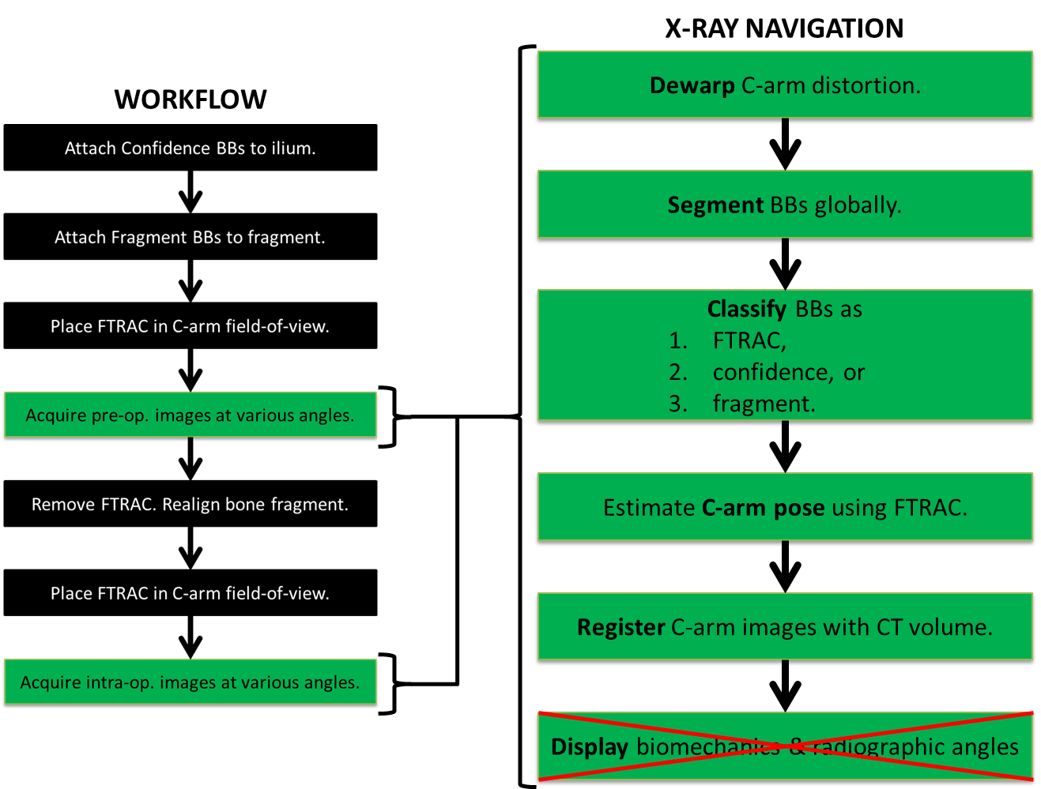

Figure 16 – Experiment 1 workflow (pelvic phantom). Note that the final step of the X-Ray Navigation subroutine was ultimately excluded because the experimental protocol was conducted offline (i.e. detached from BGS).

Step 1: *Attach confidence BBs to ilium.*

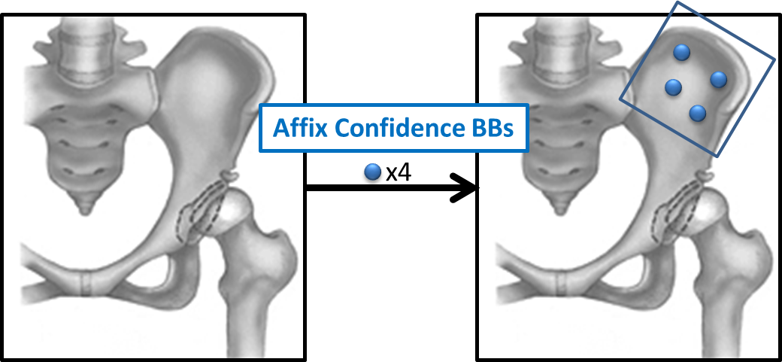

Figure 17 – In Step 1, the confidence BBs were affixed to the operative ilium via drilling and super glue.

In Step 1, the confidence BBs were affixed to the operative ilium. Their purpose was to establish a virtual reference frame. Defining a local coordinate system with respect to the confidence BBs proves useful when computing the fragment transformation (this is discussed more in the results section).

Step 2: *Attach fragment BBs to acetabular fragment.*

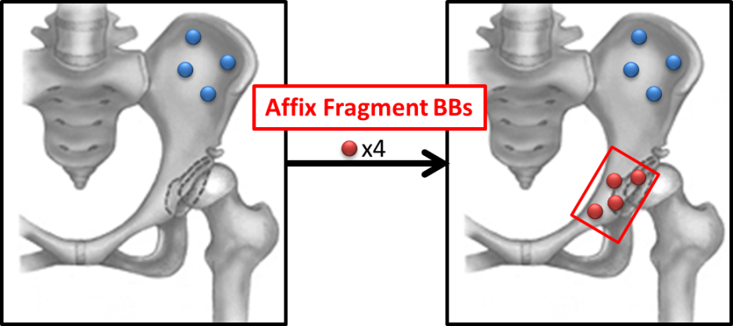

Figure 18 – In Step 2, the fragment BBs were affixed to the fragment via drilling and super glue.

In Step 2, the fragment BBs were affixed to the fragment created by the first two cuts of the PAO procedure. These BBs were used to track the motion of the fragment.

Step 3: *Place FTRAC in C-arm field-of-view.*

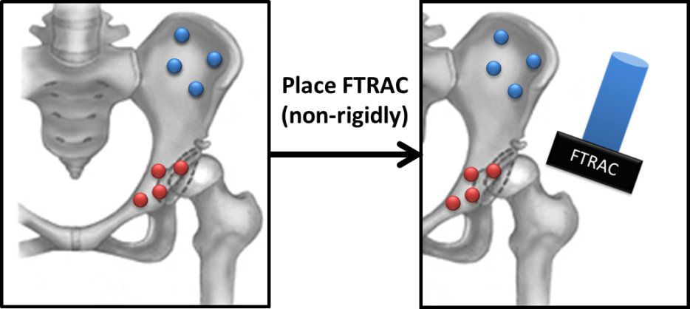

Figure 19 – In Step 3, the FTRAC is non-rigidly placed in the field-of-view of the surgical site.

Step 4: *Acquire pre-op. X-ray images at various angles.*

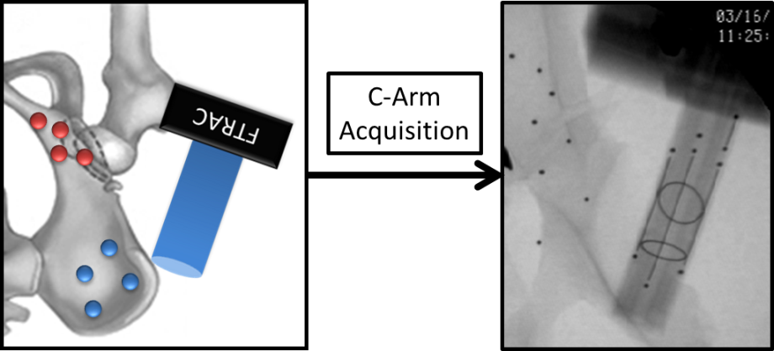

Figure 20 – In Step 4, pre-operative X-ray images of the surgical site are taken at various angles.

In Steps 3 and 4, the fluoroscopic tracker (FTRAC) is non-rigidly placed in the field-of-view of the surgical site, and a series of images are taken with the C-arm imager at various angles. The FTRAC must be present in each of the X-ray images. Most importantly, it *must not move* from one image to the next among the two sets of pre-operative and intra-operative images. That is, the position of the FTRAC must not change between each of the images taken in the pre-operative image set, and likewise for the intra-operative image set. Any movement would compromise the pose estimations.

Step 5: *Remove FTRAC. Realign bone fragment.*

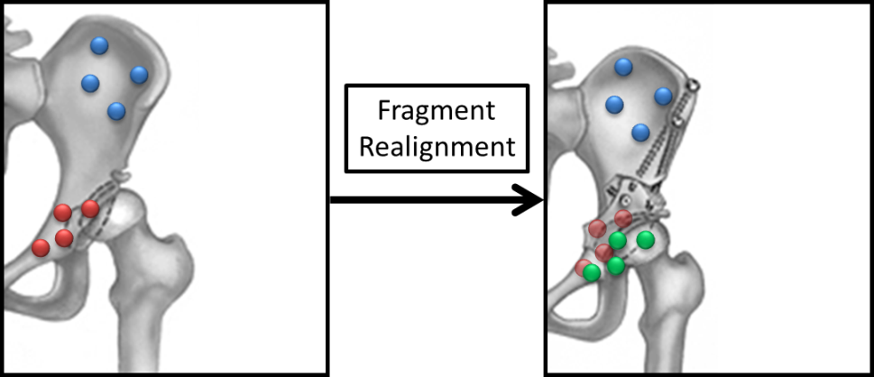

Figure 21 – In Step 5, the FTRAC is removed from the operating block and the fragment is realigned. In the right-hand side image, the new fragment BB locations are shown in green.

Steps 6 & 7: *Place FTRAC in C-arm field-of-view and acquire intra-op. X-ray images at various angles.*

By a procedure exactly analogous to that performed in Steps 3 and 4, the FTRAC is placed once again in the field-of-view of the surgical site, and a series of images are taken with the C-arm imager at various angles.

#### Image Dewarping

The C-arm imager housed in the JHU Homewood mock OR is relatively susceptible to distortion. Therefore, an extra step consisting of image dewarping proved necessary, as was described in the Solution Methodology.

The data from Experiment 1 was analyzed in an offline manner and the results are discussed in the next section.

#### Optical Tracker Registration

The optical tracker-based method was utilized to obtain a “ground truth” registration against which to compare the quality of the results obtained from the X-ray-based method. The protocol followed to obtain this registration is not an original contribution and is therefore not described here.

### Experiment 2: Cadaver Study

#### Goals

The second test of the proposed method was executed on a cadaveric pelvis. The threefold goals of the experiment were

1. to test the durability of BB fixation on biological tissue,
2. to prove the robustness of the proposed method on a human tissue data set (as opposed to a synthetic phantom), and
3. to enact the pipeline protocol in a realistic surgical scenario.

Note that prior to this experiment, a test of BB fixation was performed on a human femur specimen. The test confirmed that drilling a burr, adding super glue, adding the BB, and coating it with more super glue was a viable method of BB fixation on the cadaveric tissue in the case of the femur sample. This indicated that the BB fixation was likely to work on the cadaveric pelvis. Importantly, this fixation method is not clinically applicable, and another method would have to be proposed for the X-ray image-based navigation system to be taken to clinical trials.

#### Materials

Below is a list of materials crucial to each navigation type. Not included is the optically tracked cadaveric pelvis (the cadaveric specimen was a donor body intact from the waist to the feet).

|  |  |
| --- | --- |
| X-Ray Navigation | Optical Tracker Navigation |
| * four (4) confidence BBs, size 3 (large) | * Polaris® optical tracker camera |
| * four (4) fragment BBs, size 8 (small) | * optical tracker system |
| * FTRAC | * pointer tool (optically tracked) |
| * C-arm (JHU Bayview Alpha Center) |  |

#### Methods

The methods followed in this experiment are identical to those prescribed for Experiment 1 in Figure 1 with two notable exceptions:

1. The cadaveric specimen was intact on arrival, and the PAO procedure therefore had to be performed in full (by Dr. Armiger in this case). This contrasts with Experiment 1 where the pelvic phantom was pre-broken at the fragment line, and the reorientation of the fragment was achieved by simply shifting the fragment piece without any surgical tools.
2. Due to issues of occlusion, the acetabular fragment had to be reoriented more than one time before good quality intra-operative X-ray images (i.e. all BBs visible) were obtained.

#### Optical Tracker Registration

It is important to mention once again that the optical tracker-based method was used during the cadaveric study to obtain a ground truth registration. As before, the details of the protocol for that method are not mentioned here.

## Results

Results are presented for the cadaver surgery.

*Pose Estimation (POSIT vs. ECM)*

The accuracy of the POSIT and ECM algorithms for pose estimation were compared. Let the projection matrix for image calculated by each algorithm be dentoed and , and let the coordinates of FTRAC point in 3-dimensional FTRAC-centered patient space, where , be denoted . The values of are known from the CAD model of the FTRAC. The estimated projections of the FTRAC points in x-ray image space were computed as

The manually segmented position of the FTRAC BB in image is dentoed by and is treated as the ground truth. The errors reported in the following tables are the Euclidean distances and for the three post-realignment C-arm images. Figure xxx shows overlays the estimated projections of the FTRAC points on a representative post-realignment x-ray image.



Figure 22 – Estimated projections of FTRAC points by manual, ECM, and POSIT segmentation



Table 2 – Projection errors in post-realignment images from POSIT.



Table 3 – Projection errors in post-realignment images from ECM.

*Fiducial Registration Error*

The fiducial registration error (FRE) between the optical and x-ray navigated systems were compared using four sets of points: (1) pre-realignment confidence points, (2) post-realignment confidence points, (3) pre-realignment fragment points, and (4) post-realignment fragment points.

FRE was computed by first taking a point cloud registration between optical points and x-ray navigated points . The point cloud transformation was applied to the x-ray navigated points to yield estimated optical points, . FRE was calculated as

In this case, because there are four confiden ce (or fragment) points.



Figure 23 – Fiducial registration errors (mm)

A visual representation of the FREs are given in Figure 24. These plots overlay the optical points and estimated optical points on the pre-operative CT model of the pelvis. The leftmost plot shows pre and post-realignment fragment points, and the right plot shows pre- and post-relaignment confidence points.

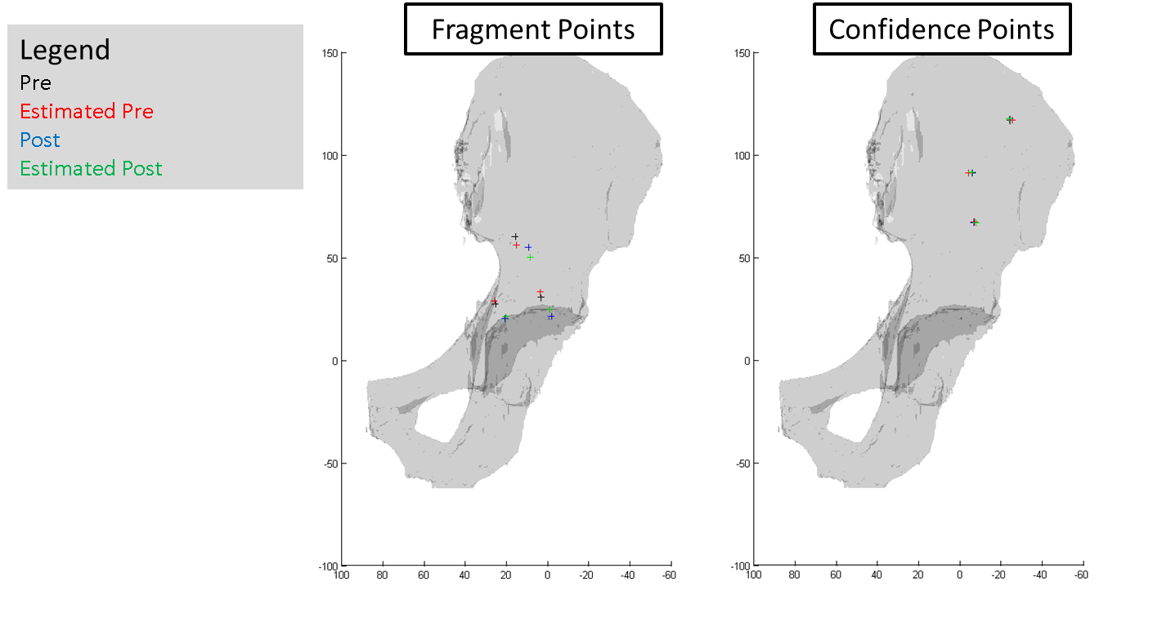

Figure 24. Plots of points measured directly by optical tracker (pre, post) and x-ray navigated points registered to optical tracker space (estimated pre, estimated post). See text for discussion

*Transformation Error*

The transformation that mapped the pre-realignment to post-realignment fragment points was compared using the proposed x-ray navigated method and the current optical tracking procedure. Data from the optical tracker was regarded as ground truth. Denote these transformations as and . See Solution Methodology for a discussion of how to compute these unknown transformations from known transformations. The transformations are given below:

An error transformation was calculated as

If both the x-ray and optical navigation gave identical results, would be the identity matrix. However, due to measurement inaccuracies, noise, and possible bias in both methods, this was not the case. was decomposed into its translational and rotational error components, where the rotations are reported as Euler angles. The two rows in Table xxx shows this decomposition for when pose estimation was performed using ECM and POSIT.



Figure 25 – Translational and rotational errors in the

## Discussion

**Error Analysis**

The FREs were of reasonable magnitude and were comparable between ECM and POSIT. Surprisingly, ECM yielded larger translational and rotational errors of compared to POSIT. This result was surprising considering the data in Table 3 – Projection errors in post-realignment images from ECM., which shows that ECM generally gave lower errors for estimating projections of FTRAC points in x-ray images. As described earlier, both algorithms have their own advantages and disadvantages. While ECM does not require prior knowledge of corresponding feature points, it does require an initial estimate of the pose. In contrast, POSIT requires prior knowledge of matching feature points but does not need initialization. The correspondenceless property of ECM makes it an attractive algorithm for the x-ray navigation pipeline since FTRAC BBs do not have to be matched to one another across several x-ray images to estimate the pose.

With both ECM and POSIT, the translational error in the z-direction was much larger than the x- and y-translational errors. This result was expected since it is generally more difficult to localize points in the direction perpendicular to the imaging plane due to projection physics.

There are several sources that may have contributed to errors in the x-ray and optical measurements. In the x-ray navigation pipeline, a first-pass BB segmentation was performed using radial symmetry. However, the algorithm would occasionally miss BBs, and these were manually selected by the user. Slight inaccuracies in the these BB positions would effect the pose estimation, backprojection, 2D-3D registration, and estimated pre-to-post fragment transformation. In addition, the confidence BBs had a larger diameter than the fragment and FTRAC BBs, making it difficult to precisely locate their centers. It is also possible that the FTRAC moved slightly while acquiring sets of pre-operative or intra-operative C-arm images, contributing to pose estimation error.

**Future Work**

There are several directions for future work. It would be desirable to automate the classification of confidence, fragment, and FTRAC BBs using epipolar geometry. Although manually segmenting BBs is accurate and relatively fast, automating the classification would reduce surgical time and preclude misclassification by the user. The method for fixating BBs in the cadaver surgery (namely, drilling a bone burr and applying adhesive) is not suitable for a live patient. One future direction would be to investigate safe ways to fixate BBs in patients—for example, by using an injector similar to that produced by RSA Biomedical.

In theory it should be possible to perform pose estiamtion without using the FTRAC. The size and weight of the FTRAC can be slightly obtrusive during surgery. If the configuration of confidence points is known, they could serve the same purpose as the FTRAC with pose estimation.

## References

1. Armand M, Lepisto J, Tallroth K, Elias J, Chao E. Outcome of periacetabular disease. Acta Orthopedica 2005;76(3):303-13.

2. Armiger RS, Armand M, Lepisto J, Minhas D, Tallroth K, Mears SC, Waites MD. Evaluation of a computerized measurement technique for joint alignment before and during periacetabular osteotomy. Computer Aided Surgery 2007;12(4):215-24.

3. Armiger RS, Armand M, Tallroth K, Lepisto J, Mears SC. Three-dimensional mechanical evaluation of joint contact pressure in 12 periacetabular osteotomy patients with 10-year follow-up. Acta Orthopedica 2009 04;80(2):155-61.

4. Chintalapani G, Jain AK, Taylor RH. Statistical characterization of C-arm distortion with application to intra-operative distortion correction. Proc SPIE 2007;6509:65092Y.

5. David P, Dementhon D, Duraiswami R, Samet H. SoftPOSIT: Simultaneous pose and correspondence determination. International Journal of Computer Vision 2004 09/15;59(3):259-84.

6. Dementhon DF, Davis LS. Model-based object pose in 25 lines of code. International Journal of Computer Vision 1995;15(1):123-41.

7. Jain AK, Mustafa T, Zhou Y, Burdette C, Chirikjian GS, Fichtinger G. FTRAC---A robust fluoroscope tracking fiducial. Med Phys 2005 October 2005;32(10):3185-98.

8. Kang X, Taylor RH, Armand M, Otake Y, Yau WP, Cheung PYS, Hu Y. Correspondenceless 3D-2D registration based on expectation conditional maximization. Proc SPIE 2011 March 3, 2011;7964(1):79642Z.

9. Millis MB, Murphy SB. Osteotomies of the hip in the prevention and treatment of osteoarthritis. The Journal of Bone & Joint Surgery 1995;41:626-47.

10. Otake Y, Armand M, Armiger R, Kutzer M, Basafa E, Kazanzides P, Taylor R. Intraoperative image based multi-view 2D/3D registration for image-guided orthopaedic surgery: Incorporation of fiducial-based C-arm tracking and GPU-acceleration. Medical Imaging, IEEE Transactions on 2011.

1. DEA estimates contact pressures using spring models and physical cartilage parameters. Consult the thesis of Ryan Murphy for more information about the application of DEA in BGS.