Stephen Chen

CIS 2: Paper Seminar

3/05/15

**Project Description:**

Venous Thromboembolism (VTE) is a disease process that includes both Deep Vein Thrombosis (DVT) and Pulmonary Embolism (PE). DVT is caused by blood clots forming in the deep vein. ⅓ of the time, DVT may suddenly lead to PE which can be fatal. PE happens when the blood clot detaches from the deep vein and makes its way over to the pulmonary vein, obstructing the blood flow through the lungs.

Since VTE is most prevalent in hospitals, we propose to develop a clinician performance review tool for risk-appropriate VTE prophylaxis. The tool will be able to keep track of clinician compliance, ranking clinicians anonymously with their peers. Additionally, it should be able to combine with the output from the APL NLP algorithm and allow for rich, automated retrospective analysis on past prophylaxis data.

**Paper:** Impact of a venous thromboembolism prophylaxis “smart order set”: Improved compliance, fewer events

**Authors:** Amer M. Zeidan, Michael B. Streiff, Brandyn D. Lau, Syed-Rafay Ahmed, Peggy S. Kraus, Deborah B. Hobson, Howard Carolan, Lambrianidi Chryso, Paula B. Horn, Kenneth M. Shermock, Gabriel Tinoco, Salahuddin Siddiqui, and Elliott Haut

I chose this paper because it gives additional background information about our project as well as gives actual statistics on the effectiveness of the VTE CDS tools. In doing so, it provides insight for further statistical analysis that can be done in this realm.

**Background information:**

Venous thromboembolism is a disease process that affects over 700,000 Americans each year. Medical patients constitute the majority that suffer from venous thromboembolism (VTE). The risk of acquiring VTE can be allayed with risk appropriate VTE prophylaxis treatment. However, many hospitalized patients do not end up receiving risk-appropriate prophylaxis. In fact, in 2005, suboptimal VTE prophylaxis practices were noticed at the Johns Hopkins Hospital. This led to the development of a smart order set. This smart order set is called a “VTE risk stratification and prophylaxis recommendation tool”. It is the smart order set to be used for all admitted medically ill patients. This tool consists of two checklists and outputs the risk-appropriate VTE prophylaxis for the clinician to prescribe. This system is an opt-in system where clinicians can, at any time, override the recommended prophylaxis.

The choices that the smart order set makes can be represented by a simple flow chart:





The hypothesis of this paper was that implementation of a VTE prophylaxis “smart order set” would increase order for risk-appropriate VTE prophylaxis and decrease VTE events without compromising safety.

**Methodology:**

A retroactive cohort study was done on patients. The researchers picked two months, November 2007 (1 month prior to smart order set activation) and April 2010 (1 month prior to data collection). The Johns Hopkins Patient Record and Computerized Provider Order Entry were manually reviewed by the researchers. There was a comparison of VTE prophylaxis patients pre and post-implementation, using 2-sided chi square tests for categorical variables and unpaired t-tests for continuous variables. The independent variables compared were patient demographics as well as risk factors and contraindications.

**Key Results:**

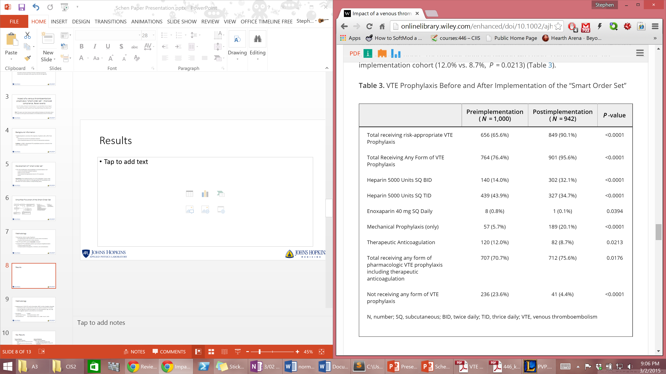

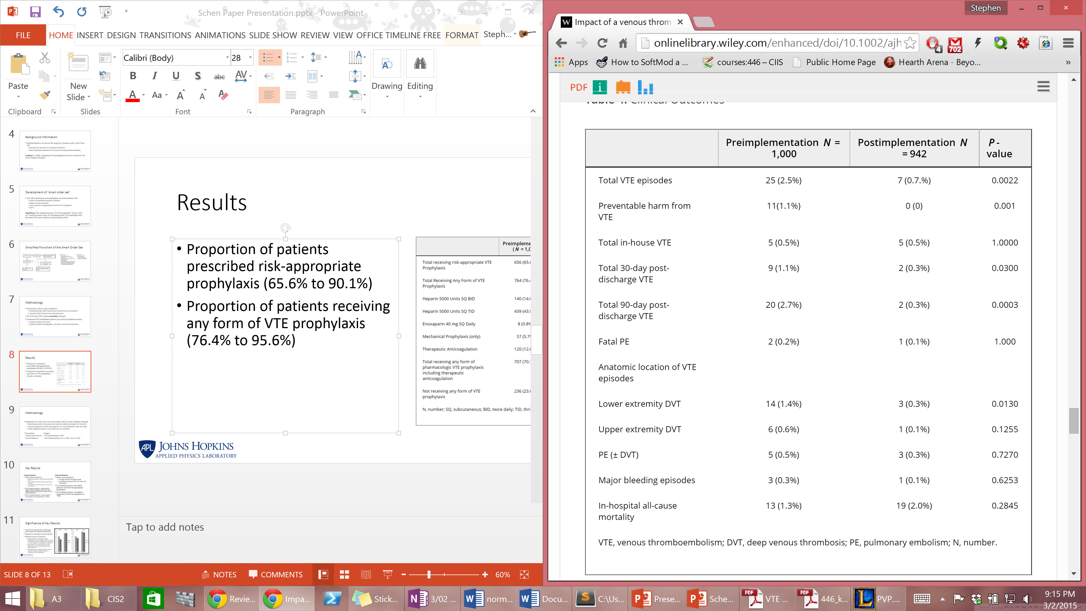

**Significance of Key Results and Conclusion:**

The paper concluded, from these results that patients were being harmed as far as the frequency of VTE events went, when clinicians did not follow the set guidelines for risk appropriate prophylaxis. It emphasized the importance of evidence based, well-validated risk stratification tools. Also, the paper concluded that patients who undergo risk-appropriate prophylaxis for VTE do not have their health compromised when looking at major bleeding episodes and in-hospital all-cause mortality.

For future directions, this paper talked about incorporating an alert function for prompt risk assessment and a real-time provider report card to improve compliance.

**Personal Thoughts:**

I believe that this paper shows the importance of risk-appropriate prophylaxis and the associated smart order set. It does this with a large sample size (~1000 for both the group before the smart order set and the group after its activation). The p-values of <0.0001 show that there is a very high statistical probability that the use of the smart-order set results increases the probability of clinicians giving risk-appropriate prophylaxis. Additionally, the study also makes a point to show that both total VTE episodes went down (from 25 occurrences to 7 occurrences with a p value of 0.0022).

The study then makes slightly more dubious assumptions. For instance, it talks about how it eliminated the occurrence of preventable harm from VTE. In the paper, preventable harm was defined as VTE in the absence of risk-appropriate VTE prophylaxis. However, it seems like some of the patients, even in the presence of risk-appropriate prophylaxis, got VTE (7 of them). This makes it seem that this was more of a statistical anomaly and that if one were to repeat this experiment for a separate date, the results may not indicate quite so confidently that one can eliminate preventable harm. A larger sample size would be needed to make a stronger conclusion.

The author also claims that there was no statistical difference for patient harm due to the prophylaxis treatment between the pre-implementation and the post-implementation. However, numerically, with the same sample size of ~1000, we can see how the in-hospital all mortality actually went up (from 13 to 19). Whether or not this was caused by the VTE prophylaxis treatments themselves remains inconclusive due to the p value of 0.2845. This was mostly caused by the fact that hospital mortalities in general are rare and thus, similarly, needs a larger sample size in order to make a useful diagnosis.

Additionally, this study does not survey to see if nurses actually carried out the prescribed intervention. During our interview with our mentor, Brandyn Lau, this has actually been a problem where unfortunately, about only 70% of the nurses actually follow the prescribed prophylaxis that they are given.

Last but not least, the study also only had a small scope, only looking at medically ill patients. There’s a separate smart order set for trauma patients and the efficacy of that tool was not assessed.

Looking towards the future, we will create an automated clinician report tool to increase compliance as well as well as allow for retrospective data analysis. This would be done in hopes of solving the problem of having too small of a sample size. Part of the reason why the sample size was so small, seemed to have stemmed from the fact that the data was manually taken out of the database by the researchers. We hope to be able to automate the process and create useful retrospective trends. Additionally, we hope to combine the results from the clinician report tool with the APL VTE NLP tool to generate more conclusive statistics on the efficacy of the smart order set in a broader range of patient populations, allowing a non-compliant clinician to view patient outcomes that may reinforce compliance as well as give the researcher a larger pool to draw useful statistics from. Ultimately, our tool will be the base by which future performance evaluation tools can be built on top of, allowing for performance evaluation of not only the residents and the doctors, but also for the nurses themselves, improving healthcare by bringing every aspect of it as close to the standard as possible.