Alex Vacharat
Critical review of the scientific research paper “Virtual Remote Center of Motion Control for Needle Placement Robots”, by E. Boctor et al.
Paper Choice Justification
This paper was chosen as part of the research of methods for solving the unstable remote center of motion (RCM) of the Robotic Needle Driver. It presents a method for algorithmically correcting the error using motors during operation via a heuristic search. This method provides users to capability to implement devices which do not require careful construction of the robot about the fulcrum point [1]. Furthermore, the user does not need to have a priori knowledge of the kinematic chain [1]. However, since the robot constructed in our lab, the Johns Hopkins URobotics Laboratory, was carefully constructed and only contains an error on the scale of a couple of millimeters, we have decided to forego algorithmic correction and attempt a mechanical correction. This paper presented a possible alternative solution to our problem however, and careful consideration was given to the methods presented before deciding on a path forward.
Technical Summary
Many surgical robots implemented today, such as the da Vinci™ laparoscopic surgery machine (©Intuitive Surgical), incorporate a remote center of motion as their core method of actuation. As such, much research has been done on RCM robots due to their potential for medical applications. RCM surgical robots offer many advantages over traditional surgical methods, including but not limited to:
- High accuracy and precision
- Virtual and physical barriers for patient protection
- Needle tip tracking
- Wide range of motion from a single entry point
Boctor et al. describes some disadvantages associated with implementing an RCM module as well. These include:
- “Precise construction must guarantee the existence of a known fulcrum point” [1]
- “A tool holder must be carefully designed for each new tool, placing it exactly on the fulcrum point” [1]
- “Each joint must be fully encoded” [1]
- “The kinematic chain must be a priori known” [1]
Due to the very strict requirements associated with constructing an RCM module, Boctor et al. also suggest generating a virtual RCM in software by using a combination of precise and dynamic kinematic models of the robot [1]. Boctor’s group successfully united a programmed-RCM robot with an AI-based search algorithm, eliminating the need for encoded joints or complete knowledge of robot kinematics, and resulted in a quickly convergent needle placement actuation [1].
In order to implement their method, Boctor’s group purposely eliminated the Stoianovici rotation stage [2], and held the needle tip off of the RCM point [1]. In their virtual RCM implementation, they decouple the pitch and yaw of the robot and move each of them individually and simultaneously [1]. After each incremental motions, the AI checks the needle’s current position and alignment and uses a heuristic search algorithm to determine which next motion will cause a better alignment [1]. By continually performing this process, the AI is able to quickly converge upon an accurate placement and alignment of the needle [1].
Two heuristics present themselves when attempting to generate a virtual RCM: a distance heuristic between the needle tip and the target, and the cross product between two vectors (one defined from the “needle base to the needle tip” and one from the “insertion point to the target”) [1]. Comparing the two heuristics however, the cross product is preferred due to its ability to be done anywhere in space, whereas the distance-based heuristic requires that the tip be placed at the insertion point [1].
Figure 1 depicts multiple methods of workflow for placing and aligning the needle [1]:
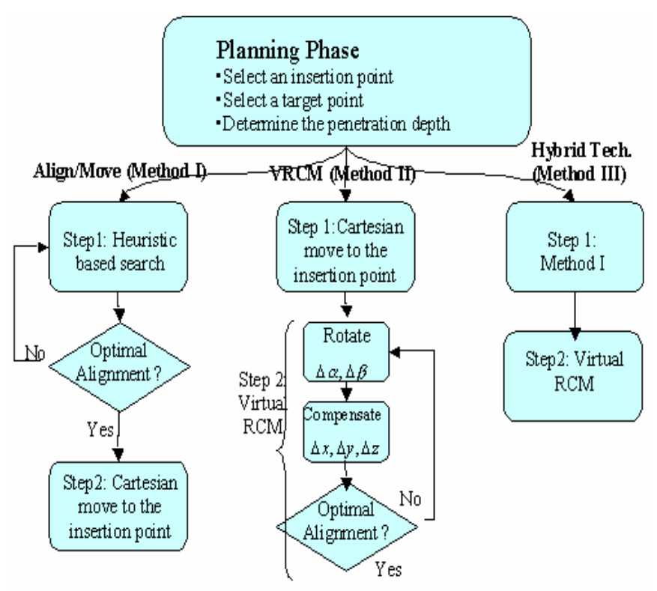
Figure 1: Needle Insertion Flow Chart, E. Boctor et al.
Boctor notes that the Hybrid technique (Method III) is the most accurate method, yielding displacement errors <0.8mm and angle errors <1.5⁰, while being approximately on the same algorithmic complexity level of that as Method I [1]. Furthermore, Method II yields approximately the same results as Method I, but is significantly slower [1]. They note that given any initial condition, this algorithm can achieve an optimized solution in about a second [1].
Analysis
Boctor’s group demonstrated that by using a virtual RCM, neither the robot nor the tool holder require careful construction, and that most errors can be compensated for using heuristic correction software. It’s interesting to note that the algorithm has little knowledge about its kinematics - rather, it uses information from displacement vectors gained from the tracker to make educated guesses about how to actuate. This is a very effective way of solving the RCM stability issue, and applying this method to future devices may save resources, since the devices would not require such a precise level of construction and design.
For future work, I would suggest combining this heuristic search algorithm with a carefully constructed robot in order to achieve higher accuracy and precision. Since the robot would already be carefully constructed and has accuracies of under a millimeter already, this algorithm would serve to minimize the error even further, potentially enabling the usage of RCM robots in more delicate surgeries.
References
- Boctor EM, Webster RJ, III, Mathieu H, Okamura AM, Fichtinger G: Virtual remote center of motion control for needle placement robots. Comput Aided Surg. 2004;9:175–183.
- Stoianovici D: URobotics – Urology Robotics at Johns Hopkins. Comp Aid Surg, 2001, (6):360-369

